R

RestaurantERP — Restaurant Management System

User & Training Manual
From the table to the kitchen to the ledger — floor, orders, KDS, delivery, sessions and reports
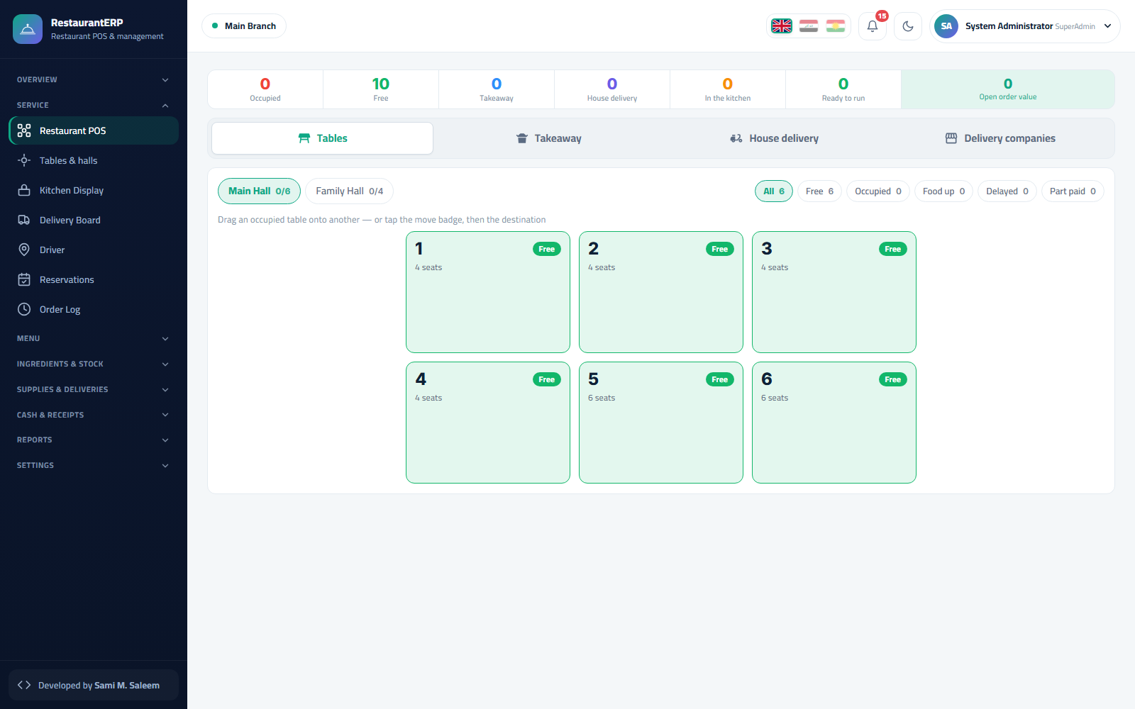
Version 1.0 · Prepared 2026-09-12
Every screen in this manual comes from a demo environment with entirely fictional data.

Table of Contents
- 1. Introduction and Quick Start
- 1.1 What is RestaurantERP?
- 1.2 Roles
- 1.3 Signing in
- 1.4 The layout
- 1.5 The five-minute service tour
- 2. Setup: Halls, Tables, Stations, Menu and Recipes
- 2.1 Restaurant setup
- 2.2 Menu and modifiers
- 2.3 Recipes
- 2.4 Ingredients and stock
- 2.5 Users, permissions, cashier PINs
- 3. Service: Floor, Orders, Takeaway and Delivery
- 3.1 Cashier session first
- 3.2 The floor
- 3.3 Taking an order
- 3.4 Takeaway
- 3.5 House delivery and delivery companies
- 3.6 Reservations
- 3.7 Paying and receipts
- 4. Kitchen, Money and Reports
- 4.1 Kitchen display (KDS)
- 4.2 Cashboxes and expenses
- 4.3 Reports
- 4.4 Back office and accounting
- 4.5 Administration
- 4.6 Frequently asked questions

Chapter 1Introduction and Quick Start

1.1 What is RestaurantERP?
RestaurantERP runs a restaurant, café or food-court outlet from a single web system: the dining floor and its tables, orders and the kitchen display, takeaway and delivery, cashier sessions, and — underneath — a complete trading back office (menu and recipes, ingredient stock, purchasing, treasury and double-entry accounting). It is built on the same platform as TradeERP, so everything the restaurant sells ends in real stock movements and a balanced journal entry.
Area | What it covers
Service | Restaurant POS (tables, takeaway, house delivery, delivery companies), delivery board, driver screen, reservations, order log, receipts
Kitchen | Kitchen display (KDS) with stations and ticket states, printed kitchen tickets, 86'd (sold-out) board, waste
Menu | Dishes, modifiers, categories, prices; recipes that explode into ingredient issues at settlement
Ingredients & stock | Stock on hand, batches/expiry, ledger, adjustments, counts
Suppliers & purchases | Purchase invoices, receipts, returns
Cash & receipts | Cashier sessions, cashboxes, payment methods, discounts, expenses
Reports | Daily sales, item sales, kitchen timing, table occupancy, delivery, discounts, payments, waste, theoretical vs actual cost, peak hours
Administration | Users, permissions, branches, numbering, backups, integrity checks, audit trail
Demo note. Every screen in this manual comes from a demo restaurant with automatically generated data. Nothing in it is real.

1.2 Roles
Role | Where they work
Owner / Administrator | Everything, including setup, permissions, backups
Manager | Floor, kitchen, menu, stock, purchases, reports
Cashier | POS, floor, delivery board, receipts, own session
Kitchen | Kitchen display only
Driver | Driver screen — orders assigned to them and cash-on-delivery custody
Accountant | Treasury, journal, statements, periods

1.3 Signing in
The login page offers two ways in: the cashier picker (tap your name, type your PIN) for the front of house, and the username / password form for everyone else. Choose the language with the flags — Arabic and Kurdish switch the layout to right-to-left.
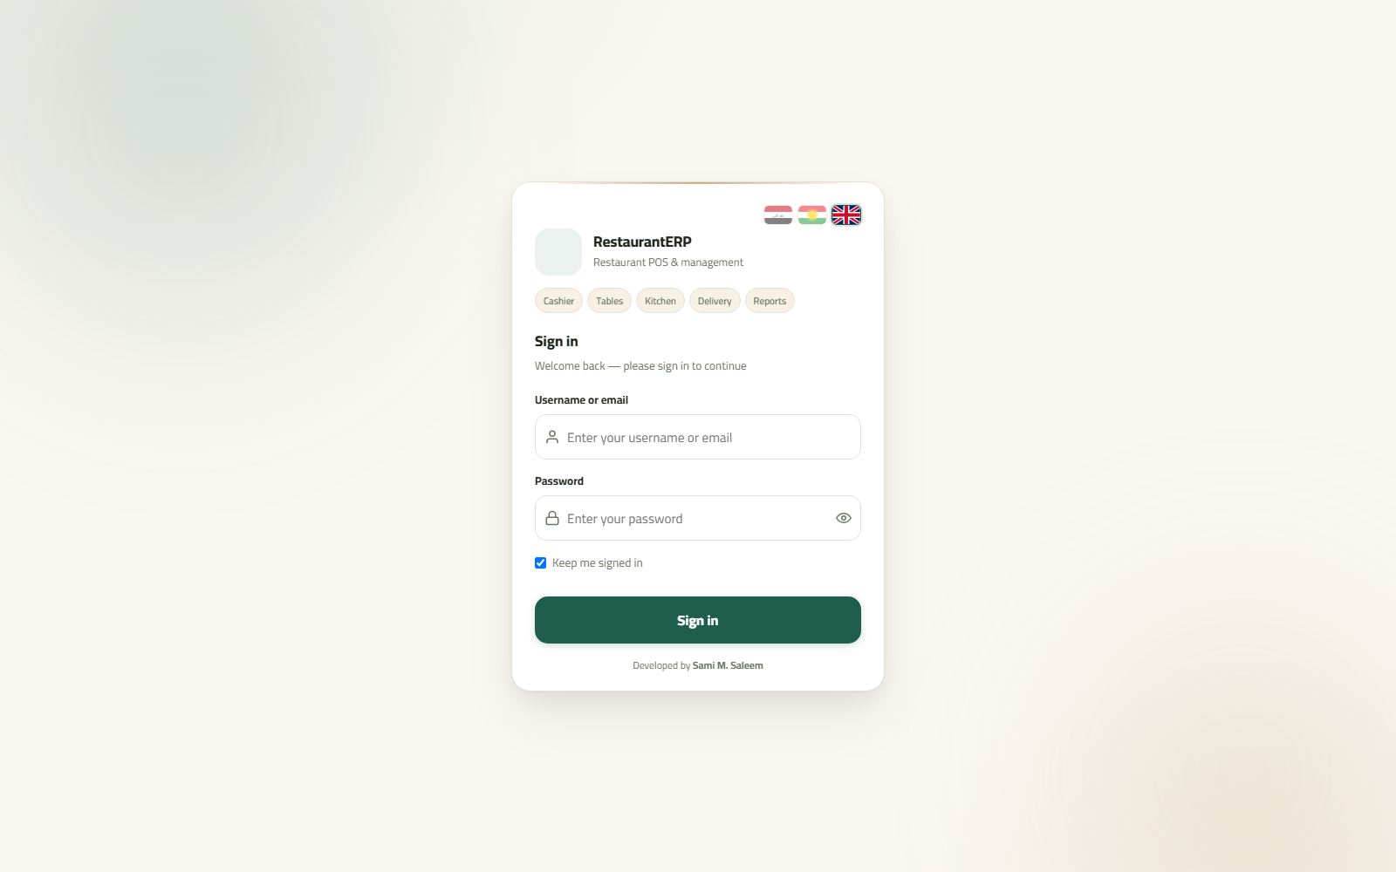Sign-in

1.4 The layout
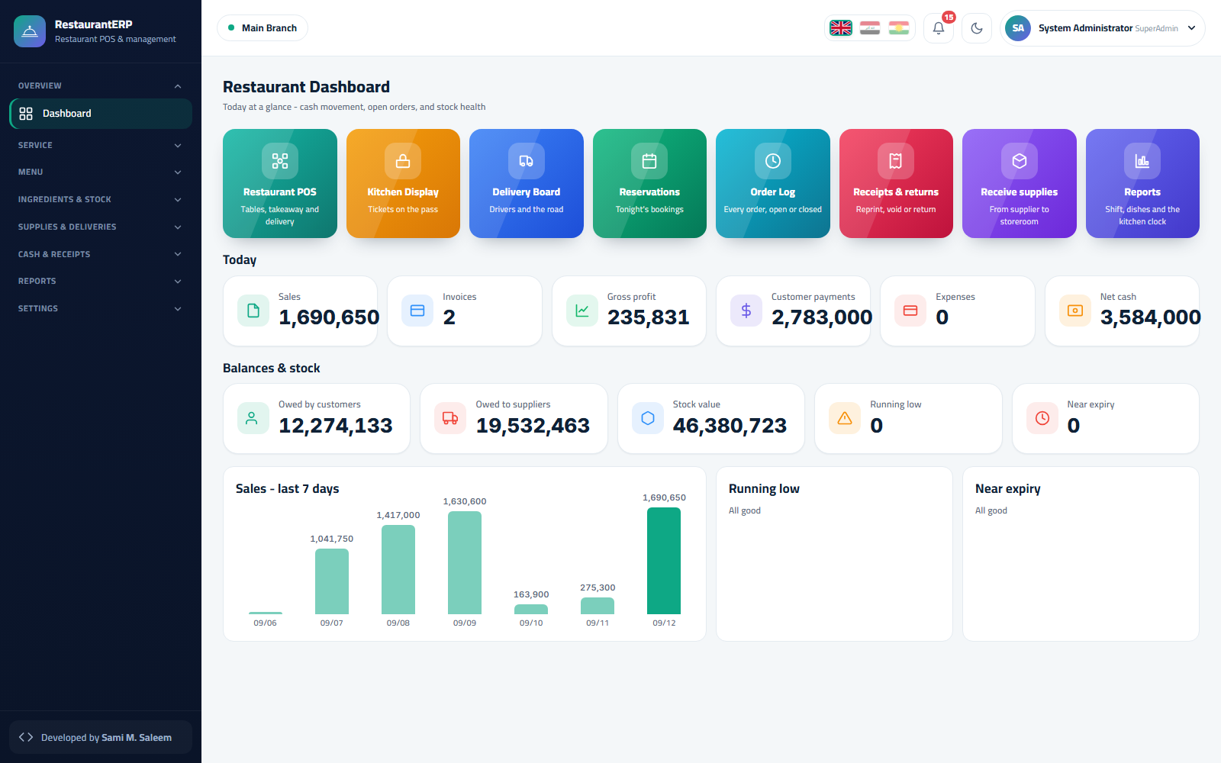Restaurant dashboard
- Sidebar — Overview, Service, Kitchen, Menu, Ingredients & stock, Suppliers & purchases, Cash & receipts, Reports, Settings.
- Top bar — active branch, language, notifications, dark mode, profile.
- Dashboard — quick tiles (Restaurant POS, Kitchen display, Delivery board, Reservations, Order log, Receipts & returns, Receive supplies, Reports), today's counters, balances & stock, sales of the last 7 days, low-stock and near-expiry lists.

1.5 The five-minute service tour
- Service → Restaurant POS: the floor shows every table with its state (free, occupied, ready to serve, late).
- Tap a free table → enter the guest count → the order screen opens.
- Add dishes from the menu wall; set options (modifiers) and notes; Send to the kitchen.
- Kitchen → Kitchen display: the ticket appears at its station; the cook bumps it through preparing → ready.
- Back on the table: Pre-bill, then Pay (cash, card, split). The receipt prints; the sale, its stock issues (from recipes) and the journal entry are posted together.

Chapter 2Setup: Halls, Tables, Stations, Menu and Recipes

2.1 Restaurant setup
Settings → Restaurant setup is the one-stop wizard for a new outlet: company details, kitchen stations (grill, cold, bar, dessert…), halls (dining areas) and their tables with seat counts, payment methods, service-charge and VAT rules, receipt header/footer and printer assignments.
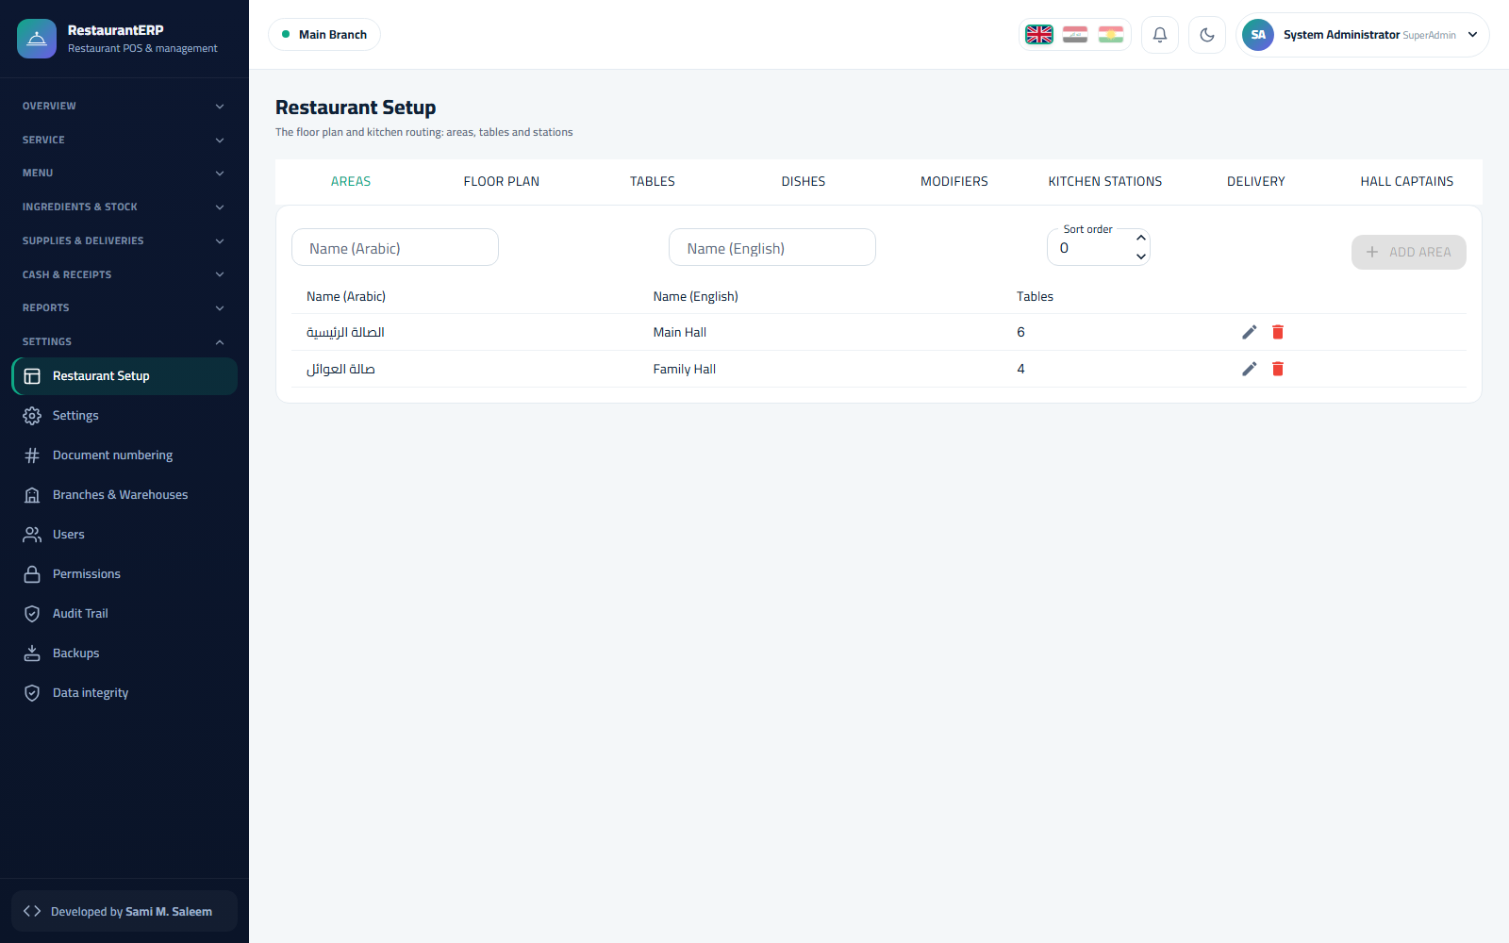Restaurant setup 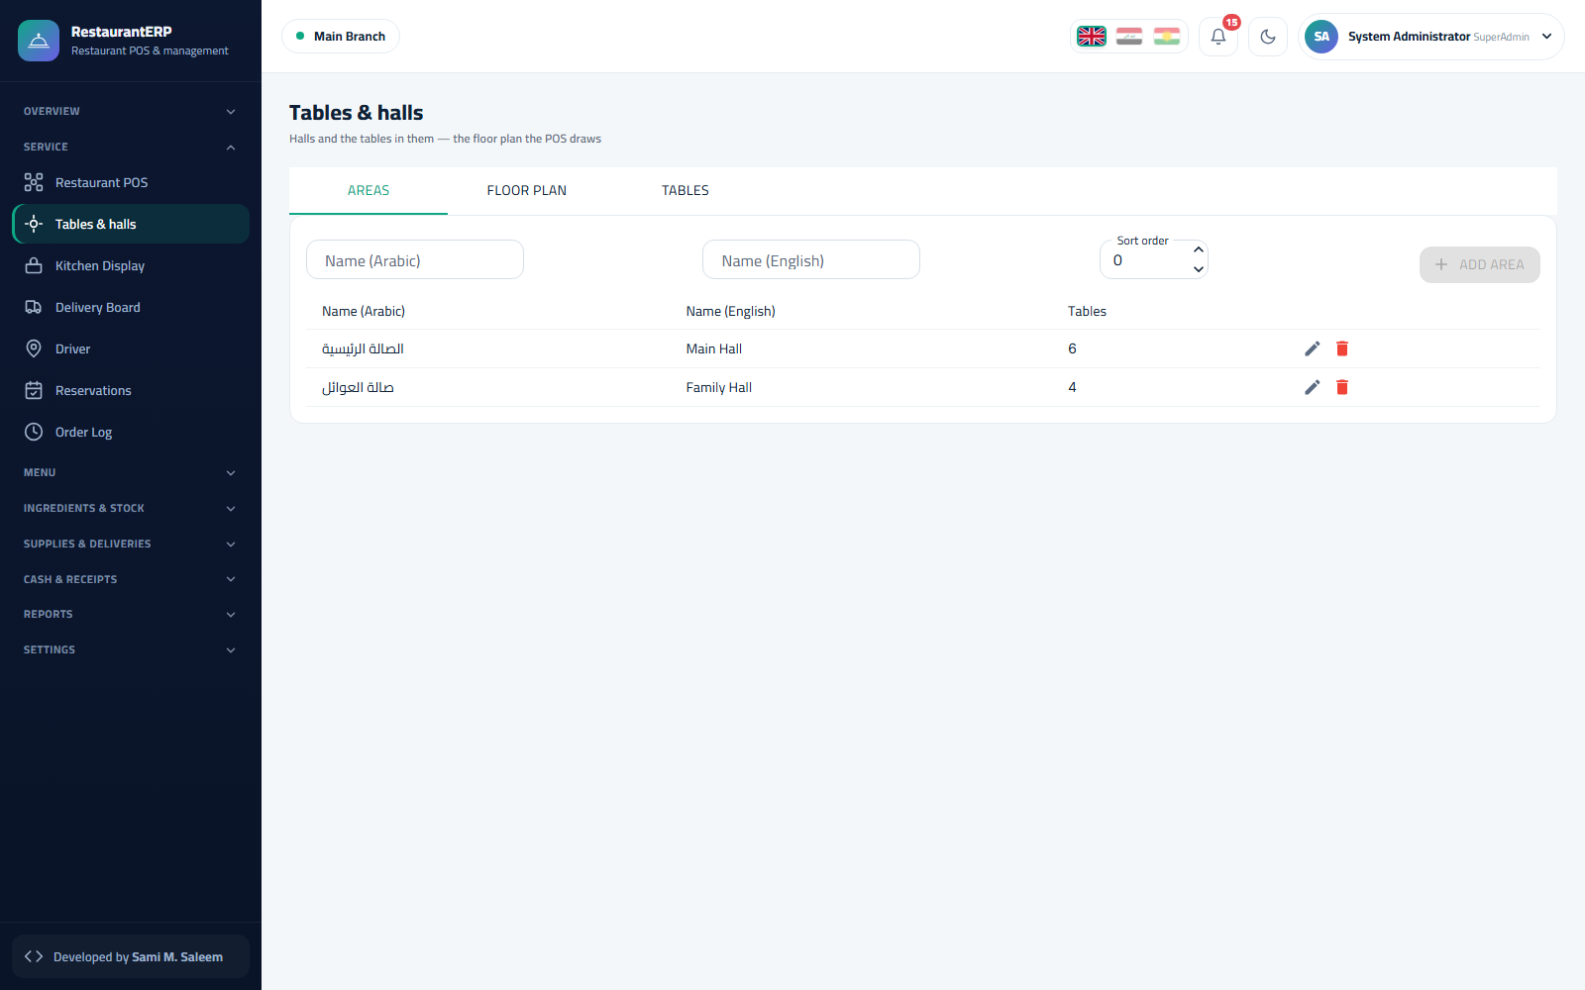Halls and tables

2.2 Menu and modifiers
Menu → Menu & modifiers. Dishes are grouped by category with English/Arabic names, price, kitchen station and status. Modifiers (size, extras, "no onion"…) are option groups attached to dishes; each option can change the price. Import a whole menu from Excel with Import from file.
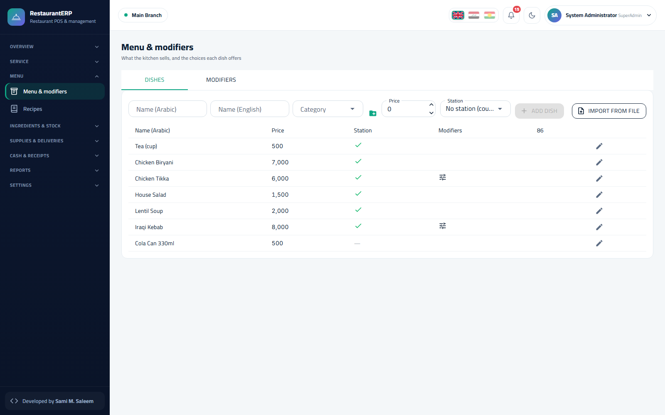Menu and modifiers

2.3 Recipes
Menu → Recipes. Pick a dish and list its ingredients with quantities per portion. When an order is settled the recipe explodes: each ingredient is issued from stock (FEFO, from the batch that expires first) and its real cost becomes the dish's cost of sale. Dishes without a recipe simply sell at zero stock impact.
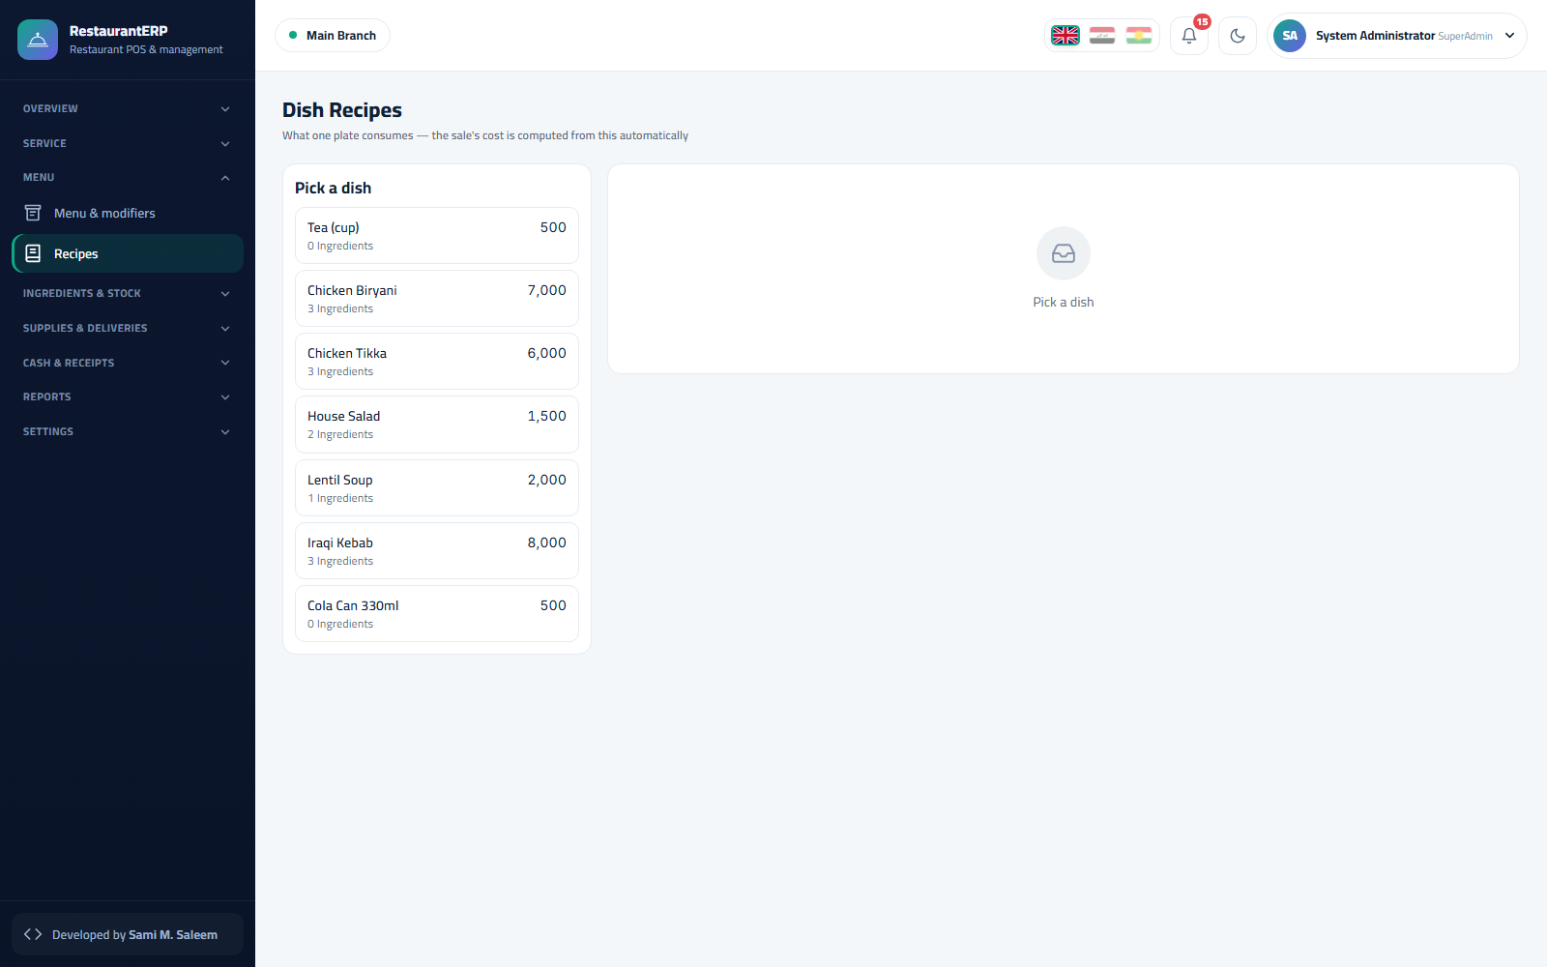Dish recipes
Why it matters. The Theoretical vs actual cost report compares what the recipes say you should have used with what the stock count says you actually used — the fastest way to find waste and over-portioning.

2.4 Ingredients and stock
The stock module is the same engine used by TradeERP: Stock on hand, Batches / expiry, Ledger, Adjustments, Counts. Ingredients are bought from suppliers through Suppliers & purchases → Purchase invoices / Receive supplies and consumed by recipes.
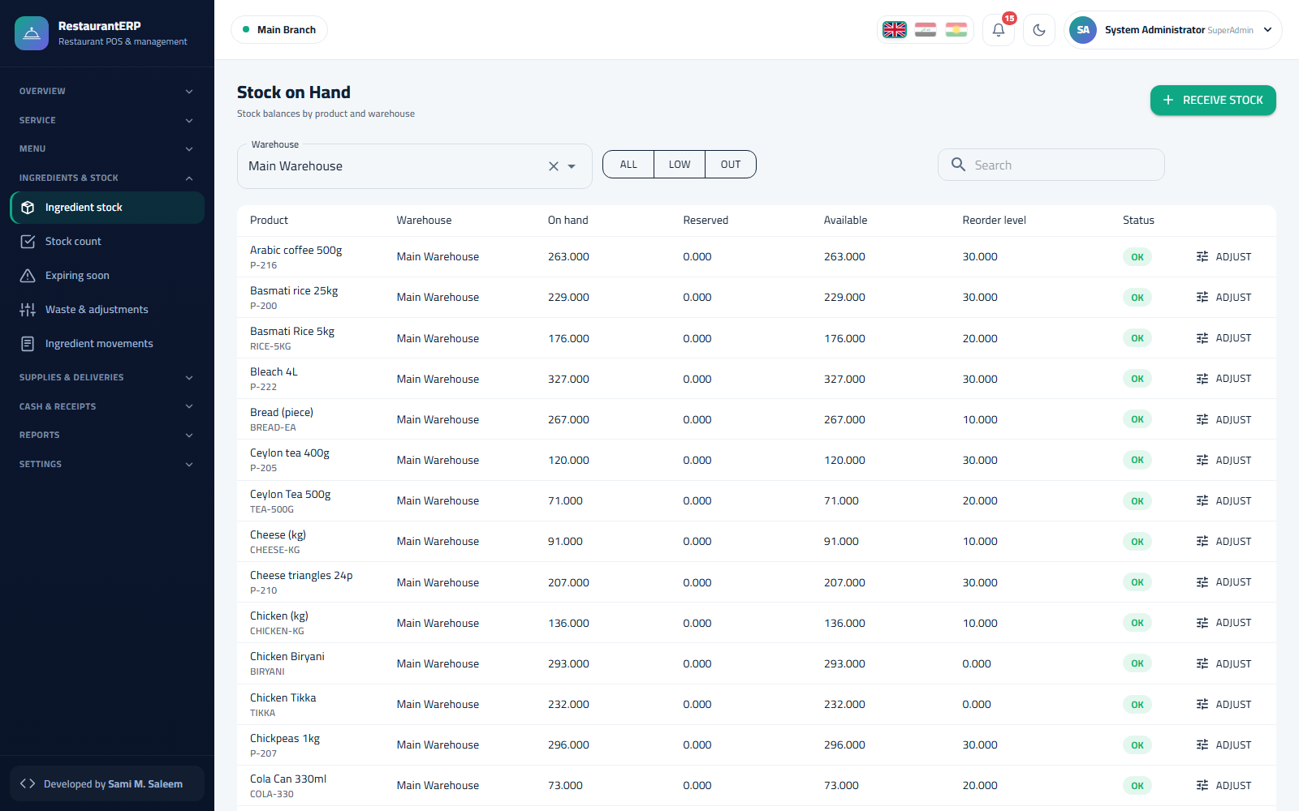Ingredient stock on hand 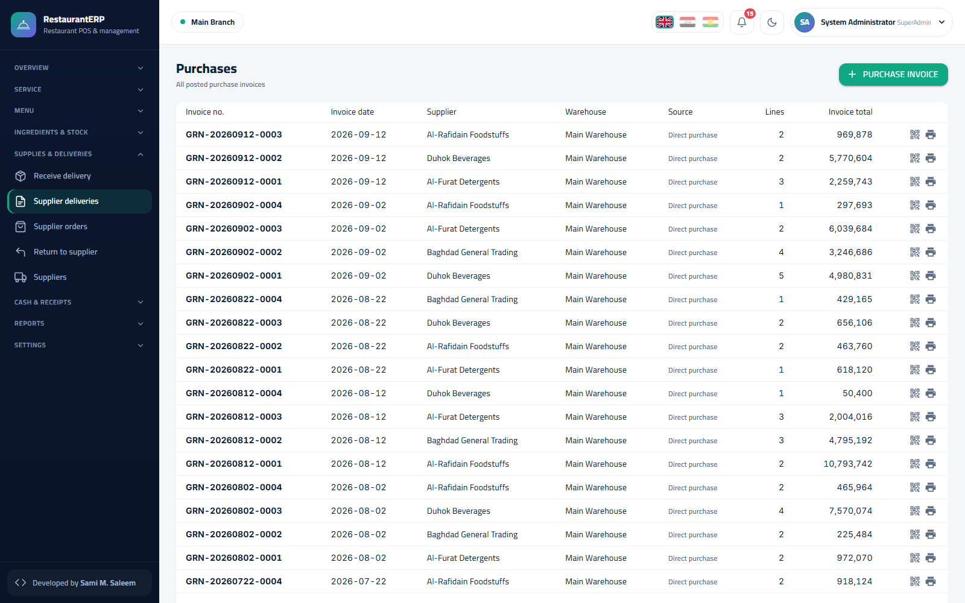Purchase invoices

2.5 Users, permissions, cashier PINs
Settings → Users creates staff accounts; front-of-house users get a cashier PIN so they can sign in from the picker in two taps. Settings → Permissions is the role matrix — e.g. only managers can void a sent item, give discounts above the limit, or reopen a closed session.
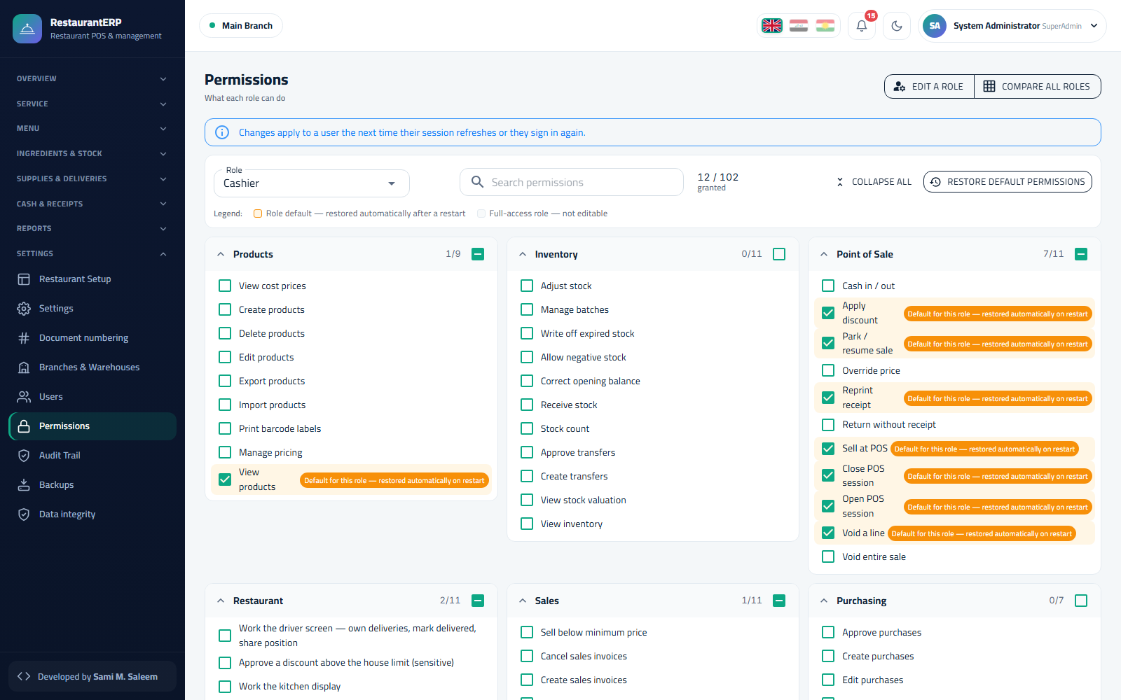Permission matrix

Chapter 3Service: Floor, Orders, Takeaway and Delivery

3.1 Cashier session first
Nothing can be sold without an open cashier session. From Cash & receipts → Cashier sessions (or the prompt on the POS) choose the cashbox, enter the opening float and Open. At the end of the shift Close it: the system shows expected cash versus counted cash and records the variance with the closer's name.
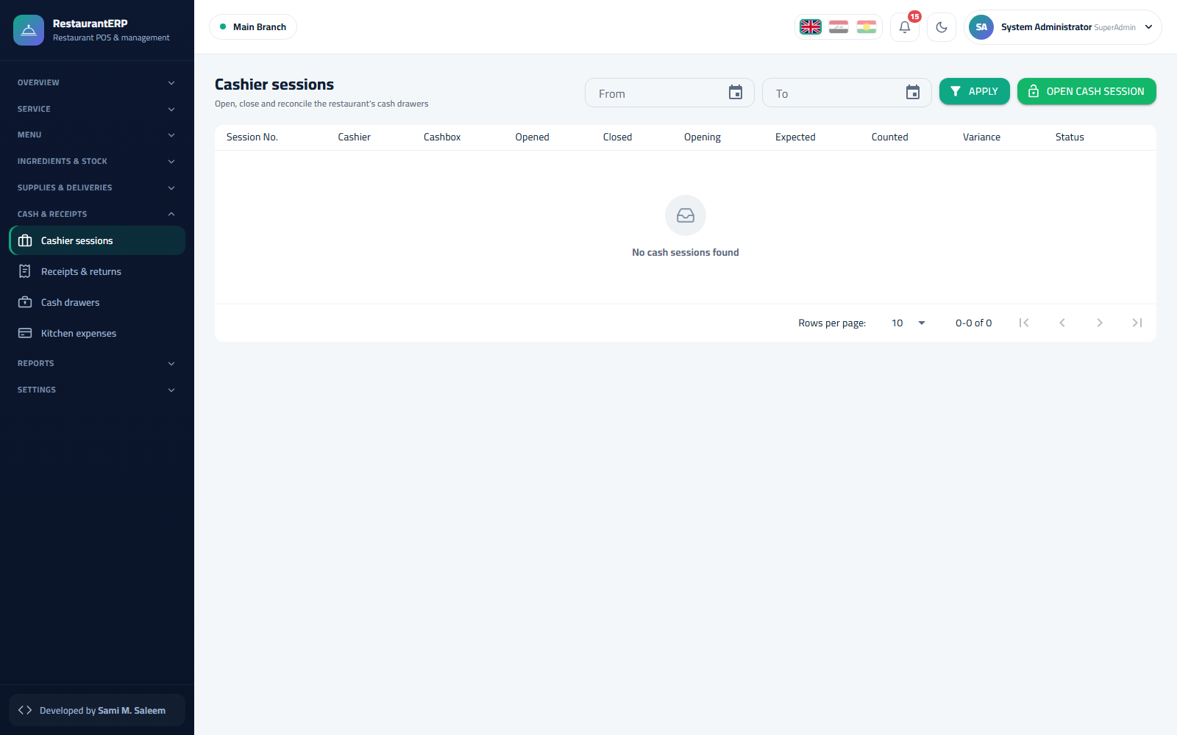Cashier sessions

3.2 The floor
Service → Restaurant POS opens on the Tables tab: one card per table with its number, seats, current guests, running total, elapsed time and a colour state — free, occupied, ready to serve, late, partly paid. The counters on top summarise the hall (occupied, free, in kitchen, ready, takeaway, deliveries, open-orders value). Halls are switched with the chips.
The floor board
Table actions:
- Tap a free table → guest count → new order.
- Tap an occupied table → open its order.
- Move / merge — drag an occupied table onto another, or use Move to transfer dishes between tables (two-step dialog).
- Split bill — by items or by equal shares.

3.3 Taking an order
The order screen shows the menu wall (category chips, quick-item bars, search) on one side and the ticket on the other.
- Tap dishes to add them; tap a line to change quantity, choose modifiers, add a note for the kitchen, or remove it (removing a sent item needs a manager reason and is logged).
- Send — items go to their kitchen stations; the table turns in kitchen.
- Add more items later; only the new ones are sent.
- Pre-bill prints the check; Pay settles (see below).
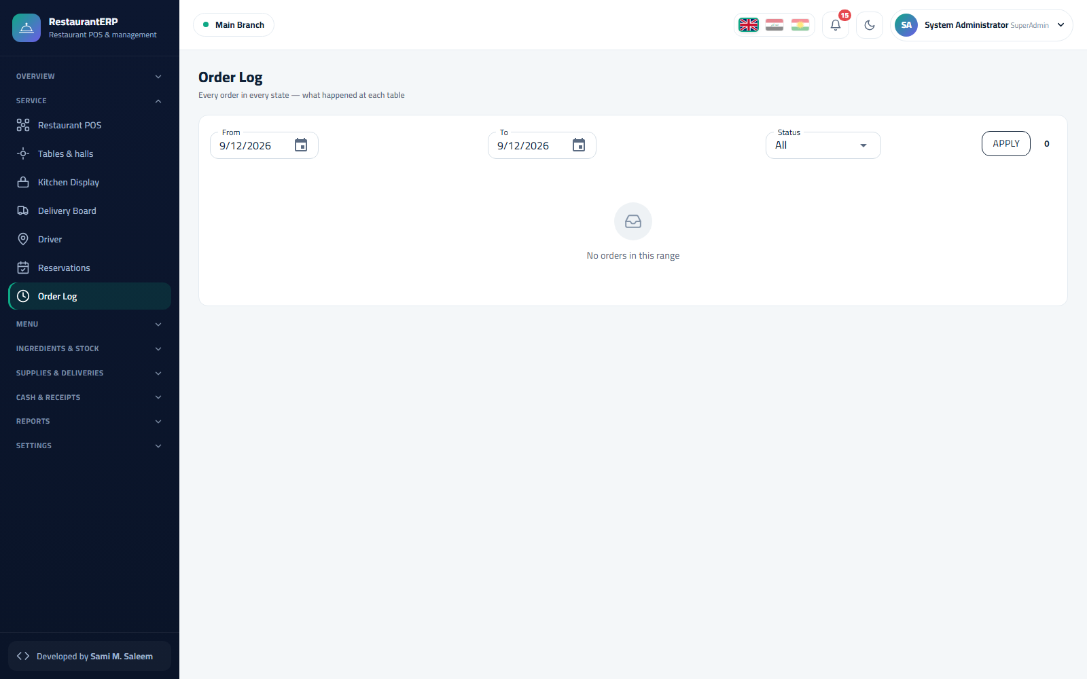Order log — every order with state and totals

3.4 Takeaway
The Takeaway tab holds counter orders without a table: same order screen, the customer's name or number on the ticket, and a ready state to call them.

3.5 House delivery and delivery companies
- Service → Delivery board — three columns: to prepare, out for delivery, delivered, plus the driver custody bar (cash the driver is carrying). Assign a driver, mark handed-over, and settle when the driver returns.
- Delivery companies (aggregators) are handled as a separate channel with their own commission and settlement.
- Service → Driver screen — the driver's own view: the orders assigned to them, addresses and phone numbers, amounts to collect, and a delivered button.
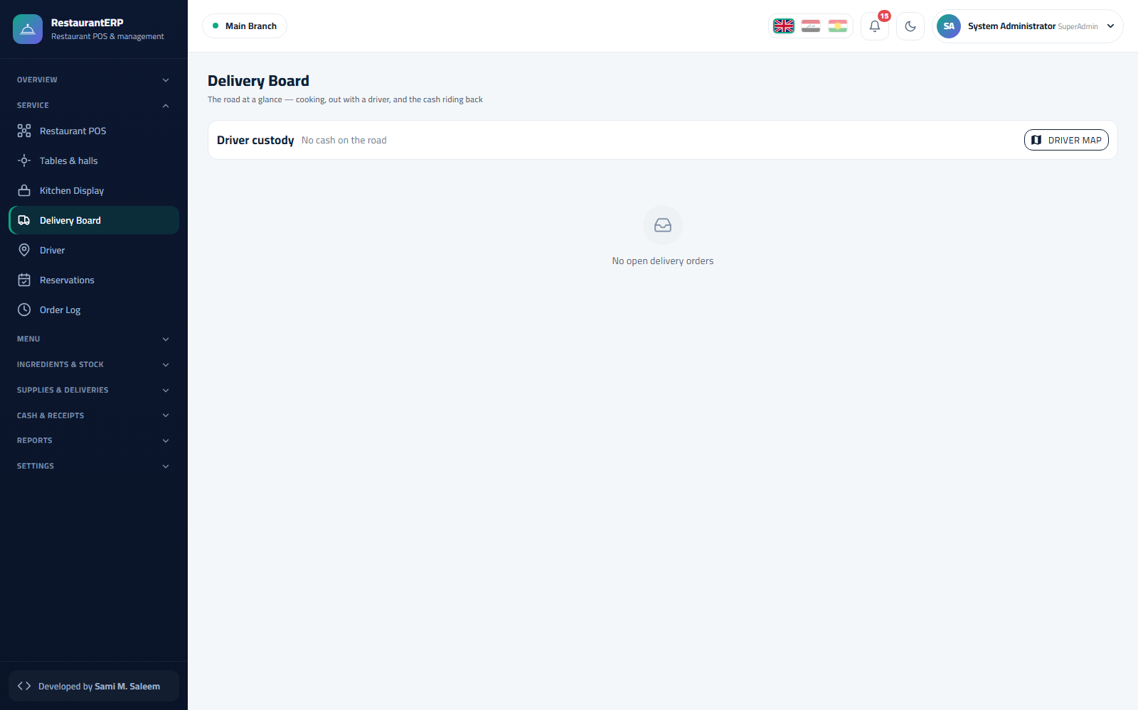Delivery board 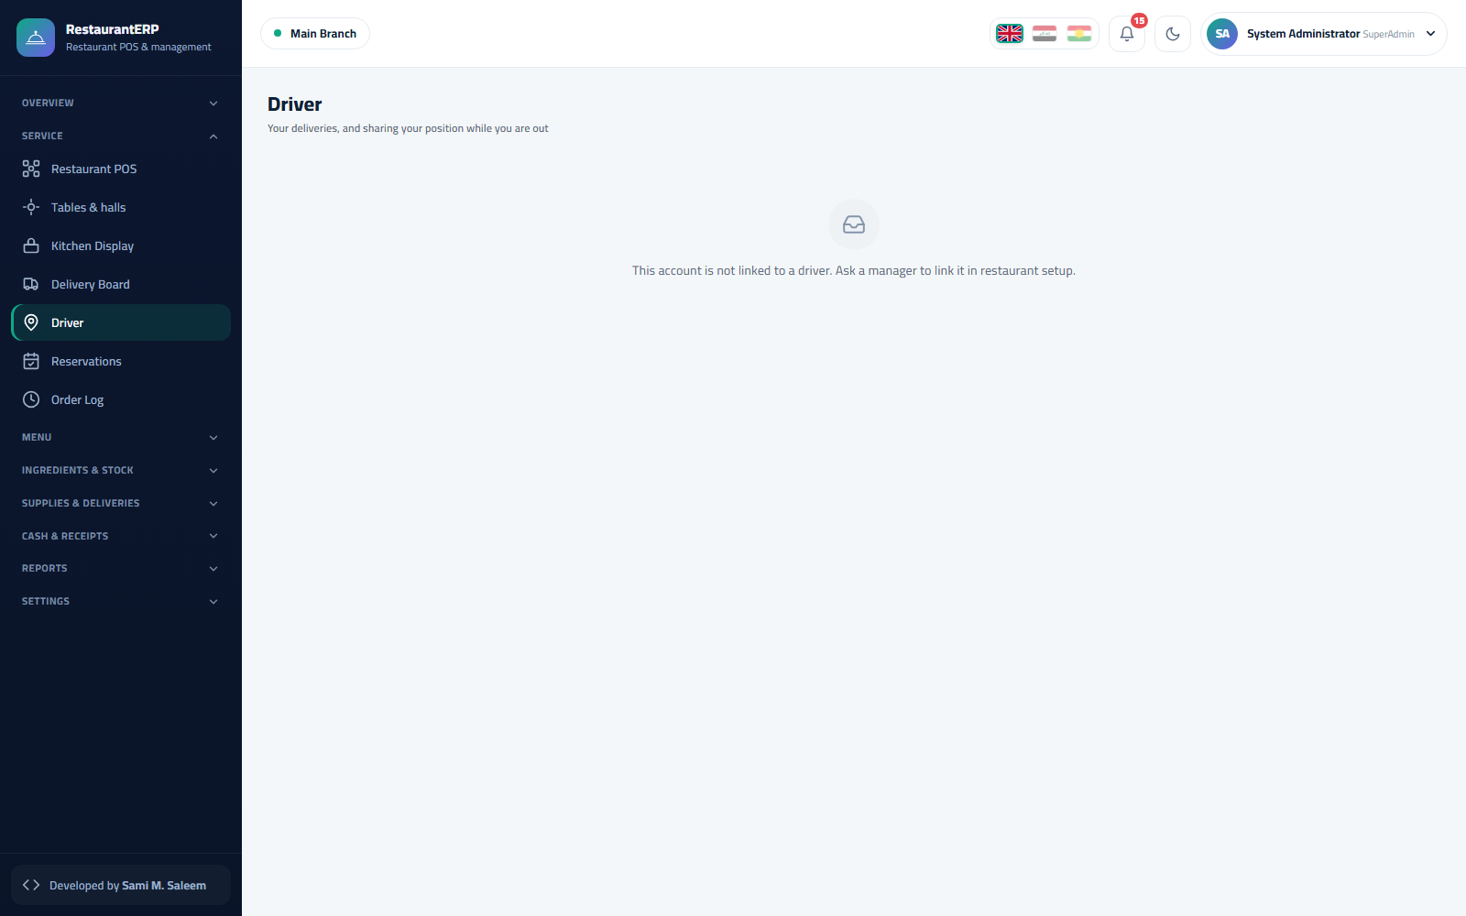Driver screen

3.6 Reservations
Service → Reservations. Date, time, guests, name, phone and preferred hall/table; reserved tables show a badge on the floor and the reservation converts to an order with one tap on arrival.
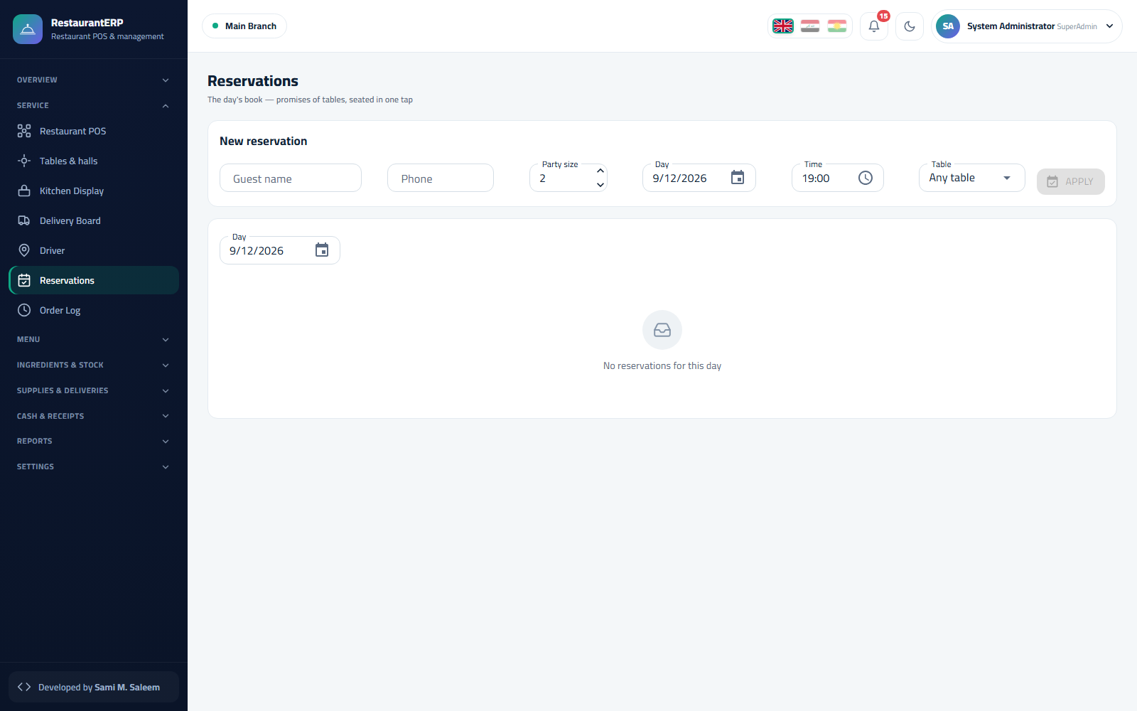Reservations

3.7 Paying and receipts
Pay accepts cash, card, or mixed; applies discounts (within the user's limit — beyond it a manager code is required); adds service charge if configured; and prints the receipt. Cash & receipts → Receipts & returns lists every receipt and lets a manager issue a return (full or per item) with a reason.
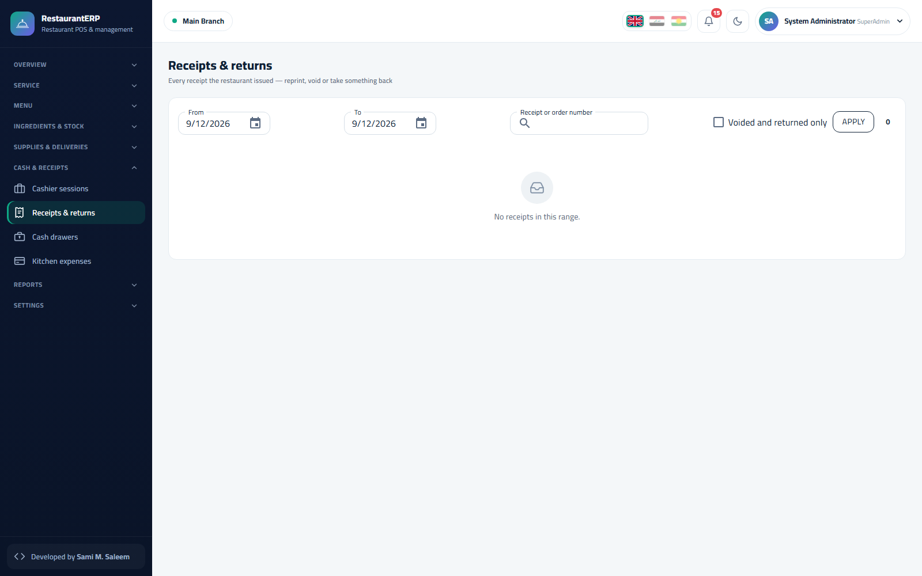Receipts and returns

Chapter 4Kitchen, Money and Reports

4.1 Kitchen display (KDS)
Kitchen → Kitchen display is the screen on the pass. Each station sees its own tickets in three columns — new, preparing, ready. A cook taps a ticket to advance it; a ticket that exceeds the target time gets a red frame and a late badge. Tickets can also be printed on an 80 mm kitchen printer.
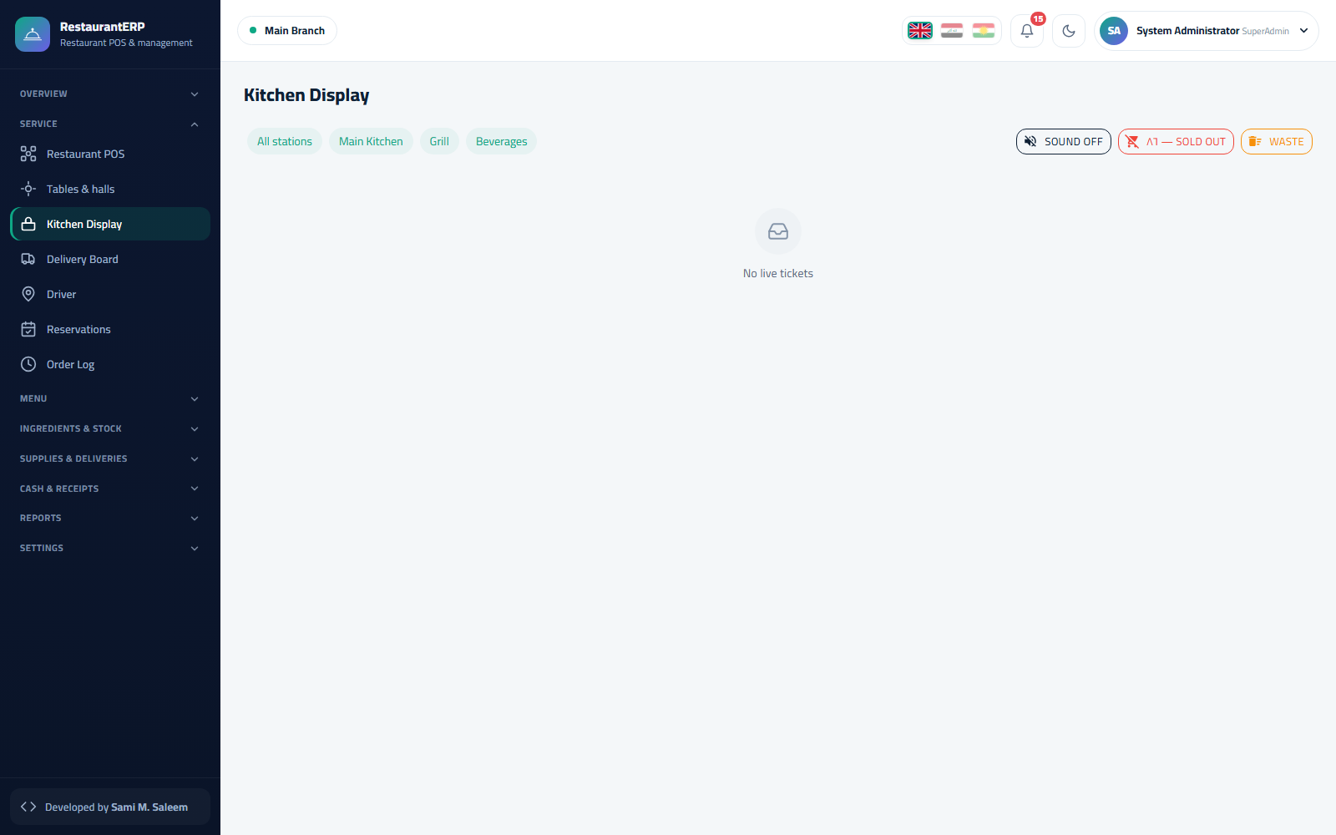Kitchen display
- 86 board — mark a dish sold-out; it greys out on every POS immediately.
- Waste — record a wasted portion (dropped plate, wrong order) with a reason; stock is issued and the waste report captures it.

4.2 Cashboxes and expenses
Cash & receipts → Cashboxes shows each cashbox with its balance and open session; Expenses records petty cash spending (gas, cleaning, tips paid out) against the session's cashbox.
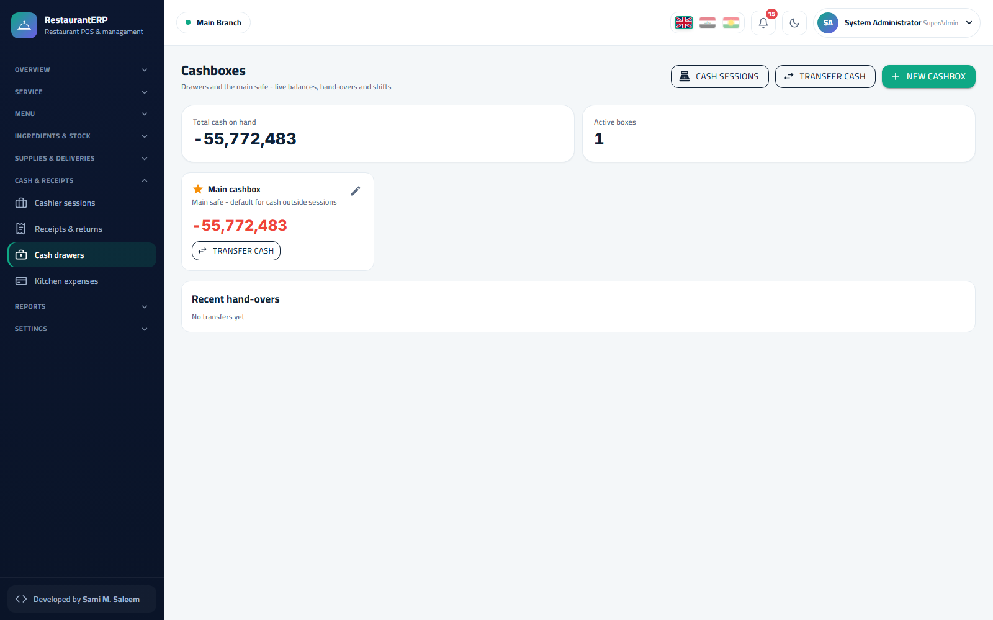Cashboxes

4.3 Reports
All reports have the same period picker, Apply, Excel and Print.
Report | What it shows
Daily sales | Sales per day by channel (tables, takeaway, house delivery, companies) with discounts, service charge, VAT and net
Item sales | Quantity and revenue per dish and category, linked to recipe cost
Kitchen timing | Average preparation time per station and per dish, late-ticket count
Table occupancy | Turns per table, average ticket, average stay
Delivery | Orders and cash per driver and per company, commission
Discounts | Every discount with who gave it and why
Payments | Totals per payment method per session
Waste | Wasted items, cost and reasons
Theoretical vs actual cost | Recipe cost vs stock-count cost — the shrinkage finder
Peak hours | Sales by hour × weekday heat-map
Shift | Per-session summary: opening, sales, expenses, expected, counted, variance
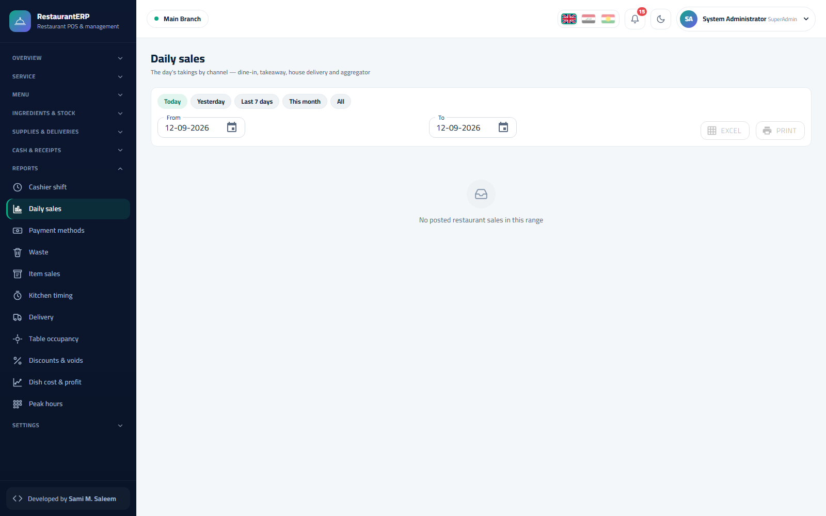Daily sales 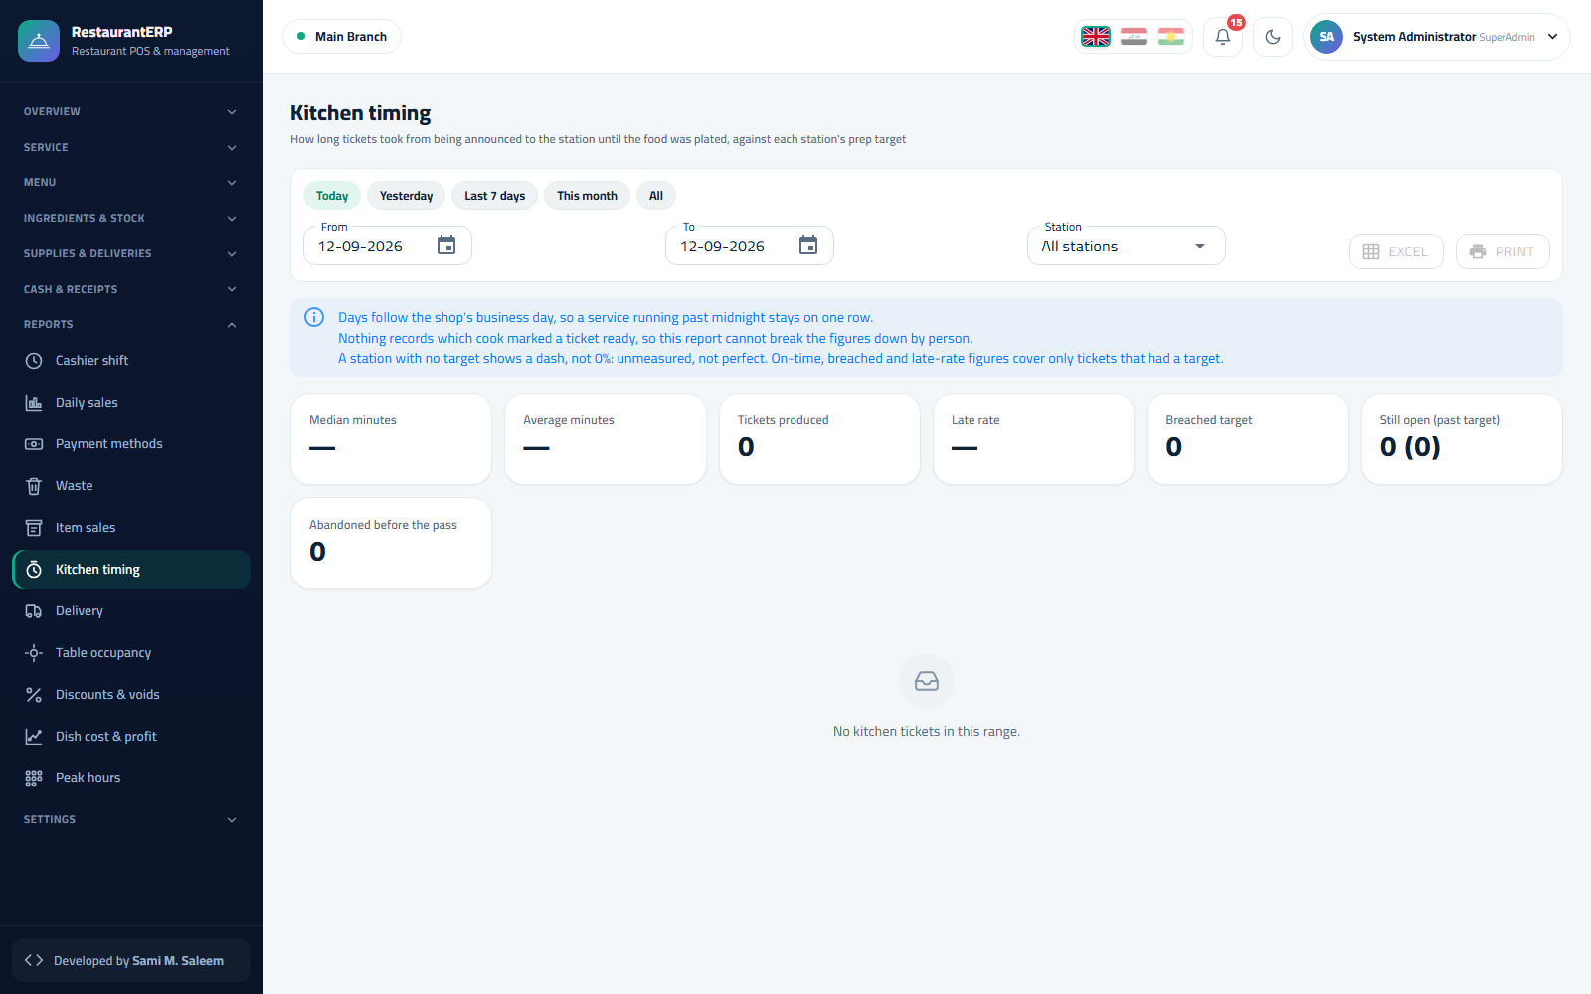Kitchen timing 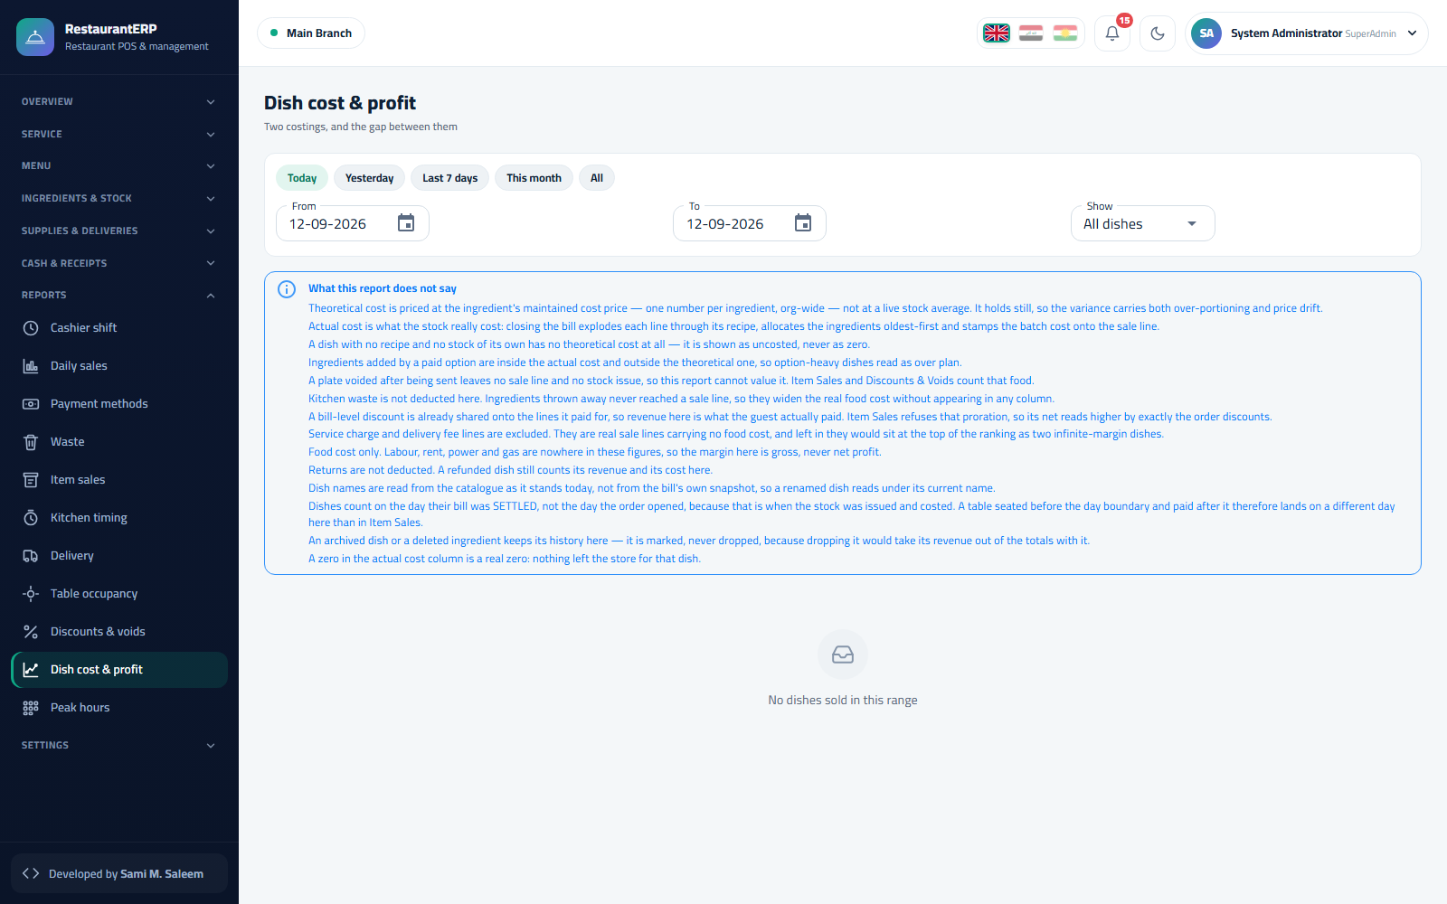Theoretical vs actual cost 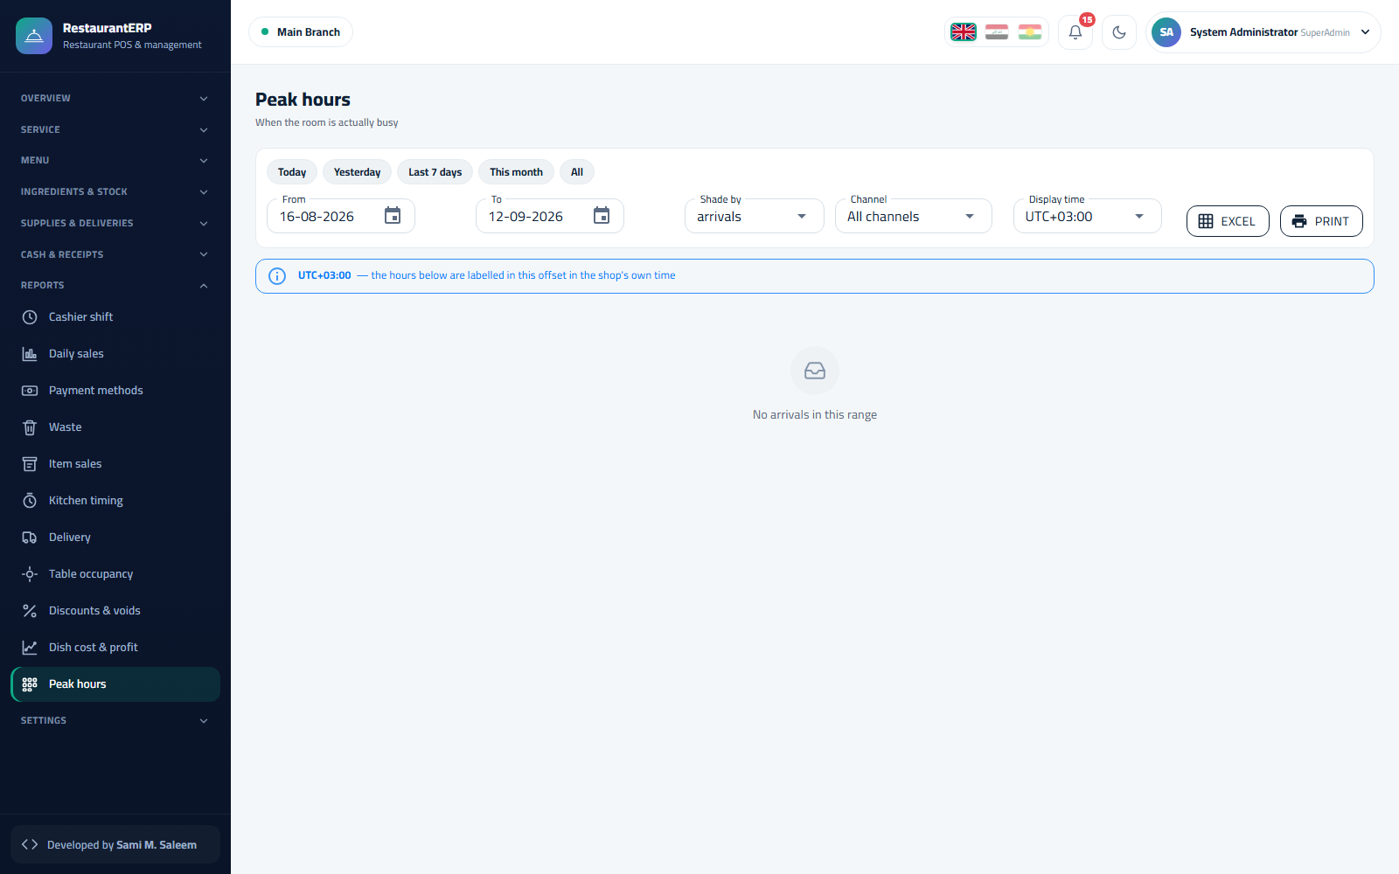Peak hours

4.4 Back office and accounting
Purchasing, treasury, journal, ledger, statements and accounting periods work exactly as in TradeERP (see the TradeERP manual, chapters 4 and 6): every settled order posts sales revenue, service charge, VAT, cost of sales and inventory in one balanced entry.

4.5 Administration
- Audit trail — who did what (voids, discounts, reopened sessions, permission changes).
- Data integrity — reconciliations between tickets, receipts, sessions, stock and journal.
- Backups — nightly and on-demand.
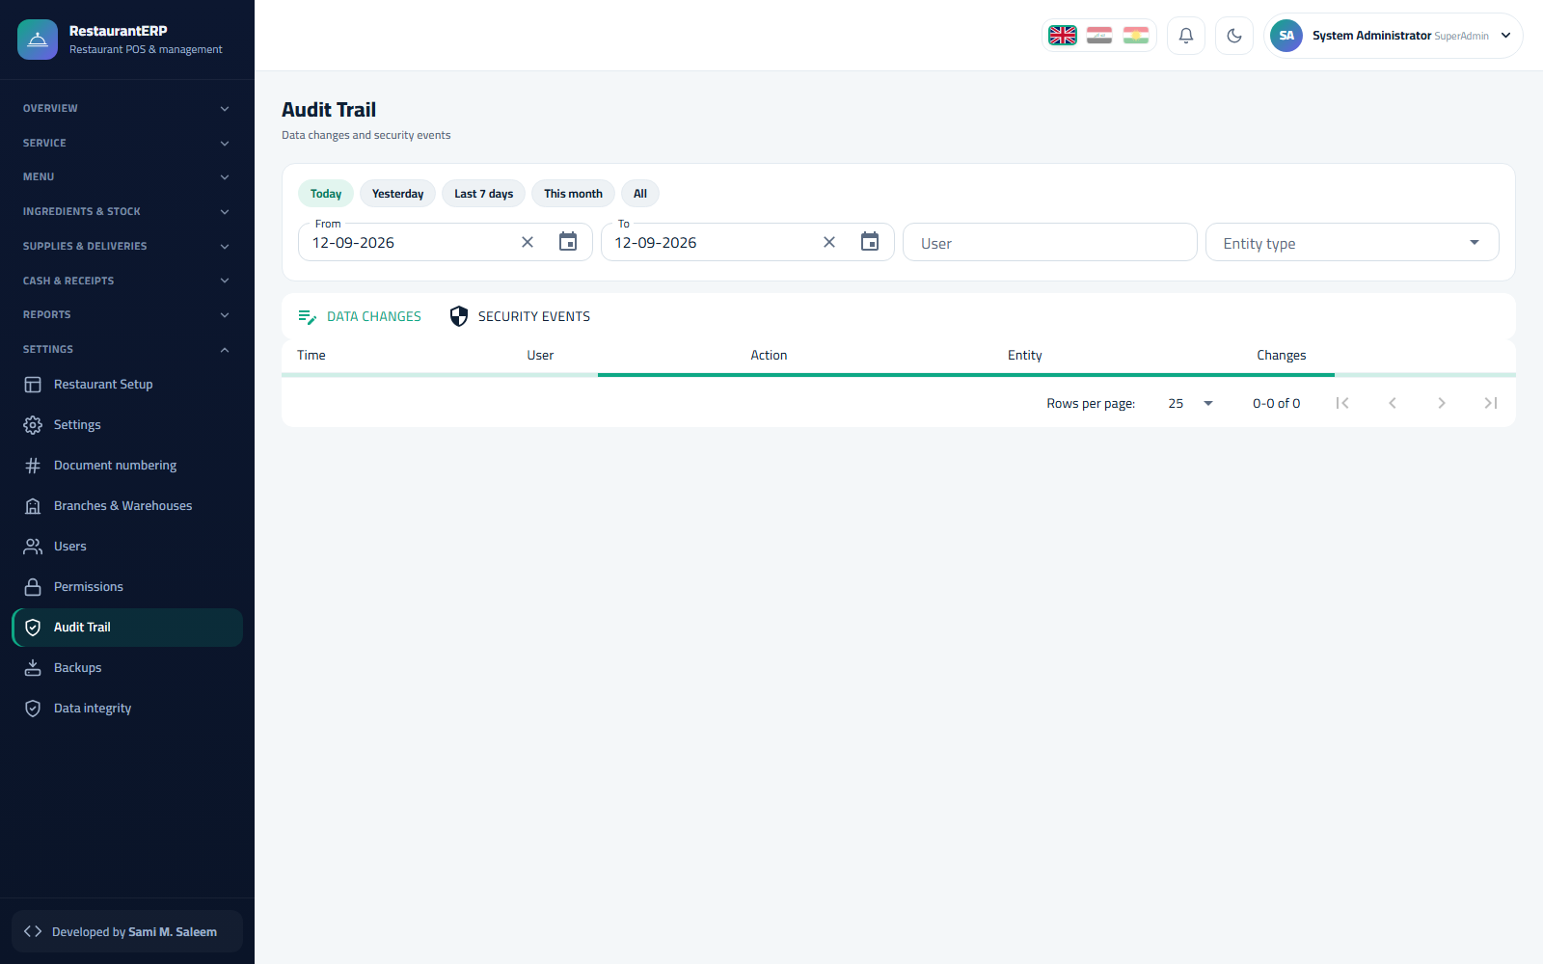Audit trail

4.6 Frequently asked questions
A dish is greyed out on the POS. It was marked 86 (sold out) on the kitchen board; un-mark it there.
The table shows "late". A ticket at one of its stations passed the target time; check the kitchen display.
Can I move part of an order to another table? Yes — Move on the floor, pick the items, choose the destination.
The variance at session close is not zero. The system records it with the closer's name; managers review variances in the Shift report.
How do delivery companies get paid? Their orders accumulate in the company's account; settle them from the delivery report when the company pays.

