S

SchoolERP — School Management Platform

Complete User & Training Manual
From zero to advanced — for every school employee and parent
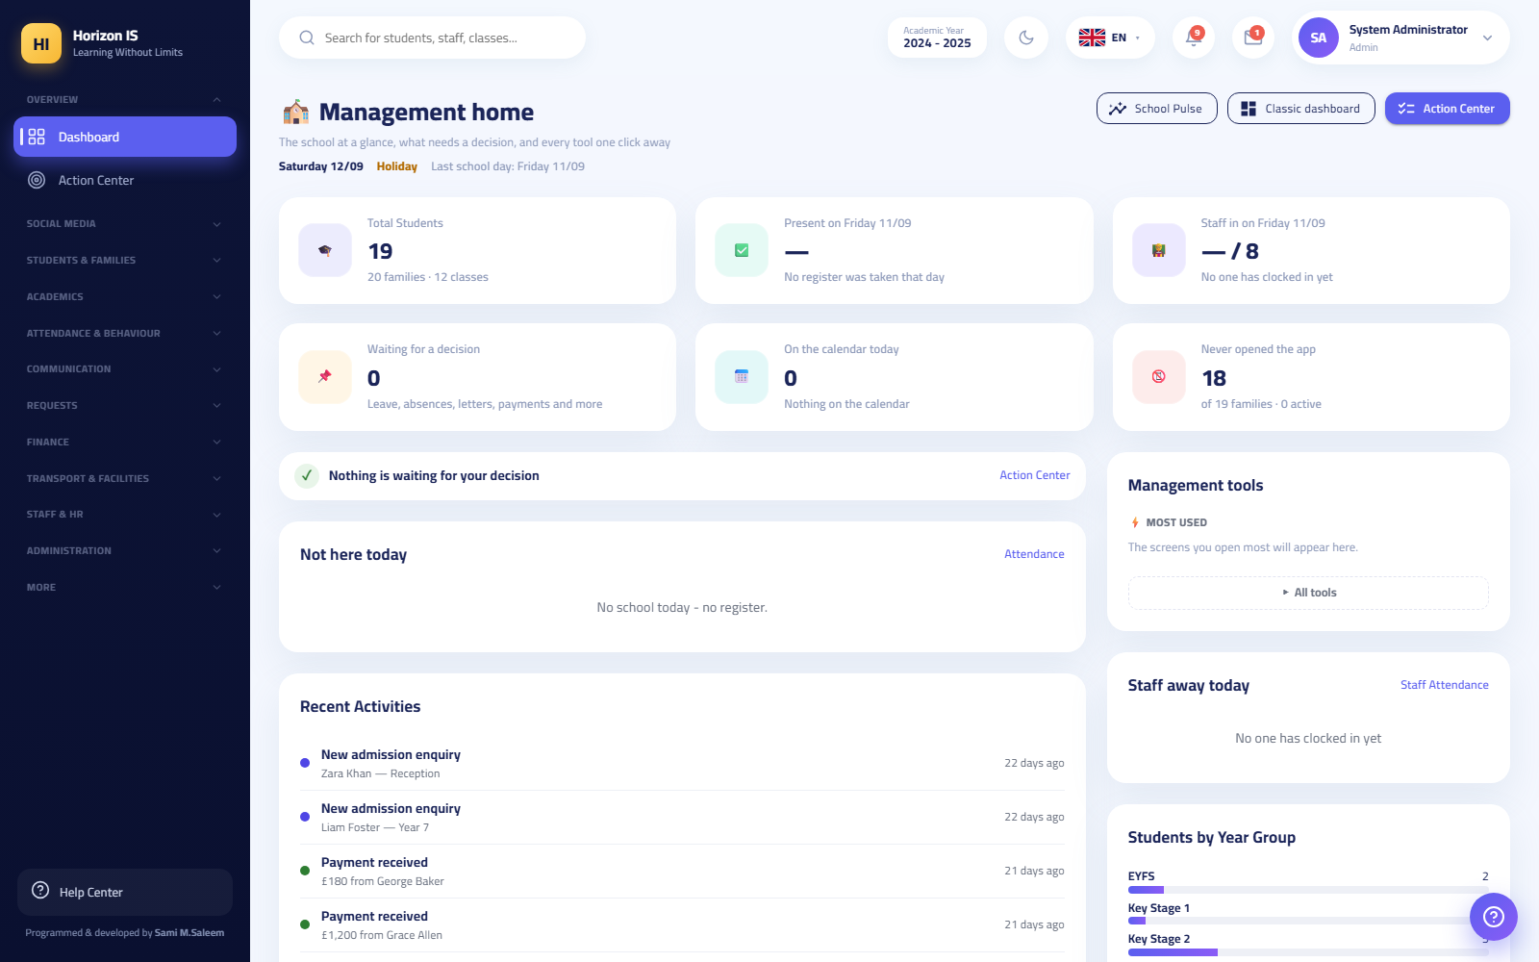
Version 1.0 · Prepared 2026-09-12
Every screen in this manual comes from a demo environment with entirely fictional data.

Table of Contents
- 1. Introduction and Quick Start
- 1.1 What Is the System?
- 1.2 Who Uses the System?
- 1.3 Devices and Browsers
- 1.4 The Six Interface Languages
- 1.5 Signing In to the Portal
- 1.6 Two-Step Verification at Sign-In
- 1.7 The Temporary Password and the Forced Change
- 1.8 Changing Your Password Yourself
- 1.9 Enabling Two-Factor Authentication (2FA)
- 1.10 Signing Out
- 1.11 Understanding the Sidebar
- 1.12 Your Landing Page by Role
- 1.13 A Tour of the Dashboards
- 1.14 Patterns Repeated on Every Screen
- 1.15 The Mobile App at a Glance
- 1.16 The New Staff Member's First-Day Checklist
- 1.17 The Demo Environment Note
- 1.18 Related Topics
- 2. Role Guides: Leadership and Administration
- 2.1 Quick Overview of the Six Roles
- 2.2 1) SuperAdmin
- 2.3 2) School Owner — SchoolOwner
- 2.4 3) Principal
- 2.5 4) System Administrator — Admin
- 2.6 5) Registrar
- 2.7 6) IT Staff — IT
- 2.8 Appendix: Signing In for Leadership Role Holders
- 3. Role Guides — Academic Staff
- 3.1 11.1 The Teacher
- 3.2 11.2 Head of Department and Head of Section
- 3.3 11.3 The Form Tutor
- 3.4 11.4 The Librarian
- 3.5 11.5 The Nurse and the Doctor
- 3.6 11.6 The Safeguarding Officer
- 3.7 Related topics for the whole chapter
- 4. Role Guides: Operations and Families
- 4.1 A Quick Look at the Roles in This Chapter
- 4.2 The Accountant
- 4.3 The Accountant's Role in the System
- 4.4 The Finance Bridge
- 4.5 The Fee Structure and Fee Assignment
- 4.6 Record a Payment and Issue a Receipt
- 4.7 Vouchers and the Journal
- 4.8 Payment Requests from Families
- 4.9 Finance Reports and Balance Follow-up
- 4.10 Extra Screens in the Accountant's Hands: the School Shop, the Cafeteria, and Uniforms
- 4.11 The Receptionist
- 4.12 The Bus Driver
- 4.13 Driver Clock-in (the Time Clock)
- 4.14 Running a Trip — Driver Mode
- 4.15 Operational Staff — the Cleaner and the General Staff Member
- 4.16 The Parent — the Complete App Guide
- 4.17 Choosing the School
- 4.18 Signing in with the Family Code
- 4.19 Device Approval
- 4.20 The Parent Home Screen
- 4.21 The "My Children" Tab and Attendance Follow-up
- 4.22 Grades — Visible Only When Published
- 4.23 Homework
- 4.24 Installments — View Only
- 4.25 Messages: Text, Voice, Photos, and Files
- 4.26 Reporting an Absence
- 4.27 Booking Appointments with Teachers
- 4.28 Tracking Your Child's Bus
- 4.29 My Account and Requesting Account Closure
- 4.30 The Parent Web Portal
- 4.31 The Student
- 4.32 The Student App Tabs
- 4.33 My Attendance
- 4.34 My Reports
- 4.35 The Library Catalog
- 4.36 Related Topics for the Whole Chapter
- 5. Module Guides: People &amp; Academics
- 5.1 1. Students
- 5.2 2. Families
- 5.3 3. ID Cards
- 5.4 4. Classes &amp; Sections
- 5.5 5. Timetable
- 5.6 6. Homework
- 5.7 7. Exams
- 5.8 8. Grades
- 5.9 9. Library
- 5.10 10. Lesson Plans &amp; Learning Resources
- 5.11 11. Classroom Tools
- 5.12 12. Recognition Wall
- 5.13 Permission summary for this chapter
- 6. Module Guides: Attendance, Behavior, and Communication
- 6.1 Section One: The Attendance Hub
- 6.2 Section Two: Staff Attendance and the Time Clock
- 6.3 Section Three: Behavior
- 6.4 Section Four: The School Calendar
- 6.5 Section Five: The Communication Hub (Conversations)
- 6.6 Section Six: Official Letters
- 6.7 Section Seven: Parent Meetings
- 6.8 Section Eight: The Social Media Hub
- 6.9 Section Nine: Telegram Linking
- 6.10 Appendix: The Demo Environment
- 7. Module Guides — Finance, Operations, and Administration
- 7.1 1. Finance Section Overview
- 7.2 2. The Finance Bridge
- 7.3 3. Fee Structure
- 7.4 4. Installments, Payments, and Receipts
- 7.5 5. Accounting
- 7.6 6. The Shop
- 7.7 7. The Requests Section
- 7.8 8. Transport and Facilities
- 7.9 9. Staff HR
- 7.10 10. Administration and System
- 7.11 Chapter Summary
- 8. End-to-End Workflows
- 8.1 Chapter Map
- 8.2 1) Setting Up a New Academic Year and Terms
- 8.3 2) Creating Grade Levels, Classes, and Sections
- 8.4 3) Adding a New Staff Member: Employment Record + Login Account + Roles
- 8.5 4) Enrolling a Student + Linking the Family + the Family Login Code + First App Sign-In
- 8.6 5) Teaching Assignments + Building the Timetable
- 8.7 6) Recording Daily Attendance — the Teacher on Web and App
- 8.8 7) Exams → Mark Entry → Publication Approval → Family Access
- 8.9 8) Fees: Fee Structure → Assignment → Recording a Payment → Printing the Receipt
- 8.10 9) School-Wide Announcements + Class Posts + Stories
- 8.11 10) End-of-Year Rollover: Promotion, Graduation, and Departures
- 9. Troubleshooting, FAQ, and Glossary
- 9.1 Part One: Troubleshooting
- 9.2 Part Two: FAQ
- 9.3 Part Three: Glossary
- 9.4 Appendix

Chapter 1Introduction and Quick Start
Welcome to the official training manual for the School Management System used across the the school group. This chapter is the starting point for every new staff member. Read it in full before moving on to the other chapters.
What will you learn in this chapter?
- What the system is, who uses it, and which devices it runs on.
- How to sign in for the first time and how to change your temporary password.
- How to read the sidebar and understand why a colleague sees screens you do not.
- A quick tour of the dashboards by role.
- The patterns repeated across every screen of the system: search, filters, tables, export and print buttons.
- A ready-made checklist for your first day.

1.1 What Is the System?
The system is an all-in-one school management platform: students and families, attendance, grades, timetables, fees and finance, school transport, staff affairs, and parent communication — all in one place.
The system consists of two parts working on the same data:
Part | Who mostly uses it | How you reach it
The web portal | Management, teachers, the registrar, the accountant, and all school staff | From an internet browser at your school's address
The "Horizon International School" mobile app | Parents and students first and foremost, plus teachers and staff for daily tasks | From the app store on your phone
Important: Every school has its own independent system. Your data, your accounts, and your portal address belong to your school alone and are never mixed with any other school in the group. In the mobile app you pick your school once from the school picker screen, and from then on the app connects only to your school's system.

1.2 Who Uses the System?
Every user has one account with a specific role. The role determines which screens they see and which actions they are allowed. The roles in the system:
Category | Roles
Leadership (sees everything) | School Owner, School Principal, System Administrator (Admin)
Academic management | Stage Head, Department Head, Homeroom Teacher
Teaching | Teacher
Office and administration | Registrar, Accountant, Receptionist, IT Officer
Specialists | Nurse, Doctor, Safeguarding Officer, Librarian
Services | Bus Driver, Facilities Worker, General Staff
Families | Parent, Student
System-provider only | SuperAdmin — never granted to any school employee
Tip: Do not memorize this list. The only rule you need: you see only what your role allows. If you need a screen that does not appear for you, ask school management to grant you the permission — never borrow a colleague's account.
The details of each role and its permissions are in the "Accounts, Roles, and Permissions" chapter.

1.3 Devices and Browsers
- The web portal works from any modern browser: Chrome, Edge, Firefox, or Safari. We recommend the latest version of Chrome or Edge on a desktop or laptop — especially for data-entry and printing screens.
- The portal also works from a phone browser, but the the school app is easier and faster for daily use on mobile.
- Your device needs no special installation for the portal — just your school's internet address and a stable connection.
Important — device security: The system recognizes every device you sign in from. When the school enables device approval, your first browser is approved automatically, and any additional device stays "awaiting school approval" until an IT officer approves it. This is protection for student data, not a malfunction.

1.4 The Six Interface Languages
The system — portal and app alike — works in six languages:
- Arabic (the default in the app, with a right-to-left interface)
- English
- Kurdish (Badini)
- Turkish
- German
- Swedish
Where do you change the language?
- On the sign-in page: a small row of flags above the sign-in card — click the flag of the language you want.
- Inside the portal after signing in: the same flag row sits in the top bar, and you can switch at any time without signing out.
- In the app: from the sign-in screen, or later from the "My Account" (حسابي) screen.
Tip: Changing the language affects only your account and your device — it does not affect any other user.

1.5 Signing In to the Portal
Purpose Accessing your account on the web portal, for the first time or any time after.
Who can Everyone with an account: all staff, plus parents and students (if the school has enabled their portal).
Before you start
- Get from the administration office or the IT officer: your school's portal address, your username or email, and your temporary password.
- The temporary password is shown to the administration staff member only once, when your account is created — keep it somewhere safe until your first sign-in.
Steps
- Open the browser and type your school's portal address. The sign-in page appears at the path /login.
- Pick your language from the flag row above the card if you wish.
- In the "Email / Username" (البريد الإلكتروني / اسم المستخدم) field, type your email or username — either is accepted.
- In the "Password" (كلمة المرور) field, type your password (the temporary one if this is your first sign-in).
- Tick the "Remember me" (تذكّرني) box only if the device is your personal device — never tick it on a shared device.
- Click the "Sign In" (تسجيل الدخول) button.
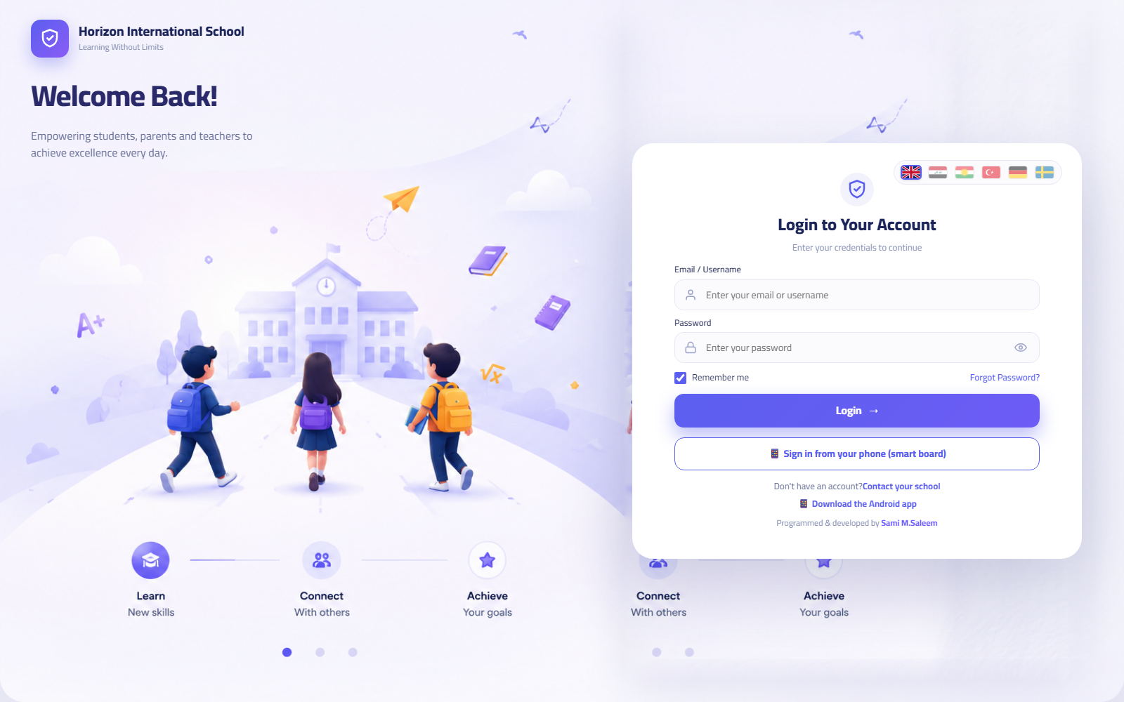Sign-in page
Expected result
- If your credentials are correct and no extra verification applies: you go straight to the dashboard for your role (see Your landing page by role).
- If your account has two-step verification enabled: you go to the code-entry page (next section).
- If your password is temporary: the system forces you to set a new password before anything else (see The temporary password).
Common errors
Message on screen | Meaning | What to do
"The email or password is incorrect." | A typing mistake or outdated credentials | Check your keyboard language and Caps Lock, then calmly try again
"The account is temporarily locked after repeated failed attempts. Try again in 15 minutes." | 5 consecutive wrong attempts | Wait the full 15 minutes, then try. If you have forgotten the password, ask administration to reset it
"The parent portal is currently closed by the school." | The school has temporarily suspended family sign-in | Applies to parents and students only — contact the school office
"This device is awaiting school approval." | A new device not yet approved | Ask the IT officer to approve the device, then try again
"This device has been blocked." | The device is blocked by management | Contact school management
Troubleshooting
- The page does not open at all? Verify the address letter by letter and check your internet connection. If the problem persists, tell the IT officer — it may be a temporary server outage.
- Forgot your password? There is no self-service "forgot password" link; resets are done by administration from the users screen, and you will receive a new temporary password that must be replaced at your first sign-in.
- A parent with no email address? Families sign in through the app with the family code printed by the school — see the "Families and Access Codes" chapter.
Related topics Two-step verification • The temporary password • Signing out • the "Accounts, Roles, and Permissions" chapter

1.6 Two-Step Verification at Sign-In
Purpose An extra layer of protection: after your password, the system asks for a changing code from an authenticator app on your phone.
Who can Every account that has enabled two-factor authentication (2FA) in its settings. We strongly recommend it for everyone with access to sensitive data: management, the accountant, the IT officer, the safeguarding officer.
Before you start An authenticator app (such as Google Authenticator or Microsoft Authenticator) must already be installed on your phone and linked to your account (see Enabling two-factor authentication).
Steps
- Sign in with your email and password as usual.
- The "Two-Step Verification" (التحقق بخطوتين) page appears at the path /login/2fa and asks: "Enter the 6-digit code from your authenticator app."
- Open the authenticator app on your phone and copy the current 6-digit code.
- Type the code and click "Verify and Sign In" (تحقّق وادخل).
Expected result You go straight to your dashboard. If your password is temporary, the system takes you after the code to the set-password page.
Common errors
- "Incorrect code. Try again." — the code changes every few seconds; wait for the new code in the app and type it quickly.
- Entering an old code after leaving the page open too long — the verification step is valid for 5 minutes only; if you exceed it, go back with the "Back to sign-in" button and start over.
Troubleshooting
- Lost your phone or deleted the authenticator app? Contact school management or the IT officer to reset your account.
- A wrongly set phone clock produces rejected codes — turn on automatic time setting on your phone.
Related topics Enabling two-factor authentication • Signing in

1.7 The Temporary Password and the Forced Change
Purpose Every new account (or an account whose password was reset) starts with a temporary password. The system does not let you work with it: at your first successful sign-in it forces you to choose a password of your own.
Who can Every account holder flagged with "temporary password" — which is the state of every new account.
Before you start Prepare a new password that meets the system policy:
Important — password policy: at least 10 characters, and it must include: an uppercase letter (A-Z), a lowercase letter (a-z), a digit (0-9), and a symbol (such as ! or # or @). An example of the correct pattern: Kitab#2026x — do not use this exact example.
Steps
- Sign in with the temporary password (and complete the two-step verification step if you have one).
- The system automatically takes you to the "Set Your Password" (عيّن كلمة المرور) page at the path /account/change-password with the message: "Your account uses a temporary password. Choose a new password to continue."
- In the "Temporary password" (كلمة المرور المؤقتة) field, type the password you received from administration.
- In the "New password" (كلمة المرور الجديدة) field, type your new password per the policy above.
- Click "Set and Continue" (تعيين والمتابعة).
Expected result The system accepts the new password and then opens your session and you reach your dashboard. Before this step succeeds there is no session at all — the screen cannot be "skipped" and no other page can be opened.
Common errors
- A message that the current password is incorrect: retype the temporary password carefully — watch out for look-alike characters (O and zero, l and one).
- A message that the new password does not meet the policy: the policy itself is shown on screen; usually what is missing is the symbol, or the length is under 10.
- Typing the new password in the temporary-password field and vice versa — read the field labels before typing.
Troubleshooting
- Lost the temporary password before your first sign-in? Ask administration for a "password reset" from the users screen — it issues a new temporary password and cancels the old one.
- Finished setting your password and then forgot the new one the same day? Same solution: a reset by administration.
Warning: Your password is personal. Do not write it on a note stuck to the screen, and do not share it with a colleague for any reason. Every action in the system is recorded under the account holder's name in the audit log.
Related topics Changing your password yourself • the "Accounts, Roles, and Permissions" chapter

1.8 Changing Your Password Yourself
Purpose Changing your password at any time while signed in to the portal — without going back to administration.
Who can Every signed-in staff member. (The settings page opens for all staff for this purpose, even if the "Settings" link does not appear in your sidebar.)
Before you start You need your current password, plus a new one that meets the policy (10 characters; uppercase + lowercase + digit + symbol).
Steps
- Open the settings page at the path /settings (management finds it in the sidebar under the "Administration & System" section; other staff type the path in the address bar).
- From the side tabs, choose the "Security" (الأمان) tab.
- Scroll down to the "Change Password" (تغيير كلمة المرور) section.
- Fill in the three fields: "Current password" (كلمة المرور الحالية), "New password" (كلمة مرور جديدة), "Confirm new password" (تأكيد كلمة المرور الجديدة).
- Click "Update Password" (تحديث كلمة المرور).
Expected result You return to the settings page with a success message: "Password updated successfully". Use the new password from your next sign-in.
Common errors
- "The current password is incorrect" — retype your current password carefully.
- The new password is rejected even though it looks right — make sure it contains a symbol and that the length is at least 10 characters.
Important: On some screens you may come across an old hint mentioning "8 characters". The rule actually enforced on the server is 10 characters with an uppercase letter, a lowercase letter, a digit, and a symbol — always go by that.
Related topics Enabling two-factor authentication • The temporary password

1.9 Enabling Two-Factor Authentication (2FA)
Purpose Linking your account to an authenticator app on your phone so that an extra code is required at every sign-in.
Who can Every staff member, from the settings page, "Security" tab.
Before you start Install an authenticator app on your phone (Google Authenticator, Microsoft Authenticator, or an equivalent).
Steps
- Open /settings ← the "Security" (الأمان) tab ← the "Two-Factor Authentication (2FA)" (المصادقة الثنائية) section.
- Click "Enable 2FA" (تفعيل 2FA). A QR code and a backup text key appear.
- In the authenticator app choose "Add account" and scan the QR code with the camera (or enter the text key manually).
- Type the "6-digit code" (رمز من 6 أرقام) shown in the app into the designated field.
- Click "Verify and Enable" (تحقّق وفعّل).
Expected result A badge appears showing the feature is enabled. From now on, every sign-in needs the password + the app code.
Common errors
- Typing the code after it has expired — the codes refresh continuously; type the code currently shown.
- Scanning the QR code with the regular camera app instead of the authenticator app — the account is added from inside the authenticator app itself.
Troubleshooting
- Want to turn the feature off? Same place, the "Disable 2FA" (إيقاف 2FA) button.
- Changed your phone? Disable the feature from the old device before handing it over, or ask IT to reset your account.
Related topics Two-step verification at sign-in

1.10 Signing Out
Purpose Closing your session on this device to protect your account and student data.
Steps
- Click your name at the far end of the top bar — the user menu drops down.
- Click "Sign Out" (تسجيل الخروج) (the red option at the end of the menu).
Alternative route: /settings ← the "Security" tab ← the "Sessions" section ← the "Sign Out" (تسجيل الخروج) button.
Expected result You return to the sign-in page, and no one can open your screens from this browser without your password.
Warning: On any shared device (the computer lab, the reception desk machine, the teachers' room computer) always sign out before leaving the seat. Closing the browser window alone is not always enough.

1.11 Understanding the Sidebar
The sidebar is the map of the system. Everything you can do, you reach from here.

The Eleven Sections
The sidebar items are arranged into eleven fixed sections (in this order):
# | Section | What it contains (examples)
1 | Home | Dashboard, Action Center
2 | Social Media | School posts, announcements, content moderation
3 | Students & Families | Students, families, ID cards
4 | Academics | Classes, timetable, homework, exams, grades, library
5 | Attendance & Behavior | Attendance, behavior, calendar
6 | Communication | Messages and chats, letters, appointments, Telegram linking
7 | Requests | Absence requests, payment requests, my leave, account-closure requests
8 | Finance | Finance bridge, fee structure, accounting, the school shop
9 | Transport & Facilities | Transport, health, cleaning, maintenance, duty roster, assembly call
10 | Staff Affairs | Staff, staff attendance, circulars
11 | Administration & System | Users, roles and permissions, audit log, reports, settings
An extra section named "Other" (أخرى) may appear at the end of the sidebar if your school has customized the menu order.

How the Sidebar Behaves
- Sections collapse and expand: click a section title to collapse or expand it.
- Auto-expand: the section containing the currently open page expands by itself — if you get lost, look at which section is open to know where you are.
- The sidebar is filtered by your permissions: leadership (School Owner, School Principal, System Administrator) sees every item. Other staff see an item only if they hold its permission. That is why your sidebar differs from a colleague's — and that is completely normal.
- Fixed menus for families: the student sees a short menu (their dashboard, My Attendance, My Child's Bus, homework, calendar, library, my reports) and the parent likewise (their dashboard, My Child's Bus, messages, calendar, my reports).
- Some items open as a "hub" with top navigation strips: such as "Students", "Attendance", "Timetable", and "Grades" — inside the page you find a row of pill buttons for moving between the group's screens.
- The order is customizable: school management can reorder the menu or hide items via "Menu Design" in settings — so if your sidebar's order differs from this manual's pictures, don't worry; the names and paths are the same.
- The "Help Center" card: at the bottom of the sidebar is a card that opens the help page /help, with guided tours and a way to reopen the welcome screen to switch language.
Tip: An item you need for your work does not appear? Do not try to enter by typing the path directly — the page itself will refuse you too. The correct solution: ask administration to grant you the permission from the "Roles and Permissions" screen; the change takes effect at your next sign-in.

1.12 Your Landing Page by Role
At sign-in (or when opening the site root /) the system automatically routes you to your role's dashboard:
Your role | Your first page | Path
Teacher | Teacher Dashboard | /teacher
Student | My Dashboard | /student
Parent | My Children | /parent
Department Head / Stage Head | My Department | /my-department
Any other role (management and office) | Home | /dashboard
The "Home" button in the sidebar always leads to your own dashboard, whatever your role.

1.13 A Tour of the Dashboards

The Management Dashboard /dashboard
The first page for the school principal and office staff: today's indicators, plus quick-action buttons that shortcut the most repeated tasks — record attendance, add a student, record a payment, new announcement, exit log. The "Customize Dashboard" (تخصيص اللوحة) button lets you choose which cards appear for you.
The management dashboard

The Action Center /action-center
One queue for everything awaiting a decision: result-publication approvals; absence, payment, and leave requests; devices awaiting approval. Every card has a button that opens the relevant screen directly. Usually the first page the principal opens in the morning.
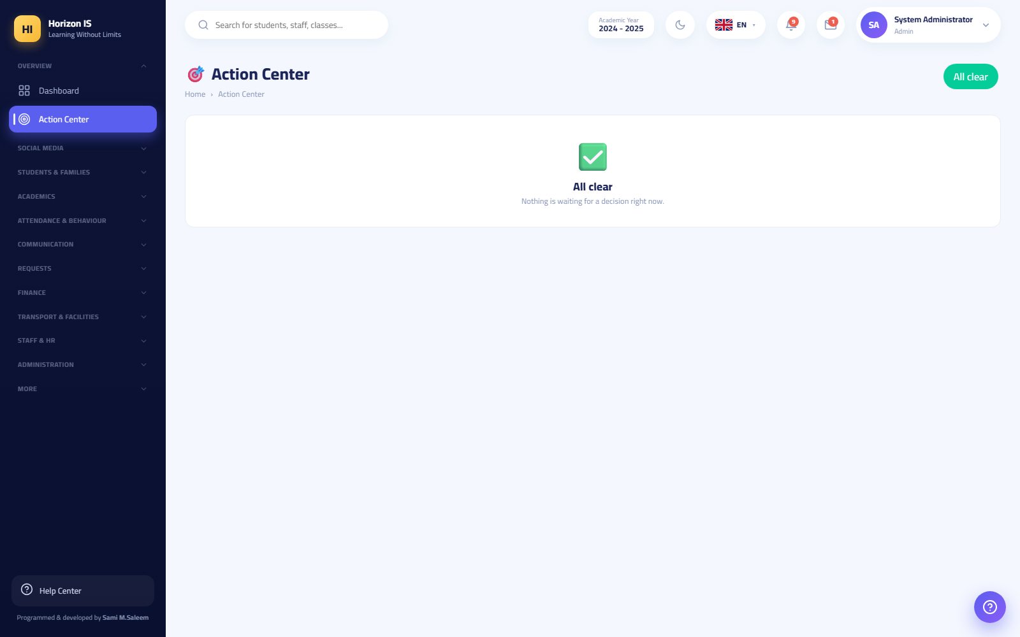The Action Center

The Teacher Dashboard /teacher
Today's periods with direct shortcuts: record the period's attendance, homework, grades.
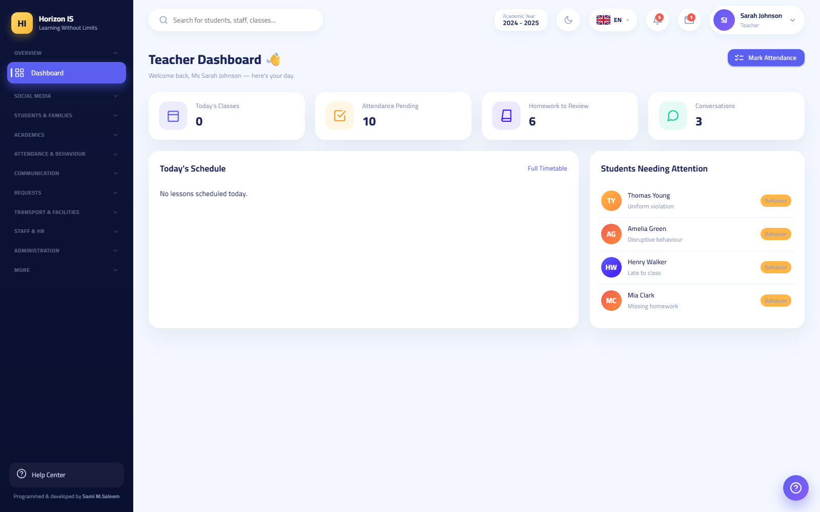The teacher dashboard

The Parent Dashboard /parent and the Student Dashboard /student
The parent sees a card for each child with links: medical documents, leave request, attendance, report card. The student sees their summary and a report-card button. (Families mostly use the app — see The mobile app at a glance.)
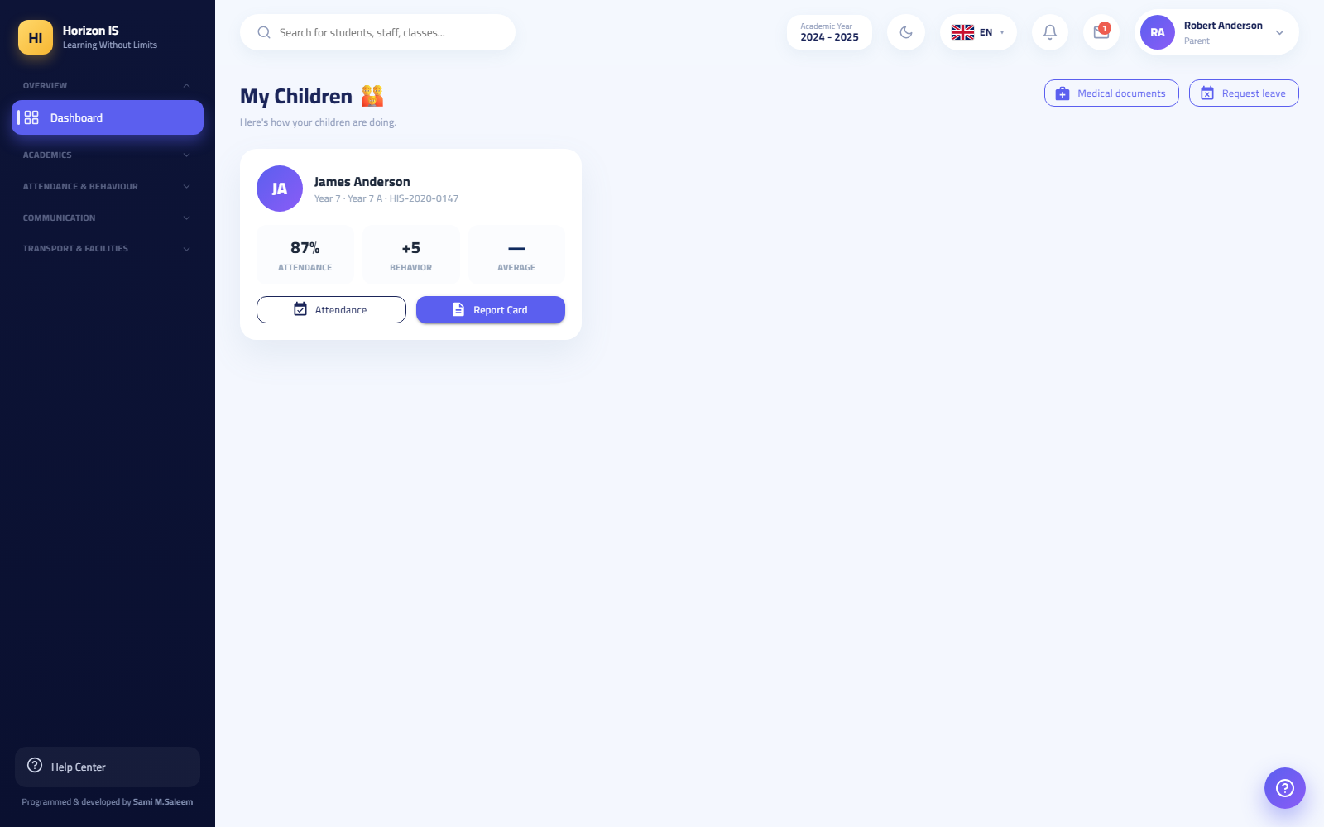لوحة ولي الأمر على الويب 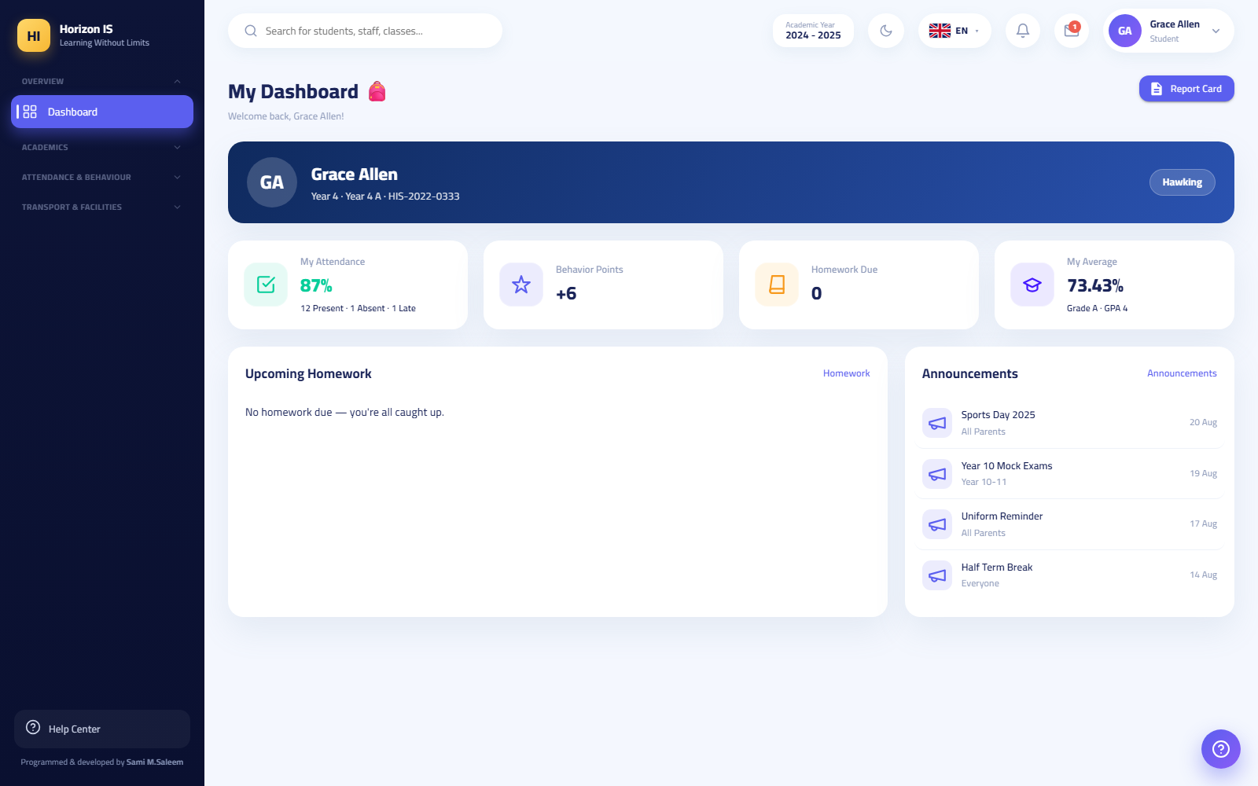لوحة الطالب على الويب

1.14 Patterns Repeated on Every Screen
Learn these patterns once, and you will know how to use any new screen in the system.

Search Boxes
At the top of every list (students, staff, families, chats) is a search box. Type part of the name — in Arabic or English — and the list shrinks instantly as you type. No "Search" button needed.
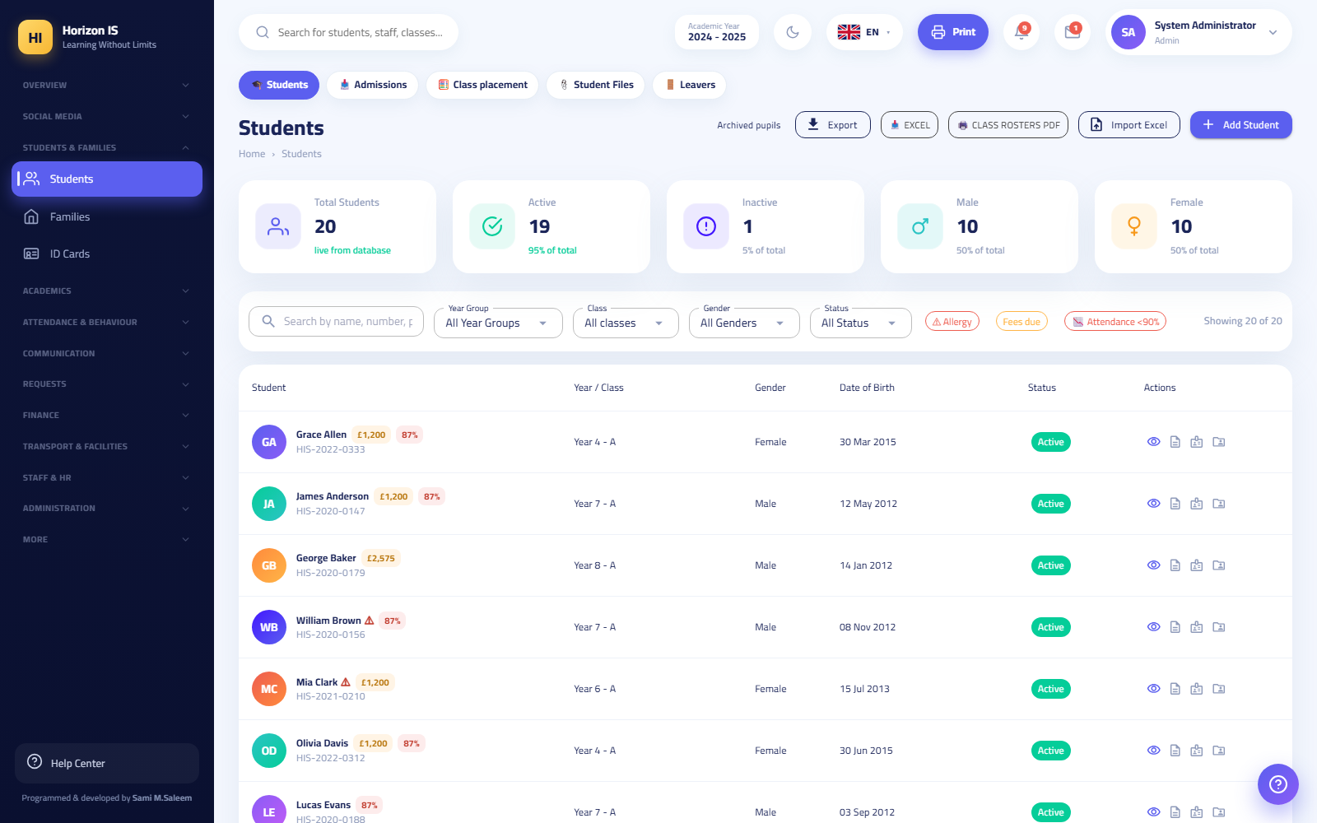The students list with search and filters

Filters and Chips
- Dropdown lists to narrow results: class, section, status, date.
- Chips with live counters: as in Admissions & Enrollment — each stage is a chip showing its number of applications, and clicking it filters the table.
- The "Clear Filters" (مسح الفلاتر) button restores the full list.

Tables
Lists are shown as tables: each row is one record, with action icons at its end (view ✏ edit 🗑 delete). Clicking a student's or family's name opens their full profile.

Add, Edit, and Delete Dialogs
- Add buttons carry the item's name: "Add Student" (إضافة طالب), "Add Class" (إضافة صف), "New User" (مستخدم جديد) — and open a dialog (or page) with the required fields, the mandatory ones marked.
- Editing opens the same form pre-filled with the current data.
- Deleting always asks for confirmation — and some dangerous operations demand a stronger confirmation (typing a confirmation word or pressing the button twice). Read the confirmation text before agreeing.

Export and Print
- Excel/CSV export: most lists have an "Export" button that downloads a spreadsheet file for working outside the system.
- PDF printing: official reports (class rosters, today's absences, the monthly register, report cards) come out as a ready PDF with the school letterhead — you preview it, then print from the browser.

Confirmation Messages (Toasts)
After every successful save, a short message appears at the edge of the screen and then disappears — such as: "Attendance saved successfully.". The golden rule: no message = no save. If you do not see the confirmation, stay on the page and check for red error messages next to the fields.
Example: You recorded Grade 7's attendance and then closed the page quickly without noticing a red error message on a student with a missing status — the result is an unsaved record. Make it a habit to wait for the confirmation message before leaving any screen.

1.15 The Mobile App at a Glance
The Horizon International School app is the primary interface for families, and it serves staff too for daily tasks:
- School selection: on first launch, you pick your school from the list of the group's schools.
- Signing in: with email/username and password (plus the authenticator-code field if enabled) — or, for a parent: "Sign in with school code" (الدخول برمز المدرسة) by typing the family code from the school's slip or scanning the QR with the camera.
- Device approval: every new phone is registered and shown to the school for approval; the message "awaiting school approval" means the IT officer has not approved the phone yet.
- Quick sign-in with biometrics: after the first sign-in, the app offers to enable unlocking with fingerprint or face.
- Interface by role: the parent sees their children, messages, and notifications; the teacher sees their classes and attendance recording; and so on for each role.
The full app details are in the "Mobile App" chapter.

1.16 The New Staff Member's First-Day Checklist
Print this page and tick each item as you complete it:
- [ ] 1. I received from administration/IT: the portal address + username + temporary password.
- [ ] 2. I opened the portal in a modern browser (Chrome or Edge preferred) and the sign-in page appeared.
- [ ] 3. I picked my language from the flag row.
- [ ] 4. I signed in with the temporary password.
- [ ] 5. I set a new password (at least 10 characters: uppercase + lowercase + digit + symbol) and stored it somewhere safe.
- [ ] 6. I confirmed my first page matches my role (teacher ← Teacher Dashboard, administrative staff ← Home...).
- [ ] 7. I opened the sidebar sections one by one and got to know the screens available to me.
- [ ] 8. I opened the Help Center from the bottom of the sidebar and tried a guided tour.
- [ ] 9. I opened /settings ← the "Security" tab and enabled two-factor authentication (practically mandatory for anyone with access to financial, health, or administrative data).
- [ ] 10. I read the circulars in the "Staff Affairs" section — official instructions arrive here and your reading of them is recorded.
- [ ] 11. If I will use my phone: I installed the the school app, picked the school, signed in, and waited for device approval if requested.
- [ ] 12. I tried signing out and then signing in again with my new password.
- [ ] 13. I learned the name of my school's IT officer and how to reach them for any sign-in problem.
Tip for the trainer: Dedicate one short session with every new staff member on their first day for items 1-6, and leave the rest as self-study to be reviewed at the end of the week.

1.17 The Demo Environment Note
For training, a separate demo environment with fictional data is available (the demo student, Demo Parent...). Only in this environment is the shared password School@2025 used for the demo accounts.
Warning: The demo environment is for training only. Never enter any real student or family data into it, and never use the demo password in the live system.

1.18 Related Topics
- The "Accounts, Roles, and Permissions" chapter — creating accounts, granting permissions, the users screen.
- The "Families and Access Codes" chapter — how families sign in with the app and the family code.
- The "Mobile App" chapter — the app guide, screen by screen.
- The "Attendance", "Grades", and "Finance" chapters — the first daily tasks after mastering this chapter.

Chapter 2Role Guides: Leadership and Administration
This chapter is dedicated to the holders of leadership and administration roles in the system: SuperAdmin, School Owner (SchoolOwner), Principal, System Administrator (Admin), Registrar, and IT Staff (IT). For each role you will find: a responsibility summary, what appears in their sidebar, what they can and cannot do, the daily, weekly, and monthly work routine, common mistakes, best practices, and troubleshooting steps.
Important: Access in the system is built on Permissions granted to roles from the Roles & Permissions page at /admin/permissions. The four leadership roles (SuperAdmin, SchoolOwner, Principal, Admin) automatically see all menu items. All other staff see only the items whose permission they hold.
Tip: Any change to a role's permissions takes effect for a user only at their next sign-in. If you changed a permission and the staff member does not notice the difference, ask them to sign out and sign back in.
Example: In the demo environment only, the trainer may use the demo account with the password School@2025 to walk trainees through the screens. Never use this account in a real school environment.

2.1 Quick Overview of the Six Roles
Role | Name in the System | Visibility Scope | Typical Use
SuperAdmin | SuperAdmin | All schools (crosses single-school boundaries) | Emergency account reserved for the system provider only
School Owner | SchoolOwner | Their school only — all screens | Top-level oversight and approval of major decisions
Principal | Principal | Their school only — all screens | Daily educational and operational leadership
System Administrator | Admin | Their school only — all screens | Day-to-day system operation and settings
Registrar | Registrar | Student records, admissions, and families | Admissions and registration office
IT Staff | IT | Accounts, devices, and security only | Managing accounts, devices, and family codes
Who can grant whom?
Grantor | Can Grant
SuperAdmin | All roles including SuperAdmin and SchoolOwner
SchoolOwner | SchoolOwner, Principal, Admin, and all regular roles
Principal / Admin | Principal, Admin, and all regular roles (not SuperAdmin nor SchoolOwner)
IT | Regular roles only (not Principal, Admin, SuperAdmin, nor SchoolOwner)
Warning: No one but the SuperAdmin can modify the permissions of the SuperAdmin role itself. The message shown is: "Only a SuperAdmin can change the SuperAdmin role's permissions".

2.2 1) SuperAdmin

Responsibility Summary
The platform-wide "break-glass" emergency account. It crosses single-school boundaries and sees the data of all schools in the group. This account is reserved for the system provider (platform technical support), not for any staff member inside the school.

What They See
- All eleven sidebar sections and every item in them, in any school.
- Passes through every gate in the system: administration pages, user management, financial screens, and everything else.

Can / Cannot
Can: - Grant the SuperAdmin or SchoolOwner role to any account (the only one who can grant SuperAdmin). - Modify the permissions of the SuperAdmin role itself (the only one who can do so). - Everything the other leadership roles can do.
Cannot (by policy, not by technology): - Must never be used for daily work. Every operation made with this account is recorded in the Audit Log (/audit) and must be justifiable.

Routine
- No daily routine. Used only when technical support is needed: restoring access, fixing a platform-level setting, or an emergency intervention.

Common Mistakes
- Handing this account's credentials to a staff member inside the school. Do not — use SchoolOwner or Admin instead.
- Using it for daily data entry, which renders the audit log worthless.

Best Practices
- Always enable two-factor authentication (2FA) on this account.
- Review the audit log periodically for any unexpected use of it.

Troubleshooting
- If you need a SuperAdmin intervention (such as modifying the SuperAdmin role's permissions or granting a new SchoolOwner), contact the platform's technical support — there is no substitute inside the school.

Related Topics
- School Owner — the correct alternative for top-level oversight inside the school.
- Roles & Permissions.

2.3 2) School Owner — SchoolOwner

Responsibility Summary
The account of the school's owner. Holds the complete permission bundle (all sixty permissions) and is treated as a "management" role on every screen, but is confined to their own school only. Its purpose: general oversight, approval of major decisions, and granting leadership roles.

What They See
- All sidebar sections: Home, Social Media, Students & Families, Academics, Attendance & Behavior, Communication, Requests, Finance, Transport & Facilities, Staff Affairs, Administration & System.
- The administration dashboard at /dashboard with the quick actions (record attendance, add student, record payment, new announcement).
Administration dashboard

Can / Cannot
Can: - All system operations: students, finance, payroll, settings, publication, year rollover… etc. - Grant the SchoolOwner, Principal, and Admin roles (from the /users page). - Approve the publication of report cards (as the second manager in the dual-approval gate).
Cannot: - Grant the SuperAdmin role. - See the data of other schools in the group.

Routine
Weekly: 1. Open /dashboard and review the school's indicators. 2. Open the Finance Bridge /finance-bridge and Fee Collection /finance/fees/collection to track revenue. 3. Review the Action Center /action-center to make sure no pending decisions are piling up.
Monthly: 1. Download the Monthly Report from /monthly-report (a PDF for each month — management only). 2. Review the Financial Statements /finance/reports and Family Balances /family-balances. 3. Review the Audit Log /audit, at least as a sample.
Yearly: - Approve the year-end rollover plan (/year-rollover or from Settings) after archiving the year's results from /settings.

Common Mistakes
- Using the owner account for daily work (entering attendance, recording payments). This muddies the audit log and increases the account's risk.
- Leaving the owner account without two-factor authentication.
- Granting the Principal or Admin role "temporarily" and forgetting to revoke it.

Best Practices
- Enable two-factor authentication from /settings (Your Account section).
- Dedicate a separate account to each person — never share the owner account.
- Make the official publication channel Social Media (/social) with an "All classes" audience, not individual messages.

Troubleshooting
- Forgot the password: it is reset by a SuperAdmin or another SchoolOwner from /users (the "Reset Password" button issues a temporary password shown only once).
- Account locked: after 5 failed attempts it locks for 15 minutes. Wait, then try again.

Related Topics
- Principal and System Administrator — the daily operations.
- The "Finance" chapter of this manual — the Finance Bridge, fees, and installments.

2.4 3) Principal

Responsibility Summary
The school's educational and operational leader. Holds the complete permission bundle inside their school: all student, academic, attendance, finance, staff, and administration screens. They are the decision-maker on approvals: publishing results, attendance review, absence requests, and role management.

What They See
All sidebar items; the most important for their daily work:
Item | Path | Purpose
Home | /dashboard | Indicators dashboard and quick actions
Action Center | /action-center | Everything awaiting a decision: publication approvals, absence/payment/leave requests, pending devices
Attendance | /attendance | The daily record + the "Management Review" button to approve the day
Absence Insights | /attendance-insights | The early-warning dashboard (high/medium/low risk)
Grades | /grades and its tabs | Gradebook, grading systems, report designs and publication
Absence Requests | /absence-requests | Approve or reject parents' requests
Staff | /staff and its tabs | Profiles, attendance, leave, payroll
Monthly Report | /monthly-report | A monthly PDF for management
Action Center

Can / Cannot
Can: - All operations for students, families, academics, attendance, behavior, finance, and staff. - Lock and unlock term grades (Term Lock), and approve report-card publication. - Grant the Principal and Admin roles and all regular roles from /users. - Edit the permissions matrix from /admin/permissions.
Cannot: - Grant the SuperAdmin or SchoolOwner role. - Modify the SuperAdmin role's permissions. - See other schools.
Important: Report-card publication passes through a dual-approval gate: one manager requests approval, and a different second manager approves it, then the publication is executed. The system prevents anyone from approving their own request: "Your request needs another manager's approval." — and each approval is valid for exactly one publication run. Students on hold due to a payment hold are automatically excluded from publication.

Routine
Daily: 1. Open /action-center first thing — approve or reject every pending item. 2. From /attendance, use the Management Review button to approve the day's records. 3. Review /absence-requests (approve/reject absence requests). 4. Check Messages /communication — management has a Send Alert button for urgent broadcasts.
Weekly: 1. /attendance-insights — handle high-risk cases (the "Warn Guardian" button, then "Review"). 2. /behavior and /recognition — follow up on behavior and recognition. 3. /staff/attendance and /staff/leave — staff discipline and leave requests. 4. /finance/fees/collection — the collection rate.
Monthly: 1. Download /monthly-report. 2. Review the payroll draft in /staff/payroll before approval. 3. A sample from /audit.
Termly/Yearly: - Exam scheduling and printing the room pack from /exams. - The publication gate in /report-templates (request approval ← another manager approves ← publish to families). - Archive the year's results, then roll over from /settings or /year-rollover (type RENEW to confirm).

Common Mistakes
- Approving the publication and publishing with the same account — the system will block you; arrange with a second manager in advance.
- Forgetting to archive the year's results before the rollover — archiving always comes first.
- Editing a role's permission and expecting it to take effect immediately — it takes effect at the staff member's next sign-in.
- Unchecking a "core" permission of a role (part of its default bundle) — it will come back automatically when the system restarts; the core bundles are a "floor" that cannot be stripped.

Best Practices
- Make /action-center your daily starting point — all pending items in one place with an "Open" button on each card.
- Use the dual-approval gate with discipline: whoever requests does not approve.
- Customize your dashboard from the "Customize Dashboard" button in /dashboard.

Troubleshooting
- A menu item missing for a staff member: check /admin/permissions (does the role hold the permission?), then Feature Flags /feature-flags (example: turning off the finance module hides all fee screens), then Menu Designer /settings/menu (the item may be hidden in the school's layout).
- Publish button rejected: there is no unconsumed approval for the same design and the same stage — request a new approval.
- A staff member cannot record a payment: recording payments is restricted to management and the Accountant role only, whatever their other permissions.

Related Topics
- System Administrator — your partner in daily technical operations.
- The "Grades & Results" chapter — the publication gate and the payment hold in detail.
- The "Attendance" chapter — the daily review and approval.

2.5 4) System Administrator — Admin

Responsibility Summary
The person responsible for the daily operation of the system inside the school. Holds the complete permission bundle just like the Principal, but their focus is: accounts, permissions, settings, import and export, storage, backup, and the print and menu designers. The bootstrap account in every school is named admin and is forced to change its password at first sign-in.

What They See
All menu items; their main tools are in the Administration & System section:
Item | Path | Purpose
Users | /users | Creating accounts, resetting passwords, disabling
Roles & Permissions | /admin/permissions | The permission matrix that actually controls the menu
Departments | /admin/departments | Academic departments and their heads
Audit Log | /audit | Who did what and when (read-only)
Storage | /storage | Media budget, heaviest uploaders, and migration buttons
Reports | /reports | The cross-module report generator
Documents | /documents | The school's document repository
Settings | /settings | School profile, academic years, backup, your account
Plus the Settings tabs: Media Settings /settings/media, Print Designer /settings/print, Menu Designer /settings/menu, Data Center /admin/data, Import Center /import, in addition to Feature Flags /feature-flags and Year-End Rollover /year-rollover.
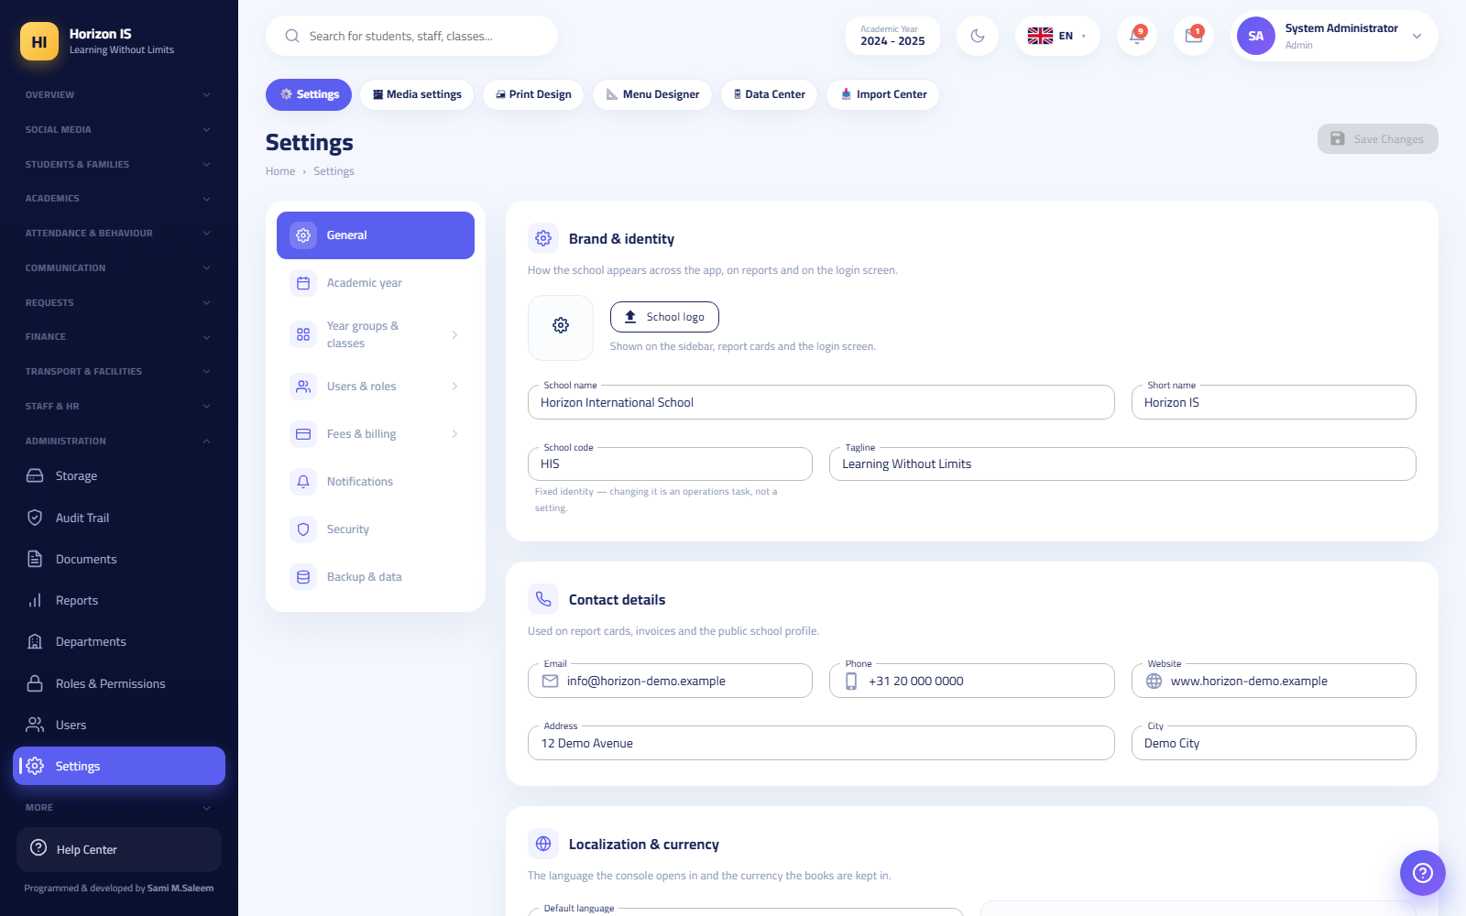School settings

Can / Cannot
Can: - Everything the Principal can (the same complete bundle). - Grant Principal, Admin, and all regular roles.
Cannot: - Grant SuperAdmin or SchoolOwner. - Modify the SuperAdmin role's permissions. - Change the School Code in Settings — the code is a fixed, read-only publishing identity.

Workflow: Creating a New User Account
Purpose: Create a sign-in account for a staff member, student, or family and link it to the correct record.
Who can: Management (SuperAdmin, SchoolOwner, Principal, Admin) and IT staff.
Before you start: - Make sure the personal record exists first (the staff member in /staff, the student in /students, the family in /families). - Have the user's correct email address ready.
Steps: 1. Open Users from the sidebar (/users). 2. Click New User — the "Create Account" dialog opens. 3. Enter the Full Name and Email. 4. Choose the Role — only the roles you are entitled to grant are shown (the server verifies again; no school manager can mint a SuperAdmin account). 5. In the Represents field choose the link type: Staff / Student / Family, then choose the matching record. 6. Click Save. The temporary password appears in a green panel once only, with the text: "Share it with the user — they will be asked to change it at first sign-in". 7. Deliver the temporary password to the user securely (a hand-delivered slip or a trusted channel).
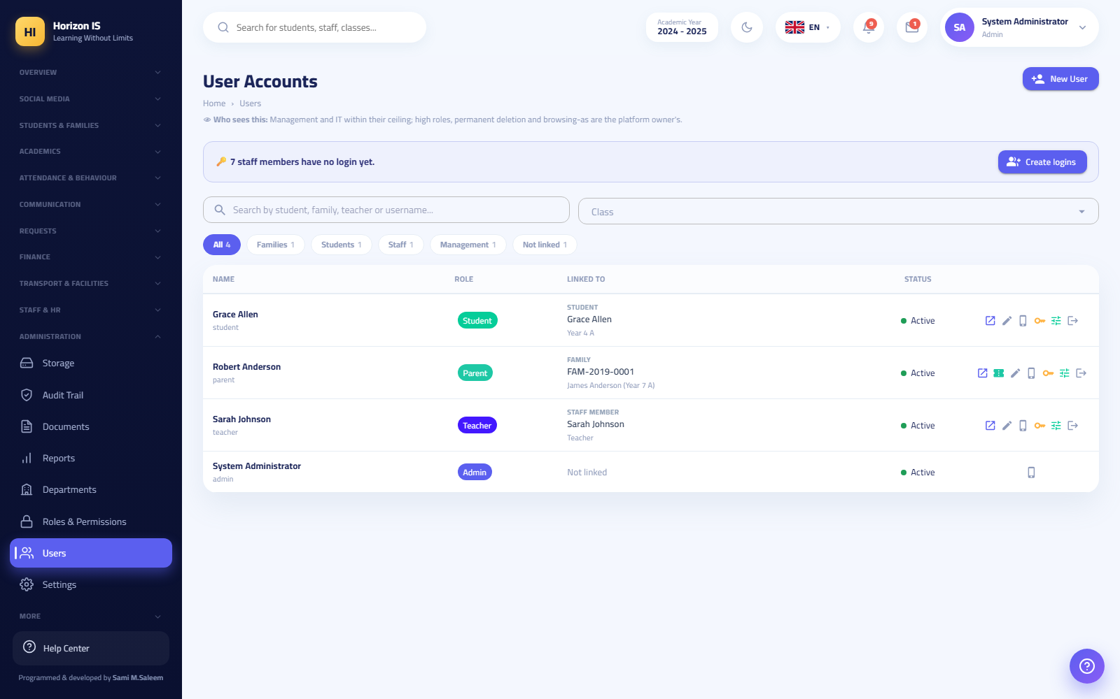Users screen
Expected result: A new active account whose holder is forced at first sign-in to set a new password (at least 10 characters, with an uppercase letter, a lowercase letter, a digit, and a symbol) via the /account/change-password page.
Common mistakes: - Closing the dialog before copying the temporary password — it will never appear again; use Reset Password to issue a new one. - Creating the account before the personal record, leaving it unlinked — create the record first. - Choosing a role higher than needed "just in case" — grant the lowest role sufficient for the job.
Troubleshooting: - The user cannot sign in: check the error message on the sign-in screen — wrong credentials, a locked account (5 attempts → 15 minutes), a device awaiting approval, or a blocked device. - Disabling a departing staff member's account: disabling from the same /users page terminates all their sessions immediately (app and web) because it revokes refresh tokens and rotates the security stamp.
Related topics: The permissions workflow, the IT section for their ceiling on the same screen.

Workflow: Editing the Permissions Matrix
Purpose: Define what each role in the school sees and does.
Who can: Whoever holds the role-management permission — by default: management and IT staff.
Before you start: Know precisely which screen you want to open or close for which role; every menu item is tied to a specific permission.
Steps: 1. Open Roles & Permissions (/admin/permissions). 2. Choose the role from the left panel. 3. Check or uncheck permissions (grouped by module: Students, Attendance, Finance…). There are Grant All and Clear All buttons. 4. Click Save Changes (or Discard to undo).
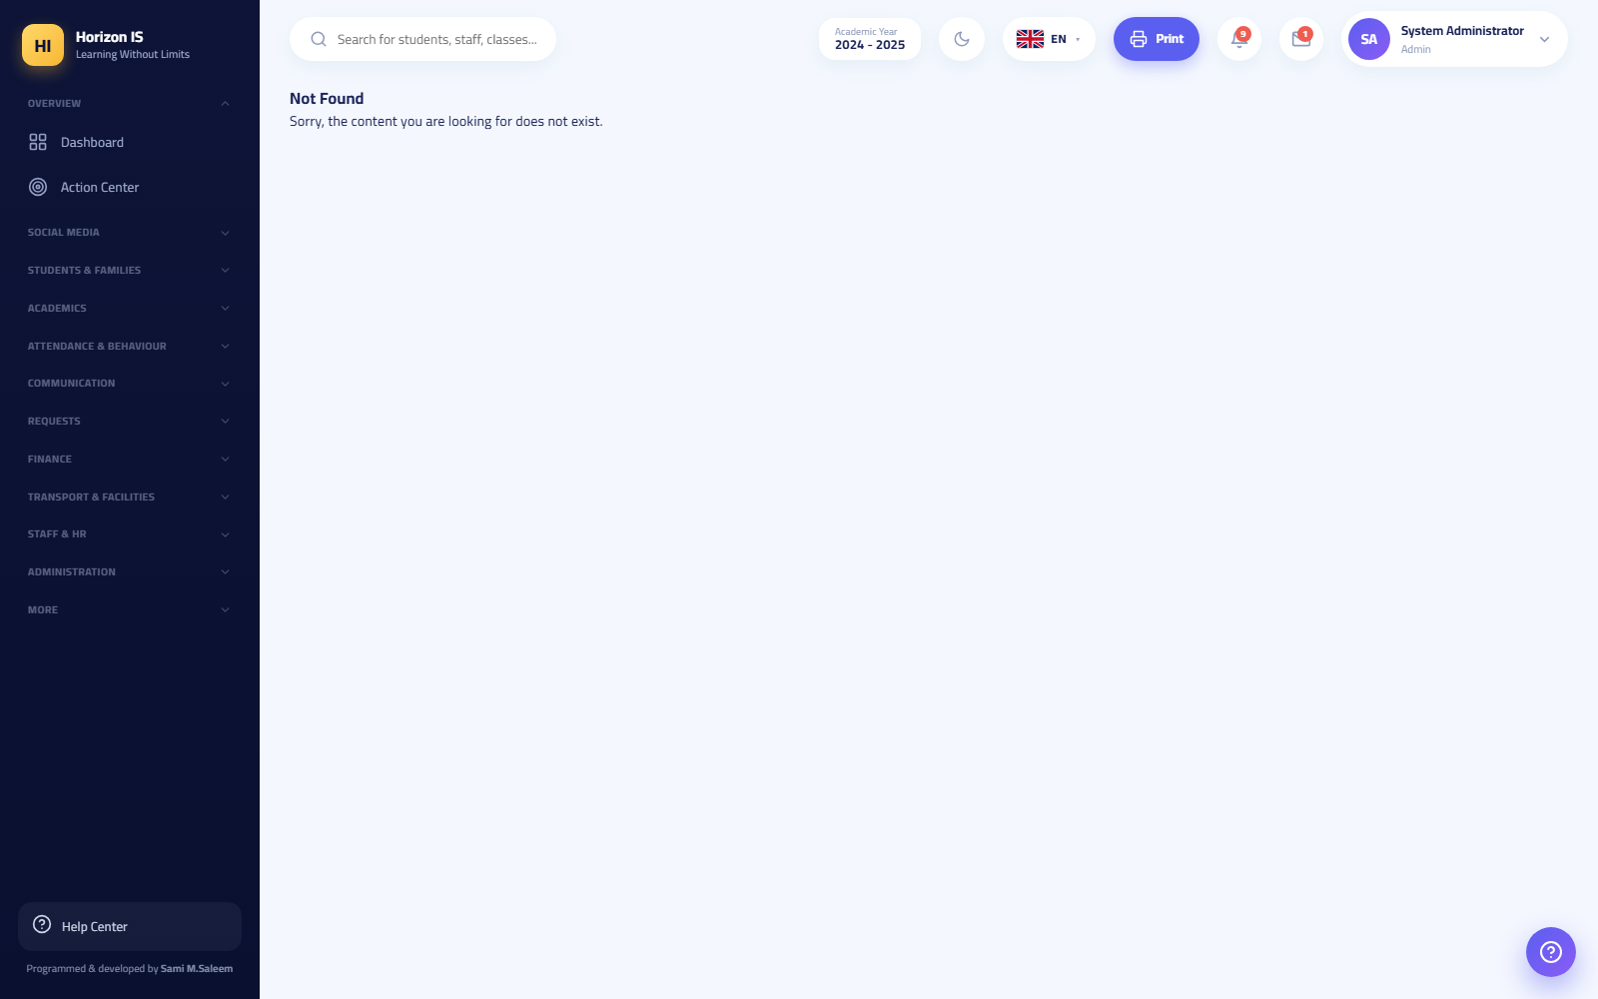Permissions matrix
Expected result: The changes take effect for every holder of the role at their next sign-in, and their sidebar updates automatically.
Common mistakes: - Trying to strip a "core" permission from the role's default bundle — it comes back automatically when the system restarts (the default floor is always restored so a role never suddenly loses its essential screens). Additions on top of the floor are preserved. - Expecting the matrix to control class scope — the "my classes / my bus / my children" visibility is managed automatically through assignments, not through the matrix.
Troubleshooting: - Strange roles in the list (Dean, InstituteOwner…): they appear under "Unknown roles" with a warning — leftovers from old data; they cannot be granted to anyone. - The SuperAdmin row is locked: normal — only a SuperAdmin can edit it.
Related topics: Overview — the who-grants-whom table.

Routine
Daily: 1. /action-center — the technical items (pending devices, requests). 2. Password-reset requests from /users. 3. Verify the backup succeeded (the Backup section in /settings).
Weekly: 1. /storage — watch the media budget and the heaviest uploaders. 2. /audit — a sample of sensitive events (sign-ins, financial changes). 3. /import and /admin/data — scheduled import jobs.
Monthly: 1. Review /admin/permissions with management: are the granted permissions still needed? 2. Disable departed users' accounts from /users. 3. Review /feature-flags — never leave a feature flag off without a documented reason.

Common Mistakes
- Sharing the admin account among several people — create a personal account for each individual and stop the shared use.
- Issuing a temporary password and sending it in a public group — deliver it to its owner only.
- Leaving departed staff members' accounts active.

Best Practices
- After the first sign-in to the bootstrap admin account and changing its password, create personal accounts for management and keep admin for emergencies.
- Document every permission change in an internal log (who requested it and why).
- Use the Menu Designer /settings/menu to simplify staff menus instead of stripping permissions they need.

Troubleshooting
- A fee screen missing for everyone: the finance module flag is off in /feature-flags.
- A user whose permissions you changed does not see the new items: sign out and back in.
- The edit/reset button hidden for a specific account in /users: the account outranks you (e.g. SchoolOwner) — the server refuses even if you try.

Related Topics
- The IT section — the division of labor between the System Administrator and IT staff.
- The "Settings & System" chapter — backup, storage, and feature flags.

2.6 5) Registrar

Responsibility Summary
The admissions and registration office staff member. Manages student records from application through enrollment: student profiles, families, admissions, class placement, required student documents, ID cards, and reports and exports.

What They See
The default Registrar bundle opens these items for them (in addition to the common items: Home, Social Media, Circulars, My Leave):
Item | Path | What They Do There
Students | /students | The full register: search, add, edit, Excel export, section PDF file
Admissions | /admissions (a tab inside Students) | The application pipeline: new application, stage promotion, "Enroll as Student"
Class Placement | /students/placement (tab) | Balanced placement of the unplaced into sections
Student Documents | /student-documents (tab) | Tracking required documents and reminding about missing ones
Families | /families | The family directory, adding a family, export, PDF file
ID Cards | /id-cards | Designing and printing student and staff cards
Classes | /classes | Viewing classes and sections (no creation)
Timetable | /timetable | Viewing the timetable (without the builder studio)
Calendar | /calendar | Viewing the school calendar
Reports | /reports | Generating and exporting reports
Documents | /documents | The document repository (view)
Student register 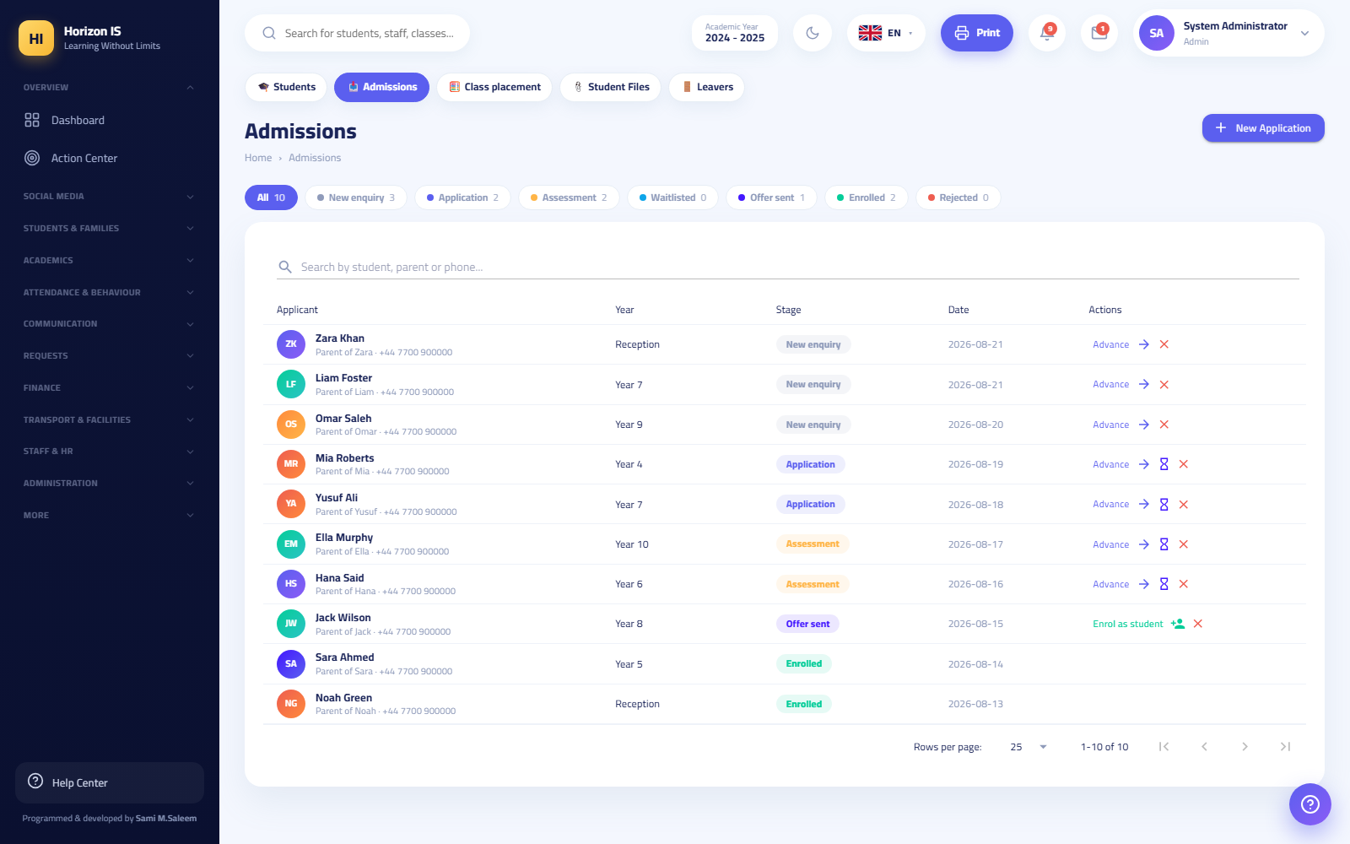Admissions pipeline

Can / Cannot
Can: - Create, edit, import, and export student records. - Create and edit families and link siblings ("Existing family — enroll a sibling"). - Manage admissions fully through "Enroll as Student". - Class placement, printing ID cards, and exporting reports.
Cannot: - Delete a student — deletion is restricted to management. - Any financial screen (they get a 403: "Financial data is restricted to the finance office"). - The gradebook, health records, safeguarding records. - Managing users or permissions, or creating classes. - Generating family sign-in codes — the codes panel inside the Families page is shown to management and IT staff only.

Routine
Daily: 1. /admissions — process new applications and move the stages ("Promote"), and enroll the accepted ("Enroll as Student"). 2. /students/add — register new students with their families (one form; at minimum the father or mother for a new family). 3. /student-documents — the "Missing" tab, then the "Remind Missing" button.
Weekly: 1. Excel export from /students to reconcile with the paper records. 2. Print the sections PDF whenever the placement changes. 3. /id-cards — print cards for new students.
Seasonally (start of year): 1. /students/placement — "Place All", then manual handling, then "Approve & Lock" (the final lock belongs to management). 2. Support management in preparing for the annual rollover (cleaning statuses, completing missing data).

Common Mistakes
- Creating a new family for a student who has an enrolled sibling — use "Existing family (enroll a sibling)" so they inherit the parents and receive the sibling discount automatically.
- Entering the name in one language only — the form requires the name in both Arabic and English (it appears on reports and cards in both languages).
- Trying to delete a student enrolled by mistake — ask management; usually the right fix is changing the status, not deleting.
- Sending parents to the Registrar for an app sign-in code — codes are generated by IT or management.

Best Practices
- Complete the phone details for the father (mandatory) and the mother at enrollment — they are the foundation of the school's communication.
- Review the "Missing" tab in student documents weekly so documents do not pile up.
- When enrolling a student from an admission application, enroll them from inside the application itself so the application status advances to "Enrolled" automatically.

Troubleshooting
- The message "Financial data is restricted to the finance office": normal — fees are the domain of the Accountant and management.
- I cannot see the Class Placement tab: it requires the edit-students permission — which is part of your default bundle; if it disappeared, ask the System Administrator about a change in the matrix.
- No Add Class button in /classes: correct — creating classes is for management only; you only see the list.

Related Topics
- The "Students & Families" chapter — the full enrollment workflow step by step.
- The IT section — family sign-in codes (to direct parents to the right party).

2.7 6) IT Staff — IT

Responsibility Summary
The person responsible for accounts, devices, and security — with no financial or academic access. Their four major duties: managing user accounts, approving devices, generating family sign-in codes, and processing account-closure requests. The bootstrap account is named it and its first sign-in must be on the web portal, where it is forced to change its password.

What They See
The default IT bundle: user management, role management, audit-log viewing, security-screen viewing, and family viewing (their only gateway to sign-in codes). So the following appears in their menu:
Item | Path | What They Do There
Home | /dashboard | A general dashboard
Action Center | /action-center | Pending items, including devices
Families | /families | The family directory + the Family Sign-in Codes panel
Account Closure Requests | /departure-requests | Approving/rejecting parents' account-closure requests
Users | /users | Creating accounts, resetting, disabling
Departments | /admin/departments | Viewing/managing the department structure
Roles & Permissions | /admin/permissions | The permission matrix
Audit Log | /audit | Reviewing events
In addition to the common items (Social Media, Circulars, My Leave). They do not see: Settings, Storage, Reports, or any financial or academic screen.
Tip: The staff devices page /staff/devices lives in the "Staff" group, which may not appear in your sidebar (it requires the staff-affairs permission). Open it directly by typing the path into the browser — your role is authorized to approve devices from there.
And in the mobile app, IT staff have a dedicated shell (ItShell) with four tabs: 1. IT Dashboard — system health: database size, stored media, last backup, active sessions, failed sign-in attempts in the last 24 hours, bulk lock/unlock by role, recent security events, and the audit log. 2. Accounts — searching and creating accounts. 3. Device Approvals — the "Awaiting approval" list with approve/block. 4. My Account.

Can / Cannot
Can: - Create and manage user accounts, reset passwords, and disable accounts. - Edit the permissions matrix for regular roles. - Approve and block devices (web and app). - Generate and print family sign-in codes. - Approve/reject account-closure requests. - Review the audit log and security events.
Cannot — hard ceilings enforced by the server: - Grant the SuperAdmin or SchoolOwner role — the message: "This role cannot be granted from the IT console" (they can never be granted from the IT console). - Grant the Principal or Admin role — the message: "Only school management can grant management roles". - Manage or reset the password of any account that already holds one of those roles — the message: "This account can only be managed by school management". - Any financial screen (403), academic screen, or system settings.
Important: These ceilings are a protection for the system, not a deficiency in your account. Route any request to grant a management role to the Principal or the System Administrator.

Workflow: Family Sign-in Codes
Purpose: Enable parents to sign in to the mobile app with a one-time code, with no email and no password.
Who can: Management and IT staff (the codes panel inside the Families page is shown to them only).
Before you start: - Make sure the family is registered in the system (created by the Registrar or management). - Have the printer ready — the code is printed at the moment of generation and its text never appears again.
Steps: 1. Open Families (/families) and switch the toggle at the top from "Families" to Family Sign-in Codes. 2. Choose the generation method: - Generate for a class — codes for all families of a specific class. - Generate for all families — codes for everyone (start of year, for example). - The New Code button next to a single family — generates a code for it and immediately invalidates its old code. 3. Click Print Vouchers (PDF) immediately after generation — the voucher file opens directly (and regenerating for a single family prints an A6 card containing a QR code). 4. Deliver each voucher to its family (by hand or via the student in an envelope). 5. On the parent's side: on the app sign-in screen they tap "Sign in with school code" and type the 8-character code, or tap "Scan barcode with camera" to scan the QR.
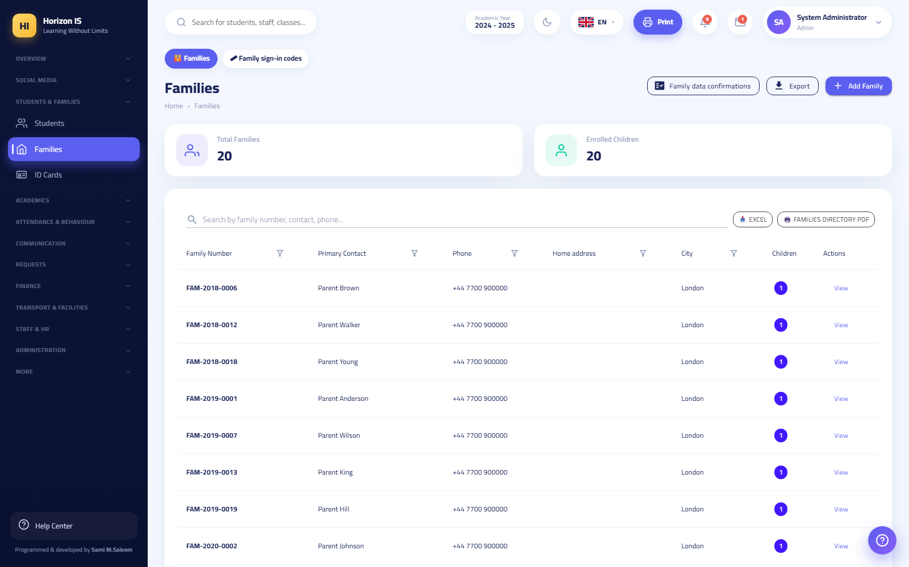Family codes panel inside the Families page
Expected result: The code works once only: it creates the family account (if it does not exist) and binds that phone to it as a trusted device. Afterwards the panel shows only who holds an active code, its expiry date, and whether it was used — it never shows the code text (stored hashed).
Common mistakes: - Closing the print window before printing — the text is gone; generate a new code for the family. - Generating a new code for a family "as a spare" — the new one invalidates the old one; if the old voucher was already distributed, you have just voided it. - Sending the code in a public WhatsApp group — the code opens the family's account; deliver it to its owner only.
Troubleshooting: - "The code is invalid or already used — request a new code from the school": the code was consumed or invalidated — generate a new code for that family alone. - The family changed phones: the old code does not work on a new phone — generate a new code (the "New Code" button next to the family). - A family account exists in /users: a code for the linked family can also be regenerated from the Users page itself.
Related topics: Device approval, the "Parent App" chapter.

Workflow: Device Approval
Purpose: Control which phones and browsers are allowed to sign in to the system.
Who can: IT staff and management.
Before you start: Know the system's rule: every sign-in records the device's identity and name. When the school enables device approval, the first device/browser is approved automatically and any subsequent one is held awaiting approval. On the web, the browser is identified by a cookie that lasts two years.
Steps (from the web): 1. Open the devices page directly at /staff/devices. 2. Review the list of pending devices: user name, device name, request date. 3. Verify the identity of the device's owner (a call or in person) before approving. 4. Approve or block the device, then save.
Steps (from the mobile app — IT dashboard): 1. Open the Device Approvals tab. 2. The list shows "Awaiting approval" — approve or block each device.
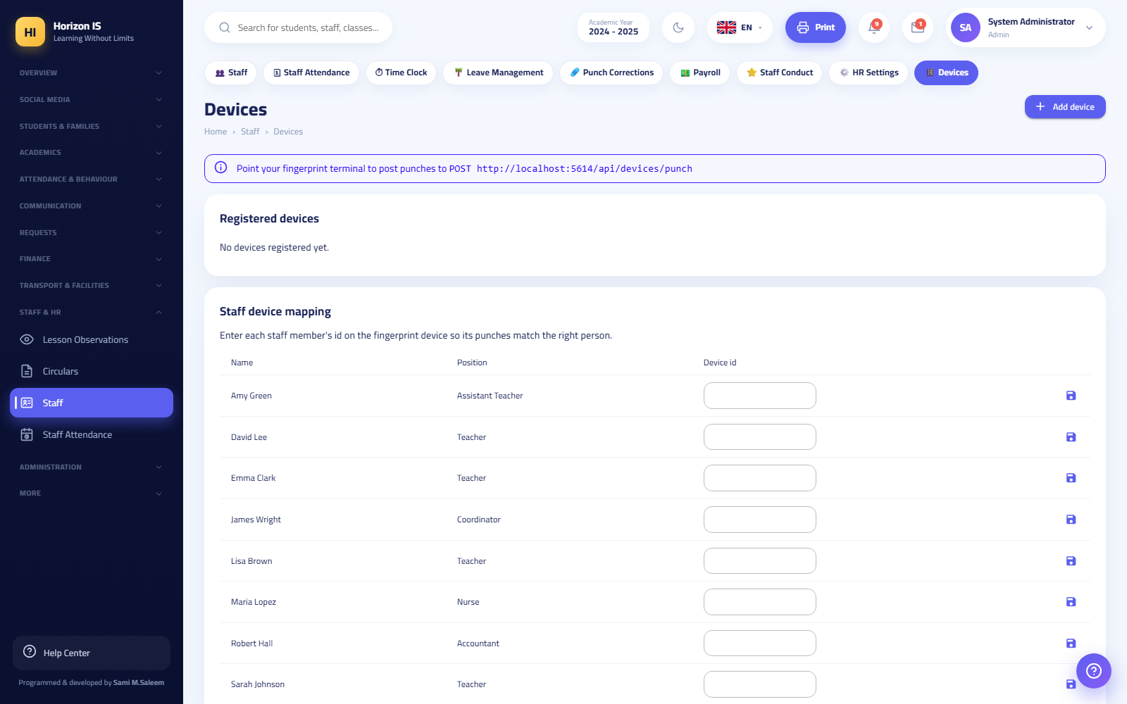Devices page
Expected result: The owner of an approved device can sign in immediately on their next attempt. The owner of a pending device sees an "Awaiting school approval" screen; a blocked one sees the blocked-device message.
Common mistakes: - Approving a device without verifying its owner — approval means permanent trust in that device. - Confusing parent devices with staff devices: a parent's new phone is approved via a new family code or via IT — there is no automatic approval for it.
Troubleshooting: - A staff member complains of "Awaiting school approval": their device is in the pending list — approve it from /staff/devices or from the app. - A staff member reinstalled the app and their device got held again: the device identity on Android changes with the signing key/reset — a fresh approval is normal. - A user blocked by mistake: find their device and switch its status from blocked to approved.
Related topics: Family sign-in codes, user management.

Workflow: User Management from the IT Console
Purpose: Creating accounts, resetting passwords, and disabling accounts, within the IT ceilings.
Who can: IT staff (and management, with no ceilings).
Before you start: Review the full workflow in the System Administrator section — the same steps from /users, with the differences below.
Steps: 1. Open /users → New User and follow the usual account-creation steps (name, email, role, linking, delivering the temporary password). 2. To reset a password: open the account → Reset Password → deliver the new temporary password (shown once). 3. To disable an account: switch its status to disabled — its sessions are cut immediately on app and web. 4. From the mobile app: the Accounts tab → search → Create Account; there is also a bulk lock/unlock by role tool for emergencies.
Expected result: Accounts managed within your role's limits: the role lists the screen shows you simply do not include the roles you are barred from.
Common mistakes: - Trying to reset the Principal's password — it will be refused: "This account can only be managed by school management". - Using the bulk lock by role without coordinating with management — an emergency measure that cuts off an entire segment's access.
Troubleshooting: - A needed role is missing from the list: if it is Principal/Admin/SchoolOwner/SuperAdmin, that is your role's ceiling — route the request to management. - Many failed sign-in attempts in the IT dashboard (last 24 hours): review the audit log and security events; if you suspect an attack, notify management and consider a temporary bulk lock.
Related topics: The System Administrator workflow, the permissions matrix.

Workflow: Account Closure Requests
Purpose: Processing parents' requests to close their own sign-in account (a mandatory feature for the app stores).
Who can: Whoever holds the user-management permission — IT staff and management.
Before you start: Understand the effect of approval: approval disables the account — no sign-in afterwards, sessions are terminated, devices are blocked, notifications stop — and no data is deleted; the student's school records remain intact.
Steps: 1. Open Account Closure Requests from the "Requests" section of the menu (/departure-requests). 2. Review each request: the account holder, the request date, the optional reason. 3. Contact the family if the request looks odd (for example, a child still enrolled at the school) — the request may be a mistake, or a new family code for a new phone may be all that is needed. 4. Click Approve & Close or Reject.
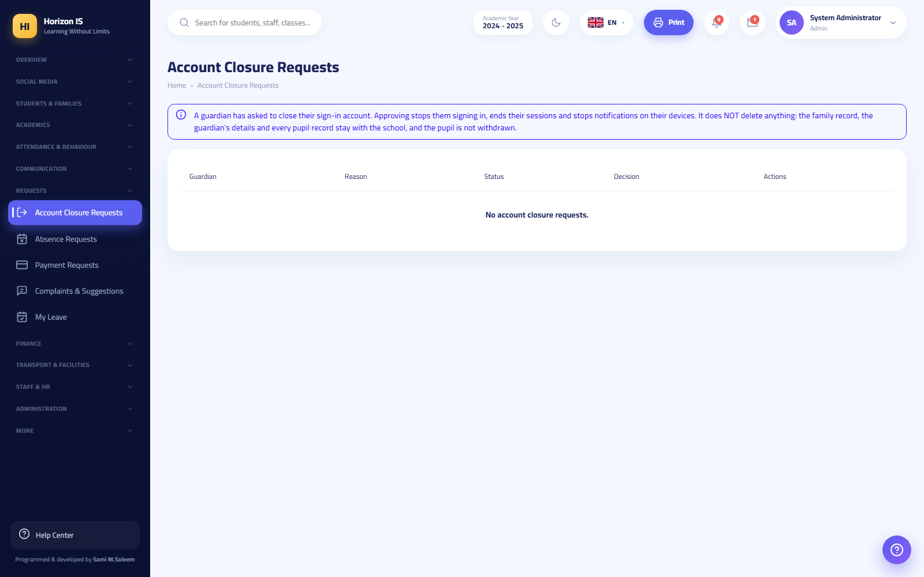Account closure requests
Expected result: On approval, the sign-in account is closed permanently and the status reaches the requester in the app. On rejection, the account stays as it is. The requester can withdraw their request from the app as long as it is pending.
Warning: Never approve a closure request coming from an app-store reviewer account during an app review period (the demo review accounts for Google Play and the App Store). A store reviewer may try the "Request Account Closure" button as part of their testing; approving it locks the review account in the middle of the review and the published store update fails. Leave the request pending or reject it, and notify the System Administrator immediately.
Common mistakes: - Assuming approval deletes the student's data — it deletes nothing; it closes the sign-in account only. - Approving the request as a workaround for a technical problem (new phone, forgotten password) — the correct fixes: a new family code or a password reset. - Confusing this page with the Departures Log page /attendance/departures — that one is for students leaving early during the school day and has nothing to do with accounts.
Troubleshooting: - The item's title in the sidebar appears as a strange technical string: a known labeling glitch in the menu naming — the correct page is "Account Closure Requests" at /departure-requests. - A staff member requests closing their account from the app: not possible — staff accounts are created by the school and closed by the school; the app tells them to contact the administration. - A family whose closure was approved then returned to the school: create the account again via a new family code.
Related topics: Family sign-in codes, user management.

Routine
Daily: 1. Device approvals (app or /staff/devices). 2. /departure-requests — new requests. 3. The IT dashboard in the app: failed sign-in attempts in the last 24 hours, and the last backup. 4. Password-reset requests.
Weekly: 1. /audit — review a sample of sensitive events. 2. Family codes: generate codes for the new phones that were reported. 3. Review the active sessions in the IT dashboard.
Monthly: 1. With management: review /admin/permissions and confirm the extra grants are still needed. 2. Disable departed users' accounts and clean up blocked/dead devices.

Common Mistakes
- Making the it account's first sign-in from the app — it must be on the web to complete the mandatory password change.
- Delivering the temporary password over an insecure channel.
- Approving devices without verifying their owners' identities.
- Approving a store reviewer's account-closure request during a review (see the warning above).

Best Practices
- Document every sensitive operation (disabling, blocking a device, approving a closure) with an internal note: who requested it, when, and why.
- Use the audit log before any decision on a suspect account.
- Teach reception staff that family codes are issued only by you or by management, so they do not promise parents otherwise.

Troubleshooting
The sign-in screen messages and their causes (shown on /login):
Message | Meaning | Action
The email or password is incorrect | Wrong credentials | Verify the name/email; reset the password if needed
The account is temporarily locked after repeated failed attempts | 5 failed attempts → 15-minute lock | Wait 15 minutes, then retry
The parent/student portal is closed | The school closed the portal | A management decision — refer to management
This device is awaiting school approval | A pending device | Approve it from the devices page
The device is blocked | A previously blocked device | Review the reason for the block before any change
- An IT staff member tries to open a financial screen: a 403 "Financial data is restricted to the finance office" appears — intended behavior.
- A permission you changed is not taking effect: the user has not signed in again yet.
- A permission you removed came back by itself: it was part of the role's default "floor" — restored on every restart, by design.

Related Topics
- System Administrator — handles what is above your ceiling (settings, storage, management roles).
- The "Parent App" chapter — the family-code sign-in experience from the parent's side.
- The "Settings & System" chapter — backup and storage (for management).

2.8 Appendix: Signing In for Leadership Role Holders
- Open the web portal and sign in at /login (email or username + password). The language switcher above the card supports 6 languages.
- If two-factor authentication is enabled on your account, you are taken to /login/2fa to enter the authenticator-app code (the step is valid for 5 minutes).
- If your password is temporary, the system routes you to /account/change-password to set a permanent one (at least 10 characters: uppercase + lowercase + digit + symbol) before opening any screen.
- After signing in, each role lands on its dashboard: the leadership roles on /dashboard.
Sign-in screen
Tip: Enable two-factor authentication for every leadership account from /settings (Your Account section). Leadership accounts are the first target of any intrusion attempt.

Chapter 3Role Guides — Academic Staff
This chapter is a hands-on guide for every member of the academic staff: the teacher, the head of department, the head of section, the form tutor, the librarian, the nurse and doctor, and the safeguarding officer. Read the section for your role from start to finish once, then come back to it whenever you need it as a reference.
Important: What you see in the sidebar depends on the permissions granted to your role. If you cannot find a screen mentioned here, you most likely do not have its permission — ask your school's system administrator. Any change to permissions takes effect at your next sign-in.
Role | Landing page after sign-in | Key screens
Teacher | /teacher — Teacher Dashboard | Attendance, gradebook, homework, behavior, messages
Head of Department / Head of Section | /my-department — My Department | My Department, department messages, timetable
Form Tutor | /dashboard (or /teacher if also a teacher) | Attendance, behavior, messages
Librarian | /dashboard | Library /library
Nurse / Doctor | /dashboard | Health /health, Medical Documents /child-medical
Safeguarding Officer | /dashboard | Student files, documents, messages

3.1 11.1 The Teacher

Role card
Name in the system: Teacher (معلّم). Landing page: when signing in on the web you arrive directly at the Teacher Dashboard (لوحة المعلم) /teacher. In the mobile app the teacher template opens with its own tabs.
What the teacher can do by default:
- View students and classes (limited to the classes assigned to them).
- Record and edit daily attendance and lesson attendance (attendance.view / attendance.manage).
- Record behavior and behavior points (behavior.view / behavior.manage).
- View the gradebook and enter marks (academics.gradebook.view / academics.gradebook.manage).
- Create homework (academics.homework.manage) and schedule exams (academics.exams.manage).
- Message parents and create groups (communication.view / communication.send / communication.groups.manage).
- View the library, reports, calendar, documents, and classroom tools.
What the teacher cannot do by default: see Teacher role limits at the end of this section.
Important: Teacher access is governed by assignment: you see the classes and subjects assigned to you in "Teacher Allocation" (توزيع المعلّمين), not the whole school's data. This works automatically and has nothing to do with the permission matrix.

The Teacher Dashboard
When you open /teacher you see:
- Four clickable stat cards: Today's Lessons (حصص اليوم) (opens the timetable), Pending Attendance (حضور معلّق) (opens attendance), Homework to Review (واجبات للمراجعة) (opens homework), Conversations (المحادثات) (opens messages).
- Today's Schedule (جدول اليوم): your lessons for today with time, subject, class, and room, the status of each lesson, and a Full Timetable (الجدول الكامل) link.
- Students Needing Follow-up (طلاب يحتاجون متابعة): a list of students flagged for attendance or behavior — clicking opens the student's file.
- A Record Attendance (تسجيل الحضور) button at the top of the page jumps straight to the attendance register.
لوحة المعلم ببطاقاتها الأربع وجدول اليوم

Recording daily attendance
Purpose: documenting your class students' attendance every morning; this register is the source of absence reports, parent alerts, and absence insights.
Who can: anyone holding attendance.manage — the teacher, the form tutor, the head of department, the head of section, and administration.
Before you start: make sure your class is assigned to you in Teacher Allocation, and that the displayed date is the correct day.
- From the sidebar open Attendance (الحضور) → the top button strip (pills) → Daily Attendance (الحضور اليومي) (/attendance).
- Choose the Class and confirm the Date.
- Next to each student press the appropriate status: Present (حاضر) / Absent (غائب) / Late (متأخر) / Excused (بعذر).
- To add a detail about a particular student, open Note (ملاحظة) on their row and write it.
- If everyone is present, use the shortcut Mark All Present (تعيين الجميع حاضر) then adjust the exceptions.
- Press Save Attendance (حفظ الحضور).
- When you need to print: Today's Absences PDF (غيابات اليوم PDF) or Month Register PDF (سجل الشهر PDF) from the same page.
Expected result: the message "Attendance saved successfully." («تم حفظ الحضور بنجاح.») appears and the register updates immediately; the absence shows in the absences screen and in management reports, and the parent sees it in the app.
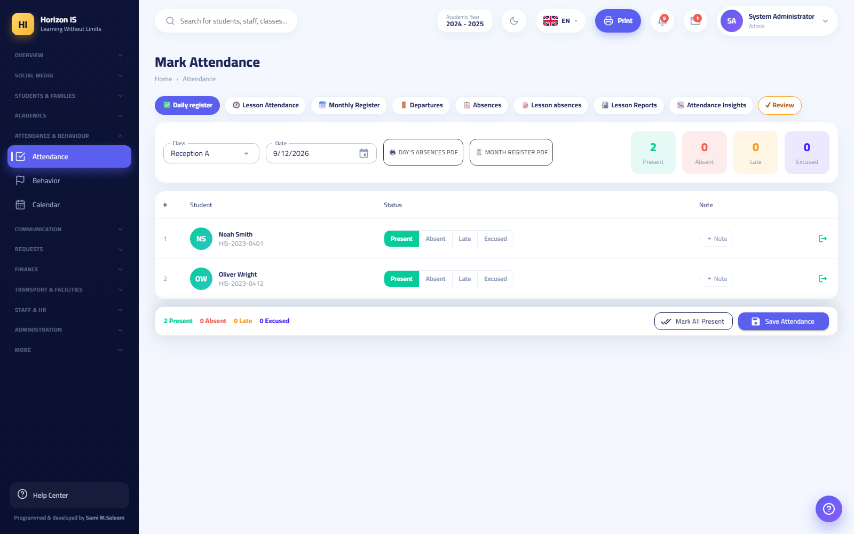سجل الحضور اليومي
Common mistakes:
- Marking the statuses then leaving the page without pressing "Save Attendance" — nothing is saved automatically.
- Recording attendance on the wrong date — check the date before saving.
- Marking a student "Absent" when they actually left during school hours — early departure has its own register (see below).
Troubleshooting:
- The register is read-only: the day has been reviewed and approved by administration (the Admin Review (مراجعة الإدارة) button in the strip). Contact administration for any change.
- The class does not appear in the list: you are not assigned to it — the timetable officer sets this in Teacher Allocation (توزيع المعلّمين).
- A student left during the day: record their departure from the same page (early departure); it then appears in the Departure Log (سجلّ الخروج) /attendance/departures, where "Returned" (عاد) is recorded when they come back. The office is always notified when a student leaves during school hours.
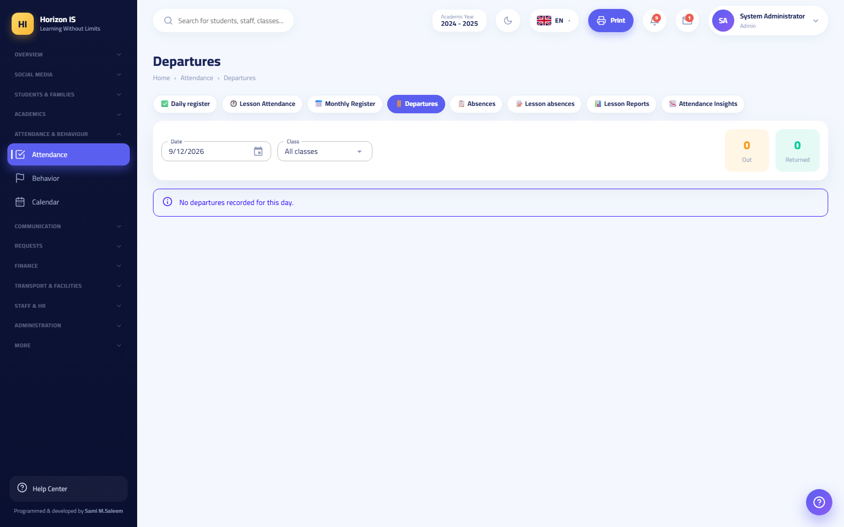سجل الخروج
Related topics: Lesson attendance · Recording attendance from mobile · the "Workflow: Daily Attendance" chapter.

Lesson attendance
Purpose: recording attendance for each lesson separately (not once in the morning) — it exposes students slipping away between lessons.
Who can: the same permissions as daily attendance.
- Attendance → Lesson Attendance (حضور الحصص) (/attendance/lessons).
- Choose the lesson from your schedule for today.
- Mark the students (Present/Absent/Late/Excused) — the action bar stays visible with live counters.
- Press Save Attendance (حفظ الحضور).
Expected result: the lesson record is saved; lesson absences appear in Lesson Absences (غيابات الحصص) /attendance/daily-lessons and Lesson Attendance Reports (تقارير حضور الحصص) /attendance/lesson-reports.
Tip: a student who is present in the morning but absent from a specific lesson automatically shows as an internal truancy case in management reports — your accuracy here protects students.
Related topics: Daily attendance.

The gradebook (entering marks)
Purpose: entering your students' marks in your subjects according to the approved assessment components (for example: coursework + final exam).
Who can: holders of academics.gradebook.view for viewing and academics.gradebook.manage for entry — the teacher holds both by default.
Before you start:
- Make sure the subject and class are assigned to you.
- Be aware that entry may be disabled at your school: some schools in the group import results from an external marking system, so the page appears read-only with a banner explaining this.
- From the sidebar open Grades (الدرجات) → Gradebook — Enter Marks (سجل الدرجات — إدخال العلامات) (/grades).
- Choose the Class, then the Subject, then the Term (semester/term).
- Enter the mark in each component column (the system prevents exceeding the component's maximum mark). The Total (المجموع) and the letter grade (التقدير الحرفي) are calculated automatically from the approved grade boundaries.
- Press Save Marks (حفظ العلامات).
- When needed: Import (استيراد) a CSV or Excel (.xlsx) file containing the student number and the marks, or Export (تصدير) the current table.
Expected result: the message "Marks saved." («تم حفظ العلامات.»). The marks are stored in the system but do not reach parents yet — results are published to families only through the report-card publishing gate managed by administration.
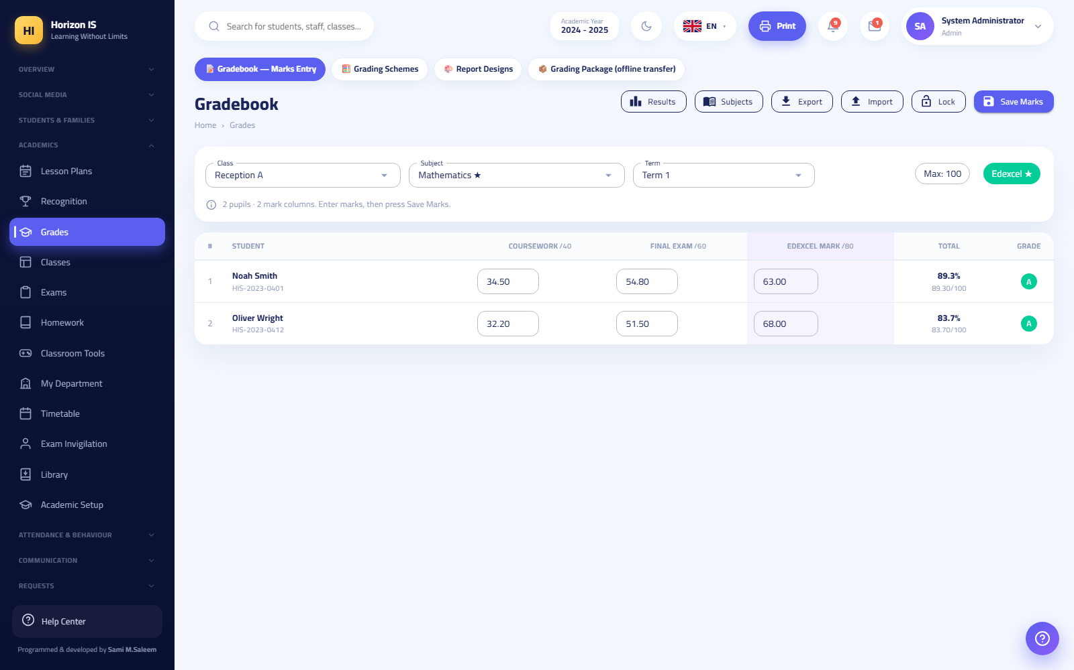صفحة سجل الدرجات مع أعمدة المكوّنات
Common mistakes:
- Entering a mark above the component's maximum — the field rejects it; review the term's components with administration if they look wrong.
- Assuming the parent sees the mark the moment it is saved — they only see it after official publication.
- Trying to import a file without a student-number column — the message "Could not read the file…" («تعذّرت قراءة الملف…») appears.
Troubleshooting:
- Banner "This term's grades are locked. See the principal for any change." («درجات هذا الفصل مقفلة. راجع المدير لإجراء أي تعديل.») — locking the term is an administrative permission (head of section or administration). You cannot edit until the lock is opened.
- The subject does not appear: review your assignment in Teacher Allocation, or make sure the subject is defined for the student's grade level in Subjects (المواد) /grades/subjects (a read-only page for non-administrators).
- The whole page is read-only: grade entry is disabled at your school by administrative decision (a school-level feature).
Related topics: the "Workflow: Exams, Grades, and Publishing" chapter · Grade lock — Head of Section.

Homework
Purpose: creating homework and tracking submission and marking; what you create here reaches students and parents in the app immediately.
Who can: holders of academics.homework.manage — the teacher, heads of departments and sections, and administration.
- From the sidebar open Homework (الواجبات) (/homework).
- Note the top cards — each one filters the list when clicked: Awaiting Marking (بانتظار التصحيح), Past Due with No Submissions (انتهى موعدها ولم يسلّم أحد), Due This Week (التسليم هذا الأسبوع).
- Press Create Homework (إنشاء واجب).
- Fill in the fields: Title (العنوان), Class (الفصل) (you may select several sections — an independent homework is created for each section, submitted and marked separately), Subject (المادة) (only the grade level's subjects for this class appear), Instructions (التعليمات) (seen by students and parents), Due Date (تاريخ التسليم).
- When needed, attach files via Attach File (إرفاق ملف): images or PDF files only, with a maximum count and size shown on screen — students and parents download these files in the app.
- Save. The message: "Homework created successfully." («تم إنشاء الواجب بنجاح.») (or "Homework created for N classes." («تم إنشاء الواجب لـ N فصلًا.»)).
Expected result: the homework appears with status Active (نشط), then changes to Late (متأخر), Awaiting Marking (بانتظار التصحيح), or Marked (مُصحَّح) depending on submissions. The student submits from their app (the "Submit"/"Resubmit" button).
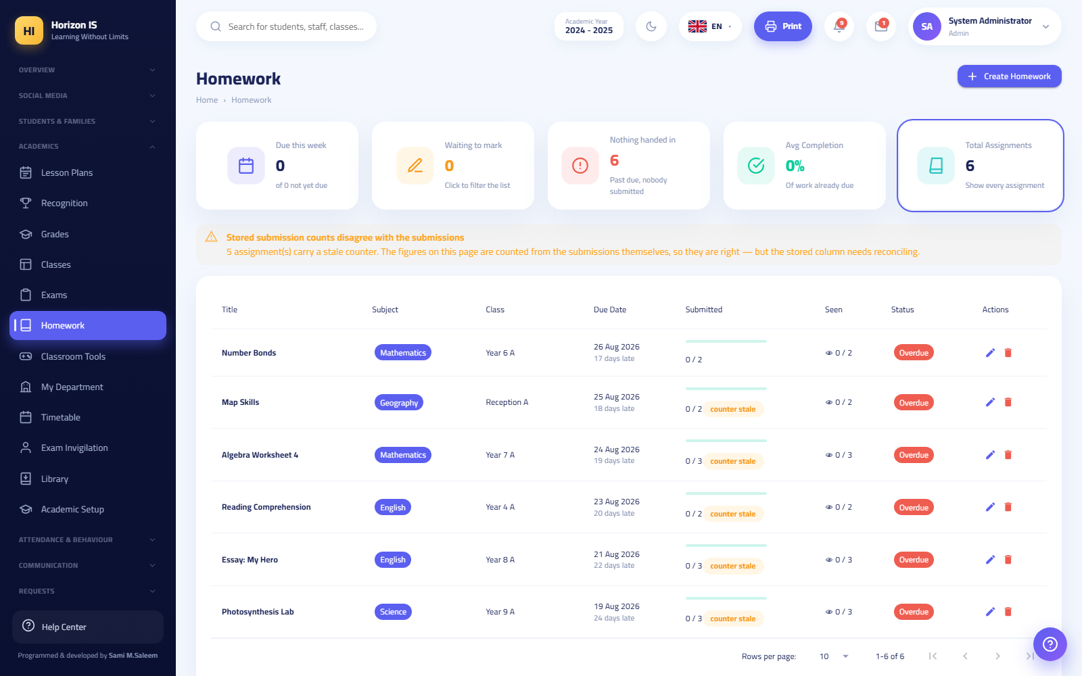صفحة الواجبات مع بطاقات التصفية وحوار الإنشاء
Common mistakes:
- Choosing a due date in the past — the system warns you "The date has already passed — this homework will be late the moment it is created" («التاريخ مضى بالفعل — سيكون هذا الواجب متأخرًا فور إنشائه») and asks for explicit confirmation.
- Attaching a Word file — only images and PDF are allowed: ""…" is neither an image nor a PDF file." («"…" ليس صورة ولا ملف PDF.»).
- Forgetting to choose the subject or the class — both are mandatory.
Troubleshooting:
- Banner "Stored submission counts do not match the actual submissions" («أعداد التسليم المخزَّنة لا تطابق التسليمات الفعلية»): the displayed numbers are computed from the submissions themselves and are the correct ones; inform the IT department to run the reconciliation.
- "No subjects are defined yet for this class's grade level" («لا توجد مواد معرَّفة بعد للصف الدراسي لهذا الفصل»): the general list is shown temporarily — ask administration to set up the grade level's subjects.
Related topics: Posting to the class feed · the Student Guide chapter (submitting homework).

Exams
Purpose: scheduling exams and printing the exam pack (schedules, room maps, door lists, seating cards).
Who can: holders of academics.exams.manage — the teacher, heads of departments and sections, and administration.
- Open Exams (الامتحانات) (/exams).
- Press Schedule Exam (جدولة امتحان) and fill in: title, subject, class, date, time, room.
- Edit or delete from the row buttons.
- Exam Seating (تجليس الامتحانات) generates a mixed seating plan for an exam day; then print: room maps, door lists, seating cards.
- Print the Master Schedule PDF (الجدول الرئيس PDF) or the Class Schedule PDF (جدول الصف PDF).
Expected result: the exam appears in student timetables and the parents' app, and the exam-day papers are ready to print.
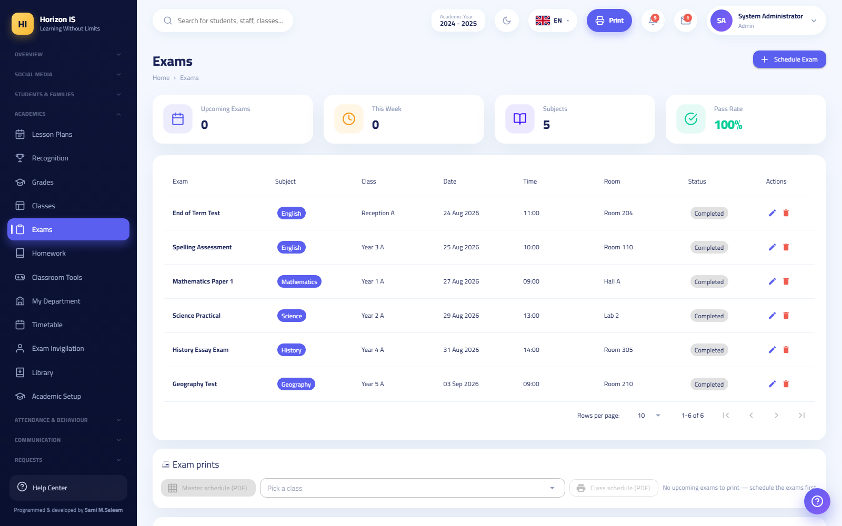صفحة الامتحانات
Related topics: The gradebook · the "Workflow: Exams, Grades, and Publishing" chapter.

Behavior, points, and recognition
Purpose: documenting behavior incidents (positive and negative) with points, managing your class board, and recognizing outstanding students.
Who can: holders of behavior.view / behavior.manage — the teacher, the form tutor, heads of departments and sections, and administration. The behavior categories themselves are configured by administration only.
Recording a behavior incident:
- Open Behavior (السلوك) (/behavior).
- Press Record (تسجيل).
- Choose the Student, then the Category (example: outstanding participation / disrupting order); this sets the Type (positive/negative) and the Points, and add a Note if needed.
- Save — the message: "Behavior recorded successfully." («تم تسجيل السلوك بنجاح.»).
Expected result: the student's points update (total positive, total negative, net points) and the record appears in "Latest behavior records" and in the student's file.
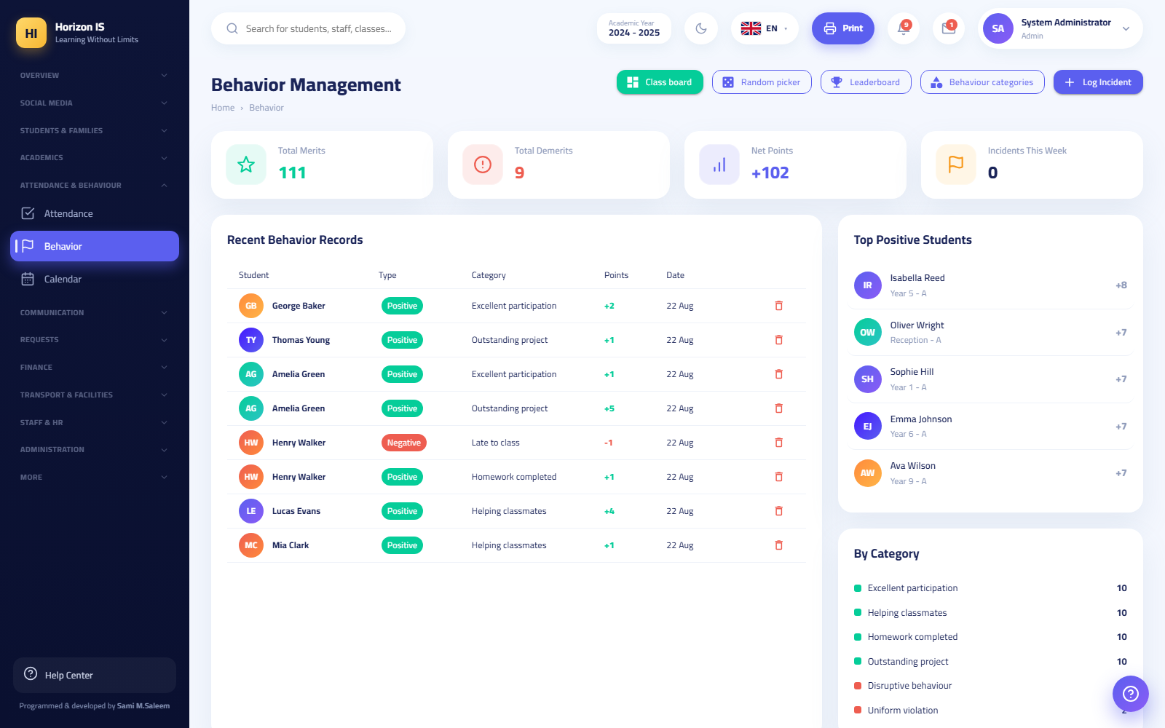شاشة السلوك
Companion behavior tools:
- Class Board (لوحة الصف) /behavior/board: award points to several students at once (select all / clear).
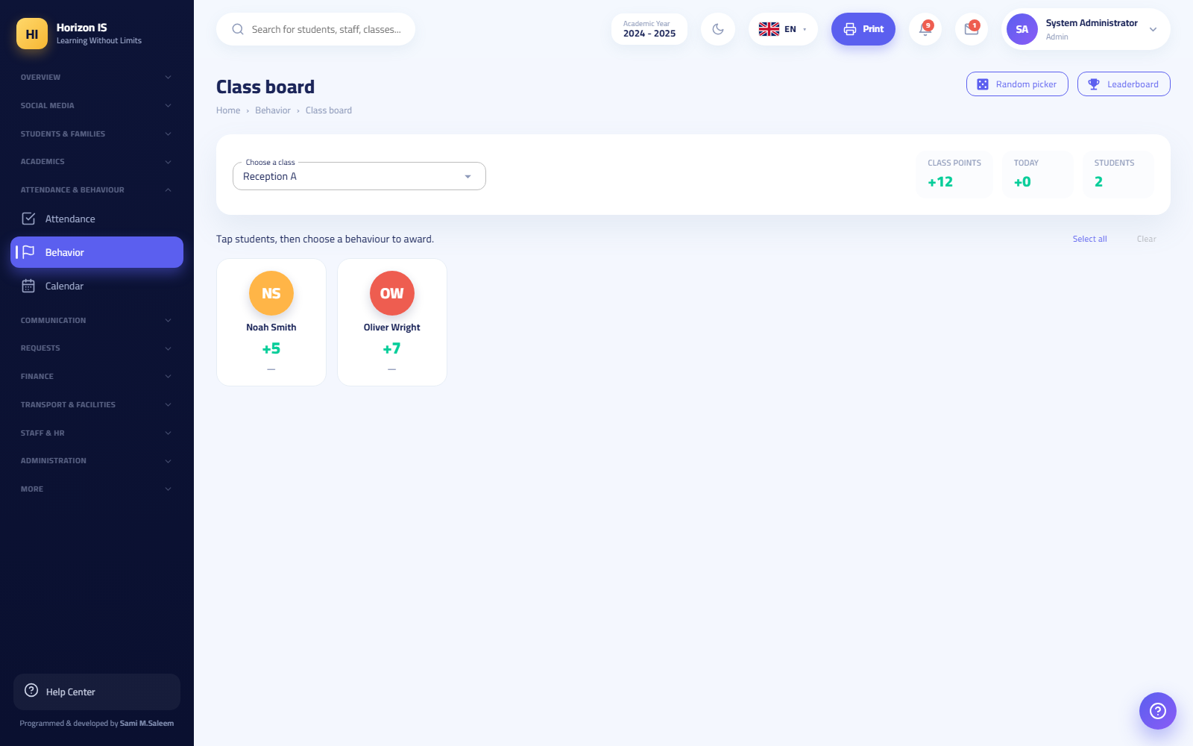لوحة الصف
- Leaderboard (لوحة المتصدّرين) /behavior/leaderboard: students ranked by points.
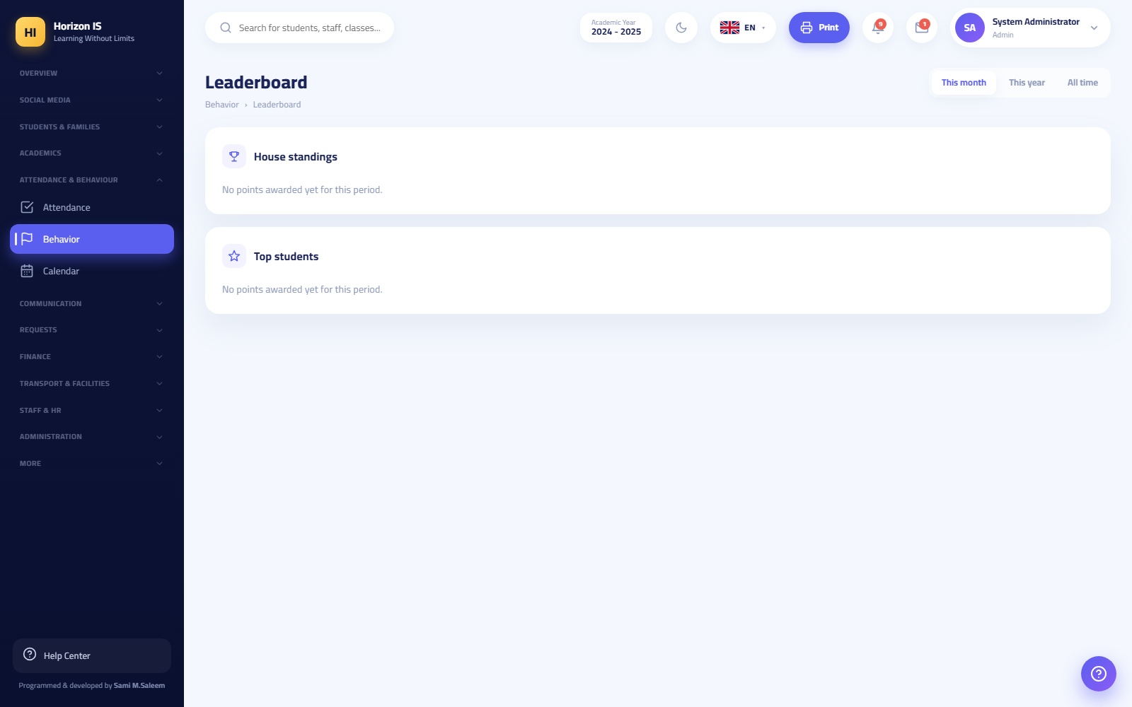لوحة المتصدرين
- Random Picker (المنتقي العشوائي) /behavior/picker: pick a student at random to participate (pick a student / pick again / reset).
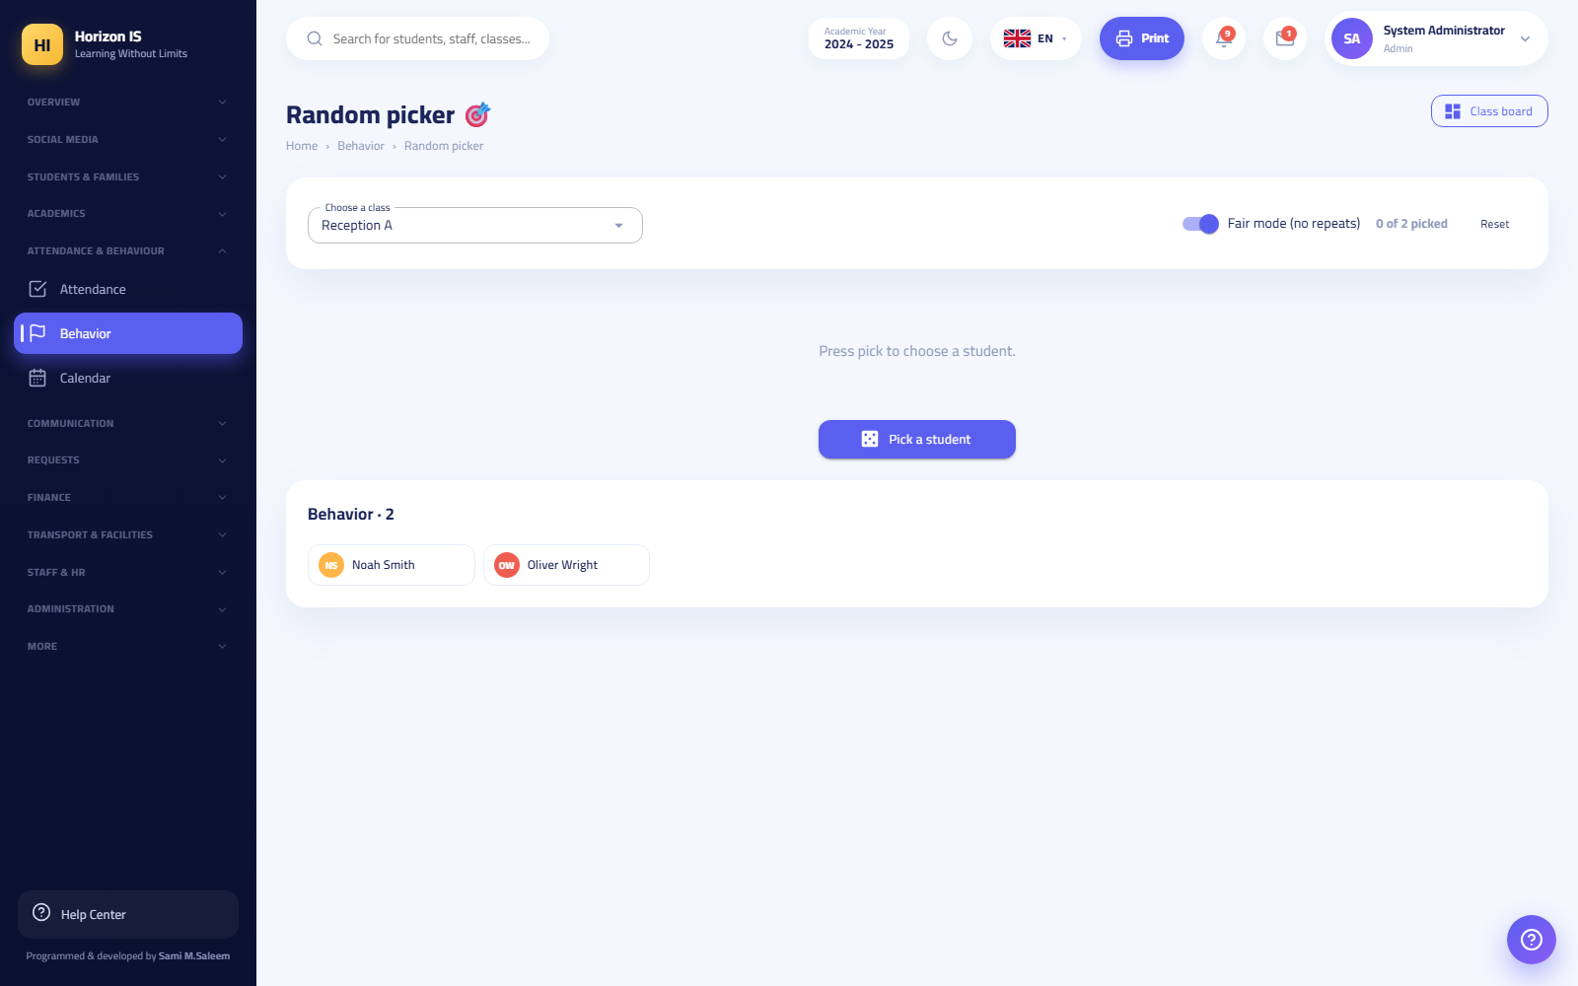المنتقي العشوائي
- Recognition Board (لوحة التكريم) /recognition: press Give Recognition (منح تكريم), choose the student, write the reason (optional — example: "Outstanding effort in mathematics"), and enable Show on the whole-school board (إظهاره على لوحة المدرسة كلها) if deserved — the message: "Recognition granted 🎉" («تم منح التكريم 🎉»).
Common mistakes:
- "No behavior categories yet — ask the administrator to set them up." («لا توجد فئات سلوك بعد — اطلب من المسؤول إعدادها.») — categories are created by administration at /behavior/categories.
- Deleting a behavior record recalculates the points — the system asks you to confirm before removal.
Related topics: Classroom tools · the Parent Guide chapter (seeing behavior points).

Classroom tools
Purpose: a toolbox for managing daily classroom activity without paper.
Who can: holders of classroom.tools.use — the teacher, the form tutor, heads of departments and sections.
Open Classroom Tools (أدوات الصفّ) (/classroom-tools) and you will find:
- The random student picker and spinning wheel.
- The group maker: split the class by number of groups or by members per group, with random shuffling.
- Team score boards: add teams, record their points, and reset them.
- Dice, coin, and number generator for educational activities and games.
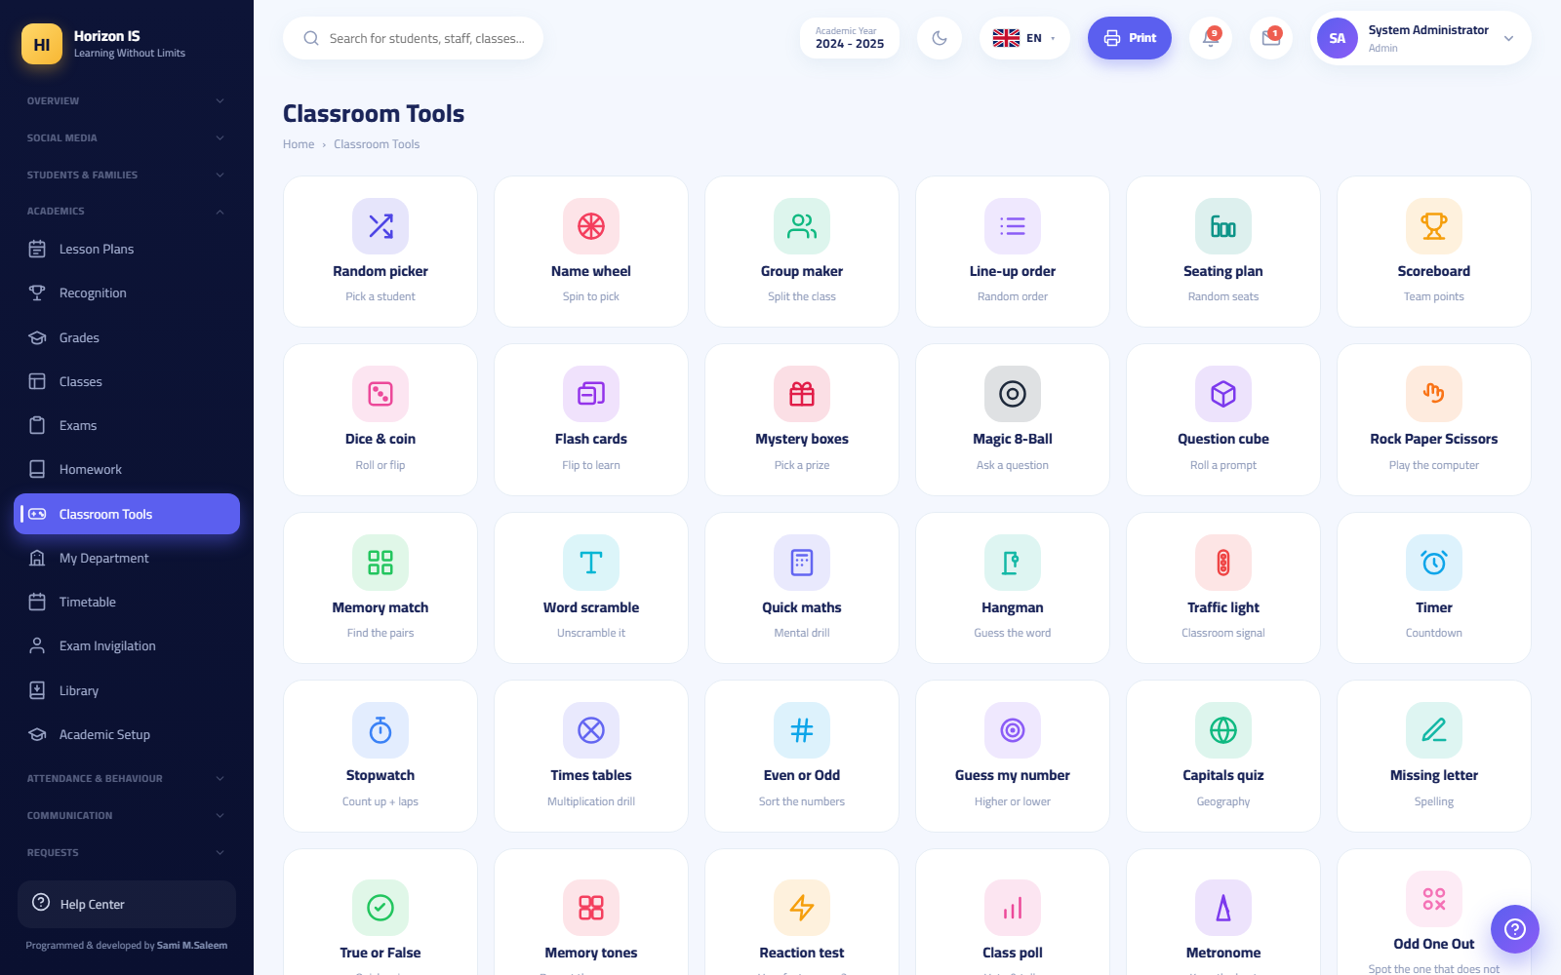أدوات الصف
Related topics: Behavior.

Communicating with parents
Purpose: direct and group messaging with your students' parents and with colleagues, from the web or mobile.
Who can: the teacher holds communication.view, communication.send, and communication.groups.manage — that is, they can read, send, and create groups and channels. Parents and students can never create groups.
Before you start: know that families are only offered official contacts: their children's teachers and the official roles (administration, registrar, nurse…) — a parent whose child is not in your classes cannot message you except through the school office.
- Open Messages and Conversations (الرسائل والمحادثات) (/communication).
- Search for the family or open an existing conversation. Use the filter: All / Unread / Pinned (الكل / غير المقروء / المثبَّت).
- Write your message and send. You can reply to a specific message, edit, unsend, and react with emoji.
- To send a file: on the web only PDF, Word, Excel, CSV, and ZIP are allowed — the system verifies the file's real type (its actual content), not its extension.
- To create a group: New Group (مجموعة جديدة), choose the type (group / channel / announcement), and add the members.
From the mobile app you get more:
- Voice messages: long-press the mic button (WhatsApp style) or tap once for a pinned recording bar — the limit is 5 minutes and 3 MB.
- Images up to 3 MB (larger ones are compressed automatically), video up to 10 MB, files up to 5 MB (pdf/doc/docx/xls/xlsx/csv/zip). PDF files open inside the app.
Expected result: the message arrives instantly with a notification to the parent in their language, and typing, presence, and last-seen indicators appear.
Common mistakes:
- Trying to send a file with a disguised extension (such as an executable named pdf) — it is rejected because the check reads the file's real content.
- Sending a general circular in a one-to-one conversation — school-wide broadcast is for administration, and class posts belong to the class feed.
Important: Your school conversations are subject to supervisory review: your head of department sees their department teachers' conversations with families and students, read-only, and deleted messages remain stored for oversight. Use school channels for professional communication only.
Related topics: Parent meetings · Department messages — Head of Department · the "Communication" chapter.

Parent meetings
Purpose: publishing available time slots that parents book from their app for one-to-one meetings (in person or online).
Who can: every staff member holding communication.view sees the page; teachers publish their own slots.
- Open Meetings (المواعيد) (/meetings).
- Press Publish Slots (نشر مواعيد).
- Set: the date and time, the duration (minutes), the number of consecutive slots, the class (optional) to restrict booking to the parents of one class, and the place: the room, or a meeting link, which marks the slot as Online (عبر الإنترنت).
- Press publish — the message: "Slots published" («تم نشر المواعيد»).
- Watch the list: a slot is Available (متاح) or Booked (محجوز) with the booker's and student's names. To withdraw a slot that no longer suits you press Withdraw (سحب) and confirm.
Expected result: the parent sees the slots in the "Available" tab of their app, books a slot and chooses the student, and Booked by (محجوز بواسطة) appears on your side the moment it is booked.
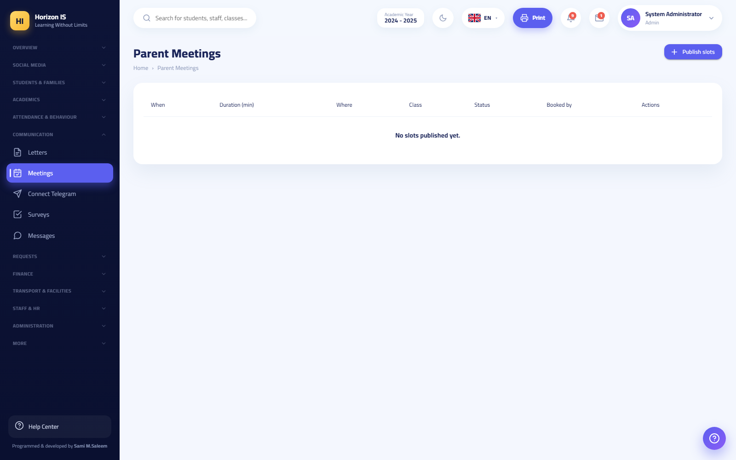صفحة المواعيد وحوار نشر المواعيد
Common mistakes:
- Withdrawing a booked slot without telling the parent — message them first, then withdraw.
- Forgetting the meeting link for remote slots — without a link the slot counts as in person in the stated room.
Related topics: Communicating with parents · the Parent Guide chapter (booking a meeting).

Lesson plans and teaching resources
Purpose: writing lesson plans and sharing teaching resources with classes or with colleagues only.
Who can: holders of academics.gradebook.view (teacher and above).
- Open Lesson Plans (خطط الدروس) (/lesson-plans) — one screen with two wings: Lesson Plans and Teaching Resources (المصادر التعليمية) (/resources).
- For a new plan: New Plan (خطة جديدة) → fill in the plan → Save Plan (حفظ الخطة).
- For a new resource: Add Resource (إضافة مصدر) → upload the file → Publish (نشر) and choose the scope: specific classes or staff only (للموظفين فقط).
Expected result: resources published to a class appear for students and parents in the app under "Learning Resources".
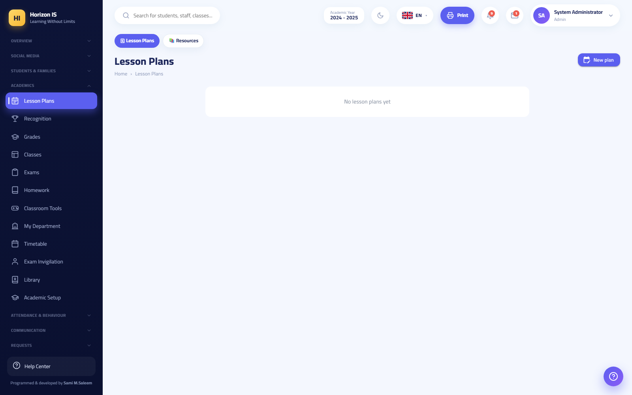خطط الدروس

Posting to the class feed
Purpose: publishing your class's news, photos, and activities in the social feed that families follow.
Who can: staff via the Social Media (سوشيال ميديا) screen; the "all classes" audience (school-wide broadcast) is normally for administration.
- Open Social Media (سوشيال ميديا) (/social) and press New Post (منشور جديد).
- Choose the audience: specific classes (صفوف محدّدة) (tick your classes) or staff only (الموظّفون فقط) — leave "all classes" for administrative announcements.
- Write the text and attach a photo, a video, or an album, then publish.
- From the mobile app you can also: add a poll or an RSVP invitation, tag students, schedule, save a draft, see who viewed the post, and send a reminder.
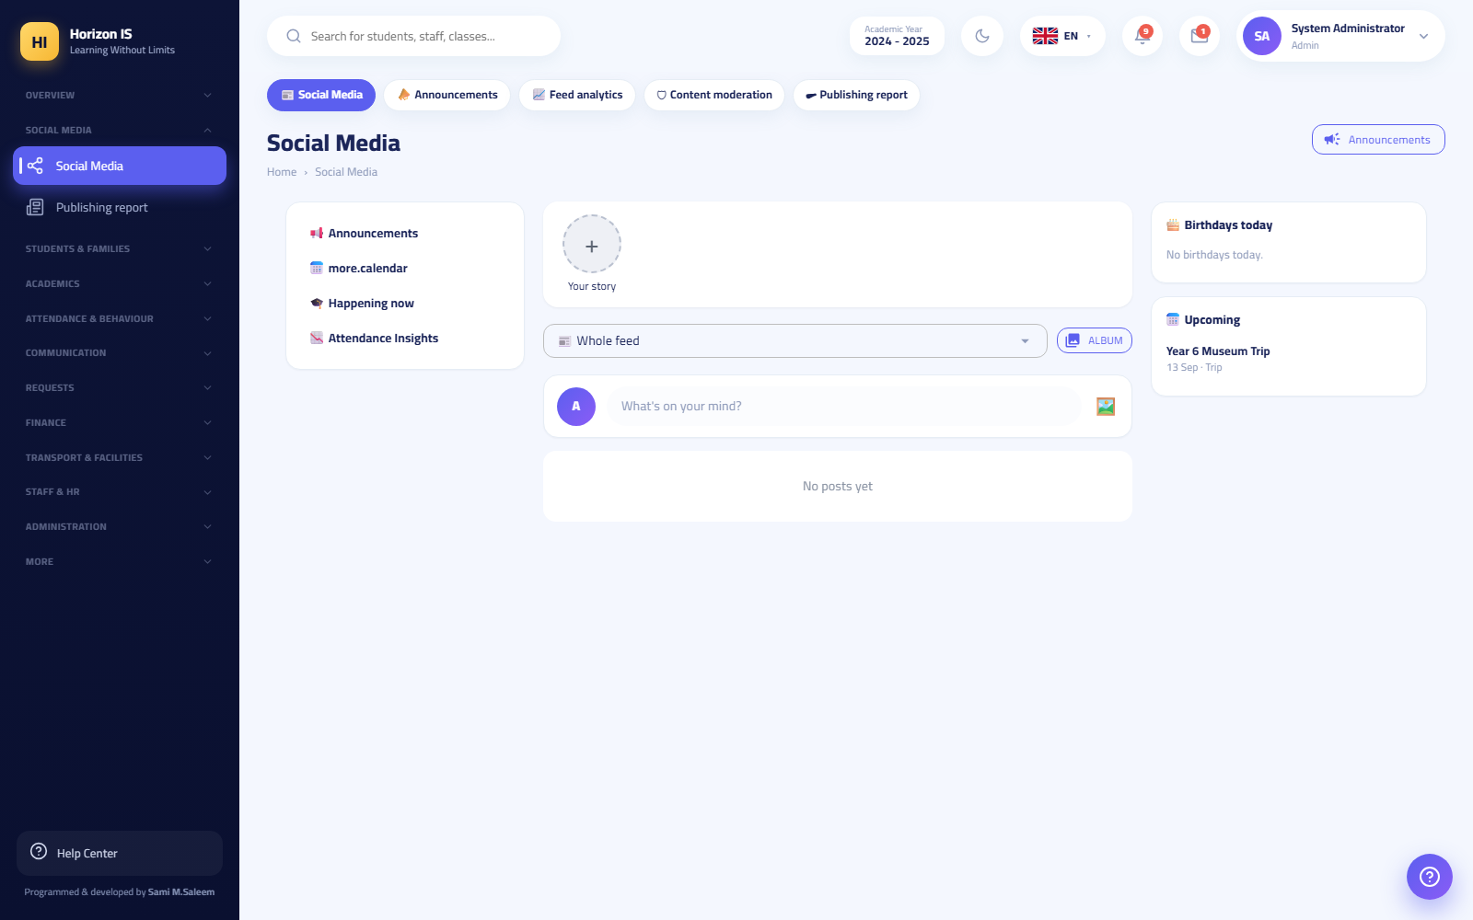الخلاصة الاجتماعية
Expected result: the post appears in the class feed for families with likes and comments, and they receive a notification.
Warning: Do not publish a student's photos in a public post without checking the school's policy and the families' media-consent permissions.
Related topics: the "Social and Announcements" chapter.

The teacher's mobile app
The teacher template's tabs in the app: Home (الرئيسية) (the Teacher Dashboard), Classes (الصفوف), Students (الطلاب), Messages (الرسائل) (including groups), Notifications (الإشعارات) (with an unread-count badge), My Account (حسابي).
Highlights of the home screen:
- The attendance clock card at the top of the screen: Clock In / Clock Out (تسجيل الدخول / تسجيل الخروج) by fingerprint ("Confirm your fingerprint to record attendance" — «أكّد بصمتك لتسجيل الحضور») with location detection — you must be inside the school zone ✓ (داخل نطاق المدرسة ✓), and fake-GPS apps are detected and blocked.
- Counters: My Classes (صفوفي), Students (الطلاب), Active Homework (واجبات نشطة), Awaiting Marking (بانتظار التصحيح).
- Quick actions: Record Attendance (تسجيل الحضور), New Post (منشور جديد), Departure Log (سجلّ الخروج), My Leave (إجازاتي), Attendance Review (مراجعة الحضور), Behavior Board (لوحة السلوك), Lesson Attendance (حضور الحصص).
Offline attendance: student lists are stored on the device; if you save attendance with no network it is stored locally and "No connection — saved and will be sent automatically when the internet returns" («لا يوجد اتصال — حُفظ وسيُرسل تلقائيًا عند عودة الإنترنت») appears, then "Pending registers sent ✓" («أُرسلت التحضيرات المعلقة ✓») when the network returns. If a pending record is rejected (for example because the day was approved), the app tells you explicitly so it can be re-recorded.
Early student departure from mobile: from the same attendance screen: Record Departure (تسجيل خروج) with the departure time, the reason, a note, and a Notify Parent (إشعار وليّ الأمر) switch.
Related topics: the full "Mobile App" chapter.

Teacher role limits
By default the teacher cannot:
- Create, edit, or delete student records, nor see the Families page.
- Open any finance screen (fees, installments, balances) — a message appears saying financial data is restricted to the finance office.
- Lock a term's grades or publish report cards to families.
- Edit the timetable or Teacher Allocation.
- See health records or safeguarding records.
- Manage users, permissions, or devices.
Tip: If you need something from this list for a specific task, ask school administration to grant you the permission from the Roles and Permissions (الأدوار والصلاحيات) screen — it takes effect after your next sign-in.

3.2 11.2 Head of Department and Head of Section

Role card
Names in the system: Head of Department (رئيس القسم — HeadOfDepartment) and Head of Section (رئيس المرحلة — HeadOfSection). Landing page: both land on My Department (قسمي) /my-department. In the mobile app the head-of-department template opens (a "My Department" tab + Messages + Notifications + My Account).
Both roles hold all teacher permissions, plus: timetable management (academics.timetable.manage), report-card publishing permission (academics.reportcards.publish), announcements management (communication.announcements.manage), and the department screens.
The difference between the two roles:
Capability | Head of Department | Head of Section
Locking and unlocking a term's grades (academics.gradebook.lock) | — | ✔ (the only non-administrative role that holds it)
Viewing families (families.view) | — | ✔
Managing classes (classes.manage) | — | ✔
Exporting reports (reports.export) | — | ✔
Important: A head's scope is governed by assignment: they see the teachers, classes, and timetables of their department only. You are appointed as a head from the Departments (الأقسام) screen /admin/departments by administration.

The "My Department" screen
Purpose: a single daily command board for the department: who is in, who is absent, what awaits your decision, and who needs a nudge.
Who can: holders of academics.timetable.manage — heads of departments and sections (and administration).
Before you start: if the message "You are not appointed head of any department yet…" («لستَ مُعيَّناً رئيساً لأيّ قسم بعد…») appears, ask administration to assign a department to you from the Departments screen.
The screen is divided into tabs:
- Overview (نظرة عامة): counters (classes, students, teachers, absent today, on leave, no lessons today, pending requests), then Today's Attendance (حضور اليوم) per class (with "Not recorded yet" («لم يُسجَّل بعد») and a direct Attendance (الحضور) button), the Absent Today (absence / leave) (الغائبون اليوم (غياب / إجازة)) list, and the No lessons today — available for cover (بلا حصص اليوم — متاحون للتغطية) list (useful when arranging urgent cover).
- Department Teachers (معلمو القسم): a table per teacher: weekly lessons, cover load over the last 90 days, today's fingerprint clock-in/out, and buttons: Record Behavior (تسجيل سلوك) (recorded and the teacher is notified), Send Alert (إرسال تنبيه), View Timetable (عرض الجدول).
- Classes and Students (الصفوف والطلاب): the department's classes and their students with Attendance (الحضور), Behavior (السلوك), and Timetable (الجدول) buttons.
- Approvals (الموافقات): leave requests (طلبات الإجازة) for your department's teachers (approve / reject) and fingerprint corrections (تصحيحات البصمة). "No pending requests 🎉" («لا طلبات معلقة 🎉») when everything is done.
- Send Alert (إرسال تنبيه): write the alert text and choose send to all department teachers (إرسال لجميع معلمي القسم) or choose teachers (اختر المعلمين) — "It arrives as an instant notification in each teacher's language, signed with your name." («يصل كإشعار فوري بلغة كل معلم، وموقّع باسمك.») then Send 📣 (إرسال 📣).
At the top of the screen are Quick Links (روابط سريعة): department messages, timetable allocation, timetable tools, attendance analytics.
Expected result: the department's daily decisions (cover, leave, alerts, attendance follow-up) all happen from one screen, and notifications reach their recipients instantly.
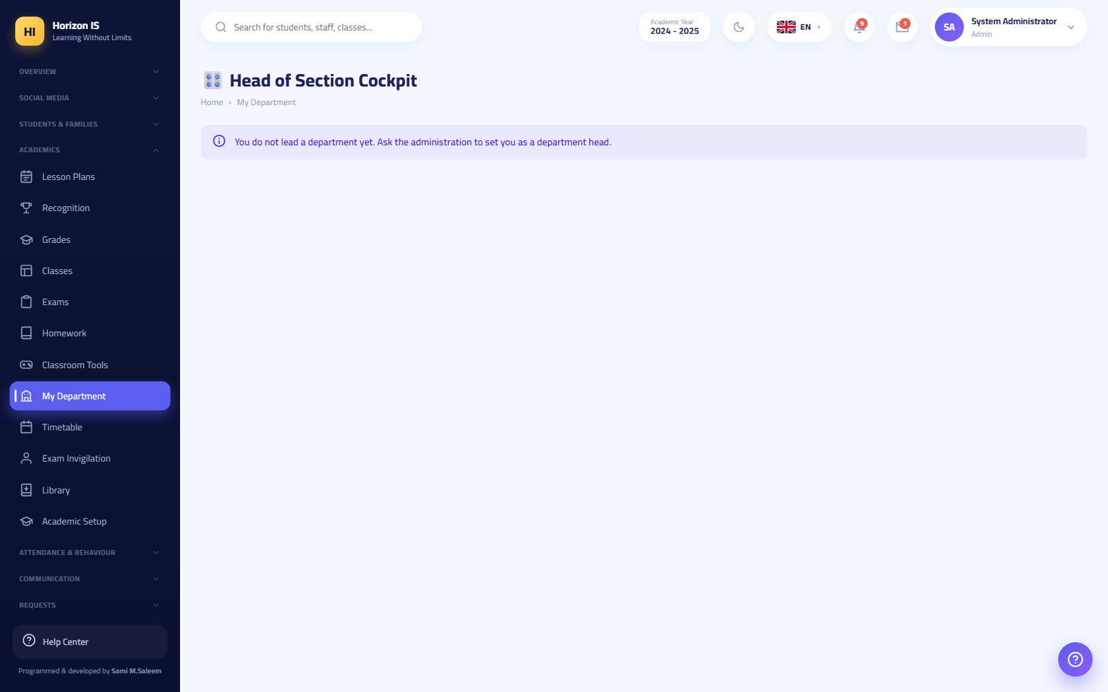شاشة قسمي بتبويباتها
Common mistakes:
- Looking for a leave request from a teacher outside your department — it will not appear; your scope is your department only.
- Expecting "Record Behavior" here to be about students — this is the staff behavior log (it feeds the administrative staff-conduct screen).
Troubleshooting:
- "No behavior categories yet" («لا توجد فئات سلوك بعد») when recording a teacher's behavior: the categories are configured by administration on the staff-conduct screen.
- Today's attendance numbers are empty: the class teachers have not recorded attendance yet — use the Attendance button next to the class to record it yourself, or remind the teacher.
Related topics: Department messages · Timetable oversight · the "Staff Affairs" chapter (leave and fingerprint).

Department messages
Purpose: a supervisory, read-only view of your department teachers' conversations with parents and students, to ensure communication quality and protect everyone.
Who can: holders of academics.timetable.manage (heads of departments and sections), each within their own department only.
- Open Department Messages (رسائل القسم) (/department-messages).
- Read the banner at the top of the screen: "Supervisory view — these are your department teachers' conversations with families and students, read-only. Teachers are expected to know their school conversations may be reviewed." («عرض إشرافيّ — هذه محادثات معلّمي قسمك مع الأهل والطلاب، للقراءة فقط. يُفترض أن يعلم المعلّمون أنّ محادثاتهم المدرسية قد تُراجَع.»)
- From the side panel choose a teacher (search by name when needed).
- Choose a conversation to read it. Deleted messages appear with the label "Deleted for both parties — retained for oversight" («محذوفة لدى الطرفين — محفوظة للرقابة»).
- When you need to document a conversation, use Export (تصدير).
Expected result: full visibility with zero interference: you cannot reply or delete from here, and your reading does not change the teacher's "read" state — the oversight is completely silent.
Common mistakes:
- Trying to open a conversation of a teacher from another department — "You are not the head of any department, or this conversation is outside your department." («لستَ رئيساً لأيّ قسم، أو هذه المحادثة خارج قسمك.»)
Important: Tell your department's teachers that this review exists — transparency is part of the safeguarding policy, not spying.
Related topics: Communication — the teacher · the Safeguarding Officer section.

Timetable oversight
Purpose: building the department's timetable, allocating teachers, and arranging cover for absences.
Who can: holders of academics.timetable.manage or classes.manage ("timetable builders") and administration.
As a head you see all the pills in the Timetable (الجدول الدراسي) strip:
- Timetable (الجدول الدراسي) /timetable: view and print any class's timetable.
- Timetable Studio (استوديو الجدول) /timetable-studio: advanced building — click a day/period cell to add a subject, teacher, and room, watch the conflicts banner (⚠️ or ✓ no conflicts), use auto-generation for a class or the whole school, and set teacher-availability constraints.
- Teacher Allocation (توزيع المعلّمين) /timetable/allocation: for each class set the teacher of every subject and its weekly lesson count, appoint the form tutor (مربي الصف) from the dedicated list, then Save (حفظ).
- Substitutions (التغطيات) /substitutions: record a teacher's absence (Record — تسجيل) and assign the substitute for each lesson (Assign — إسناد) — the fairness counters show cover loads over the last 90 days.
- Timetable Tools (أدوات الجدول) /timetable-tools: the "Now" board — what every section is doing at this moment.
Expected result: a conflict-free timetable, a substitute assigned to every exposed lesson, and every teacher sees their schedule at /teacher-timetable and in their app.
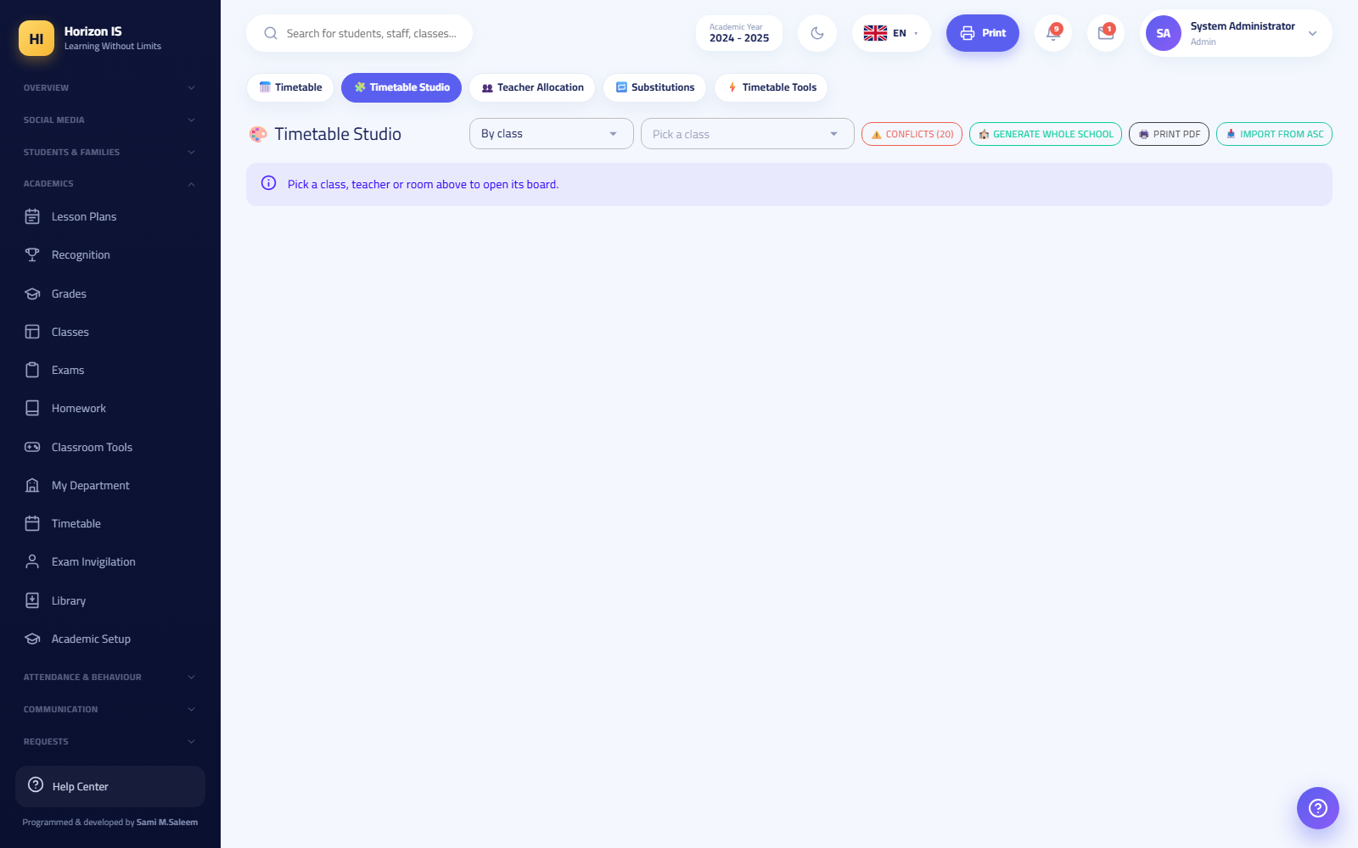استوديو الجدول
Related topics: the "Workflow: Timetable and Allocation" chapter · My Department.

Grade lock — Head of Section only
Purpose: closing a term's grades once they are complete so they cannot be edited except by decision.
Who can: holders of academics.gradebook.lock — the Head of Section and administration only. The head of department and the teacher do not hold it.
- Open Grades (الدرجات) (/grades) and choose the class, subject, and term.
- Press Lock (قفل).
- Choose: lock immediately (قفل فوري), or set open until (deadline) (مفتوح حتى (الموعد النهائي)) so it locks automatically afterwards, or cancel the deadline (إلغاء الموعد).
- Save — "Grade lock updated." («تم تحديث قفل الدرجات.»).
Expected result: teachers see the banner "This term's grades are locked. See the principal for any change." («درجات هذا الفصل مقفلة. راجع المدير لإجراء أي تعديل.») and cannot save.
Related topics: The gradebook — the teacher.
Important — publishing results: Both heads hold the publishing permission, but publishing report cards to families passes through a dual-approval gate: one manager requests approval and a different manager approves it before publication, and students under a payment hold are skipped automatically. Details in the "Workflow: Exams, Grades, and Publishing" chapter.

3.3 11.3 The Form Tutor

Role card
Name in the system: Form Tutor (مربّي الصف) — the pastoral lead for a single section. How they are appointed: from Teacher Allocation (توزيع المعلّمين) /timetable/allocation, where administration chooses the "form tutor" for each section, in addition to granting the FormTutor role on the user account.
Default permissions: viewing students and classes, recording and managing attendance, recording and managing behavior, messaging (read + send + create groups), the calendar, documents, viewing facilities, and classroom tools.
Important: The form tutor holds no grade permission by default — neither viewing nor entry. If they also teach a subject, grant them the "Teacher" role alongside their own, and they combine both roles' permissions.

The form tutor's day
Purpose: following their section's attendance, behavior, and communication — they are the first line of pastoral care.
Who can: the form tutor for their assigned section.
- In the morning: open Attendance → Daily Attendance and record your section's attendance (the same steps as the teacher).
- During the day: record behavior incidents from Behavior (السلوك), award points from the Class Board (لوحة الصف), and record the departure of any student leaving early (the office is always notified).
- For communication: create your section's parents group from Messages and Conversations (الرسائل والمحادثات) → New Group (مجموعة جديدة), and follow up on individual messages.
- For follow-up: watch the Calendar (التقويم) for school events, and read the Circulars (التعاميم) and sign as read (I acknowledge — أُقرّ بالاطلاع).
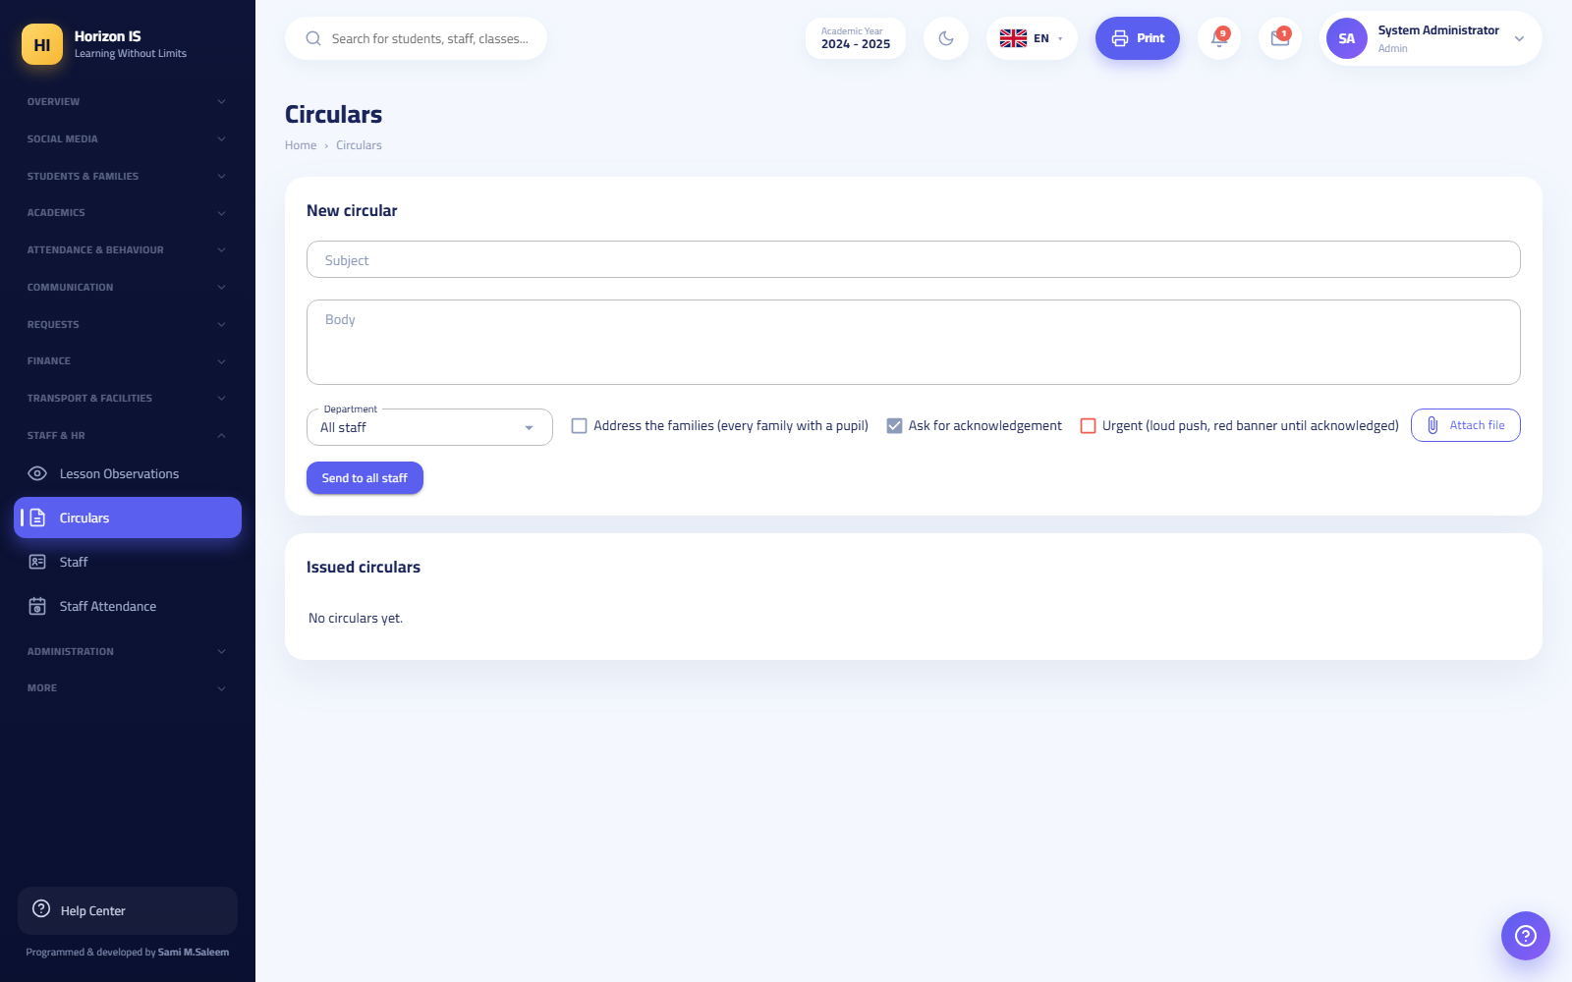التعاميم
Expected result: a section with attendance recorded daily before first period, a live behavior record, and one organized communication channel with parents.
Common mistakes:
- Waiting for a grade permission that will never come — request the additional "Teacher" role if you teach.
- Opening a parents group without ground rules — pin a group-rules message the moment you create it.
Related topics: The teacher — attendance · The teacher — behavior · The teacher — communication.

3.4 11.4 The Librarian

Role card
Name in the system: Librarian (أمين مكتبة). Default permissions: library.view and library.manage, plus the calendar and documents — no editing of student records and no academic, finance, or administration screens.
Two different screens you must tell apart:
Screen | Path | For whom | What it does
Library (المكتبة) (the circulation desk) | /library | Librarian and administration | Catalog, loans, returns, book requests
Book Catalog (فهرس الكتب) (browsing) | /books | Students and parents | Browse titles and request a book ("Request" — اطلب)
When a student opens "Library" from their menu they land on /books automatically — they never see the circulation desk.

The circulation desk — reading the screen
At the top of /library are five counters, some of which are filter buttons:
- Total Copies (إجمالي النسخ) (with the number of titles) and Available Now (المتوفّر الآن) ("on the shelf") — numbers only.
- Copies on Loan (نسخ مُعارة) and Overdue (متأخرة) — click them to filter the loans table ("click to filter").
- Pending Requests (طلبات بالانتظار) — takes you to the book-requests table.
The Loans (الإعارات) table shows by default what is on loan (longest overdue first), with filters: On Loan / Overdue / Returned / All (قيد الإعارة / متأخرة / مُرجَع / الكل) and a search box "Search for a book or borrower..." («ابحث عن كتاب أو مستعير...»).
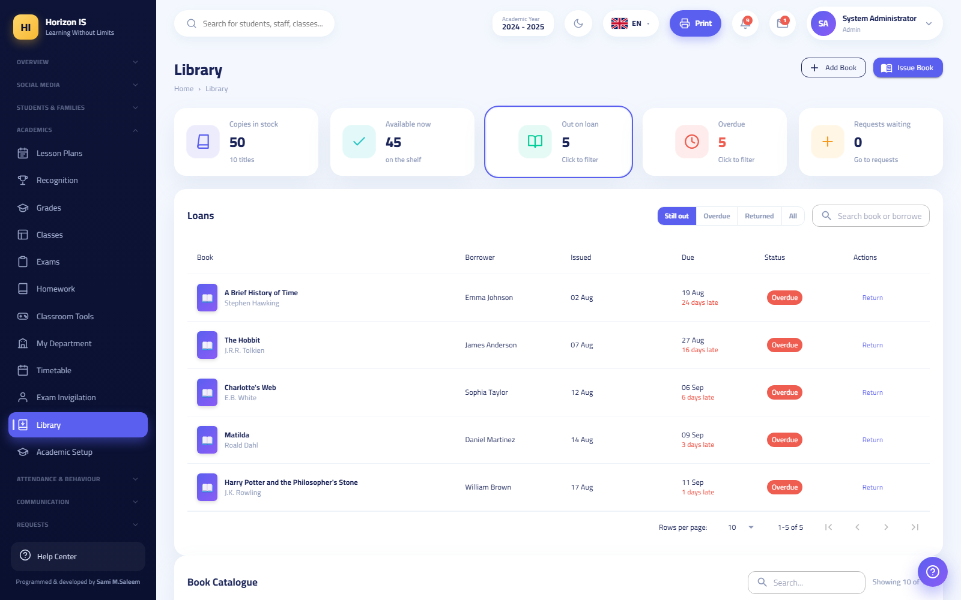مكتب الإعارة بعدّاداته الخمسة

Adding a book to the catalog
Purpose: entering a new title with its copies into the school catalog.
Who can: the librarian and administration.
- On /library press Add Book (إضافة كتاب).
- Fill in: Title and Author (both mandatory — "Title and author are required." («العنوان والمؤلف مطلوبان.»)), ISBN (الرقم الدولي), Category (التصنيف), Copies (النسخ), Shelf (الرفّ), Year (السنة), Description (الوصف), and the Cover (الغلاف) (an image of 3 MB or less).
- Save — "Book added successfully." («تمت إضافة الكتاب بنجاح.»).
Expected result: the title appears in the catalog and on the browsing screen /books for students, with its availability status.

Issuing and returning a book
Purpose: recording a copy going out to a borrower and coming back.
Who can: the librarian and administration.
Issuing:
- Press Issue Book (إعارة كتاب).
- Choose the Book and the Borrower (if you do not choose both: "Please choose a book and a borrower." («يرجى اختيار كتاب ومستعير.»)) and set the Due Date (تاريخ الاستحقاق).
- Save — "Book issued successfully." («تمت إعارة الكتاب بنجاح.»).
Returning:
- Find the loan in the table (by book or borrower).
- Press Return (إرجاع) on its row — "Book returned successfully." («تم إرجاع الكتاب بنجاح.»).
Expected result: the counters update instantly; an overdue loan shows in red with "N days overdue" («N يوم تأخير»).
Common mistakes:
- Issuing a last copy that is reserved for an approved request — check Book Requests before issuing the final copy.
- Forgetting to record the return when the book is handed back in person — the student unfairly stays "overdue".

Book requests (from students)
Purpose: deciding on the borrowing requests students send from the browsing screen /books with the Request (اطلب) button.
Who can: the librarian and administration only.
- Open the Book Requests (طلبات الكتب) table (or click the Pending Requests counter).
- Review the row: the book, the borrower, the request date, and the number of copies Available Now (المتوفّر الآن).
- Press Approve (موافقة) — approval creates the loan immediately (the default due date is 14 days later unless you set another) and the student receives a notification; hand them the book when they come. Or press Reject (رفض) and the student receives an apology notification.
Expected result: "Request approved" («تمّت الموافقة على الطلب») and the row moves to the loans, or "Request rejected" («تمّ رفض الطلب»).
Common mistakes:
- The approve button is disabled — "Out of stock" («نفد»): no copies are available right now; wait for a return or reject with a note.
Troubleshooting:
- Banner "Some copy counts need correction" («بعض أعداد النسخ بحاجة إلى تصحيح»): the stored availability counter for some titles does not match the actual loans. This page's numbers are computed from the loans and are the correct ones — "Ask the IT department to run the library reconciliation so the other screens match." («اطلب من قسم تقنية المعلومات تشغيل مطابقة المكتبة لتتوافق باقي الشاشات.»)
- A borrower named "former student" («طالب سابق»): the student's record was closed after the loan; process the return as usual.
Related topics: the Student Guide chapter (requesting a book from /books).

3.5 11.5 The Nurse and the Doctor

Role card
Names in the system: Nurse (ممرّض) and Doctor (طبيب).
- The nurse holds by default: health.view and health.edit (the sensitive medical permission pair), plus viewing students, the calendar, and documents.
- The doctor is a job-title role with no default permissions — they cannot see health records until administration grants them health.view and health.edit from the Roles and Permissions screen.
Both are official contacts: families can always open a conversation with the clinic from the app. In the mobile app the nurse gets a dedicated template with a Clinic (العيادة) tab and a Log Visit (تسجيل زيارة) button.
Warning — medical confidentiality: Everything on these screens is marked "Confidential — nurse access" («سرّي — وصول الممرضة»). Do not discuss a student's condition in public groups, and do not share screenshots. Health and safeguarding are deliberately separate silos: the nurse does not see safeguarding records.

The Health screen — reading the screen
Open Health (الصحة) (/health) to see:
- Counters: Today's Visits (زيارات اليوم) (with "ongoing" («جارية») for whoever is still in the medical room), Health Alerts (تنبيهات صحية) (flagged students), Medical Conditions (حالات طبية) (under follow-up), Special Needs (احتياجات خاصة) (supported students).
- Health Alerts (تنبيهات صحية): the list of students with allergies (الحساسية) or medical conditions (الحالات الطبية) by severity (الخطورة) — these are read from the medical notes in the student's file (entered by administration/the registrar at enrollment and updated from student editing).
- Latest Nurse Visits (أحدث زيارات الممرضة) with the outcome and the parent-notification status.
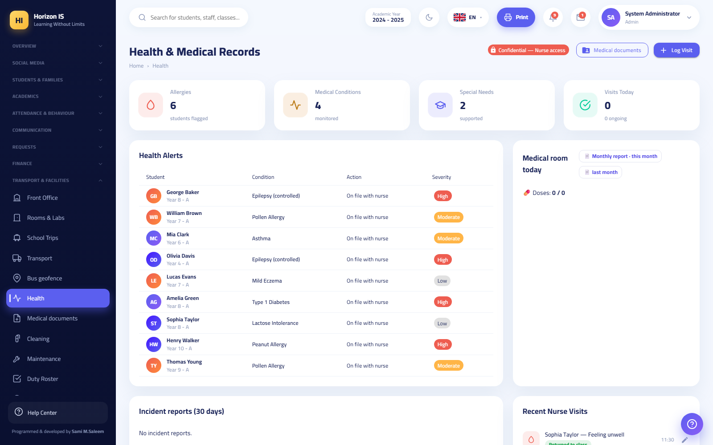شاشة الصحة

Logging a clinic visit
Purpose: documenting every student visit to the medical room: the reason, the action taken, the outcome, and informing the parent when needed.
Who can: holders of health.view/health.edit — the nurse (and the doctor once granted the permission) and administration.
Before you start: review the student's health alerts (allergy? chronic condition?) before giving any medication.
- On /health press Log Visit (تسجيل زيارة).
- Choose the Student.
- Record: the Reason (السبب), the Temperature (°C) (الحرارة (°م)) if measured, the Treatment / Medication Given (العلاج / الدواء المُعطى), and a Note (ملاحظة).
- Set the Outcome (النتيجة): Returned to class (عاد إلى الصف) / Resting (يستريح) / Sent home (أُرسل إلى البيت) / Referred to hospital (حُوّل إلى المستشفى) — or tick "The student is still in the medical room" («الطالب ما زال في الغرفة الطبية») for an ongoing visit to be closed later.
- Enable Notify Parent (إشعار ولي الأمر) if needed, then save.
Expected result: "Visit logged successfully." («تم تسجيل الزيارة بنجاح.») and the visit appears in "Latest Nurse Visits" with the tag "Parent notified" («أُشعر ولي الأمر») when enabled. A student leaving school from the medical room is always reported to the office — a student leaving during school hours is a safeguarding matter.
Common mistakes:
- Forgetting to close an "ongoing" visit after the student returns to class — it stays pending in the day's counter.
- Settling for a verbal notice to the parent without enabling the notification — enable the option so the notification is documented.
Troubleshooting:
- A student does not appear in the list: check the correct search name; the nurse sees all the school's students (school-wide scope).
- The doctor cannot see the screen at all: they have not been granted health.view yet — administration requests it from Roles and Permissions.
Related topics: Medical documents · the Parent Guide chapter (uploading documents).

Student medical documents
Purpose: reviewing the medical documents parents upload from the app (allergy letters, vaccination records, prescriptions, doctors' reports).
Who can: holders of health.view — the clinic and administration. A parent sees their own children's documents only.
- Open Medical Documents (الوثائق الطبية) (/child-medical).
- Review the saved documents: the student, the title, the Type (النوع) (allergy / vaccination / prescription / doctor's report / report / other), and the note.
- Download the document with the Download (تنزيل) button to read it.
- Update the medical notes in the student's file if something new requires it (a new allergy, for example) via administration/the registrar.
Expected result: a complete medical file for every student; the parent sees in their app that "only you and the school's medical staff can see them".
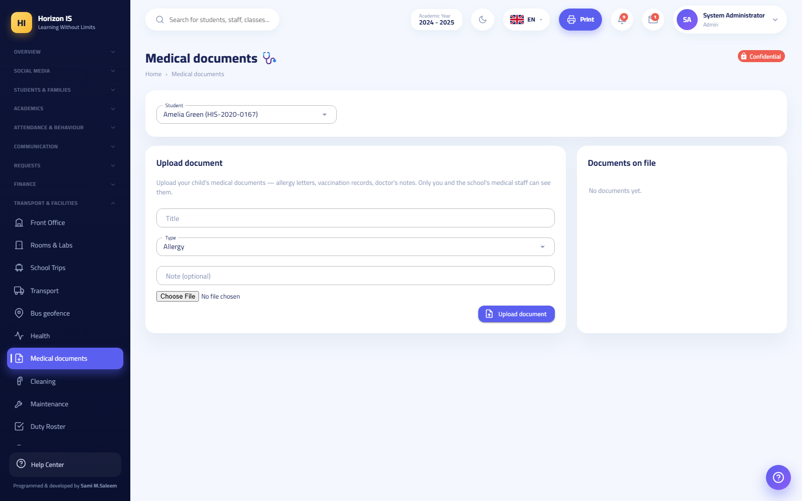الوثائق الطبية
Related topics: Logging a visit · the Safeguarding Officer section.

The clinic in the mobile app
The nurse template's tabs: Clinic (العيادة) (the home screen with the attendance clock card and the Log Visit (تسجيل زيارة) button), Messages (الرسائل), Notifications (الإشعارات), My Account (حسابي). Logging a visit from mobile matches the web steps above.

3.6 11.6 The Safeguarding Officer

Role card
Name in the system: Safeguarding Officer (مسؤول الحماية) — the school's child-protection lead.
Default permissions: safeguarding.view and safeguarding.manage (the highest protection tier in the system — "safeguarding team only"), plus viewing students, the calendar, and documents.
Characteristics of the role:
- School-wide scope: they see the files of all the school's students, not just assigned classes — because safeguarding is indivisible.
- An independent silo: safeguarding records are isolated from health records; neither the nurse nor the heads of departments hold their permissions by default — senior administration and the safeguarding team only.
- An official contact: any family can open a conversation with the safeguarding officer directly from the app.

The safeguarding officer's daily work
Purpose: gathering the early-warning threads (attendance, behavior, notes) and acting on them within the school's policy.
Who can: the safeguarding officer and senior administration.
- Student files: open Students (الطلاب) → the student's file /students/{Id} to review their data and the Safety Contacts (جهات اتصال الأمان) tab (who is authorized to pick up the student and communicate about them) — this is an essential checkpoint in family-dispute cases.
- Documents: keep safeguarding minutes and policies in the Document Center (مركز المستندات) /documents according to your school's classification — remember that documents.view is common to many staff, so do not put sensitive details in a general document; follow the archiving channel your administration defines.
- Communication: receive family reports via Messages and Conversations (الرسائل والمحادثات), and coordinate with administration in urgent cases.
- Risk indicators: ask administration or the heads of sections for the Absence Insights (رؤى الغيابات) report (the early-warning board combines attendance and behavior into a risk score) to follow high-risk students — the screen itself is administrative.
- Content reports: whatever is reported in the social feed reaches the administrative Content Moderation (الإشراف على المحتوى) list; coordinate with administration to handle any content that affects a student.
Expected result: all the safeguarding threads — attendance, behavior, messages, and documents — converge on one authorized person, with the least possible spread of the information.
Common mistakes:
- Sharing details of a safeguarding case in a staff group — safeguarding is run strictly on a need-to-know basis.
- Mixing up the clinic record and the safeguarding record — each has its own channel; a medical visit belongs to the nurse, a suspicion of harm belongs to the safeguarding officer.
Troubleshooting:
- You cannot see a screen you expect: safeguarding permissions do not open the health, finance, or academic screens — ask administration for any additional permission you need for your task, and it takes effect at your next sign-in.
Related topics: Department messages — supervisory oversight · Medical documents · the "Administration and Security" chapter (the audit log).

3.7 Related topics for the whole chapter
- Chapter 10 — Role Guides: Leadership and the Office (administration, the registrar, the accountant, IT…).
- The workflow chapters: daily attendance, exams/grades/publishing, timetable and allocation, communication and announcements.
- The Mobile App chapter: installation, choosing the school, signing in, and device approval.
- The Quick Start chapter: signing in, changing the temporary password, and switching language.
شاشة تسجيل الدخول

Chapter 4Role Guides: Operations and Families
This chapter is dedicated to the operational roles and the families: the Accountant, the Receptionist, the Bus Driver, the operational staff (Cleaner / General Staff), and then the complete guides for the Parent and the Student — who use the mobile app first and foremost.
Important: Everything you see in the menus depends on your permissions. If an item mentioned here does not appear for you, it means your role does not hold its permission. Check with school administration or the IT officer.

4.1 A Quick Look at the Roles in This Chapter
Role | Name in the system | Where they usually work | Default permissions
Accountant | Accountant — محاسب | Web portal | Full finance + view students and families + reports + cafeteria and school shop
Receptionist | Receptionist — موظف استقبال | Web + app | No default permissions — granted as needed
Bus Driver | BusDriver — سائق باص | Mobile app | Transport view + calendar only
Cleaner | Cleaner — عامل خدمات | App (time clock) | No default permissions
General Staff | Staff — موظف عام | App (time clock) | No default permissions
Parent | Parent — ولي أمر | Mobile app | Messaging (view) only — sees their own children only
Student | Student — طالب | Mobile app | Messaging (view) only — sees their own data only

4.2 The Accountant

4.3 The Accountant's Role in the System
The Accountant is the school's "finance office." Default permissions: view revenue, manage the fee structure, manage invoices, manage payments, view students and families, view and export reports, calendar, documents, and management of the cafeteria and the school shop.
Important: Financial data is protected by a dedicated guard. Anyone who is not the Accountant or Administration is denied entry to every finance screen with an explicit message. Recording payments in particular is restricted to Administration or the Accountant role only — even if another employee was granted a finance permission in the matrix.
The Accountant's sidebar menu includes the Finance section: the Finance Bridge, the Fee Structure (with its wings), Accounting (the journal), the School Shop — plus Payment Requests in the Requests section.
Note: If the "Finance ERP" feature is switched off for your school in the feature flags, all fee screens disappear from the menu. This is a deliberate setting, not a malfunction.

4.4 The Finance Bridge
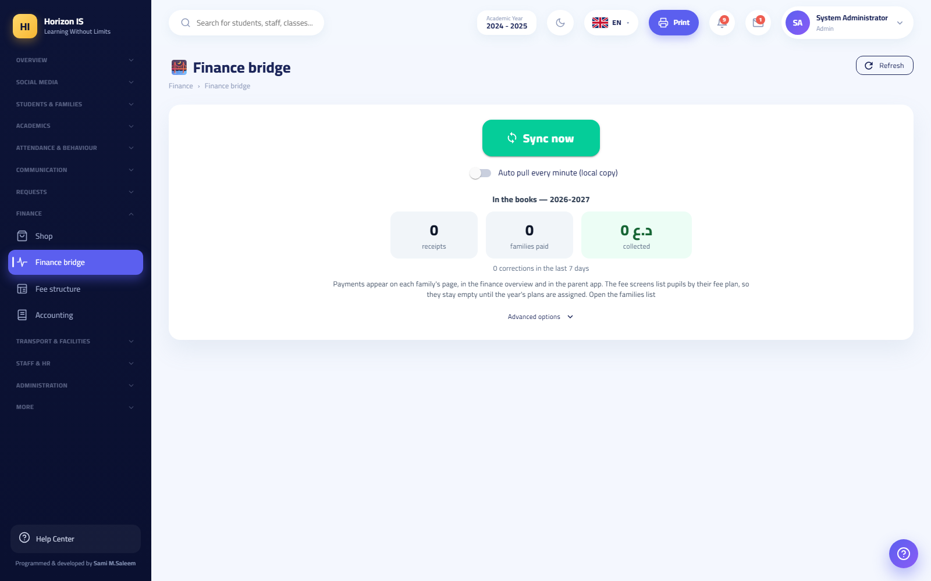الجسر المالي
Purpose Synchronize the school's fee records with the accounting books, and exchange encrypted finance packages (.sep files) with other systems. All accounting screens trace back to it as the parent page for finance.
Who can Administration and the Accountant (revenue-view permission finance.revenue.view).
Before you start - Make sure the fee and payment data is complete for the day. - If you are going to import a .sep package, obtain it from its official source only.
Steps 1. Open Finance ← Finance Bridge (path /finance-bridge). 2. Review the dashboard: amounts are shown converted to the system currency (at the exchange rate on receipt or the system rate). 3. Click Sync now to run an immediate synchronization between fees and the books, and Refresh to refresh the view. 4. To manage the encryption key: Generate / Rotate / Pin key — create a key, rotate it, or pin it. 5. To import a package: Choose .sep file, then review the preview, then Apply + notify families to apply it and notify the families. 6. Use Link suggestions to match unlinked records.
Expected result The accounting books and the students' fees match, and any imported package is reflected on the families' balances with the families notified.
Common mistakes - Rotating the key without coordinating with the other party — old packages will no longer open. - Applying a .sep package from an untrusted source.
Troubleshooting - "I can't see the page": your role does not hold finance.revenue.view — check with Administration. - The package fails to open: make sure the current key is the same key as the sending party's.
Related topics Fee Structure · Record a Payment · Finance Reports

4.5 The Fee Structure and Fee Assignment
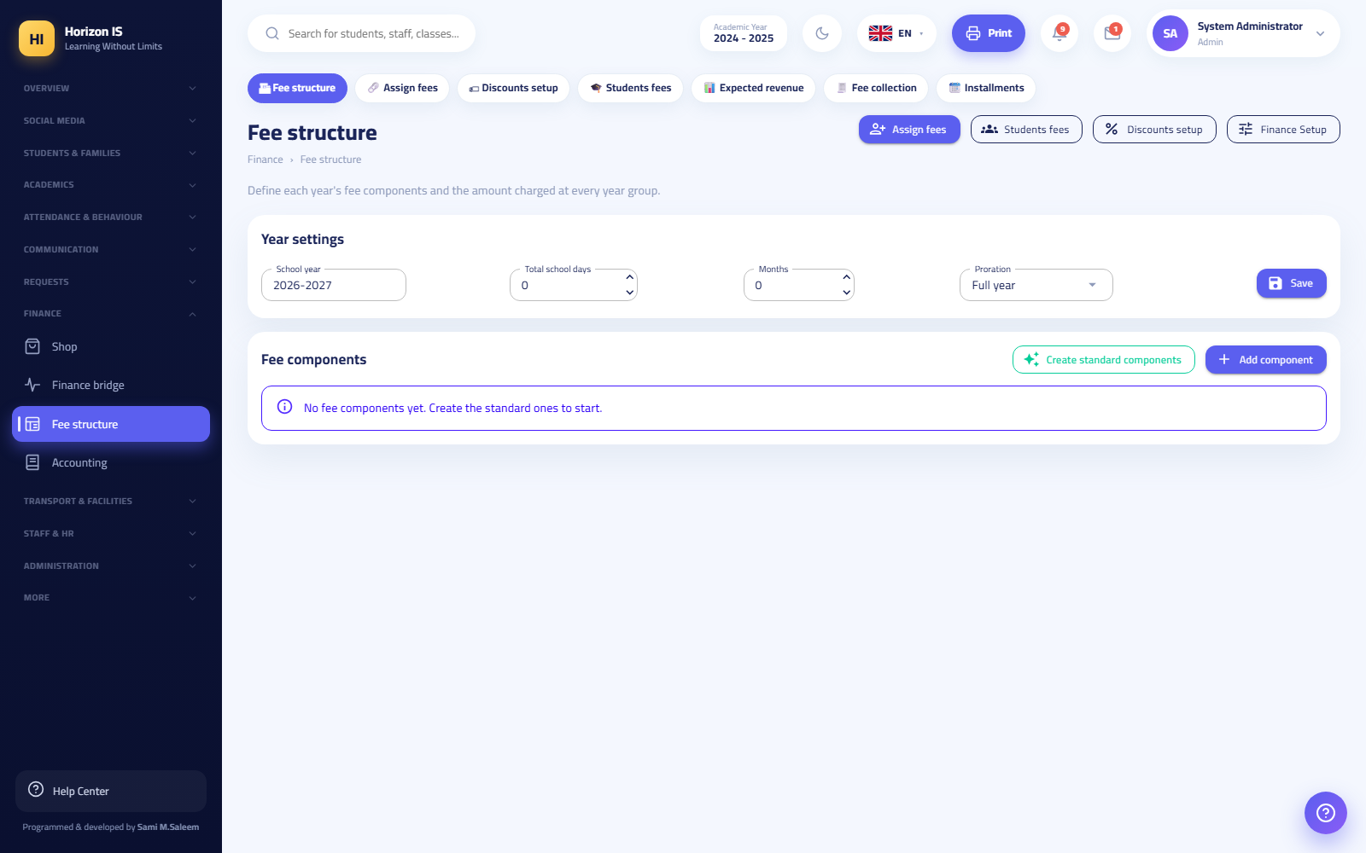هيكل الرسوم
Purpose Define the components of the annual fees, set the amount for each stage/grade, then finalize each student's fee with their discounts.
Who can Administration and the Accountant (permission finance.fees.manage).
Before you start - Administration's decision on the year's amounts and discounts is ready and in writing. - The current academic year is set in Settings.
Steps 1. Open Finance ← Fee Structure (/finance/fees). The page is a hub with pill buttons at the top of the screen: Fee Structure, Installment Assignment, Discount Setup, Student Fees, Expected Revenue, Fee Collection, Installments. 2. In the Year Settings card: set the academic year, the number of days and months, and the pro-rating method (none / by months / by days), then save. 3. In the Fee Components card: click the button to create the standard components, or add a component manually (Arabic/English name, source: manual or meals-linked, whether it accepts discounts, active). 4. In the grades table: enter the amount of each component for each stage/grade, then Save (حفظ). 5. Move to the Discount Setup pill (/finance/fees/discounts): add the named discounts (Arabic/English, active), including the sibling discount, then save. 6. Move to the Installment Assignment pill (/finance/fees/assign): pick the student, review their computed fee, apply the discounts, finalize the final fee and save. 7. After auditing: use the audit button to lock the student's fee for that year. The lock prevents unintended edits, and Administration can reopen it.
Expected result Every student has a clear final fee with their discounts, and the Expected Revenue report (/finance/fees/report) reflects the numbers directly, with a print button.
Common mistakes - Entering the amounts in the table and forgetting the save button before leaving the page. - Editing a component after collection has started — better to add a new component instead of changing the old one. - Leaving a discount inactive and then wondering why it does not appear in assignment.
Troubleshooting - "The menu doesn't show the Fee Structure": the finance feature is off, or the permission is missing. - "The student's fee is locked": it has already been audited — ask Administration to reopen it.
Related topics Record a Payment · Family Balances · Payment Requests

4.6 Record a Payment and Issue a Receipt
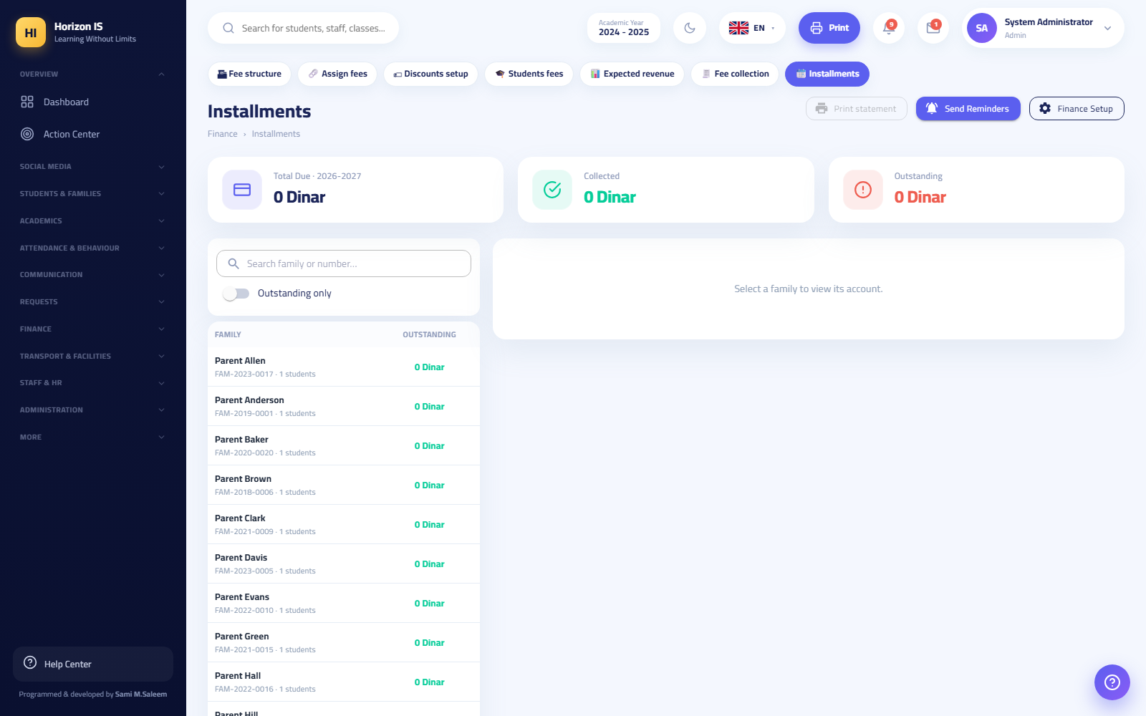شاشة الأقساط
Purpose Record family payments against installment plans, and issue an automatic receipt number for every payment.
Who can Administration or the Accountant only. This is a restriction at the role level itself; anyone else who tries sees the message: "Recording payments is restricted to the finance office."
Before you start - Identify the paying family (payments are recorded at the family level, not per individual student). - Know the payment currency (dinar or dollar) and the exchange rate saved in the system. - Confirm the cash box (البوكس) the payment will be deposited into.
Steps 1. Open Finance ← Fee Structure ← Installments (/finance/installments). 2. In the left panel: search for the family (there is an "Outstanding only" filter). Select the family. 3. If the family has no plan yet: click Set Plan (تحديد الخطة) and split the fee into payments. 4. Click Record Payment (تسجيل دفعة). In the dialog enter: the date, the amount, the currency (dinar/dollar — converted automatically at the saved exchange rate into the school's main currency), the payment method, the cash box, notes, and optional attachments (up to 4MB per file). 5. Save. The system issues an automatic receipt number in the form R-yymmdd-#### and the message "Payment recorded …" appears. 6. To print the family's account statement: the Print Statement (طباعة الكشف) button on the same page. 7. To send a reminder about overdue installments: the send-reminders button.
Expected result The payment appears in the payments list (receipt number, date, amount, equivalent in the main currency, method, cash box), the family's balance updates immediately, and the parent sees the amount in their app (view only).
Warning: A locked payment (shown with a 🔒 mark) cannot be deleted. Check with Administration if you need a correction — corrections are made with a reversing entry, not by deletion.
Common mistakes - Recording the payment against the wrong family when names are similar — verify the family number and its children before saving. - Choosing the wrong currency; conversion runs at the saved exchange rate, so review the equivalent before saving. - Forgetting to pick the correct cash box, which throws the box session off.
Troubleshooting - "The Record Payment button doesn't work / is hidden": your account is neither Accountant nor Administration. - "The equivalent amount is wrong": the saved exchange rate is stale — update it from the finance settings before recording.
Related topics Vouchers · Payment Requests · Family Balances

4.7 Vouchers and the Journal
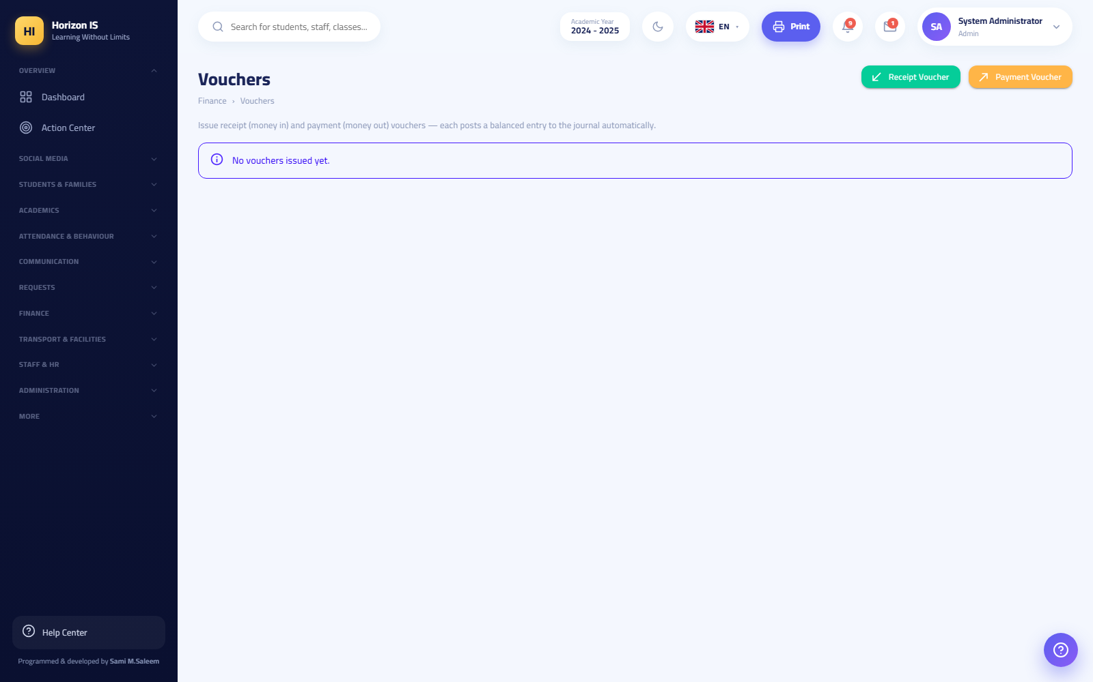السندات
Purpose Issue the official receipt and payment documents, and record daily entries in the accounting books.
Who can Administration and the Accountant (finance.revenue.view).
Before you start - Create the chart of accounts the first time from /finance/accounts using the create-default-tree button (or import it as CSV). - Set up the cash boxes from Accounting Setup (/finance/setup) — the add-box button.
Steps 1. Open Finance ← Accounting (/finance/journal) — the journal. Pills at the top of the page take you to: Chart of Accounts, Financial Statements, Vouchers. 2. For a manual entry: click New Entry / قيد جديد and fill in the debit and credit sides. 3. For vouchers: open Vouchers (/finance/vouchers) and choose Receipt Voucher (سند قبض) to receive cash, or Payment Voucher (سند صرف) to pay it out, then print the document. 4. For statements: open Financial Statements (/finance/reports) to view the accounting reports.
Expected result Tidy entries in the journal, and official printed vouchers for every cash movement.
Common mistakes - Issuing a receipt voucher instead of recording an installment payment: installment payments are recorded from the Installments screen so the family's balance shows correctly — the voucher is a document, not a substitute for recording.
Troubleshooting - "The tree is empty": it has not been created yet — the create-default button in /finance/accounts.
Related topics Record a Payment · Finance Bridge

4.8 Payment Requests from Families
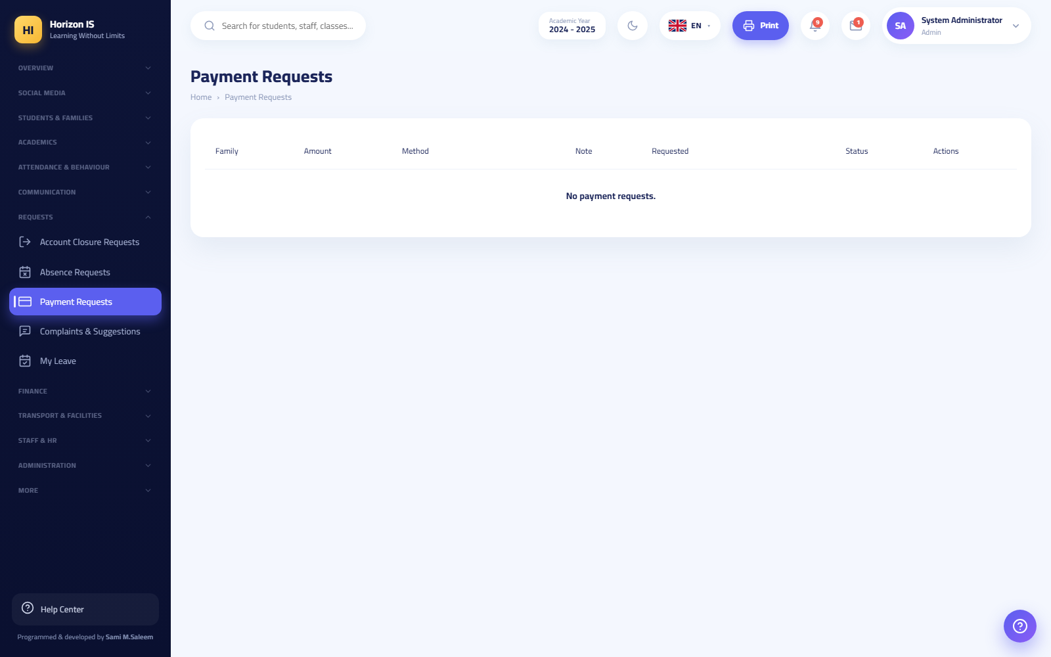طلبات الدفع
Purpose Process the "I paid / I will pay" notices coming from the parents' app.
Who can Anyone holding finance.payments.manage (the Accountant and Administration by default).
Before you start Verify that the cash has actually arrived (cashier, transfer…) before taking any action.
Steps 1. Open Requests ← Payment Requests (/payment-requests). 2. Review the request: the family, the declared amount, the note. 3. Click Acknowledge (استلام) to confirm you have seen it, or dismiss the request if it was a mistake. 4. Then actually record the payment from the Installments screen — a separate and mandatory step.
Expected result The request leaves the waiting list, and the real payment is recorded with its receipt in Installments.
Warning: The "Acknowledge" button does not record any money. Without the recording step in Installments, the family's balance stays exactly as it was.
Common mistakes - Settling for the acknowledgment and not recording the payment — the most frequently repeated mistake on this screen.
Troubleshooting - The page is hidden: the finance feature is off or the permission is missing.
Related topics Record a Payment

4.9 Finance Reports and Balance Follow-up
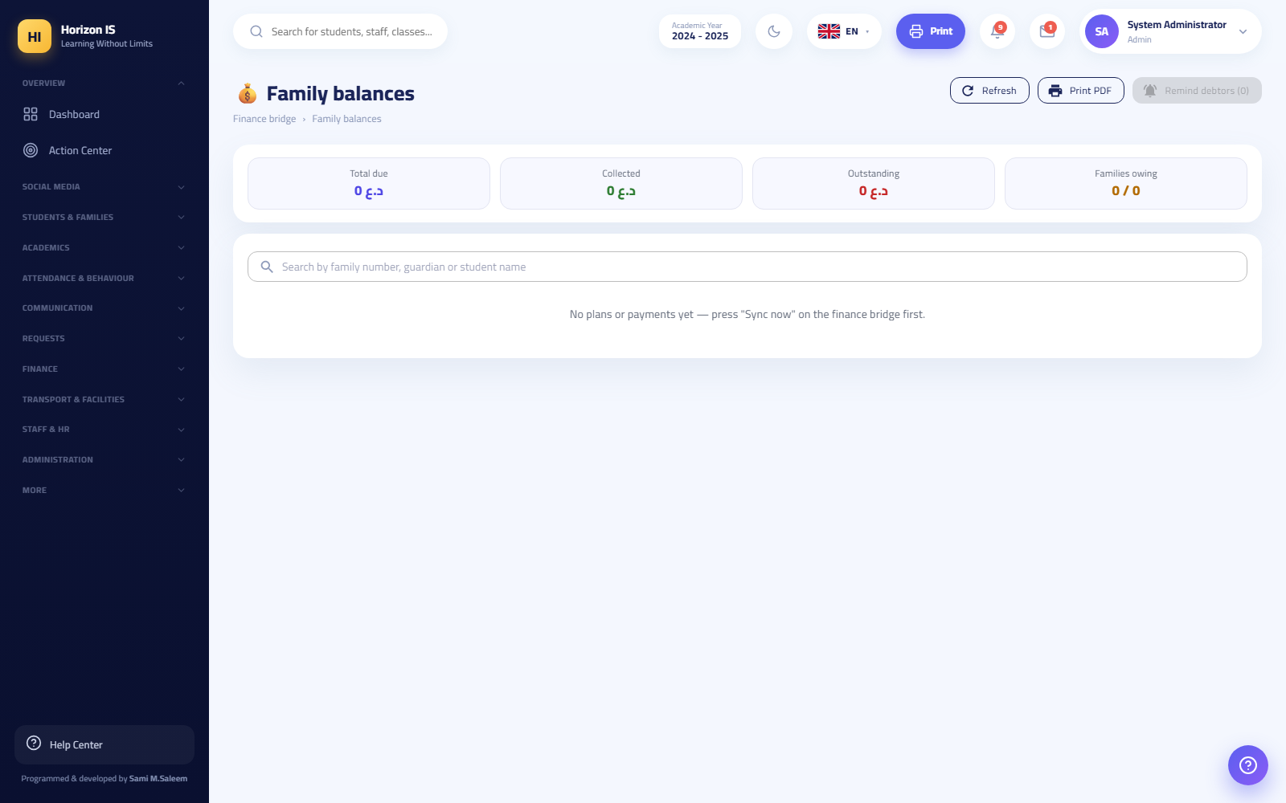أرصدة العوائل
Purpose Follow up on collection and arrears, and print the reports.
Who can Administration and the Accountant.
Steps 1. Fee Collection (/finance/fees/collection): a read-only dashboard of collection activity. 2. Expected Revenue (/finance/fees/report): a summary of the anticipated revenue with Print. 3. Student Fees (/finance/fees/students): each student's financial position with quick links. 4. Family Balances (/family-balances): what remains due from each family; Refresh, Print PDF, and Remind debtors (n) (تذكير المدينين) buttons — the reminder needs a second click to confirm. 5. General Reports (/reports): a cross-module report generator with CSV download and printing (the Accountant holds report viewing and exporting).
Expected result An accurate daily picture of collection, and a printable debtor list with bulk reminders.
Related topics Fee Structure · Record a Payment

4.10 Extra Screens in the Accountant's Hands: the School Shop, the Cafeteria, and Uniforms
The Accountant holds, by default, management of the School Shop and management of Meals:
- School Shop (الحانوت) (/shop): a point of sale that charges to the student's account — top-up-by-amount button, scanning, product management (/shop/products).
- School Cafeteria (المطعم) (/meals): meal subscriptions per student (setting the status, managing non-subscription reasons), and the weekly menu from /meals/menu — "Published" means families see it in the app.
- Uniform Store (متجر الأزياء) (/uniforms): uniform stock, bundles by stage, selling/issuing.
Tip: A fee component of the "meals-linked" type in the fee structure feeds automatically from the cafeteria subscriptions — do not enter it manually.

4.11 The Receptionist
Purpose of the role An account labeled with the correct title for the front-office employee. The role has no default permissions: no special screens automatically, and everything the receptionist needs is granted from the permission matrix according to school policy.
What works immediately after the account is created? - Signing in to the web and the app (the general staff pages: Home, Social Media, Circulars, My Leave). - The time clock in the app: any account linked to a staff record gets the fingerprint + GPS clock-in/clock-out card — regardless of role. - Circulars (/circulars): reading Administration's circulars and confirming with the Acknowledge button. - My Leave (/my-leave): leave balance and submitting a leave request.
An important point for families The Receptionist is on the "official contacts" list — they may be shown to families in chats as the "School Office." For the receptionist to actually receive and reply to family messages, Administration must grant them the messaging permission (view + send) from /admin/permissions.
Tip for Administration: Common permissions granted to reception depending on the school's needs: view students, admissions and enrollment, calendar, messaging, pickup call (/pickup — needs facilities view). Grant only the minimum that suffices; the change takes effect at the employee's next sign-in.
Common mistakes - Being surprised by an "empty menu" after the first sign-in — this is normal; the menu grows with every permission granted. - The first sign-in uses a temporary password, and the system forces changing it immediately (at least 10 characters: uppercase + lowercase + digit + symbol).
Related topics The permission matrix — Administration chapter · Messaging on the parent side

4.12 The Bus Driver
The bus driver works primarily from the mobile app. Default permissions: transport view + calendar. He sees his own trips only; the full fleet map and the bus roster are reserved for the transport office and Administration.
Important: The bus driver is on the "never shown to families" list — he never appears as a contact in the parents' app.
The driver app tabs: Drive (القيادة) (driver mode), Notifications (الإشعارات), My Account (حسابي).

4.13 Driver Clock-in (the Time Clock)
Purpose Prove daily attendance and departure with a fingerprint and a GPS location inside the school geofence.
Who can Every employee linked to a staff record — including the driver. The card appears at the top of his home screen.
Steps 1. Open the app. At the top is the Time Clock card. 2. Tap Clock In (تسجيل الدخول). 3. Confirm your fingerprint when "Confirm your fingerprint to clock in" appears. 4. Wait for the location fix: "Pinpointing your location…". You must be "Inside school range ✓" — otherwise "Move closer to the school location" appears with the remaining distance. 5. When leaving: Clock Out (تسجيل الخروج) the same way.
Expected result The status line changes to "Inside since …", and the punch appears in the staff attendance log on the web.
Warning: "Mock location" apps are detected and forbidden. When one is detected, this appears: "Mock location detected — stop fake GPS apps" and the punch is not accepted.
Troubleshooting - "Out of range" while you are at the school: turn on high-accuracy GPS, stand in an open spot, and try again. - Missed a punch? Submit a punch correction (تصحيح بصمة) and Administration approves it from the punch-corrections screen.

4.14 Running a Trip — Driver Mode
Purpose Broadcast the bus's live location to the families and the school during the trip, and record each student boarding and getting off.
Who can The bus driver (only the trips assigned to him). There is a web counterpart: Driver Mode /transport/drive.
Before you start - Make sure the transport office has assigned you today's route and its riders. - Charge the phone and turn on mobile data and GPS.
Steps 1. Open the Drive tab — the Driver Mode screen. 2. Choose today's route (the morning trip or the return trip). 3. Tap Start Trip (ابدأ رحلة). 4. Location disclosure: the app shows an explicit disclosure dialog about sharing your GPS location — read it and accept it. Broadcasting will not start without your consent, and while broadcasting a persistent notification stays in the phone's status bar reminding you that the location is being shared. 5. At every stop, update each student's status: Boarded (صعد) / Got off (نزل) / Absent — did not board (غائب). Every update sends an alert to the student's family — the message "Alert sent to the families." appears. 6. In an emergency: the emergency button, then choose the emergency type (breakdown, traffic…). The alert reaches the school. 7. At the end of the route: end the trip. The Trip Summary appears: duration, distance, and counts of who boarded, got off, and was absent.
Expected result The families see the bus "Live" on the map with the estimated arrival time and their children's boarding status moment by moment, and the school follows the trip on the fleet map.
Important — location privacy: Location broadcasting works during the active trip only. Ending the trip or closing the screen stops the broadcast. No tracking outside working hours.
Common mistakes - Forgetting to end the trip on arrival — the broadcast stays on and drains the battery. - Marking a student "Boarded" by mistake — correct the status immediately, because the family receives the alerts.
Troubleshooting - "The families don't see the bus": make sure you tapped "Start Trip", accepted the disclosure, and that the persistent notification is showing. - The broadcast dropped: open the screen again and tap resume tracking.
Related topics Bus tracking on the parent side · Transport and Facilities chapter

4.15 Operational Staff — the Cleaner and the General Staff Member
Purpose of these roles Two roles with no default permissions at all: Cleaner (عامل خدمات) and General Staff (موظف عام). Their existence guarantees that every employee at the school has a sign-in account labeled with their correct role — for payroll, the time clock, and circulars — without opening any data screen.
What does this account do? 1. The time clock in the app: fingerprint + GPS clock-in/clock-out (the same steps as the driver). Their punches feed staff attendance and payroll automatically. 2. Circulars: reading Administration's circulars and acknowledging them. 3. My Leave: requesting leave and tracking its balance. 4. In the app they get the short general interface: Home / Notifications / My Account.
Important — protecting the families: The cleaner, the general staff member, and the bus driver are on the "never shown to families" list. Even if one of them is mistakenly assigned to a class section, their name will never appear to parents as a contact. This protection is guaranteed in the system itself.
Tip for Administration: The cleaning shift roster is managed by Administration from /facilities/cleaning (facilities management permission) — the worker themselves never needs access to that screen.

4.16 The Parent — the Complete App Guide
The parent uses the Horizon International School app on the phone. Everything they see is limited to their own children, and their only permission is messaging (view) — they cannot create chat groups. App languages: Arabic (default), English, Kurdish (Badini), Turkish, German, Swedish — switched from the flags on the sign-in screen or from "My Account."

4.17 Choosing the School
Purpose One app serves the whole the school group; the first step is choosing your school.
Steps 1. Open the app for the first time. The list of the group's schools appears (name, Arabic name, city, logo). 2. Choose your child's school. The app checks the school server's connectivity before accepting the choice. 3. The sign-in screen opens with your school's name and logo.
Tip: Picked the wrong school? On the sign-in screen the Change School (تغيير المدرسة) button takes you back to the picker — you will never get stuck.

4.18 Signing in with the Family Code
Purpose First-time sign-in with no email and no password — with an eight-character code the school hands you in print (a slip or a QR card).
Who can Every family that received a code slip from the school. The codes are generated by Administration or the IT officer.
Before you start - Collect the code slip from the school. The code is single-use only.
Steps 1. On the sign-in screen tap "Sign in with school code (الدخول برمز المدرسة)". 2. The "Enter the family code 🎟" screen appears: type the code from the slip, or tap "Scan the barcode with the camera 📷" and scan the card's QR. 3. The app signs you straight in: your account is created, this phone is linked to the family, and it is trusted automatically. 4. The app will offer enabling Quick Sign-in with fingerprint/face — "Enable quick sign-in?" — enable it to make signing in easier later.
Expected result The parent home screen with your children's names.
Common mistakes - Typing an incomplete code or a code that was already used: "The code is invalid or already used — request a new code from the school." appears.
Troubleshooting - New phone? The old code does not work — request a new code from the school (generating it cancels the old one). - The camera won't read the QR: type the code manually.
Related topics Device Approval · My Account

4.19 Device Approval
Purpose Protecting the children's data: every phone is registered at sign-in, and the school approves the devices.
How does it work? - Signing in with the family code trusts the phone automatically. - Signing in with email and password from a new phone may be held for school approval: the "Waiting for school approval" screen appears with a "Back to sign-in" button. - The IT officer approves pending devices from his screen (Device Approvals) or from the web portal.
Important: The waiting screen is not an app error. Call the school so they approve your device, then sign in again.

4.20 The Parent Home Screen
The app's bottom tabs: Home (الرئيسية) · My Children (أبنائي) · Messages (الرسائل) · Notifications (الإشعارات) (with an unread counter).
From top to bottom on "Home": 1. The welcome card with the child switcher (if you have more than one child). 2. The stories strip: the school's photo stories. 3. An overview card for the selected child with the important-alerts strip. 4. Customizable mini cards. 5. The "More" services grid: Attendance · Report Absence · Cafeteria Menu · School Transport · Installments & Payments · Notifications · Calendar · Appointments · Announcements · Class Feed (with a new-items counter) · My Children's Teachers · Learning Resources · Documents (coming soon) · My Account · I've Arrived for Pickup.
Tip — pickup call: When you reach the school gate, tap "I've Arrived for Pickup (وصلتُ للاصطحاب)"; your child is called to the gate and the app responds with the waiting or called status.
Example: One child? The "Attendance" tile opens their record directly. More than one child? The children list opens first.

4.21 The "My Children" Tab and Attendance Follow-up
In the My Children tab, for each child: an indicators row (Attendance · Average · Behavior Points) and tiles: Installments · My Child's Bus · Attendance · Homework · Exams & Grades · Behavior · Documents (coming soon). The student number is shown on the card.
To follow attendance: open the Attendance tile — a full daily record (present/absent/late/excused). An absence appears the moment the teacher saves the register.
Related topics Reporting an Absence

4.22 Grades — Visible Only When Published
Purpose Letting the family see the child's report card after the school publishes it officially.
How does publication work? Grades do not reach families as they happen. The report card is prepared inside the system, then passes a double administrative approval, then is published to all the stage's families at once. What you see is a frozen copy as of the moment of publication.
Steps (in the app) 1. Open My Children ← Exams & Grades to follow the exams, and My Reports (or the publication notification) for the report cards. 2. When the "Report card published" notification arrives: open it from the same screen. 3. On the web: My Reports /my-reports — a list of published cards only, with an open button per card.
Expected result The official report card exactly as the school approved it.
Important: The family never sees unpublished grades at all. And if the account has withheld financial dues, the card may be blocked until the position is settled — check with the accounts office.
Troubleshooting - "No cards": the school has not published yet — wait for the publication announcement. - Your child's classmate's card appeared and your child's did not: most likely a payment hold — contact the accounts office.

4.23 Homework
Open My Children ← Homework: the class's homework list with due dates and attachments. The family's follow-up here is for viewing; electronic submission happens from the student's own account (the student guide).

4.24 Installments — View Only
Purpose Full financial transparency for the family: how much is due, how much was paid, how much remains.
Steps 1. From Home: Installments & Payments (or the Installments tile in "My Children"). 2. The Installments Account screen shows: Total Due · Paid · Remaining. 3. The Student Plans section: each child's installment plan. The Payments section: every payment with its currency (dinar/dollar) and method (cash/card/transfer/cheque). 4. For inquiries: the "Contact the Accounts Office (التواصل مع إدارة الحسابات)" button opens a direct chat with the accountant.
Important: The screen is view only — no paying inside the app. Payment happens at the school, the finance office records it, and it appears here immediately.
Troubleshooting - "I paid but the payment doesn't show": make sure the payment was recorded at the finance office; use the contact-accounts button.

4.25 Messages: Text, Voice, Photos, and Files
Purpose Direct, safe communication between the family, their children's teachers, and the school office.
Who can you message? The Messages tab shows: the School Office card ("General inquiries") at the top, then a row per child with their teachers and a Message (مراسلة) button per teacher. You only ever see your own children's teachers and the official contacts (Administration, Accounts, the Clinic, Reception…) — by the system's design. From the same screen you can open each child's timetable PDF.
Inside the chat - Text messages with Reply, Copy, Edit Message, Unsend, and reactions, plus typing, online, and last-seen indicators, and Mute Notifications per chat.
Voice message
- Press and hold the mic button and speak (WhatsApp style), or tap once to open a pinned recording bar with a live waveform.
- Lift your finger or tap send.
- Maximum: 5 minutes or 3MB. The first time, the app will ask for microphone permission — accept it.
Attaching photos and files
- Tap the + button (Attach / إرفاق).
- Choose: Photo from gallery · Take a photo · Video from gallery · Record a video · Document.
- Confirm sending from the preview dialog.
Accepted limits - Photos: up to 3MB — larger ones are compressed automatically on your phone before sending. - Video: up to 10MB. Files: up to 5MB. - Only these document types are allowed: PDF · Word (doc/docx) · Excel (xls/xlsx) · CSV · ZIP. The server inspects the file's real content, not its extension — disguised files are rejected. - PDF files open inside the app with a built-in viewer.
Common mistakes - Trying to send a file in an unsupported format (such as apk or exe) — it will be rejected no matter how the extension is changed. - Recording a voice message that is too long — it stops at the maximum.
Troubleshooting - "I don't see a particular teacher": only your children's current sections appear — if the teacher changed recently, wait for the update or message the school office. - Voice messages don't work: check the microphone permission in the phone's settings.
Related topics The Receptionist · Installments

4.26 Reporting an Absence
Purpose Officially notifying the school of your child's absence — instead of a phone call.
Steps 1. From Home: Report Absence (إبلاغ غياب). The "Report an Absence" screen opens. 2. Choose the child, write the reason, set the period from / to, and add a note (optional). 3. Tap Send Request (إرسال الطلب). "Absence reported ✓" appears. 4. Track the request's status on the same screen: the list of previous requests shows the status and who handled the request.
Expected result The request reaches the school's Absence Requests list, is approved or rejected, and an approval is reflected on the child's attendance record (excused absence).
Common mistakes - Reporting days after the absence — report ahead of time or the same morning whenever possible.

4.27 Booking Appointments with Teachers
Purpose Booking a meeting slot with a teacher from the slots the teacher has published.
Steps 1. From Home: Appointments (المواعيد). The "Parent Appointments" screen has two tabs: Available (المتاحة) and My Appointments (مواعيدي). 2. In "Available": choose a slot (its duration in minutes is shown, plus an Online badge if it is virtual) and tap Book (حجز). 3. Choose the student concerned, add a note if you wish, then Confirm Booking (تأكيد الحجز). "Booked successfully" appears. 4. Your confirmed appointments are in the My Appointments tab; cancellation is from there, with a confirmation message.
Common mistakes - Booking a slot for the wrong child when you have several — double-check the student's name before confirming.

4.28 Tracking Your Child's Bus
Purpose Knowing where your child's bus is moment by moment, and whether they boarded or got off.
Steps 1. From Home: School Transport (النقل المدرسي) (or the My Child's Bus tile in "My Children"). On the web: /transport/my-bus. 2. The Bus Tracking screen shows today's trip: the morning trip or the return trip. 3. During an active trip a Live (مباشر) badge appears on the map, plus two estimate lines: "Arrives at school in …" and "Arrives at your home in …". 4. Your child's status is under the map: Boarded ✅ · Arrived 🏠 · Did not board.
Expected result Complete peace of mind with no phone calls: alerts reach you automatically on boarding, getting off, and when the bus approaches.
Troubleshooting - "No bus is currently assigned.": your child is not assigned to a bus — check with the transport office. - "The bus is not moving right now.": no trip is active at this moment — normal outside trip times.

4.29 My Account and Requesting Account Closure
In My Account: changing the photo (gallery/camera/remove) · language · fingerprint / face sign-in · Check for Updates · the app version number · Sign Out.
Leave / account-closure request
Purpose The family's right to request closing the sign-in account (an app-store requirement).
Steps 1. In "My Account" open "Request to Leave / Close Account (طلب مغادرة / إغلاق الحساب)". 2. Write the reason (optional) and confirm from the confirmation dialog. 3. The request appears with a "Pending" status. You can back out with the Withdraw Request (سحب الطلب) button as long as it is pending.
Expected result The request reaches the school office (the account-closure-requests screen). Nothing changes before the school approves. On approval, only the sign-in account is closed: no signing in afterwards, sessions are ended, and notifications stop — the student's school records remain complete and nothing is deleted.
Important: Staff accounts are not closed from the app — the school created them, and closing them goes through the administration office.

4.30 The Parent Web Portal
تسجيل الدخول للبوابة
The parent can use the web portal with the same account. A fixed short menu: Home (/parent — a card per child with links to medical documents, leave requests, attendance, and the report card) · My Child's Bus · Messages & Chats · Calendar · My Reports.
لوحة ولي الأمر على الويب
Note: The first browser is trusted automatically when the school requires device approval; an additional browser may wait for the school's approval (the same rule as the phone).

4.31 The Student
The student mostly uses the app, and has a short web portal. Their permission: messaging (view) only — they cannot create groups. They see their own data only.

4.32 The Student App Tabs
The bottom tabs: Home (الرئيسية) · Schedule (الجدول) (the weekly timetable) · Messages (الرسائل) (the student's contacts — "Tap to start a chat") · Notifications (الإشعارات) (with the counter) · My Account (حسابي).
On "Home": a greeting + indicators (attendance, exam average, grade) + a Live Quiz banner when your teacher runs a live quiz + a quick actions grid: Schedule · Calendar · Homework · Exams · Grades · Attendance · Class Feed · My Teachers · News · Library · Learning Resources.
Homework (electronic submission): 1. Open Homework and choose the assignment. The due date is shown. 2. Tap Submit (تسليم) and attach your work. 3. On success, Submitted ✓ appears; you can Resubmit before closing.
Grades: the My Grades (درجاتي) screen shows the average per subject and the overall average — as far as the school has made available; for the official report card see My Reports.

4.33 My Attendance
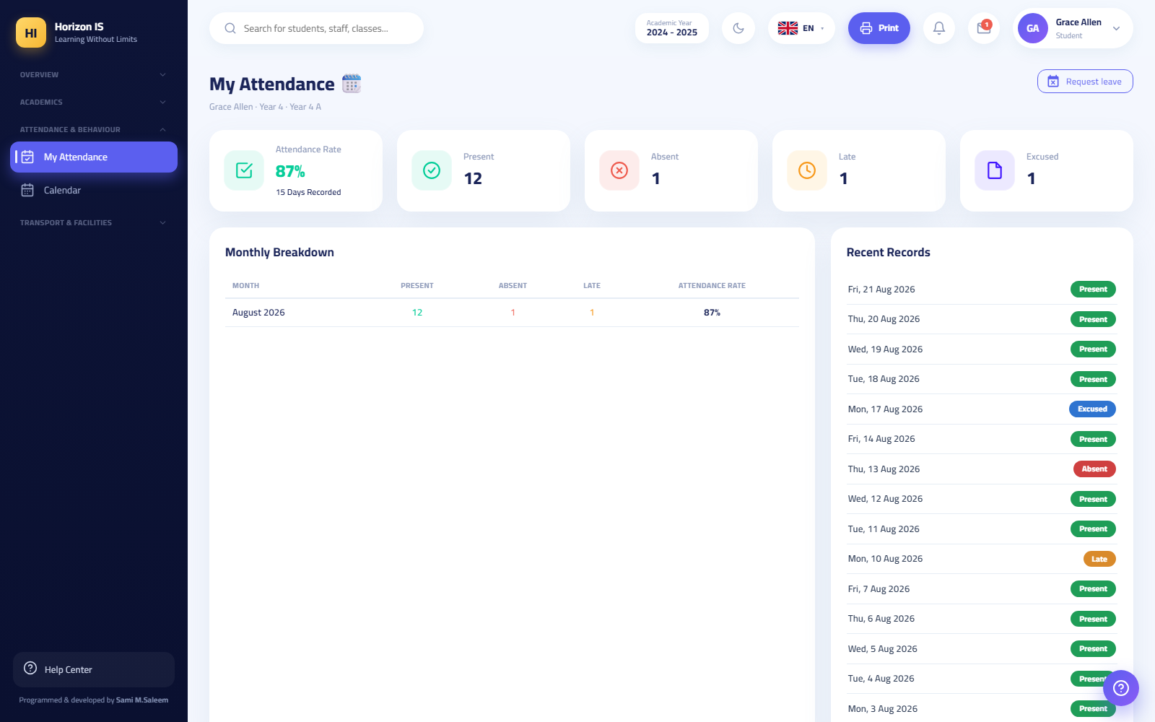صفحة حضوري
Purpose Letting the student view their complete attendance record.
Steps 1. In the app: the Attendance tile. On the web: My Attendance (/my-attendance). 2. Review the days: present / absent / late / excused. 3. The Request Leave (طلب إجازة) button on the page submits an advance absence request.
Expected result A record matching the school's registers — raise any objection to the homeroom teacher immediately.

4.34 My Reports
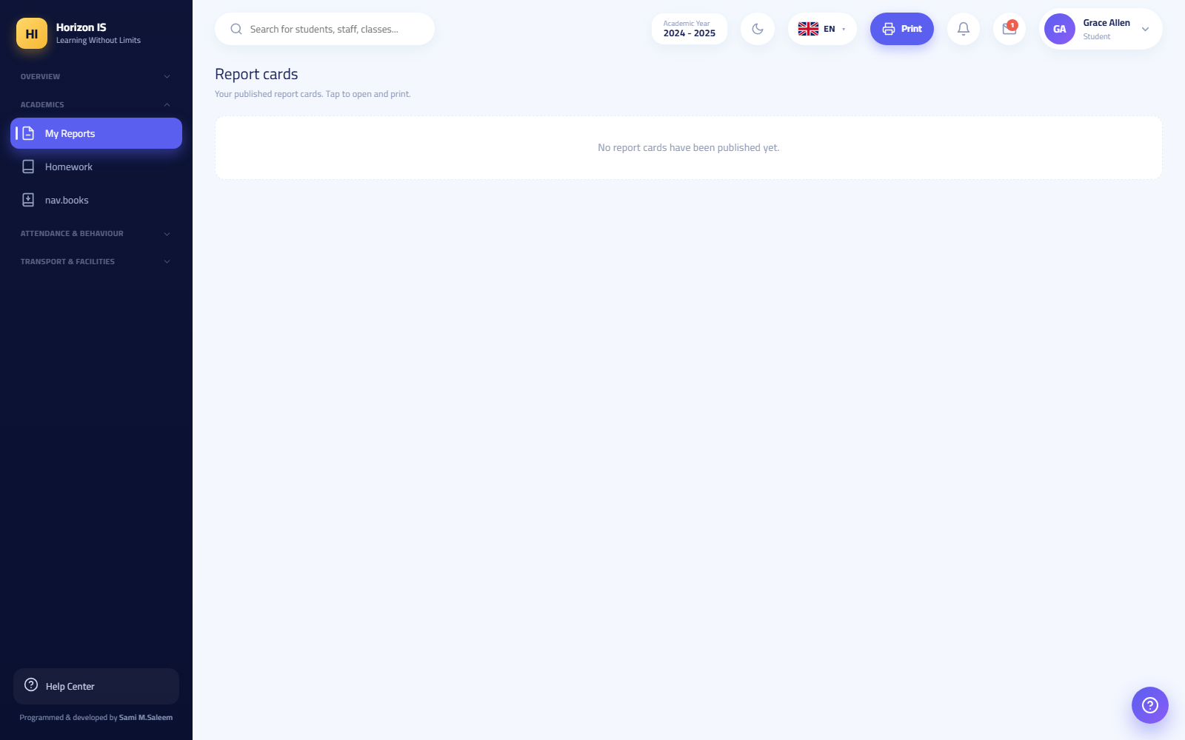صفحة تقاريري
Purpose Showing published report cards only.
Steps 1. Open My Reports (/my-reports on the web, and the reports section in the app). 2. Tap Open (فتح) on the card you want.
Important: The card appears only after the school's official publication, and it may be blocked when there are withheld financial dues — the same rules as the parent.

4.35 The Library Catalog
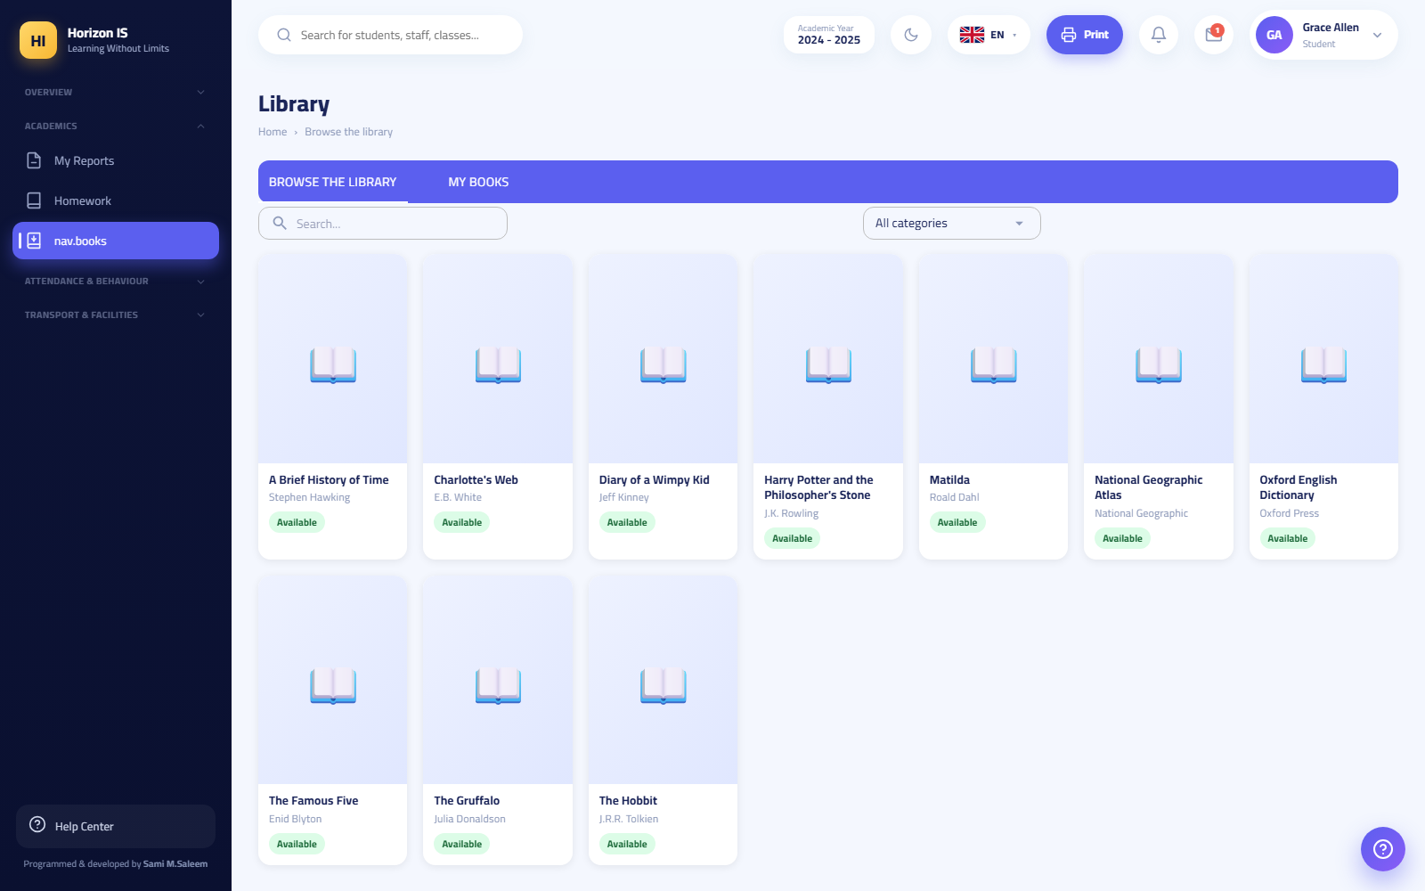فهرس الكتب
Purpose Browsing the school library's titles.
Steps 1. From the student menu choose Library (المكتبة) — the catalog page opens at /books (the browsing version, not the librarian's screen). 2. Search and browse the available titles. 3. Borrowing itself is done with the librarian at the school.

4.36 Related Topics for the Whole Chapter
- Administration chapter: the roles and permissions matrix (/admin/permissions) — it is what controls what every role here sees.
- The extended Finance chapter: the full fee cycle from the structure to the receipt.
- Transport and Facilities chapter: the fleet map, the bus roster, the geofence.
- Communication chapter: the school's official channels and the class feed.
- Grades chapter: the two-approval publication gate and the payment hold.

Chapter 5Module Guides: People & Academics
This chapter walks through the Students & Families and Academics modules of the web portal, one module at a time. For every module you will find: its purpose, who can use it, the key screens, numbered step-by-step actions, and the common mistakes with how to fix them.
Important: What appears in your sidebar depends on your permissions. If a screen described here is missing for you, you most likely do not hold the required permission — ask your system administrator. Leadership roles (Principal, School Owner, Administrator) see everything.
Modules in this chapter:
- Students — register, add/edit, profile, documents, placement & promotion
- Families — directory, sign-in codes, balances
- ID Cards
- Classes & Sections
- Timetable — view, Studio, teacher allocation, substitutions, tools
- Homework
- Exams
- Grades — gradebook, schemes, the publication gate
- Library
- Lesson Plans & Resources
- Classroom Tools
- Recognition Wall

5.1 1. Students

Overview
Purpose: Manage student records from first enrolment to graduation: core data, family links, required documents, and placement into class sections.
Who can: Anyone holding the view-students permission (students.view) sees the register — by default that includes Teacher, Form Tutor, Head of Department, Head of Section, Registrar, Accountant, Nurse, and Safeguarding Officer. Creating, editing, importing and exporting are for the Registrar and management only. Deleting a student is a management-only permission held by no ordinary role.
Key screens: Opening Students from the sidebar shows pill tabs at the top of the page:
Pill | Route | Who
Students (register) | /students | anyone with students.view
Admissions | /admissions | Registrar & management
Class placement | /students/placement | management or students.edit holders
Student Files | /student-documents | management or students.edit holders
Students register

The student register
Page /students is the student directory: a searchable, filterable table (by name, class, status...).
Main buttons:
- Add Student — opens the new-enrolment form.
- Export — exports the current list to Excel.
- Class rosters PDF — prints ready-to-hand-out section rosters.
- Clear filters — resets the table to the full view.
Tip: Clicking any student's name opens their full profile directly.

Adding a new student (with their family)
Purpose: Register a new student and create or link their family in a single step — the form is deliberately minimal, with sensible local defaults.
Who can: Registrar and management (students.create).
Before you start: - Have the student's name in Arabic and English, date of birth, and year group ready. - Have the father's name and phone (both required for a new family). - If the student has a sibling already enrolled, know the existing family's name — you will not re-enter the parents' details.
Steps:
- Open Students from the sidebar and click Add Student. The page /students/add opens, titled "Add New Student & Family".
- In Student basic information enter: the full name in English and in Arabic (one box each; the system splits it into first/middle/last automatically), gender, date of birth (age is calculated automatically), nationality, religion, blood type, and phone.
- Choose the Year Group — required; the student cannot be saved without it.
- Where relevant, enter medical notes, allergies, and SEN needs.
- In Family information take one of two paths: - Existing family (sibling enrolment): search for and pick the family — the student inherits the parents automatically. - New family: fill Father information (name and phone required), Mother information, and the family address and city.
- Click Save student.
Expected result: The student record is created and linked to their family, and you land on the new student's profile. If the enrolment was started from an application in the Admissions screen, the application automatically advances to the Enrolled stage.
Example: To enrol "Demo Student" as a sibling of an existing pupil: Add Student → enter their details → "Existing family" → search "Demo Family" → Save student. You are never asked for the parents' details.
Common mistakes:
- Creating a brand-new family for a second sibling instead of choosing "Existing family" — this produces two separate families and two different sign-in codes for the same household. Fix by re-linking the student to the correct family before distributing sign-in codes.
- Leaving the Year Group empty and wondering why saving is refused.
- Typing the three-part name into separate boxes manually — it is one box; the system does the splitting.
Troubleshooting:
- A message asking for a guardian: a new family requires at least one parent (father: name + phone).
- You cannot see the Add Student button: you do not hold students.create — ask management.
Related topics: Family sign-in codes, Class placement, the Admissions chapter.

Editing and deleting a student
- From the register open the student's profile and click Edit Profile (or go directly to /students/{id}/edit).
- Change the fields you need. The name is one box per language and is split automatically on save.
- Click Save Changes.
Warning: The Delete button on the edit page deletes the student record and is available to management only. A leaver or graduate is never deleted — their status is changed (Graduated/Left) so the academic record is preserved. Deletion is only for records entered by mistake.

The student profile
Page /students/{id} — the Student Profile — is the full file: details, safety contacts, and quick links. Buttons: Back to Students, Safety contacts, Edit Profile.

Student Files (required documents)
Purpose: Track the documents required from each student (ID, photos, certificates...) — what has been uploaded and what is still missing.
Who can: Management or students.edit holders.
Steps:
- Open the Student Files pill (/student-documents).
- To define a new document required from everyone, click New requirement.
- Switch between the Uploads and Missing tabs.
- On any uploaded file: Download file to review it, then Accept if correct, or Ask to re-upload if unclear.
- The Remind missing (n) button sends a notification to every family that has not uploaded yet — the number in brackets is how many are behind.
Expected result: A clear board showing completion, with families receiving reminders without manual messaging.
Common mistakes: Accepting files without opening and checking them — acceptance removes the student from the missing list for good.

Class placement
Purpose: Distribute unplaced students across their year group's sections, balanced by count and gender.
Who can: Management or students.edit holders.
Before you start: Make sure the sections themselves exist in the Classes module, and every student is registered in the correct year group.
Steps:
- Open the Class placement pill (/students/placement).
- Set the target section size.
- Click Distribute for one year group, or Distribute all for everything at once. The system only touches unplaced students — anyone already placed is never moved.
- Review the result. Use Remove from class to pull a student out of a section, and Undo last move to reverse the latest change.
- When satisfied, click Approve & lock to fix the placement. Unlock remains available to management if a later change is needed.
Expected result: Every student in a section, with balanced numbers and gender mix, and the placement locked against tampering.
Common mistakes: Running distribution before all required sections exist, so the few existing sections fill beyond capacity.
Related topics: Classes & Sections, Year promotion.

Year promotion and transfers
End-of-year promotion runs from the Year rollover screen (/year-rollover) — management only: the page lists every class with a proposed destination (7A → 8A; the top year proposes 🎓 Graduate), you adjust the destinations freely, then type RENEW in the confirmation box and click Run rollover. A whole-year rollover also exists in Settings → Academic Year.
Important: Before any rollover, run Archive year results from Settings so final results are snapshotted. Rollover clears all class assignments — sections are re-formed afterwards via Class placement.
There is no separate "transfer student" wizard: a leaver's status is changed on the student edit page, and closing the family's sign-in accounts goes through the Account Closure Requests screen. Full details are in the Administration chapter.

5.2 2. Families

Family directory and profile
Purpose: Manage family files: members, contacts, linked students, and app sign-in codes.
Who can: families.view holders — by default management, the Registrar (with create/edit), Head of Section, Accountant, and IT staff (specifically for sign-in codes).
Screens: The Families page (/families) has a toggle between two views: Families (the directory) and Family sign-in codes. Buttons: Add Family, Export Excel, Families directory PDF, and View to open any family's profile (/families/{id}), where you find the members, linked students, and an Edit Profile button.
Families directory

Family sign-in codes
Purpose: The code is the family's key into the mobile app with no email or password: a printed slip with an 8-character code (or QR), used once, which links the family's phone to their account.
Who can: Management and IT only.
Before you start: Have the printer ready — the code appears as text exactly once, at generation time; it is then stored hashed and nobody can retrieve it later.
Steps:
- Open Families and switch to the Family sign-in codes view (also reachable at /family-codes).
- Choose: Generate for a class (codes for one section's families) or Generate for ALL families.
- Printing opens immediately: Print slips (PDF) — one slip per family carrying the code and a QR.
- Distribute the slips to families (with the students, or at a parents' meeting).
- Parent side, in the app: login screen → Sign in with school code → type the code or Scan the code with the camera 📷. The account is created and that phone trusted automatically.
- For a single family (new phone, lost slip): the New code 🔁🖨️ button next to the family — it generates a fresh code, invalidates the old one, and prints an A6 QR card.
Expected result: After generation the board shows only who holds a live code, its expiry, and whether it was used — it never shows the code text.
Common mistakes:
- Closing the print window before printing, assuming the code can be shown again later — it cannot; generate a new code.
- Sending a photo of the slip in public groups — the code opens the family's account; hand it over in person or in a private message to that family only.
- Generating a new code "to test" while the old slip is already distributed — the new one invalidates the old immediately and the family's sign-in fails.
Troubleshooting:
- The family reports "code invalid or already used": the code was consumed or superseded by a newer one — generate and hand over a fresh code.
- New phone for the same family: an old code is never reusable — a fresh code is mandatory, or device approval via IT.
Related topics: the Mobile App chapter (family sign-in), the Administration chapter (device approvals).

Family balances
Page /family-balances shows the outstanding amount per family. Buttons: Refresh, Print PDF, and Remind debtors (n) — which requires a second press to confirm before notifications go out.
Important: This is a finance screen — only the finance office (management and the Accountant) or holders of the revenue-view permission can open it. Recording payments themselves happens on the Installments screen (Finance chapter).

5.3 3. ID Cards
Purpose: Design and print student and staff ID cards.
Who can: idcards.manage holders — by default the Registrar and management.
Screen: The ID Card Designer (/id-cards) — a two-sided design canvas (front and back).
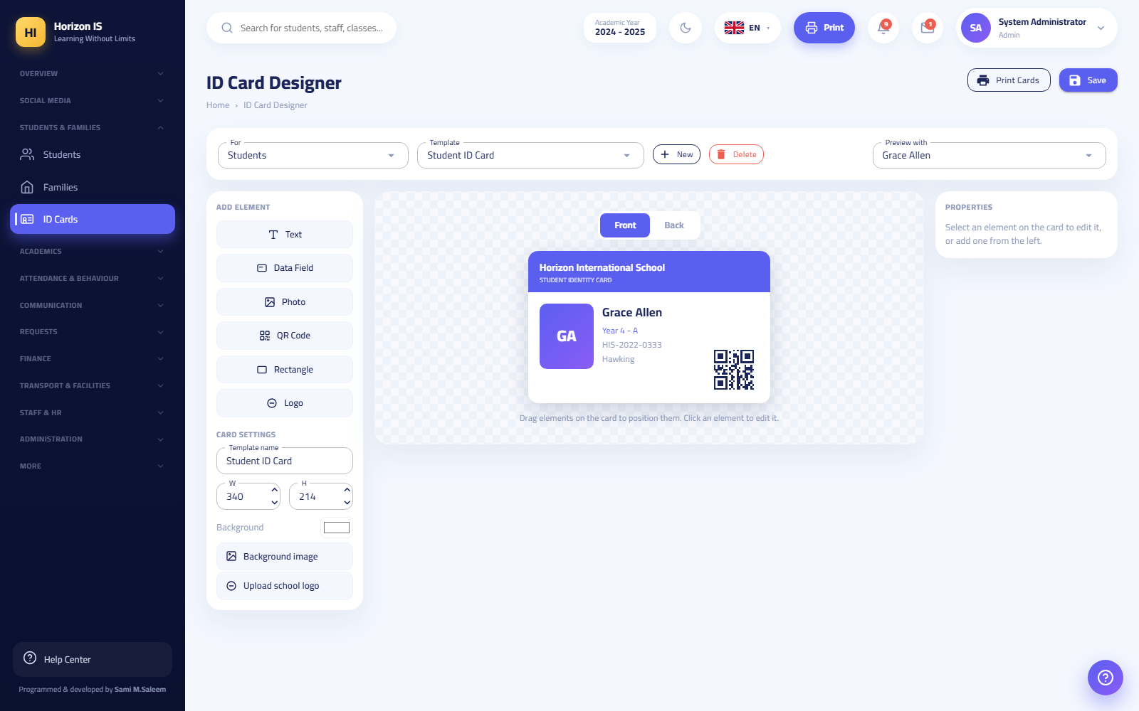ID Card Designer
Steps:
- Click New to start a design.
- Drag elements onto either side: static Text, Data Field (auto-filled from each student's record: name, class...), student Photo, QR Code, Rectangle for colour blocks, and the school Logo.
- Click Save to store the design.
- Click Print Cards and choose the target group — the system produces one card per person with their real data.
Common mistakes: Typing a specific student's name as static text instead of using a Data Field — every card then prints with the same name. Static text is for generic wording only (e.g. "Student Card").
Related topics: The student register (student photos are uploaded on their profiles).

5.4 4. Classes & Sections
Purpose: Create and manage class sections (year group + section letter). Year groups themselves (Reception, Year 1...) are pre-seeded by the system and are not created manually.
Who can: classes.view holders can look (Teacher, Form Tutor, heads, Registrar). Creating and editing sections is management-only (Head of Section also holds classes.manage).
Screen: Classes (/classes) — the section list with stat cards on top: total classes, year groups, average size, and capacity used %.
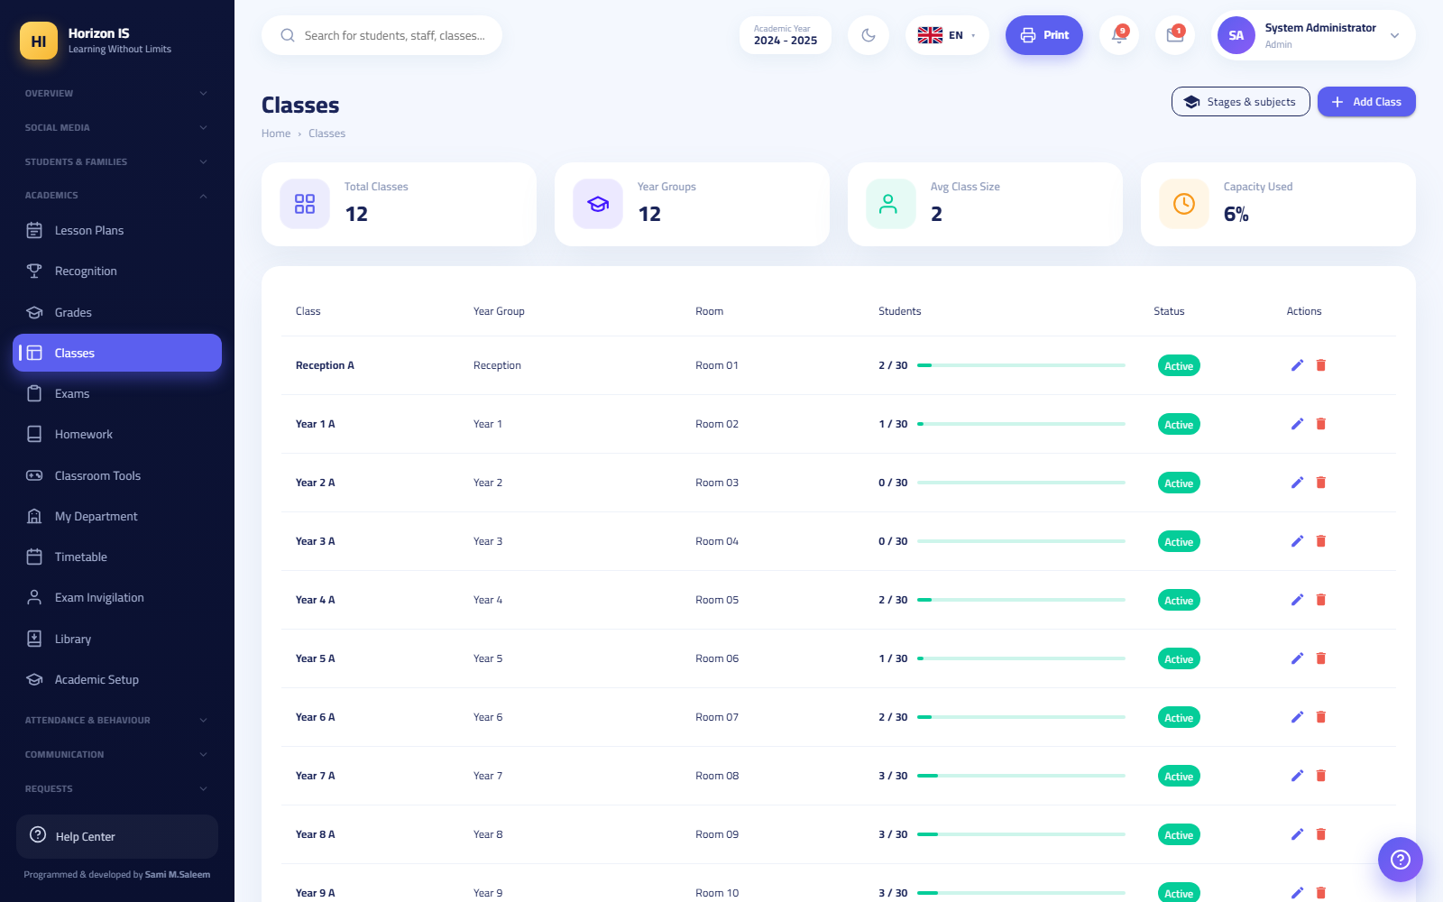Classes

Creating a section
Before you start: Know how many sections each year group needs this year, and each section's capacity.
Steps:
- Open Classes and click Add Class.
- In the dialog: pick the Year Group, type the Section (a single letter such as A — automatically uppercased), the Capacity (default 30), and the Room.
- Save. The section is automatically attached to the current academic year and its display name is built (e.g. Year 7 A).
- Edit or delete via the row icons. The edit dialog also sets the per-class student permissions: student comments, student chat, and the attendance mode.
Expected result: A ready section that appears in class placement, the timetable, and the attendance register.
Common mistakes: Trying to create a duplicate — the system refuses with an explicit message (e.g. "Year 7 - A already exists"). Also note the year group is locked when editing: a section cannot be moved to another year group; create a new section and move the students.

Subjects
The subject list per year group is managed on the Subjects page (/grades/subjects) — it feeds the timetable, teaching assignments, homework and exams. Editing is management-only (teachers see it read-only). Buttons: Add Subject, Copy From Year Group, and a link to the grading scheme.
Related topics: Class placement, Teacher Allocation.

5.5 5. Timetable
Purpose: Build the weekly timetable for every section, teacher and room, and manage absence cover.
Who can: classes.view holders can open the view page. The building screens (Studio, Substitutions, Tools) are for "builders": management, or holders of academics.timetable.manage or classes.manage — by default the Head of Department and Head of Section in addition to management.
Screens (pill tabs at the top):
Pill | Route | Who
Timetable (view) | /timetable | anyone with classes.view
Timetable Studio | /timetable-studio | builders
Teacher Allocation | /timetable/allocation | builders
Substitutions | /substitutions | builders
Timetable Tools | /timetable-tools | builders
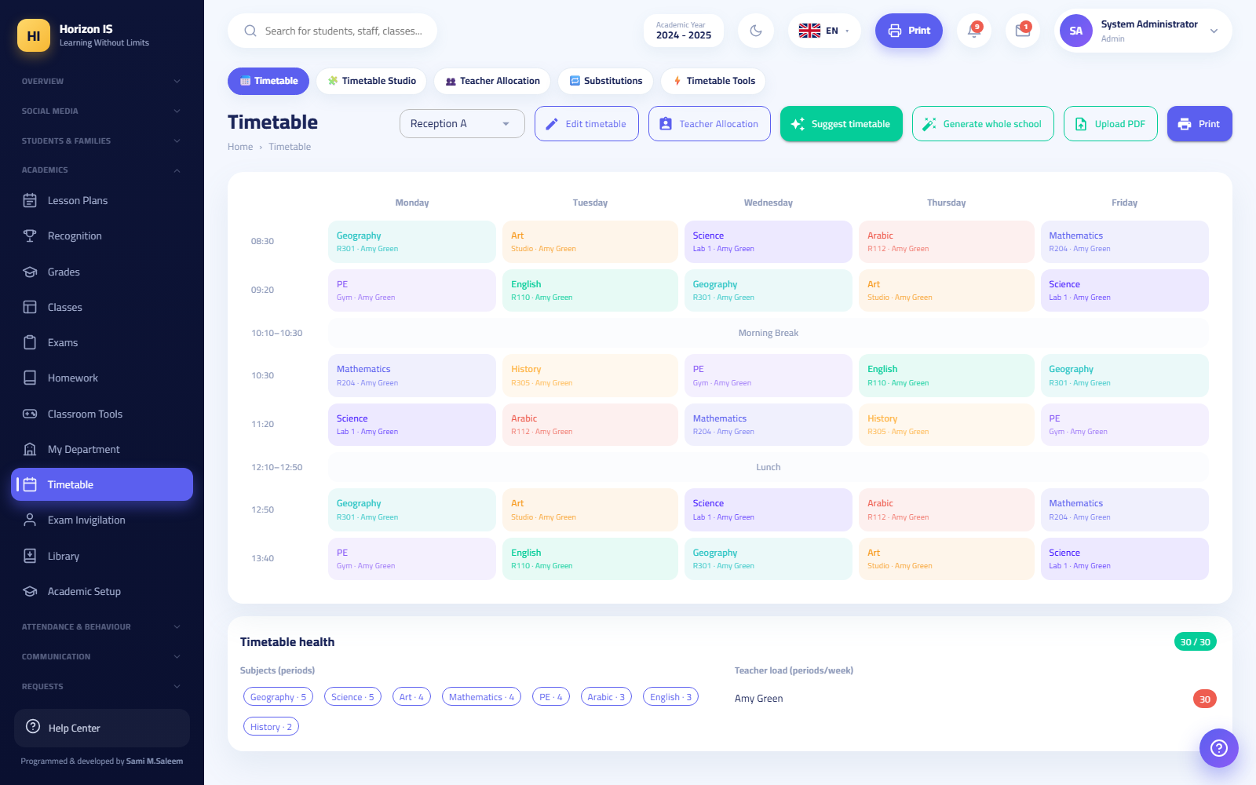Timetable view
Important: The period length and the school time zone are set in Settings ("Period minutes"). Every teacher sees their own grid at /teacher-timetable and in the mobile app.

The view page
/timetable: pick a section to see its week. Buttons: Edit timetable / Done editing (cell-by-cell editing), Teacher Allocation, Suggest timetable, Generate whole school, Upload PDF / Remove PDF (to display an externally designed timetable), the View grid / View PDF toggle, Print, and Clear period.

Teacher Allocation
Purpose: Decide who teaches each subject in each section and how many lessons per week — this is the "fuel" for auto-generation in the Studio.
Steps:
- Open the Teacher Allocation pill and pick the section.
- For each subject: choose the teacher and the weekly lesson count.
- Pick the Class teacher from the dropdown.
- Click Save.
Expected result: Each subject's lessons appear in the Studio's unplaced-lessons "tray", ready to be placed onto days.
Common mistakes: Forgetting the weekly lesson count (it stays zero), so the subject never appears in the Studio at all.

Timetable Studio
Purpose: The advanced builder: conflict checking, teacher availability, auto-generation, and aSc import.
Before you start: Complete Teacher Allocation for all sections, and set the period length in Settings.
Steps:
- Open Timetable Studio (/timetable-studio).
- Choose the view mode: Class / Teacher / Room, then pick the target.
- Manually: click any cell (day + period) to add or edit a slot — the dialog asks for Subject, Teacher and Room. Each slot has a lock 🔒 (protects it from auto-generation) and a delete button. Unplaced lessons wait in the tray.
- Generation rules: the ⚖️ Rules button sets generation constraints; 🚫 Availability records teacher unavailability.
- Automatically: ⚙️ Auto-fill this class fills one section, or 🏫 Generate whole school — a confirmation dialog warns that it replaces the existing board.
- Watch the conflicts banner at the top: "⚠️ Conflicts" with a count, or "✓ No conflicts".
- 🖨️ Print: per-class PDF (door card), one teacher's week, or all classes (the school book).
- 📥 aSc import: upload an aSc Timetables file, review the match preview (matched/unmatched classes and teachers), then apply — the import replaces the board.
Expected result: A conflict-free timetable, printed per class and teacher, instantly visible to every teacher, student and parent.
Common mistakes:
- Running "Generate whole school" after hours of manual work without locking the important slots — generation replaces everything unlocked. Lock what you want kept first.
- Ignoring the conflicts banner — a conflict means a teacher is in two places at once.
Troubleshooting:
- The tray is empty although the timetable is incomplete: check the lesson counts in Teacher Allocation.
- An aSc import leaves subjects without teachers: check the preview page — unmatched entries need manual name matching, then re-import.

Substitutions
Purpose: The daily cover board: record a teacher's absence and assign cover lesson by lesson.
Steps:
- Open Substitutions (/substitutions).
- Click Record to log a teacher absence (multi-day absences supported).
- Next to each uncovered lesson click Assign and pick the cover teacher — the fairness counters show how much cover each teacher has already carried, so the load is spread evenly.
Related topics: Staff leave (Staff & HR chapter).

Timetable Tools
/timetable-tools: utilities, most notably the NOW board — click Show to see what every section is doing at this very moment and who is teaching it. Useful for management when looking for a teacher or checking timetable adherence.

5.6 6. Homework
Purpose: Create and track homework; students submit from the app and parents can follow along.
Who can: academics.homework.manage holders — by default the Teacher and both heads. Students see their homework in the app and web portal.
Screen: Homework (/homework) — overview tiles at the top sort the backlog into clickable piles that filter the list: Waiting to mark, Nothing handed in, Due this week.
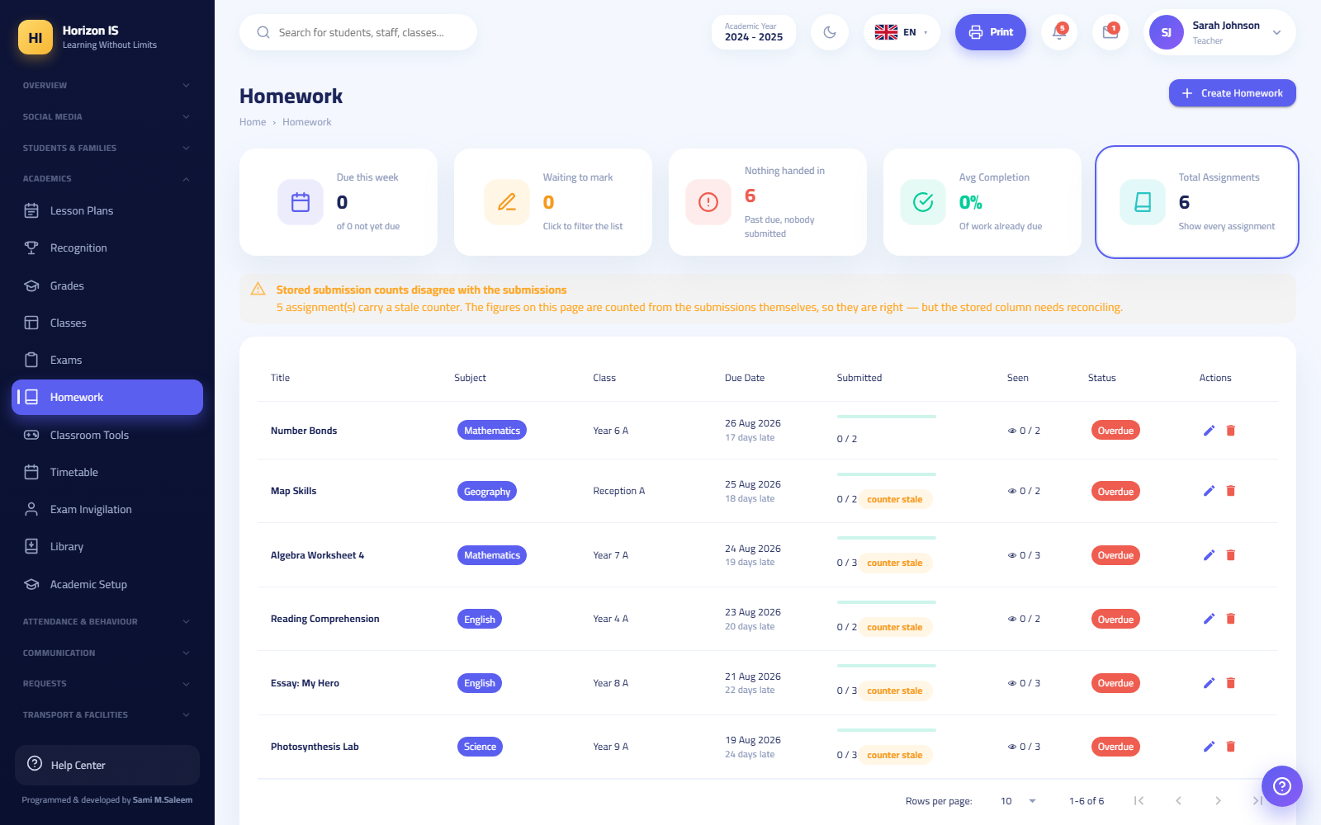Homework
Steps (creating homework):
- Open Homework and click Create Homework.
- Set the section, subject, title, description and due date, attaching files as needed.
- Save — the homework reaches the section's students in the app immediately.
- Track submissions from the overview tiles; use Edit or Delete when needed, and view the students' attached files.
Expected result: The student sees the assignment in the app and submits digitally ("Submit", then "Submitted ✓", with "Resubmit" available before the due date).
Common mistakes: Creating homework without a proper due date, so it never appears under "Due this week" and tracking falls apart.
Related topics: Gradebook, the Mobile App chapter.

5.7 7. Exams
Purpose: Schedule exams, generate seating plans, and print the full paper pack.
Who can: academics.exams.manage holders — by default the Teacher and both heads (plus management).
Screen: Exams (/exams).
Exams
Steps (scheduling an exam day):
- Click Schedule Exam and fill the dialog: Title, Subject, Class, Date, Time, Room. Repeat per exam.
- Use Edit and Delete to adjust, and Clear this day to empty a whole day and start over.
- Click Generate seating to produce a mixed seating plan for one exam day (sections interleaved to reduce cheating).
- Print the pack: Master schedule PDF, Class schedule PDF, Room charts PDF, Door lists PDF, Seat slips PDF.
Expected result: A published exam schedule, and rooms equipped with printed seating charts, door lists and seat slips.
Common mistakes: Generating seating before all of that day's exams are scheduled — regenerate after any change to that day's exams.
Related topics: Grades, Classes.

5.8 8. Grades

How the module works
Purpose: Enter marks (or import them), compute results, design report cards, and then publish them to families through a dual-approval gate.
Who can: academics.gradebook.view holders open the gradebook (teachers hold view and entry). Locking a term belongs to the Head of Section and management. Approval and publishing are management-only.
Important — the golden rule: Parents and students see no grade before publication. Everything entered or imported stays internal until the report card passes the full publication gate (request approval → a different manager approves → publish).
Screens (pill tabs at the top):
Pill | Route | Who
Gradebook — Marks Entry | /grades | academics.gradebook.view holders
Grading Schemes | /grading-schemes | management (entry feature on)
Report Designs | /report-templates | management
Grading Package (offline transfer) | /grading-package | management (entry feature on)
Important: Marks entry sits behind a per-school feature switch. In some group schools entry is off and results arrive ready-made from the external grading system via the import screen (/grading-import) — the gradebook then shows read-only as "Gradebook", while the publication gate stays exactly the same.

Setting up grading schemes
Before the first mark is entered, the rules must exist in Grading Schemes (/grading-schemes) — management:
- New scheme, or Edit an existing one.
- The Terms button opens the academic-terms dialog: define one or two terms (or more), each with an English and Arabic name, an order, a weight, and weighted components inside — for example: coursework 40 + final exam 60. The term's maximum mark = the sum of its components.
- Grade Boundaries: set the letter boundaries (A, B...) shown in the gradebook and on report cards.
- Assign the scheme to the relevant year groups.
Warning: A term or component that already carries real student marks cannot be removed — the system refuses and names the blocked items. Plan the structure before entry begins.

Entering marks (the gradebook)
Before you start: Make sure a grading scheme is assigned to the year group and the term is not locked.
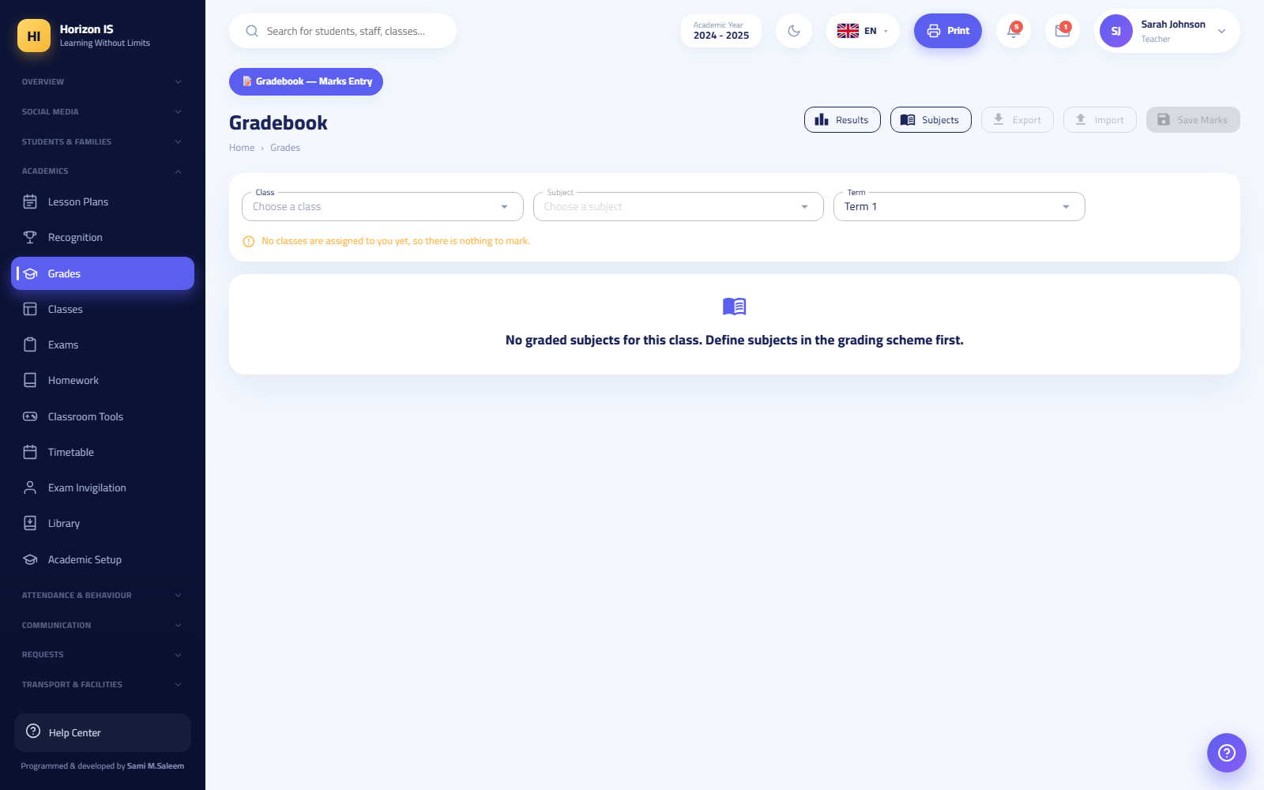Gradebook
Steps:
- Open Grades (/grades).
- Pick the Class, then the Subject, then the Term.
- Enter marks in the component columns — each column enforces its maximum, and the row shows the Total and the letter grade live, per the scheme's boundaries. (An optional international/Edexcel column exists where enabled.)
- Click Save Marks.
- For large sheets: Export CSV, fill externally, then Import.
Expected result: Marks are saved and appear in the Results screen (/grades/results) — and remain invisible to families until publication.
Term locking: Once entry is complete and reviewed, the Head of Section or management locks the term (the lock button; a "Locked" or "Open until {date}" chip appears). Locking blocks any further teacher edits.
Common mistakes:
- Entering a mark above the maximum — the cell refuses; check the component definition if the maximum looks wrong.
- Switching sections without Save Marks — anything unsaved is lost.
- Expecting parents to see grades as soon as they are saved — they never will before publication; this is by design.
Troubleshooting:
- Cells are read-only: either the term is locked (ask management), or marks entry is switched off at your school (results are imported).
- No component columns: the scheme is not assigned to the year group or the terms are not defined — see Grading Schemes.

Results and report cards
- Results (/grades/results): computed results per section; Export CSV, Print All Cards, and open any student's card.
- Report Card (/report-card/{student}): view, print, download PNG, and certificate.
- Class Report Cards (/report-cards/{class}): batch printing.
- Academic Transcript (/students/transcript/{student}): a live-computed cumulative record, with print.
Card design: From Report Designs create a design and click Design to open the visual designer (/report-designer/...): elements for text, data field, image/logo, student photo, marks table, grade boundary, comment, box/panel, and signature — multi-page, with Preview, Save and Add page.

The publication gate: from draft to the parent's phone
Purpose: Guarantee that no result reaches families until two different managers have reviewed and agreed.
Who can: Management only (requesting approval, approving, and publishing).
Before you start: Marks complete and the term locked, the card design ready, and the payment-holds list up to date if used.
Steps:
- Open Report Designs (/report-templates — the same page serves the "report publish" and "payment holds" routes).
- Pick the design and the target year group.
- Click Request approval.
- A different manager (not the requester) opens the Approvals table — or the request's card in the Action Center (/action-center) — and clicks Approve or Reject. Self-approval is blocked in both the UI and the server: "Your request needs another manager's approval."
- After approval, click Publish to families.
- Students under an uncleared payment hold are skipped automatically — holds are managed and imported on the same page (Import fees roster).
Expected result: Families see the cards in My Reports (/my-reports) and in the app. A published card is a frozen snapshot taken at publish time: later mark changes never leak into what was published.
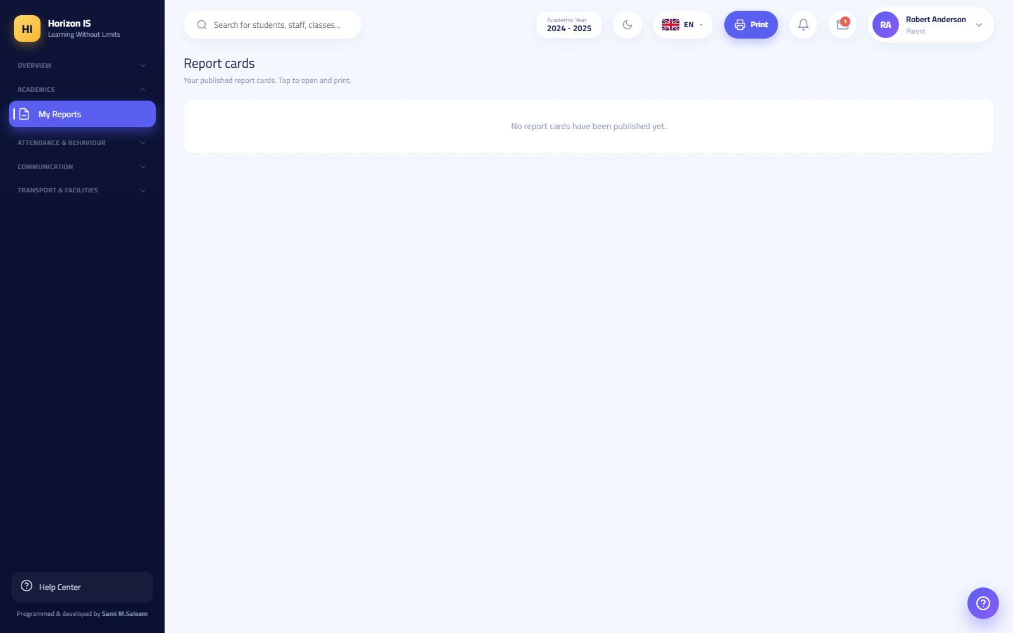My Reports — what the parent sees
Important: One approval is good for one publish run on that exact design + year-group pair. Republishing — even to fix a mistake — requires a fresh request and a fresh approval, and the previously visible version is archived automatically.
Common mistakes:
- A manager trying to approve their own request — rejected by design; a second manager is mandatory.
- Editing marks after publishing and expecting parents' cards to update — they will not; run the approval-and-publish cycle again.
- Forgetting to refresh payment holds before publishing, so cards reach families that should have been held (or vice versa).
Troubleshooting:
- The publish button refuses: there is no unconsumed approval for this exact design and year group — check the Approvals table.
- One family cannot see the card while others can: check the payment hold on that student.
Related topics: Action Center (Overview chapter), Family balances, the Finance chapter.

Grading package and import
- Grading Package (offline transfer) (/grading-package) — management: Export package produces an encrypted package from one system; Choose package file imports it into another — for moving grades between systems with no internet.
- GradingSystem Results Import (/grading-import): the import screen for ready results produced by the external grading system — the standard path at schools where marks entry is switched off.

5.9 9. Library
Purpose: Run circulation: books, loans, returns, and borrow requests — plus a browsable catalogue for students.
Who can: library.view holders open the circulation desk (the Librarian holds full management via library.manage; teachers hold view). Students need no permission: their sidebar "Library" entry points to the book catalogue at /books.

The circulation desk (staff)
Library
The top of the Library page (/library) shows five live counters (including out on loan and overdue) — clicking a counter filters the loan table. Table filters: Still out / Returned / All.
Actions:
- Add Book — register a new title in the catalogue.
- Issue Book — pick the book and the student and record the loan.
- Return — when the book comes back.
- Approve / Reject borrow requests coming from students via the catalogue.
Common mistakes: Handing a book back without recording Return — the student stays overdue in the counters and follow-up reports.

The book catalogue (students & families)
Page /books — a browsable catalogue of the library's titles. Students browse and request a loan; the request lands on the circulation desk for the librarian to approve or reject.
Book catalogue

5.10 10. Lesson Plans & Learning Resources
Purpose: One screen with two pills: the teacher's lesson-plan composer, and the shared learning-resources library.
Who can: academics.gradebook.view holders — in practice the whole teaching staff. Reached via the "Lesson Plans" entry (route /lesson-plans; its alias /resources opens the resources pill directly).
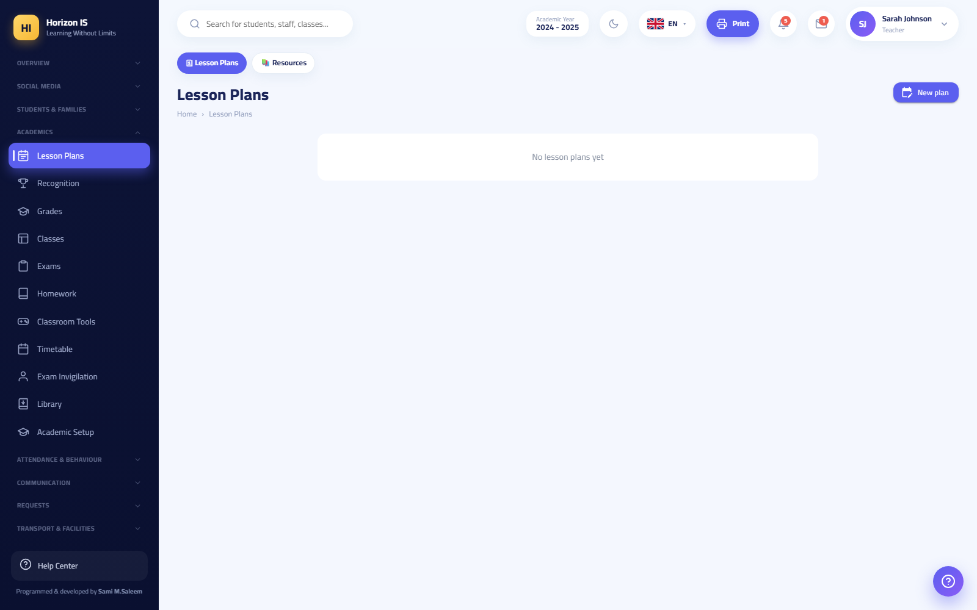Lesson Plans
Steps (a lesson plan):
- Open Lesson Plans and click New plan.
- Write the plan (section, subject, objectives, lesson flow).
- Click Save plan.
Steps (a learning resource):
- Switch to the Resources pill and click Add resource.
- Upload the file or link and describe it.
- Choose the Publish audience: a specific class (its students see it) or Staff only (internal material).
- Delete removes a resource permanently.
Common mistakes: Publishing an internal draft to a class instead of "Staff only" — check the audience before publishing.
Related topics: Homework, the Mobile App chapter (students see resources under "Learning resources").

5.11 11. Classroom Tools
Purpose: An interactive in-lesson toolbox for the teacher — designed to be projected onto the class screen.
Who can: classroom.tools.use holders — by default the Teacher, Form Tutor, and both heads.
Screen: Classroom Tools (/classroom-tools):
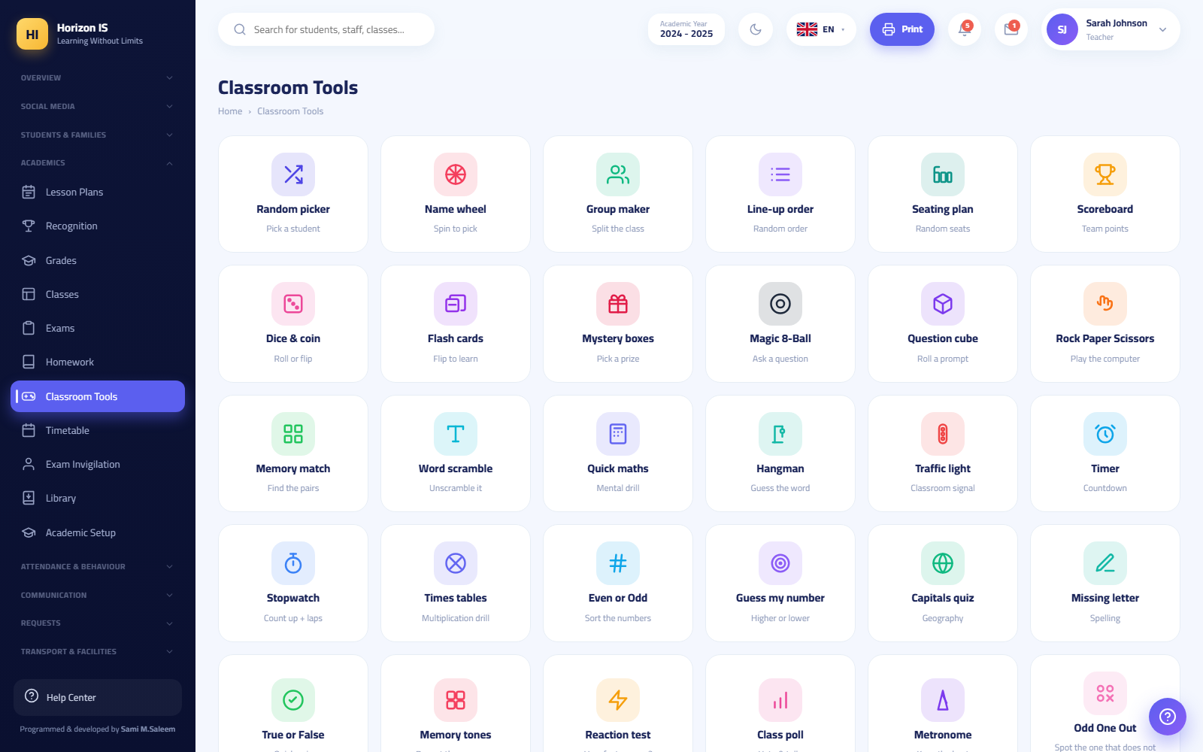Classroom Tools
- Random picker to choose a student to answer, and the spin-the-wheel version for extra suspense.
- Group maker: split the section by number of groups or by members per group, with a Shuffle button.
- Team scoreboards: Add team, count points during a contest, and Reset scores for the next round.
- Generators: dice, coin, and random numbers.
Tip: A behaviour-linked random picker also exists in the Behavior module (/behavior/picker), tied to behaviour points.
Common mistakes: Nothing here is saved to student records — these are live display tools; team scores are reset, never carried over.

5.12 12. Recognition Wall
Purpose: A public recognition wall for outstanding students — visible appreciation shown to the class and to families.
Who can: behavior.view holders — by default the Teacher, Form Tutor, and both heads.
Screen: The Recognition Wall (/recognition).
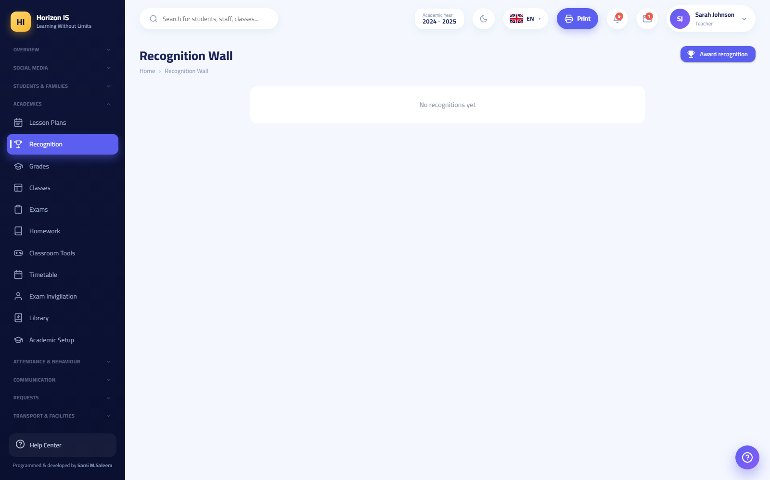Recognition Wall
Steps:
- Open the Recognition Wall and click Give recognition.
- Pick the student (or students), the award type, and write the reason for the praise.
- Save — the recognition appears on the wall.
- Delete removes a posted recognition card (e.g. a wrong pick).
Expected result: A published recognition card with the student's name and the reason for the distinction.
Common mistakes: Using the wall for negative notes — this wall is for recognition only; behaviour concerns belong in the Behavior module (incident log and points).
Related topics: the Behavior module (Attendance & Behaviour chapter), Classroom Tools.

5.13 Permission summary for this chapter
Module | To view | To manage/write
Students | students.view (most roles) | Registrar & management; delete: management only
Families | families.view (management, Registrar, Head of Section, Accountant, IT) | Registrar & management; codes: management + IT
ID Cards | — | idcards.manage (Registrar & management)
Classes | classes.view | management (+ Head of Section via classes.manage)
Timetable | classes.view | builders: management / academics.timetable.manage / classes.manage
Homework | — | academics.homework.manage (Teacher & heads)
Exams | — | academics.exams.manage (Teacher & heads)
Grades | academics.gradebook.view | entry: Teacher; lock: Head of Section & management; approval & publish: management (two different managers)
Library | library.view (Librarian, Teacher) | library.manage (Librarian)
Lesson Plans | academics.gradebook.view | Teacher
Classroom Tools | classroom.tools.use | —
Recognition | behavior.view | Teacher & heads
Tip: Permission changes made in the Roles & Permissions screen take effect at the user's next sign-in — ask them to sign out and back in to see the difference.

Chapter 6Module Guides: Attendance, Behavior, and Communication
This chapter explains three groups of screens that staff use every day:
- Attendance — daily student roll call, per-lesson attendance, reports, and staff attendance with the time clock.
- Behavior — logging behavior incidents, class points, the leaderboard, and the random picker.
- Communication — conversations with families (text, voice, images, video, files), official letters, parent meetings, social media, and Telegram linking.
Important: Every screen in the system is protected by a permission. If you do not see an item mentioned here in your sidebar, it means your role does not have the required permission. Contact school administration or the IT officer.

6.1 Section One: The Attendance Hub

Overview
Open Attendance (الحضور) from the sidebar (the "Attendance & Behavior" section). At the top of the page you will find navigation pills that gather all attendance screens in one place:
Button | Path | Use
Daily Attendance (الحضور اليومي) | /attendance | Take the class roll once per day
Lesson Attendance (حضور الحصص) | /attendance/lessons | Take attendance for each lesson separately
Monthly Register (السجل الشهري) | /attendance/register | Full month grid for each class
Departure Log (سجلّ الخروج) | /attendance/departures | Students who left during the school day
Absences (الغيابات) | /attendance/absences | Absence report and analysis
Lesson Absences (غيابات الحصص) | /attendance/daily-lessons | Daily view of lesson absences
Lesson Attendance Reports (تقارير حضور الحصص) | /attendance/lesson-reports | Detailed lesson-attendance reports
Absence Insights (رؤى الغيابات) | /attendance-insights | Early-warning dashboard (for administration)
Admin Review (مراجعة الإدارة) | Button on the Daily Attendance page | Administration sign-off on the day's roll
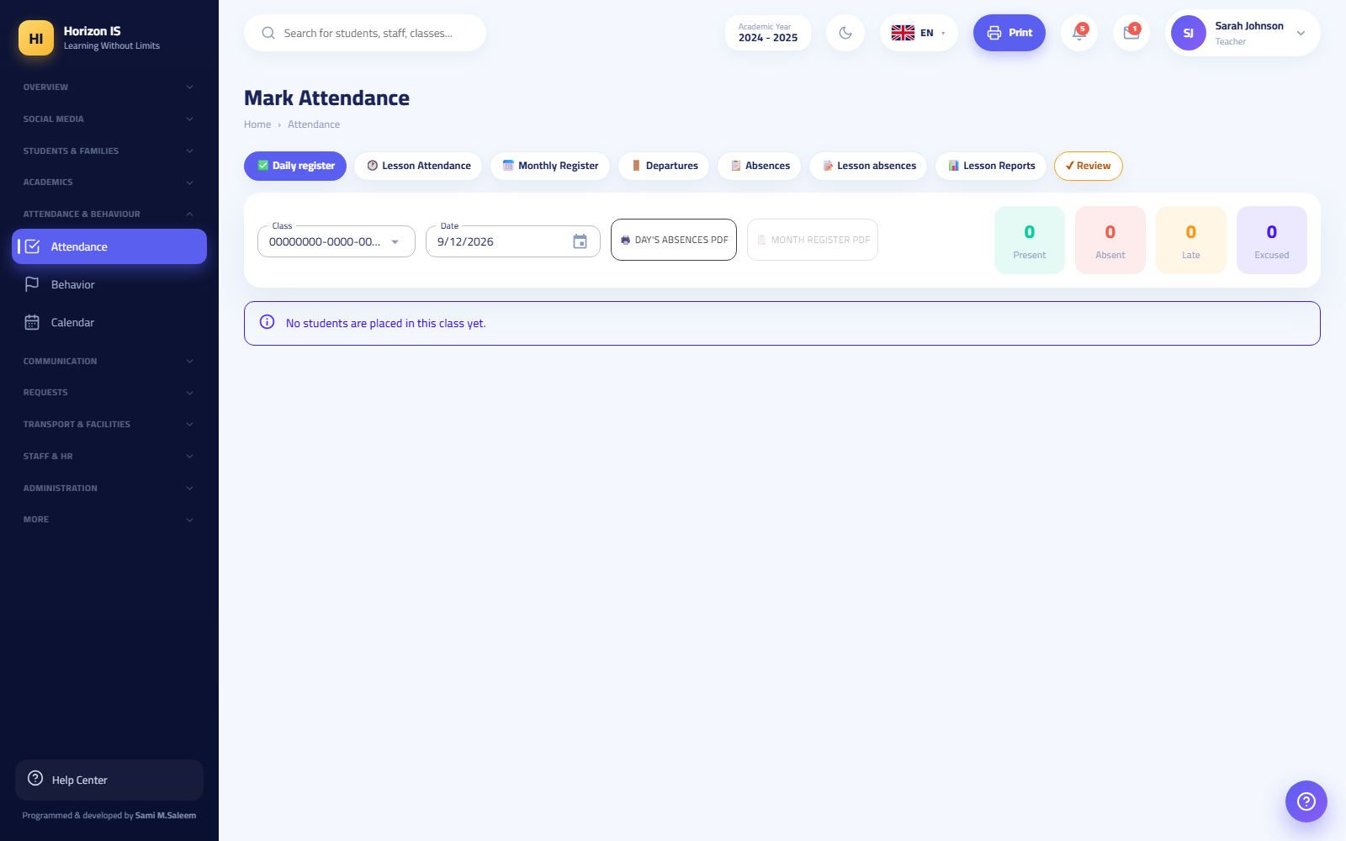Daily Attendance screen

Recording Daily Attendance (Web)
Purpose Record each student's status in the class for one day: Present, Absent, Late, or Excused.
Who can Teachers, homeroom teachers, department heads, stage heads, and administration. (Viewing requires attendance.view and recording requires attendance.manage — both are part of the default teacher role.)
Before you start - Make sure you are assigned to the class. A teacher sees only their own classes through assignments. - Check the displayed date; the page opens on today's date.
Steps
- Open Attendance (الحضور) from the sidebar. The Daily Attendance (الحضور اليومي) page opens.
- Choose the class from the list, then confirm the date.
- Next to each student, press the appropriate status: Present (حاضر) / Absent (غائب) / Late (متأخر) / Excused (بعذر).
- To add a note about a student (the reason for being late, for example), press the note icon next to their name and type the text.
- If everyone is present, press All Present (الكل حاضر) to fill the whole list at once, then adjust the exceptions.
- Press Save Attendance (حفظ الحضور).
Expected result A message appears: "Attendance saved successfully." and the student's record updates immediately. Absences appear to the guardian in the mobile app and on the "My Attendance" screen.
Tip: From the same page you can print Today's Absences PDF or the Month Register PDF to hand to administration.
Important: Once administration approves a given day (the Admin Review (مراجعة الإدارة) button), that day's record becomes read-only. Any later change requires administration to release the approval.
Common mistakes - Recording attendance on the wrong date. Verify the date before saving. - Only pressing the statuses without pressing Save Attendance (حفظ الحضور) — nothing is saved until the button is pressed. - Confusing Excused (بعذر) with Absent (غائب): "Excused" means an absence the school has approved (an accepted absence request, for example).
Troubleshooting - I don't see the class in the list: You are not assigned to it. Ask administration to update teacher assignments from the teacher allocation screen. - The page is read-only: The day has been approved by administration, or your role has attendance.view only, without attendance.manage.
Related topics Recording attendance from the phone · Lesson attendance · Absence requests · Departure log

Recording Attendance from the Mobile App
Purpose Let the teacher take their class roll from their phone, even without internet.
Who can The teacher (and anyone with attendance permissions) from the mobile app.
Steps
- From the teacher home screen open My Classes (صفوفي) and tap the class.
- Tap Attendance (الحضور) to open the roll-call screen.
- Tap each student's status in turn: Present (حاضر) / Absent (غائب) / Late (متأخر).
- The All Present (الكل حاضر) button fills the whole list at once.
- Tap Save Attendance (حفظ الحضور).
Expected result A message appears: "Attendance saved". If there is no internet connection you see: "No connection — saved and will be sent automatically when the internet returns", and then when the connection returns: "Pending rolls sent ✓".
Important: The app works offline: the student list is pre-cached, and unsent rolls are stored in a queue and sent automatically. If the server rejects a pending roll (for example because the day was approved), an explicit message appears: "Pending rolls could not be sent and were rejected — please record them again" — nothing is dropped silently.
Tip: The same roll-call screen includes early check-out for a student: tap Record Departure (تسجيل خروج), set the departure time and reason plus a note, and enable Notify Guardian (إشعار وليّ الأمر) if you want an immediate alert to reach the family.
Related topics Departure log · Lesson attendance

Lesson Attendance (Per-Lesson Roll Call)
Purpose Some schools take the roll for every lesson instead of once per day. This screen records attendance lesson by lesson, and exposes "skipping" (a student present in the morning but absent from a specific lesson).
Who can Teachers for their own lessons, plus department heads, stage heads, and administration.
Steps (Web)
- Open Attendance (الحضور) then press the Lesson Attendance (حضور الحصص) button.
- Choose the class and the lesson.
- Record each student's status: Present / Absent / Late / Excused, with the option to add a note.
- Watch the live counters in the sticky action bar above the list (including the skipping counter).
- Press Save Attendance (حفظ الحضور).
Steps (Mobile)
- From the teacher screen open Lesson Attendance (حضور الحصص).
- Choose one of today's lessons — only your own lessons appear, from your timetable.
- Record the statuses, then save.
Expected result The lesson's attendance is recorded, and its data appears in Lesson Absences (غيابات الحصص) (/attendance/daily-lessons) and Lesson Attendance Reports (تقارير حضور الحصص) (/attendance/lesson-reports).
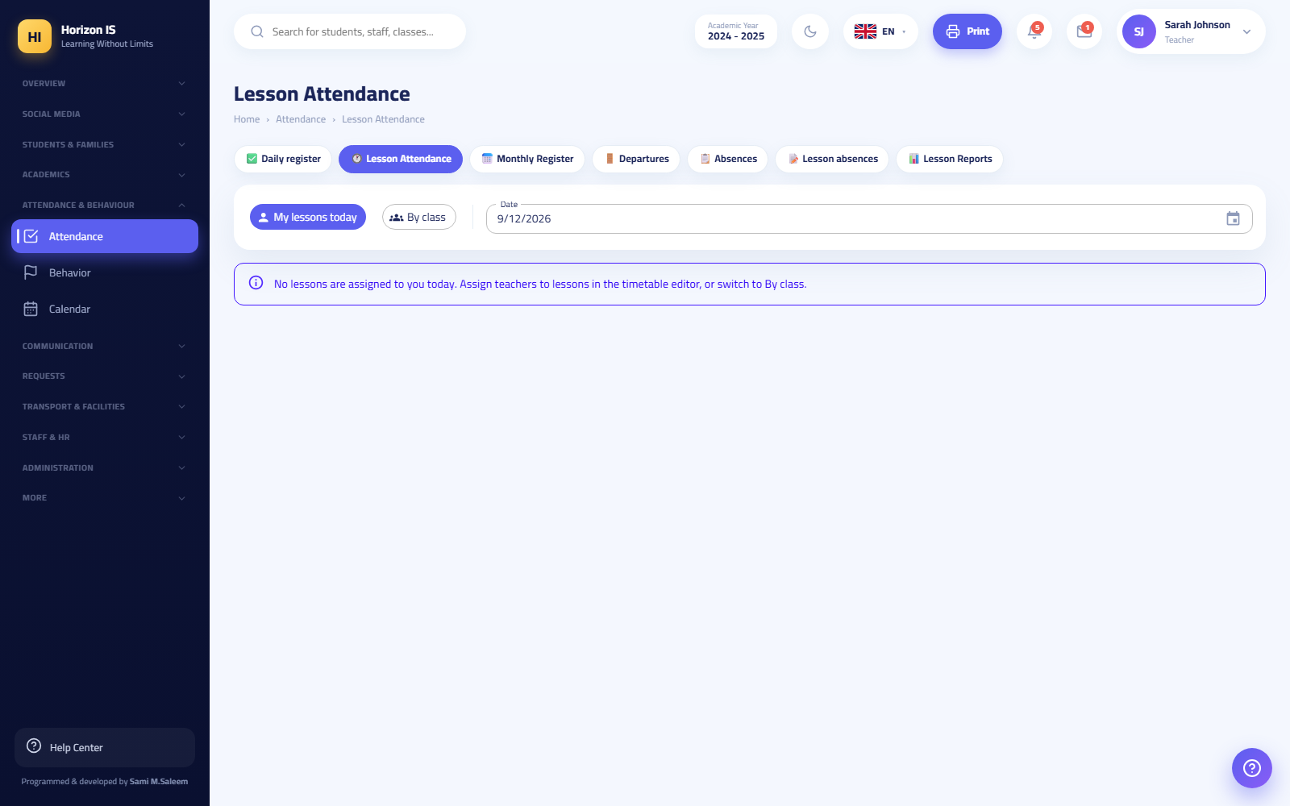Lesson attendance
Related topics Monthly register and reports · Absence insights

The Monthly Register and Absence Reports
Purpose Review attendance at the month and class level, and print official registers.
Who can Anyone with attendance.view. Export and printing are available from the screens themselves.
Screens
- Monthly Register (السجل الشهري) (/attendance/register): the full month grid for one class — each day is a column and each student a row, with symbols for Present/Absent/Late/Excused. An Export (تصدير) button is available, and the month register for each class prints via a ready-made PDF.
- Absences (الغيابات) (/attendance/absences): absence lists and analysis (read-only).
- Lesson Absences (غيابات الحصص) (/attendance/daily-lessons): a daily view of each lesson's absences (read-only).
- Lesson Attendance Reports (تقارير حضور الحصص) (/attendance/lesson-reports): aggregated lesson-attendance reports.
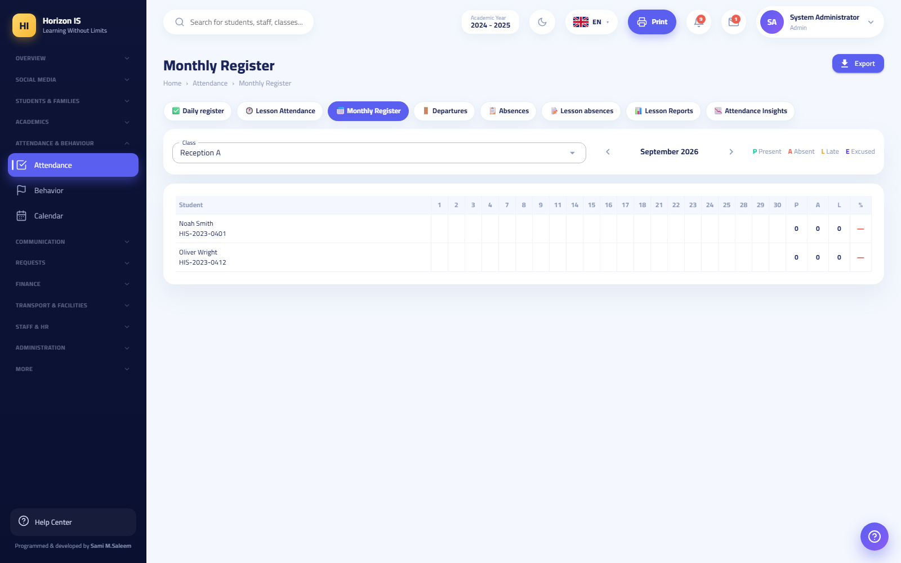Monthly register
Tip: The ready-made PDFs include: today's absences, a month register per class, and a date-range report — all from the print buttons on the attendance screens.
Related topics Absence insights · Recording daily attendance

Absence Insights (Early Warning)
Purpose An analytics dashboard that combines attendance with behavior and classifies students by risk level: High / Medium / Low, so the school can intervene early.
Who can Administration and anyone with the timetable-management permission (academics.timetable.manage). Path: /attendance-insights (also opens from /early-warning).
Steps
- Open Attendance (الحضور) then the Absence Insights (رؤى الغيابات) button.
- Review the list of at-risk students, and open the student's profile from the card.
- Use the Alert Guardian (تنبيه ولي الأمر) button to send a warning to the family, or Review (مراجعة) to record the intervention taken.
Expected result Every intervention is documented on the student's profile, and the risk level updates as attendance improves.
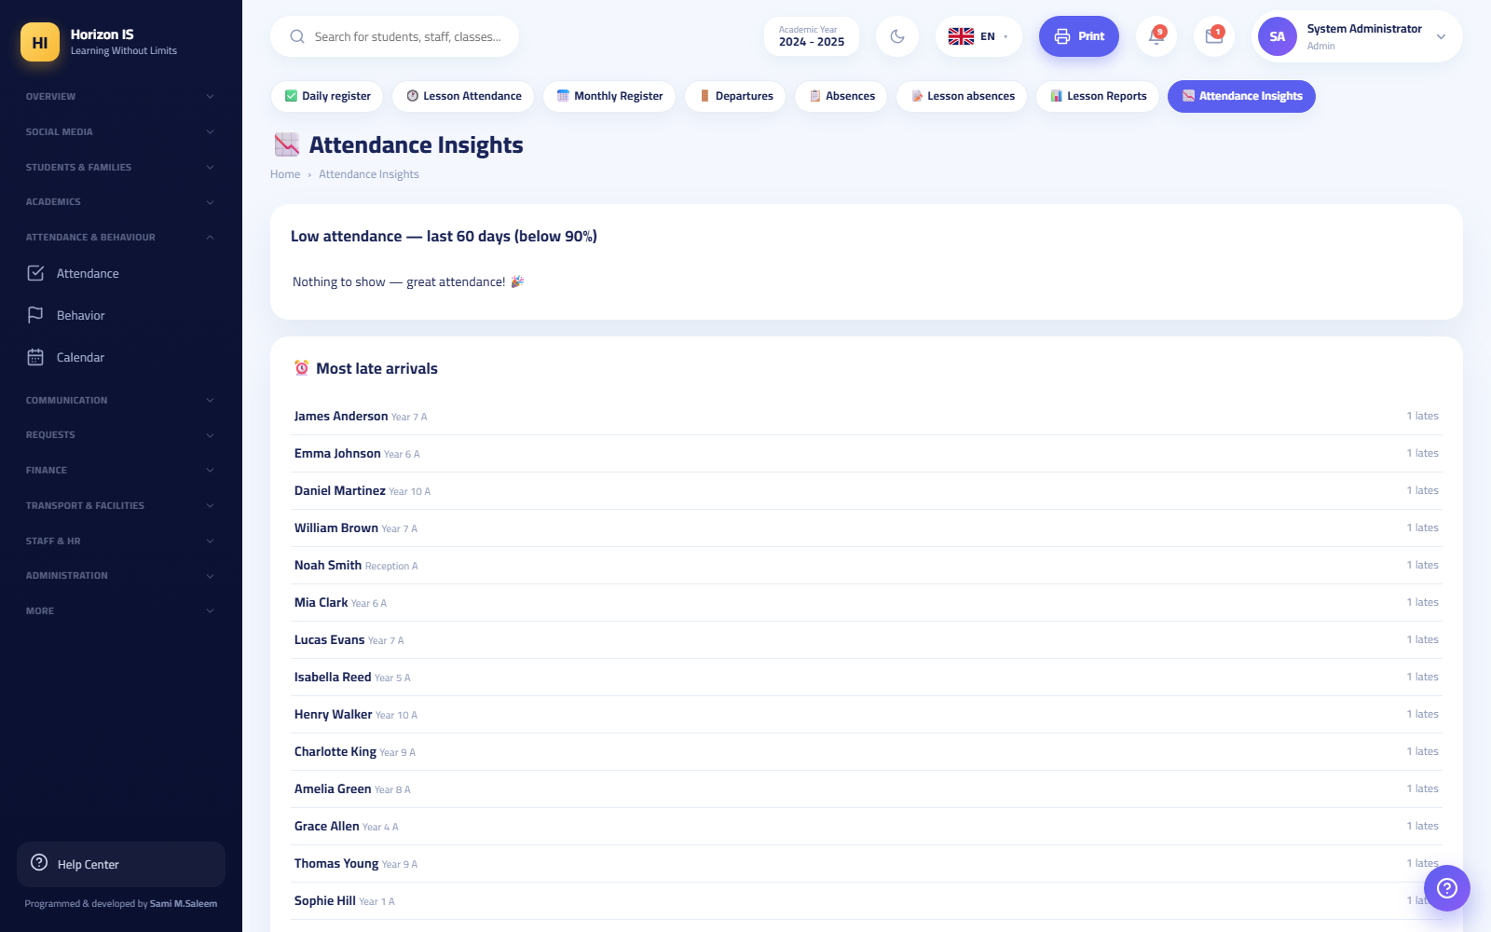Absence insights

The Departure Log (Leaving During the School Day)
Purpose Document a student leaving during the school day (medical appointment, family circumstance…) and document their return if they come back.
Who can Anyone with attendance permissions. Path: /attendance/departures.
Steps
- Record the departure from the Daily Attendance page (or from the roll-call screen on the phone — the Record Departure (تسجيل خروج) button with the time, the reason, and the guardian-notification option).
- Open the Departure Log (سجلّ الخروج) to see today's list.
- When the student returns, press Record Return (تسجيل العودة) next to their name.
Expected result The departure time and reason appear in the log, and a notification reaches the guardian if the option was enabled.
Warning: Do not confuse the Departure Log (سجلّ الخروج) (leaving a school day) with Account Closure Requests (طلبات إغلاق الحسابات) (/departure-requests) — the latter is for permanently closing a login account and is not part of attendance.

My Attendance — Student and Guardian Screen
Purpose Let the student (or guardian) view their own attendance record only.
Who can Students and guardians. Path: /my-attendance — it appears in the student's menu as My Attendance (حضوري).
Steps
- Sign in with the student or guardian account.
- Open My Attendance (حضوري) from the menu (or the Attendance (الحضور) card in the mobile app).
- Review the days and statuses. To request leave, press Request Leave (طلب إجازة).
My attendance
Related topics Absence requests

Absence Requests
Purpose Let the family report an upcoming absence, and let the school accept or reject the request, turning the absence into "Excused".
Who can - Submitting: guardians from the mobile app (the Report Absence (إبلاغ غياب) card) or from the web at /request-leave. - Processing: a staff member with attendance.manage from the Absence Requests (طلبات الغياب) page /absence-requests (the "Requests" section).
Steps — family side (mobile app)
- From the home screen tap Report Absence (إبلاغ غياب).
- Choose the child, type the reason, set the duration from / to, and an optional note.
- Tap Send Request (إرسال الطلب). You see: "Absence reported ✓".
Steps — school side (Web)
- Open Absence Requests (طلبات الغياب) from the "Requests" section.
- Review the request and press Accept (قبول) or Reject (رفض).
Expected result The request's status and the name of whoever processed it appear in the family's list. An accepted absence is recorded as "Excused" in the roll.
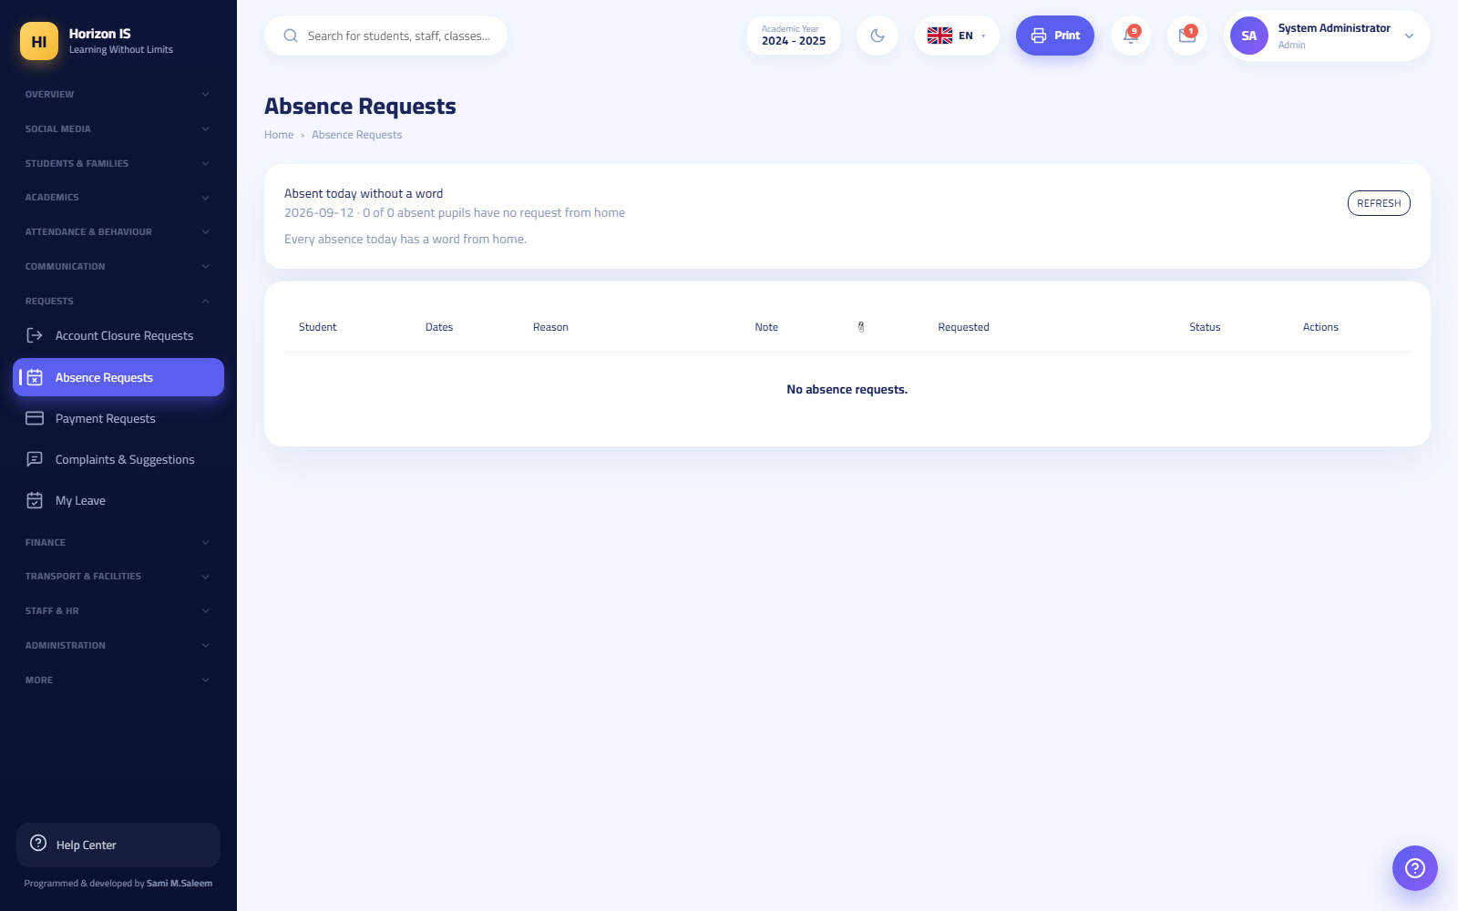Absence requests
Example: "Demo Parent" sent a two-day absence request for their son "الطالب التجريبي" (the demo student) because of a medical check-up. The registrar approved it in the morning, so the student automatically appeared as "Excused" in both days' rolls.

6.2 Section Two: Staff Attendance and the Time Clock

The Staff Attendance Register (Web)
Purpose Record daily staff attendance manually from the web: Present / Absent / Late / On Leave, with check-in and check-out times and a note.
Who can Anyone with hr.manage (usually administration). Path: /staff/attendance within the staff hub.
Steps
- Open Staff (الموظفون) then the Staff Attendance (حضور الموظفين) button.
- Set each staff member's status, enter check-in/check-out times if needed, and a note.
- Press Save (حفظ).
Expected result The day's record is saved, and payroll feeds from it automatically (unjustified absences and unpaid leave are pre-filled in the payroll run).
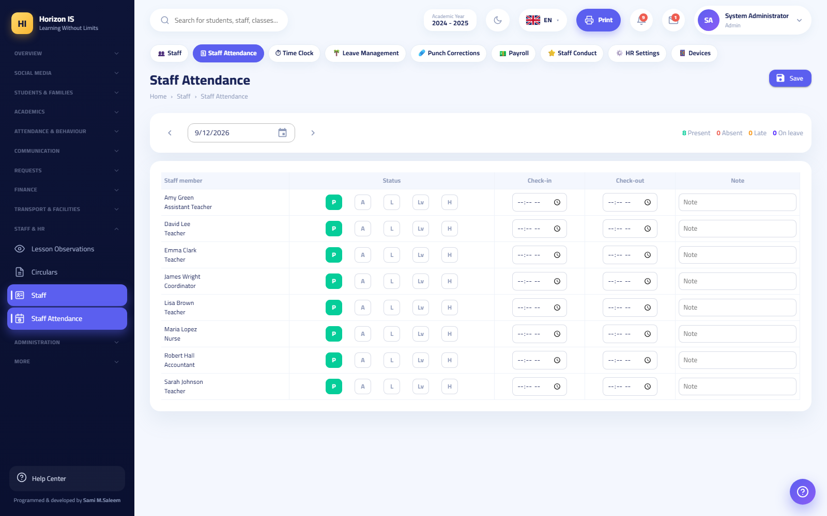Staff attendance

Clocking In from the App (Biometrics + Location)
Purpose Let staff record their daily check-in and check-out from their phone, with safeguards that prevent tampering.
Who can Every staff member linked to a staff record (LinkedStaffId) — the Time Clock (ساعة الحضور) card appears on the home screen for teachers, department heads, the nurse, the IT officer, administrative staff, and drivers. No special permission is needed.
Before you start - Administration has enabled app check-in from HR Settings. - You have granted the app location permission and turned on GPS on the phone.
Steps
- Open the app. At the top of the home screen you will find the Time Clock (ساعة الحضور) card.
- Tap Check In (تسجيل الدخول).
- Confirm your identity with your fingerprint or face — you see: "Confirm your fingerprint to record attendance".
- Wait for the location fix: "Pinpointing your location…".
- If you are within the school's zone you see: "Inside school zone ✓" and your check-in is recorded. If you are far away you see: "Get closer to the school location" with the remaining distance.
- When leaving, tap Check Out (تسجيل الخروج) in the same way.
Expected result The card shows your status: "Inside since …" or "Checked out at …", and your record appears immediately in Time Clock (ساعة الحضور) on the web (/staff/timeclock), where administration watches the live punch board.
Important — the Geofence: Clocking in is only possible inside the radius of a point the school defines (latitude + longitude + radius in meters) from HR Settings (إعدادات الموارد البشرية) (/staff/hr-settings), where the Use My Current Location (استخدام موقعي الحالي) button captures the school's coordinates in one press. The same settings define the workday start and end and the late-tolerance minutes — checking in after the start time plus the tolerance counts as late.
Warning: Fake-location apps (Fake GPS) are detected and blocked. If detected, you see: "Mock location detected — stop fake GPS apps" and the punch is not accepted.
Common mistakes - Trying to clock in before reaching the school's vicinity — wait for the "Inside school zone ✓" message. - Turning off the app's location permission and then wondering why the punch fails.
Troubleshooting - I forgot to check in or out: Submit a punch-correction request; administration approves it from Punch Corrections (تصحيحات البصمة) (/punch-corrections) with the Accept (قبول) / Reject (رفض) buttons. - The card does not appear in the app: Your account is not linked to a staff record — contact administration.
Related topics Staff attendance register · Leave Management (/staff/leave) · My Leave (/my-leave) · Approved Devices (/staff/devices)

6.3 Section Three: Behavior

Behavior Management — Logging Incidents
Purpose Document behavior incidents (positive and negative) with points, so a fair picture forms of each student's conduct.
Who can Teachers, homeroom teachers, department heads, stage heads, and administration (behavior.view to view and behavior.manage to record). Path: /behavior.
Steps
- Open Behavior (السلوك) from the sidebar.
- Press Log Incident (تسجيل موقف).
- Choose the student and the behavior category (it sets the points automatically), and add a brief description.
- Save.
Expected result The incident is added to the student's record and their points update. The guardian sees behavior points in the mobile app (the Behavior (السلوك) card under "My Children").
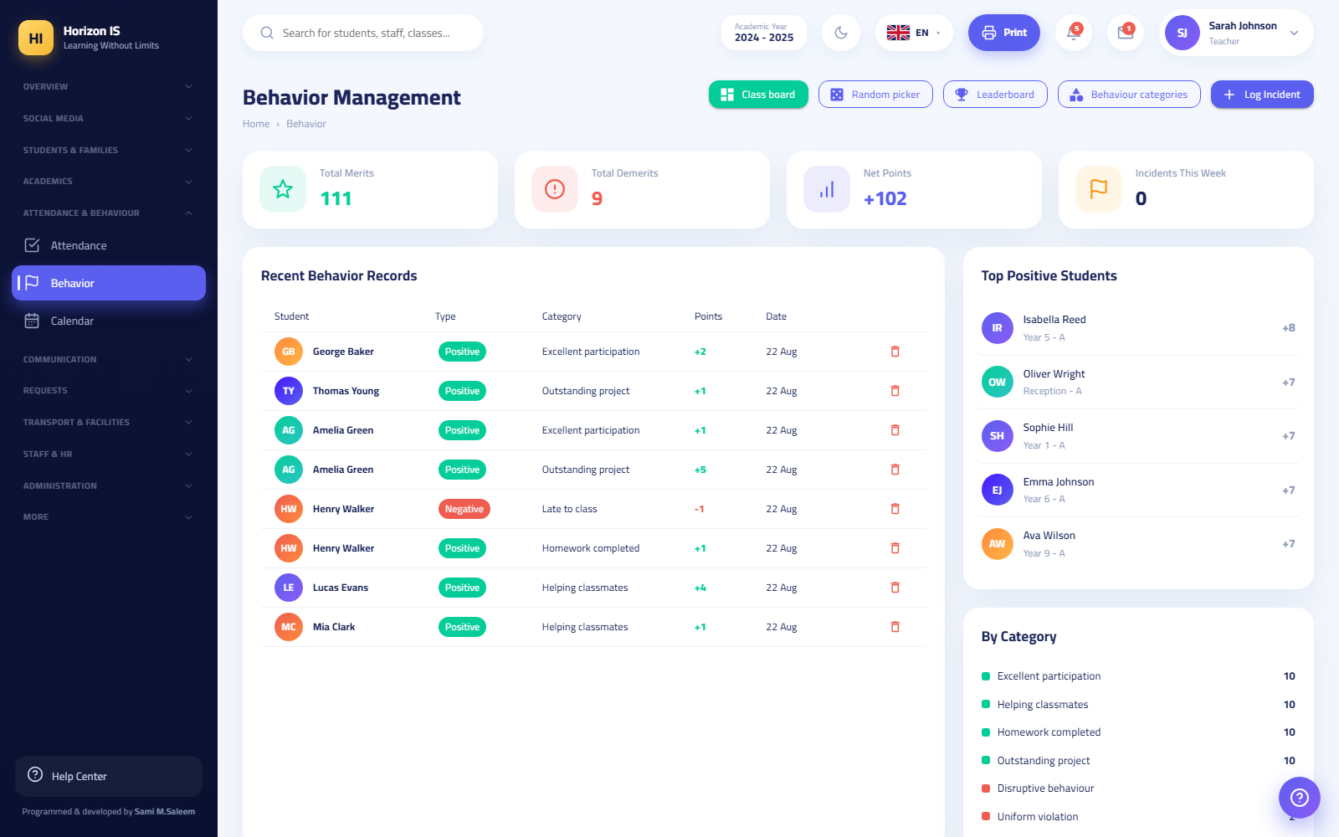Behavior management
Tip: Focus on positive points. The system is designed to reward before it punishes — the class board and the leaderboard display excellence in front of everyone.

Behavior Categories
Purpose Define the categories teachers choose from (example: "Helping a classmate +2", "Late to lesson −1").
Who can Administration only (admin roles are checked directly on this page). Path: /behavior/categories.
Steps
- Open Behavior (السلوك) then Behavior Categories (فئات السلوك).
- Press Add Category (إضافة فئة) and set the name and the points (positive or negative).
- Or press Add Starter Set (إضافة مجموعة جاهزة) to fill in a set of basic categories at once and start immediately.
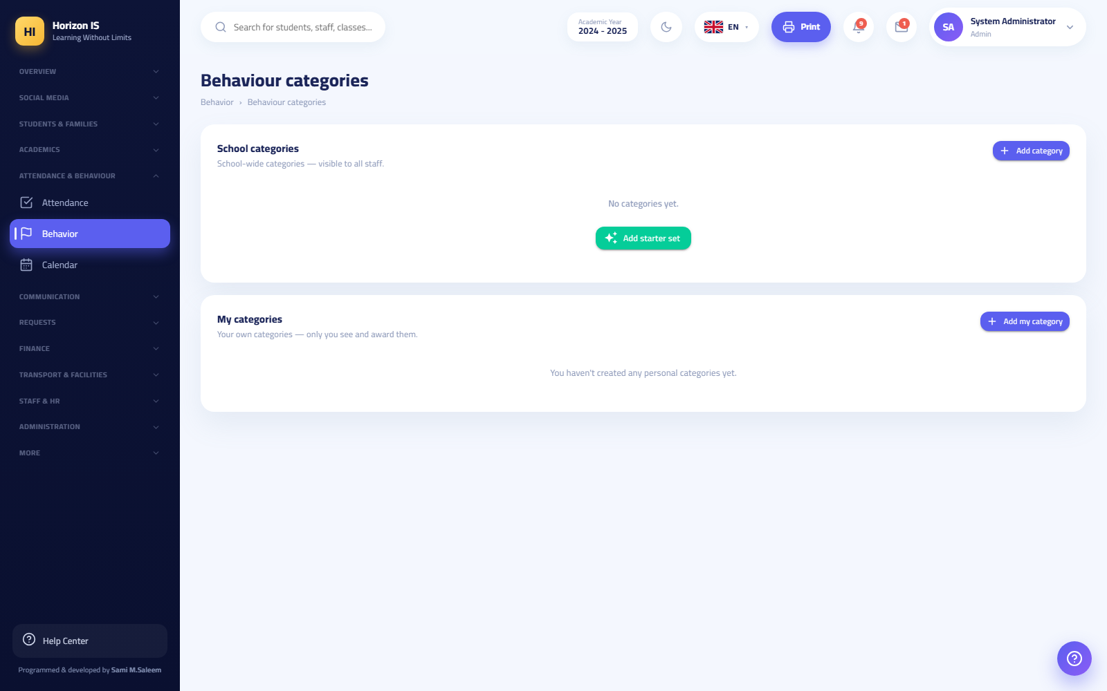Behavior categories

The Class Board
Purpose A screen displayed in front of the students: cards for the whole class with their points, for awarding points live during the lesson.
Who can Teachers and equivalent roles. Path: /behavior/board.
Steps
- Open Behavior (السلوك) then Class Board (لوحة الصف) and choose the class.
- Tap a single student, or use Select All (تحديد الكل) / Clear (مسح) to select a group.
- Award the behavior category to the selected students — the points are added instantly in front of everyone.
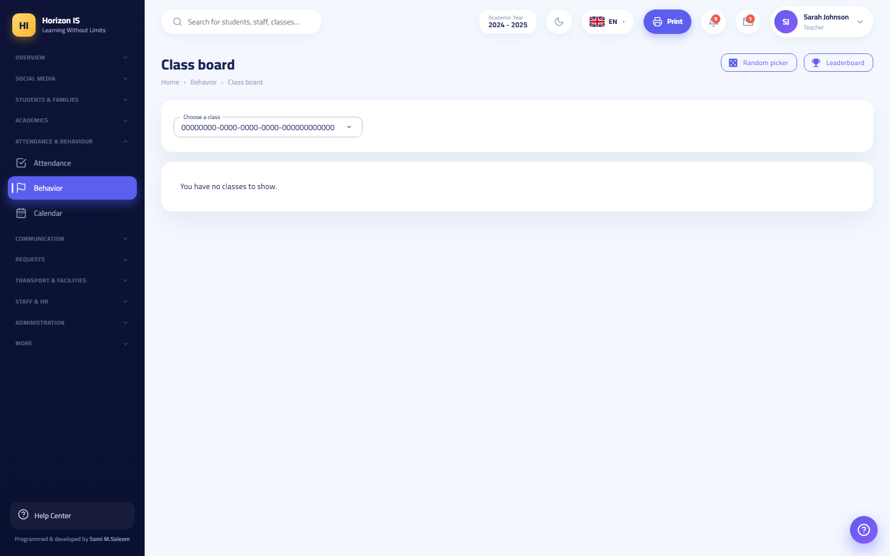Class board

The Leaderboard
Purpose Rank students by behavior points, for motivation and periodic recognition.
Who can Anyone with behavior.view. Path: /behavior/leaderboard.
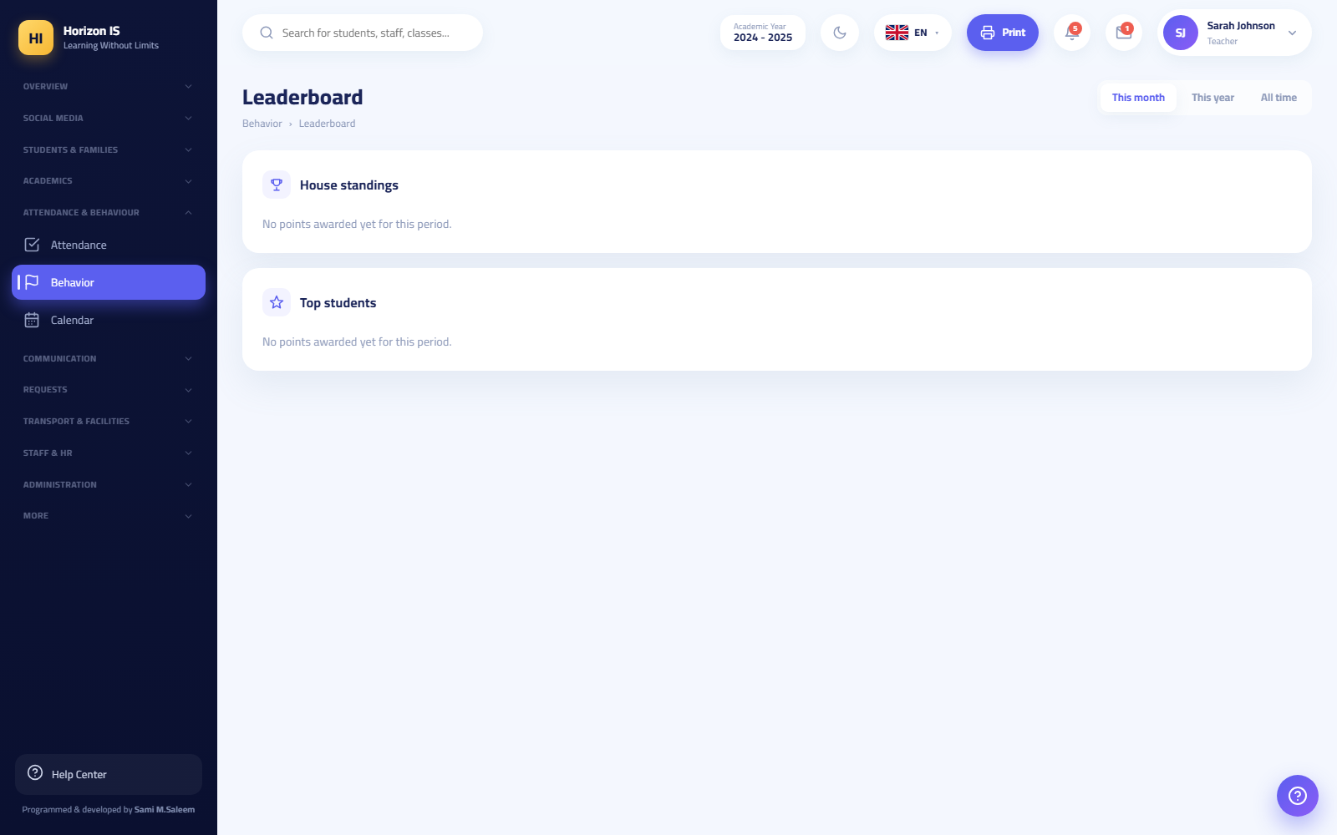Leaderboard
Related topics: The Recognition Board (لوحة التكريم) (/recognition, Academics section) for granting official recognition certificates — its buttons: Grant Recognition (منح تكريم), and deleting a recognition when made in error.

The Random Picker
Purpose Pick a student at random to participate, with complete fairness and no favoritism.
Who can Teachers and equivalent roles. Path: /behavior/picker.
Steps
- Open Behavior (السلوك) then Random Picker (المنتقي العشوائي) and choose the class.
- Press Pick a Student (اختر طالبًا) — a random name appears.
- Pick Again (اختر مجددًا) excludes those already picked; Reset (إعادة تعيين) starts a new round.
Tip: Additional classroom tools (the spinner wheel, the group generator, team scoreboards, the dice) are in Classroom Tools (أدوات الصفّ) (/classroom-tools).

6.4 Section Four: The School Calendar
Purpose Show school events (holidays, exams, activities) to all users — staff, students, and families.
Who can Viewing: nearly everyone (calendar.view is present in most roles, and students and families see it in their menus and the mobile app). Adding and editing: administration (calendar.manage). Path: /calendar.
Steps (adding an event — administration)
- Open Calendar (التقويم) from the sidebar.
- Press Add Event (إضافة حدث) and set the title, the date, and the details.
- Save — the event appears immediately for everyone.
Additional capabilities
- Export to Calendar (تصدير إلى التقويم): download the events into your personal phone calendar.
- Upload PDF / Remove PDF (رفع PDF / إزالة PDF): some schools adopt a printed yearly calendar; upload it to make a View PDF (عرض PDF) button available next to Grid View (عرض الشبكة).
Expected result One event visible to everyone: on the web, and in the Calendar (التقويم) card in the parent and student apps.
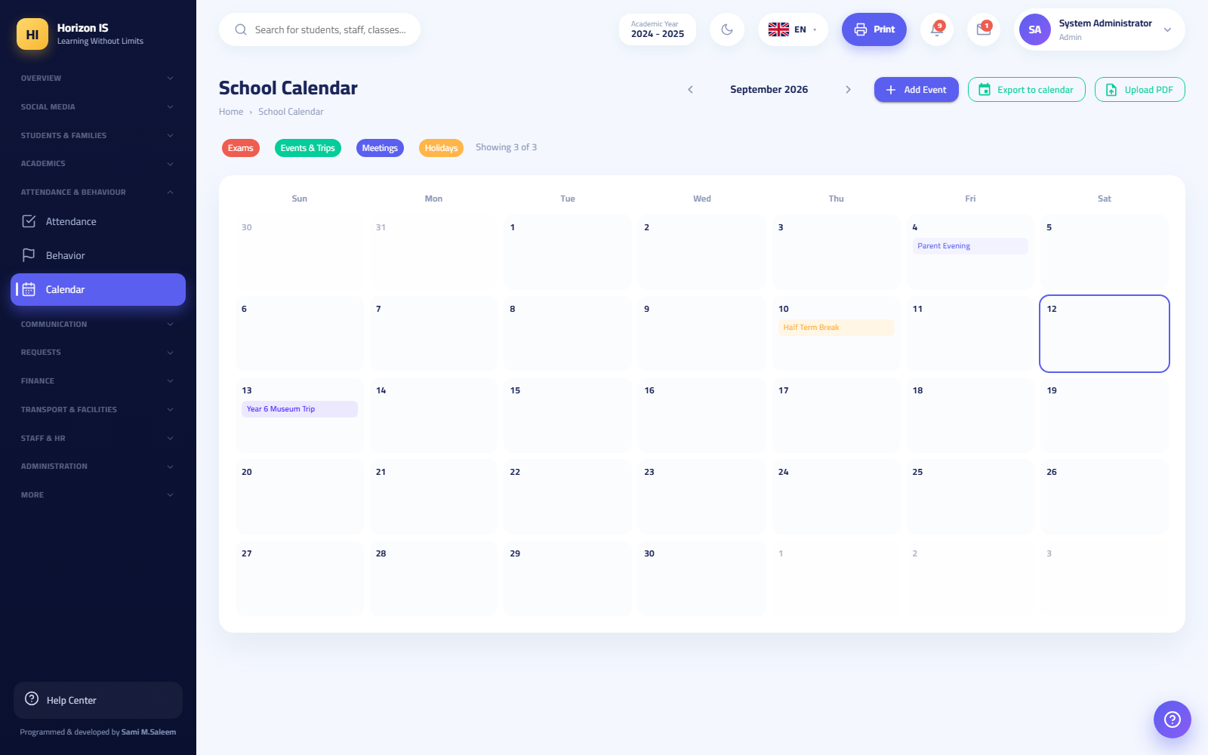School calendar

6.5 Section Five: The Communication Hub (Conversations)

Overview
The Communication Hub (مركز التواصل) (/communication, the Messages & Conversations (الرسائل والمحادثات) menu item) is the channel for personal conversations: direct chats with families, groups, and channels. Social Media, by contrast, is the school's public voice — do not confuse the two.
On one side of the screen is the conversation list with a "Search for a family…" search box and the filters All / Unread / Pinned (الكل / غير المقروء / المثبَّت) (the Pin (تثبيت) button lifts an important conversation to the top). Inside a conversation: Search in Conversation (بحث في المحادثة), and the Media, Links & Files (الوسائط والروابط والملفات) panel that gathers everything exchanged in the conversation.
Who can Anyone with communication.view — held by all relevant staff and by guardians and students (the only permission in their default role).
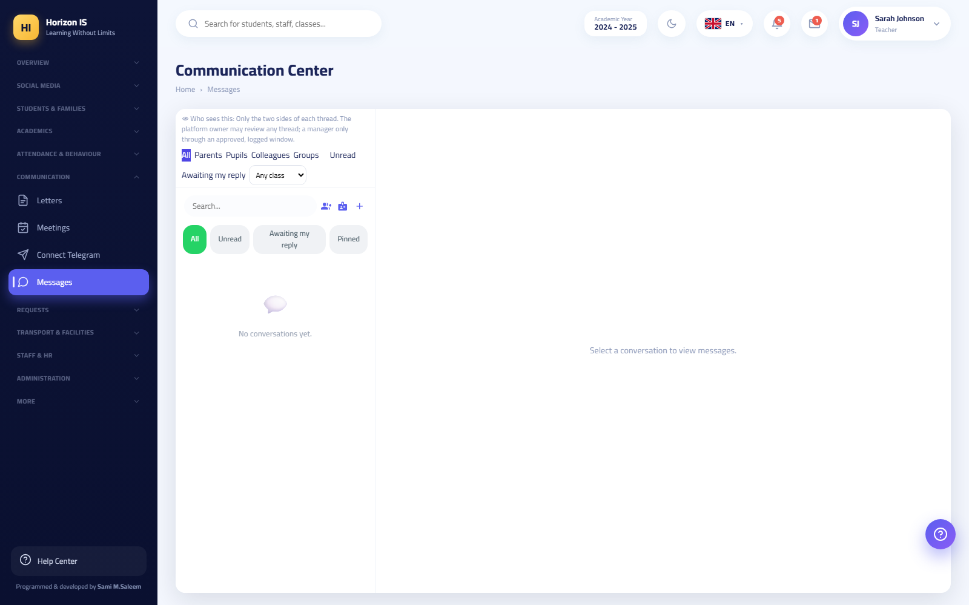Communication hub
Important — who can a family message? The parent app shows the family a School Office (مكتب المدرسة) card (general inquiries) and then each child's teachers with a Message (مراسلة) button. The system offers families official roles only: administration, the registrar, department and stage heads, the nurse, the doctor, the accountant, reception, IT, and the safeguarding officer. Cleaners, drivers, and general staff never appear as contacts for families.

Sending Messages: Text, Voice, Images, and Video
Purpose Fast, documented day-to-day communication between the teacher and the family.
Steps (text message)
- Open the conversation (or start one from search).
- Type in the "Write a message..." field and press send.
Message actions — long-press any message (in the app) or open its menu (on the web):
- Reply (رد): quote a message and reply to it.
- Copy (نسخ): copy the message text to the clipboard.
- Edit (تعديل): correct your message after sending it (it shows "(edited)").
- Unsend / Delete (تراجع عن الإرسال / حذف): delete your message for everyone — a confirmation appears: "Delete this message for everyone?".
- Reactions (التفاعلات): a quick emoji on the message.
- Mute Notifications (كتم الإشعارات): mute a noisy conversation without leaving it.
Voice messages (app)
- Long-press the microphone button and speak — exactly like WhatsApp; or tap once to open a pinned recording bar with a live waveform.
- Lift your finger (or press send) to send it.
Important: The voice-message limit is 5 minutes and 3 MB. The first time, the app will ask for microphone permission — accept it or recording will not work.
Images and video (app) — the Attach (+) (إرفاق) button offers: Image from Gallery (صورة من المعرض) / Take Photo (التقاط صورة) / Video from Gallery (فيديو من المعرض) / Record Video (تسجيل فيديو) / Document (مستند).
Tip: The image limit is 3 MB — larger images are compressed automatically inside the app before sending, so do not worry about large camera photos. The video limit is 10 MB.

Sending Files (PDF, Word, Excel, CSV, and ZIP)
Purpose Exchange official documents inside the conversation: a result, a circular, a schedule, a form.
Who can Both parties in the conversation — from the web (the paperclip 📎 button, "Attach image / video / file") and from the app (the Attach (إرفاق) button, then Document (مستند)).
Before you start The allowed types are exclusively: PDF, Word (doc/docx), Excel (xls/xlsx), CSV, ZIP. Maximum file size: 5 MB.
Steps (app)
- Inside the conversation tap + then Document (مستند).
- Choose the file from your phone — the picker shows only the allowed types.
- A confirmation dialog titled "Send file?" appears, showing the file name and size. Review them, then confirm.
- The file is sent and a 📎 bubble with its name appears.
Expected result - PDF files open inside the app with a built-in viewer — no external app is needed. - The other types (Word/Excel/CSV/ZIP) are downloaded and opened by a suitable app on the device. - On the web, files download from the message bubble, and you find all exchanged files in the Files (الملفات) panel inside the conversation.
Warning: The check is performed on the file's real content on the server, not its extension. An executable renamed report.pdf will be rejected. This protects all parties from malicious files.
Common mistakes - Trying to send unsupported types (rare image formats, program files) — use the five allowed types. - A file larger than 5 MB — compress it into a ZIP or split it.
Troubleshooting - A valid file was rejected: Make sure its extension matches its content (an Excel file saved with a csv extension is rejected, for example). Re-save it in the correct format.

Groups and Channels
Purpose A group for a class or a committee, or a one-way announcement channel.
Who can Staff who hold communication.groups.manage (teachers, homeroom teachers, department and stage heads, and administration). Guardians and students can never create groups — by deliberate design.
Steps
- In the Communication Hub press New Group (مجموعة جديدة).
- Type the group name.
- Choose the type: - Group (مجموعة): everyone writes and reads. - Channel (قناة): one-way broadcast. - Announcements (إعلانات): an official announcement channel.
- Add the members (the "Search for people…" search).
- Press Create (إنشاء).
Expected result The group conversation appears for all members immediately, on the web and in the app.
Related topics Broadcast · Department Messages (/department-messages) for internal communication among a department's teachers.

Broadcast — Send an Alert
Purpose Send one notification to a large number of families at once: it appears in the parent app's notification inbox and arrives as a push when enabled.
Who can Administration only — the Send Alert (إرسال تنبيه) button inside the Communication Hub.
Steps
- In the Communication Hub press Send Alert (إرسال تنبيه).
- Type the title and the message (both are required — "Enter a title and a message.").
- Choose the audience from Send To (إرسال إلى): - All Families (كل العوائل) — a general broadcast. - A Class's Families (عوائل صفّ) — then choose the class. - One Family (عائلة واحدة) — then choose the family.
- Press Send Alert (إرسال التنبيه).
Expected result A confirmation message with the recipient count: "The alert was sent to … families."
Example: "Tomorrow school ends at 11:00 because of the teaching-staff meeting" → Send to: All Families.
Tip: For a public feed broadcast (images, reactions, and comments) use an All Classes post on Social Media — see Section Seven. "Send Alert" is for short, urgent notifications.

Reporting Inappropriate Content
- In the Class Feed in the parent app: open the post's menu and press Report Post (إبلاغ عن المنشور). The report reaches the school's Content Moderation queue — see Moderation.
- In private conversations: there is no report button inside the conversation; take a screenshot and inform school administration or the School Office through the official conversation.

6.6 Section Six: Official Letters
Purpose Issue print-ready official letters in a specific student's name: Enrollment Certificate (إثبات تسجيل) and Clearance Letter (براءة ذمة).
Who can Anyone with communication.send. Path: /letters (the "Communication" section).
Steps
- Open Letters (الخطابات) from the sidebar.
- Choose a student to create the letter — search by name.
- Choose the letter type: - Enrollment Certificate (إثبات تسجيل): "The school administration certifies that the student … is officially enrolled in … for the academic year …". - Clearance Letter (براءة ذمة): "… has no outstanding obligations toward the school as of the date this statement was issued."
- Review the preview: the student's name, school number, class, academic year, and date are filled in automatically.
- Press Print (طباعة).
Expected result An official printed letter with the school letterhead, with two signature lines: Registrar (المسجِّل) and School Principal (مدير المدرسة).
Important: "This statement is valid only with the school stamp and signature." — Printing alone is not enough; the stamp and handwritten signature are required for it to be official.
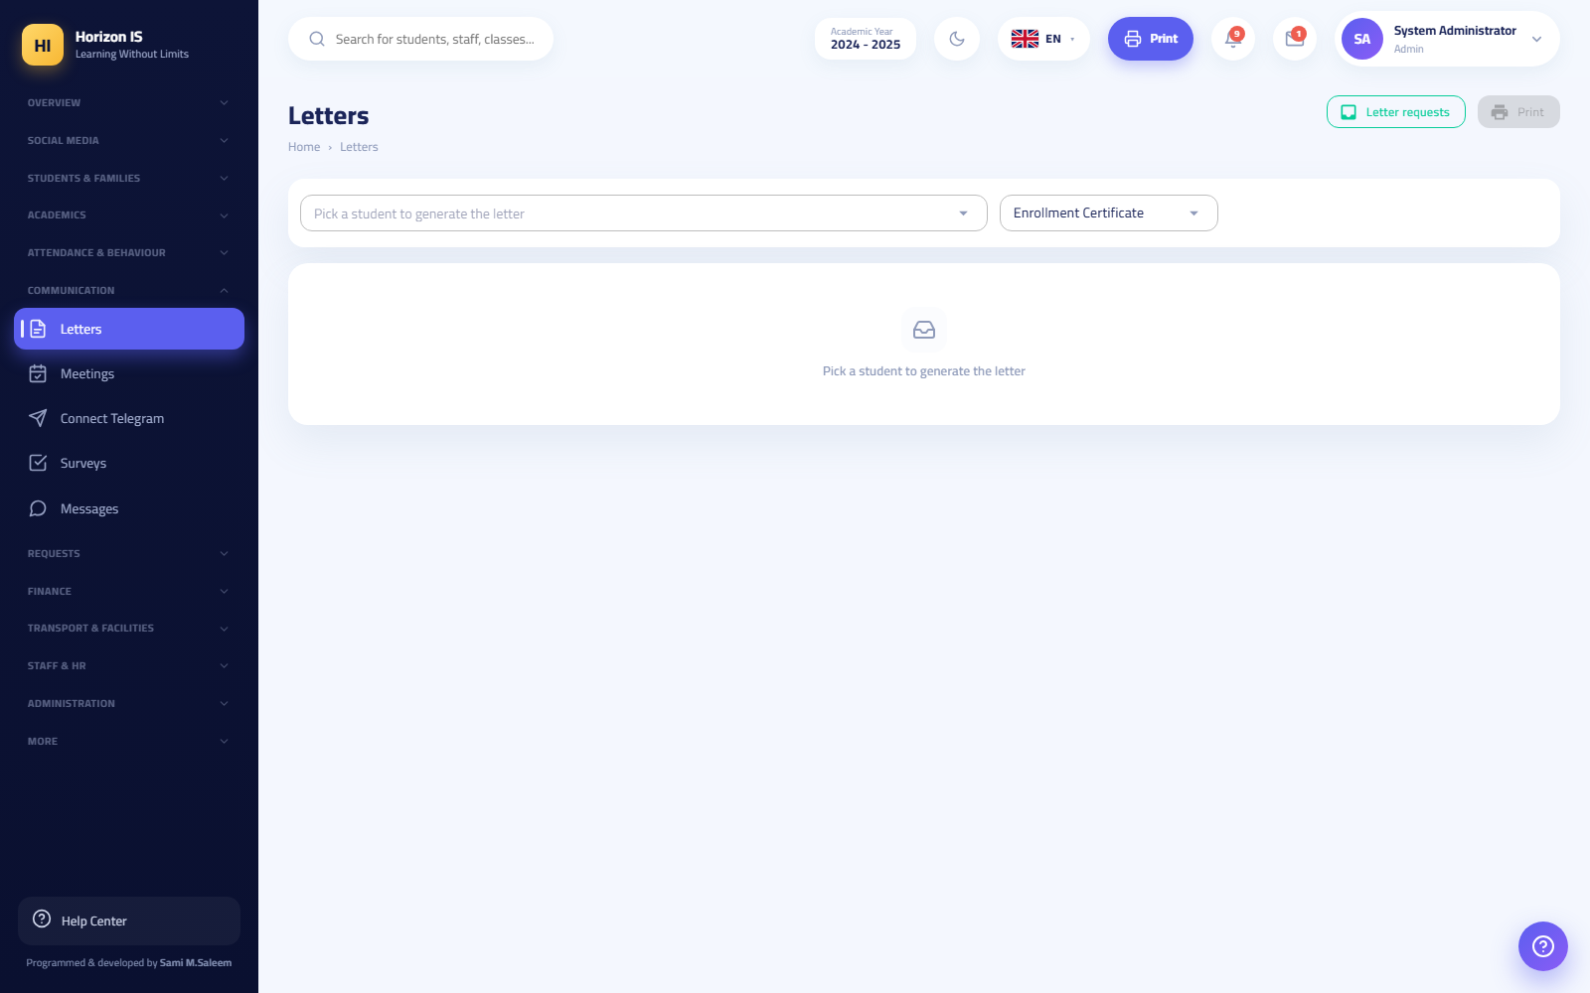Letters
Related topics Internal staff circulars (/circulars) · Document Center (/documents)

6.7 Section Seven: Parent Meetings
Purpose Organize parent meetings: the teacher publishes available slots and the family books from the app — no queues and no phone calls.
Who can - Publishing slots: teachers and staff (communication.view) from /meetings. - Booking: guardians from the mobile app (the Meetings (المواعيد) card).

Publishing Slots (Teacher — Web)
- Open Meetings (المواعيد) from the sidebar.
- Press Publish Slots (نشر مواعيد).
- Set: - The date and time ("Choose the date and time") - The duration (minutes) of each slot - The number of slots to generate back-to-back - The location: the room (القاعة), or a meeting link (رابط الاجتماع) for an online (عبر الإنترنت) meeting - Class (optional): restrict the slots to one class's families, or All Classes (كل الصفوف)
- Press publish — you see: "Slots published".
Expected result Your slot list appears with each slot's status: Available (متاح) or Booked (محجوز) with the booker's name (Booked by (محجوز بواسطة)). To withdraw an unbooked slot press Withdraw (سحب) (confirmation: "Withdraw this slot?").
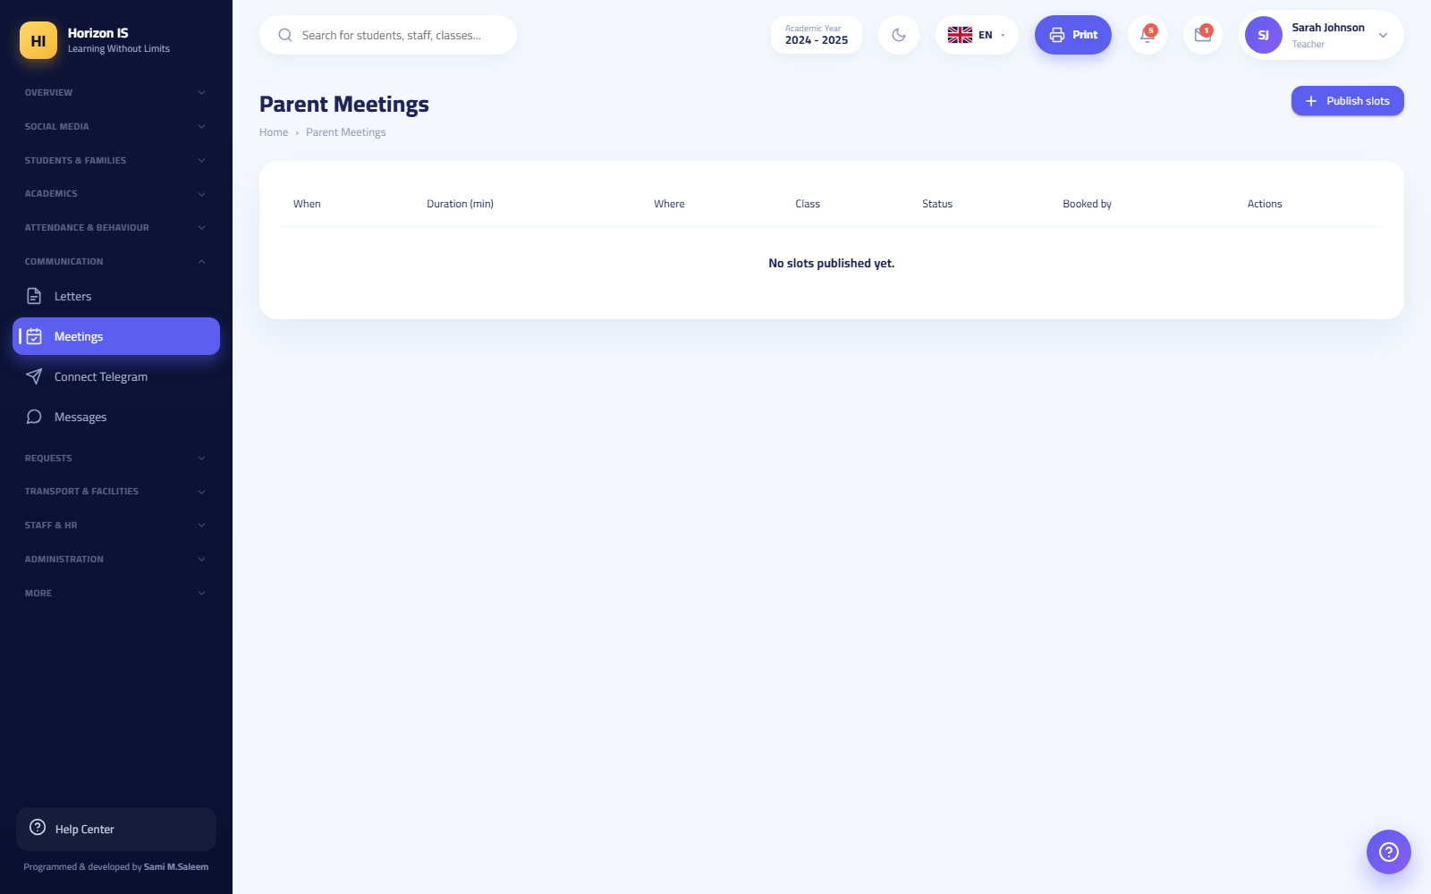Parent meetings

Booking a Slot (Guardian — App)
- From the home screen open Meetings (المواعيد) — two tabs: Available (المتاحة) and My Meetings (مواعيدي).
- In "Available" tap Book (حجز) on the suitable slot (the duration in minutes is shown, and an Online (عبر الإنترنت) badge marks virtual meetings).
- Choose the student concerned, and add an optional note.
- Tap Confirm Booking (تأكيد الحجز) — you see: "Booked successfully".
Expected result The slot moves to "My Meetings" for the family, and appears as booked in their name for the teacher. Cancellation is from "My Meetings", with a confirmation message.
Common mistakes - Publishing slots without setting a room or a link — always specify a clear location. - Forgetting to restrict the slots to the intended class, so families from other classes book them.

6.8 Section Eight: The Social Media Hub

Overview
Social Media (سوشيال ميديا) (/social) is the school's public voice: photo posts, stories, likes and comments. The hub's buttons:
Button | Path | Use
Social Media (سوشيال ميديا) | /social | The feed and posts
Announcements (الإعلانات) | /announcements | Archive of old announcements
Feed Analytics (تحليلات التغذية) | /feed-analytics | Post reach and engagement
Content Moderation (الإشراف على المحتوى) | /moderation | Pending reports
Social media

Publishing a Post (Including a School-Wide Broadcast)
Purpose Share a class activity or school news with the right audience — from a single class up to the whole school.
Who can Staff from the web (/social) and from the teacher app (New Post (منشور جديد)).
Steps (Web)
- Open Social Media (سوشيال ميديا) and press to open the composer (New Post (منشور جديد)).
- Choose the audience: - Specific Classes (صفوف محدّدة) — then tick the classes (required) - All Classes (كل الصفوف) — a broadcast to all the school's families - Staff Only (الموظّفون فقط) — an internal post families never see
- Write the text and attach an image, a video, or an album of photos.
- Press publish.
Steps (teacher app) — New Class Post (منشور صفّي جديد): choose the class, write, attach photos (automatically compressed above 3 MB) or video, and add a poll, an RSVP invitation, or student tags, then Publish Now (انشر الآن), schedule, or save a draft — "Post published" / "Post scheduled".
Expected result The post appears in the web feed and in the Class Feed in the parent app, with likes ("Like (إعجاب)") and comments ("Comment (تعليق)"). The teacher sees who viewed their post and can send a reminder to those who have not.
Important — where did the "old broadcast" go? The old Announcements page (/announcements) now carries a banner: new announcements are published through the class feed and reach everyone from there — the list shows past announcements only. So a general broadcast today = a post with the All Classes audience, or Send Alert from the Communication Hub for short notifications.
Tip: The parent app offers post search, an "All Classes" filter, the "Class Gallery", and "On This Day" memories — encourage families to follow them.

Stories
Purpose Quick daily snapshots that disappear automatically — they appear in the story bar at the top of the parent app's screen.
Who can Staff (New Story (ستوري جديد) / Add Story (أضف ستوري)).
Steps
- Press Add Story (أضف ستوري).
- Add an image / video or text ("Write something…") and an optional caption.
- Choose the audience from Who sees this? (من يرى هذا؟): Staff Only (الموظّفون فقط) / My Class's Parents (أولياء أمور صفّي) / Everyone (الجميع).
- Press Publish (نشر) — "Story published".
Expected result The story appears in the "School" bar at the top of the parent screen. After publishing you see a Viewed by (شاهدها) list with the viewer count.
Important: Size limits: 5 MB for an image and 20 MB for a video ("File too large — the limit is 5 MB for an image / 20 MB for a video").

Content Moderation (The Reports Queue)
Purpose Review posts and comments reported by guardians or staff, and hide those that violate the rules.
Who can Administration and content moderators. Path: /moderation.
Steps
- Open Content Moderation (الإشراف على المحتوى) — the Under Review (قيد المراجعة) tab lists every report: its type (post or comment), its text, and Reported by (أبلغ عنه).
- Review the content and decide: - Dismiss (تجاهل): the report is unjustified — the content stays ("Report dismissed."). - Hide (إخفاء): the content violates the rules — it is removed for everyone after confirming "Hide this content from everyone? This removes the post or comment." ("Content hidden.").
Expected result An empty queue ("Nothing to review — the queue is empty.") means every report has been handled.
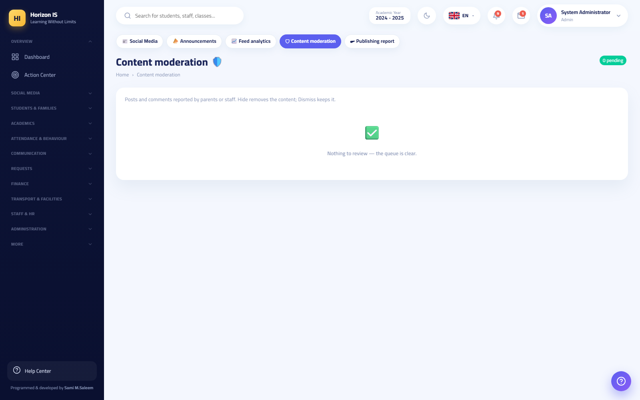Content moderation
Tip: Review the queue daily. Responding to reports quickly preserves families' trust in the platform.
Related topics Reporting content · Feed analytics

6.9 Section Nine: Telegram Linking
Purpose Receive a copy of school notifications in your Telegram account, in addition to app notifications.
Who can Every user (communication.view) — staff and guardians. Path: /connect-telegram (the "Communication" section).
Before you start - The Telegram app is installed on your phone. - The school has enabled the Telegram service. If it has not, you see: "The school has not enabled Telegram notifications yet."
Steps
- Open Connect Telegram (ربط تيليغرام) from the sidebar.
- Copy the link below — the Copy Link (نسخ الرابط) button ("Link copied"). The link is personal to your account.
- Open it inside the Telegram app (paste it into the search bar).
- Press "Start" in the bot conversation, then refresh this page — the Refresh Status (تحديث الحالة) button.
Expected result The page changes to: "Your account is linked. You will receive notifications on Telegram." From now on, school notifications also reach you on Telegram.
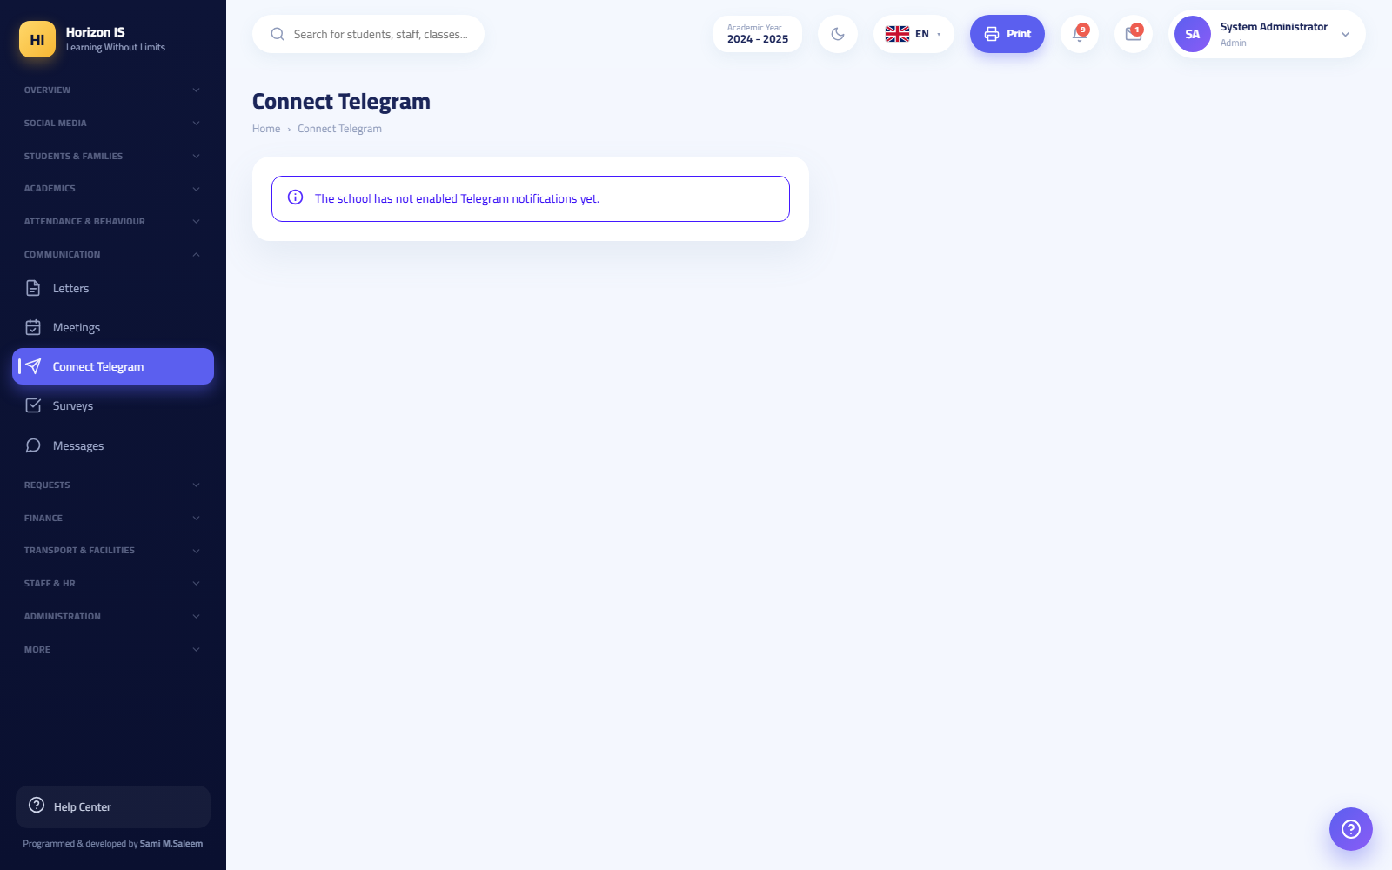Connect Telegram
Common mistakes - Opening the link in the browser instead of the Telegram app — paste it inside Telegram itself. - Forgetting to press Start (ابدأ) in the bot conversation — without it the linking does not complete.
Troubleshooting - I pressed "Start" and the page still says not linked: Press Refresh Status (تحديث الحالة). If the problem persists, copy a new link and repeat the steps.

6.10 Appendix: The Demo Environment
Example — the training environment: To practice everything above without touching real data, use the demo account with the password School@2025 on the demo environment only, with sample names such as "الطالب التجريبي" (the demo student) and "Demo Parent". Never use real student data in training.

Chapter 7Module Guides — Finance, Operations, and Administration
This chapter is your day-to-day reference for three groups of screens:
- Finance: the Finance Bridge, the fee structure, installments, payments and receipts, accounting, family balances, the school shop.
- Operations: the Requests section (absence, payment, leave), transport and facilities.
- Administration: staff HR, user accounts and permissions, menu designer, feature flags, academic years, school settings, storage, backups, the audit log, the action center, account-closure requests.
Every screen in this chapter is listed by its real name in the sidebar and its real path in the browser. If you do not see a screen mentioned here, your account most likely lacks the permission for it — see the Roles and Permissions section.

7.1 1. Finance Section Overview
Purpose Understand who sees the finance screens, and why they may disappear for some staff.
Who can
Screen | Required permission
Finance Bridge /finance-bridge | finance.revenue.view
Fee Structure /finance/fees and the other fee screens | finance.fees.manage
Payment Requests /payment-requests | finance.payments.manage
Accounting /finance/journal and its sub-screens | finance.revenue.view
Shop /shop | shop.manage
The roles that hold these permissions by default: School Owner, School Manager, System Manager (management sees everything), and the Accountant (holds the full set of four finance permissions). Any other staff member needs an explicit grant from the permissions matrix.
Important: Protecting financial data is not just hiding a menu. Every finance query on the server is guarded: anyone who is not part of the finance office and does not hold finance.revenue.view has the request rejected with the message "Financial data is restricted to the finance office" (البيانات المالية مقصورة على مكتب المالية) — even if they type the URL by hand.
Note: All fee and accounting screens disappear from the menu if the FinanceErpModule feature flag is switched off from the Feature Flags page. If the finance section suddenly disappears for everyone, check the flag first.

7.2 2. The Finance Bridge
Path: /finance-bridge — sidebar: Finance ← Finance Bridge (المالية ← الجسر المالي).
شاشة الجسر المالي

What is the Finance Bridge?
Some schools in the group record collections on a separate, offline accounting machine. The Finance Bridge is the meeting point: it receives the accounting machine's payments and applies them to family accounts inside the system, then notifies each family in its own language. The other accounting screens (the journal and the rest) link back to it as the finance home page.
Cards at the top of the screen summarize the state: Accounting families (عوائل المحاسبة), Linked codes (أكواد مربوطة), Awaiting linking (بانتظار الربط), Imported receipts (وصولات مستوردة).

Syncing new payments
Purpose Pull the accounting machine's payments, apply them to family balances, and notify the families.
Who can Management and the Accountant (finance.revenue.view).
Before you start - Make sure the bridge is configured on the server. If you see the message "The bridge is not configured on this server" (الجسر غير مهيأ على هذا الخادم), it is not a permissions problem — contact the party operating the system. - Make sure the sync key is installed (see The sync key).
Steps 1. Open /finance-bridge. 2. Click Sync now (مزامنة الآن). Or enable the Automatic every 15 minutes (تلقائي كل 15 دقيقة) option so everything runs on its own — you will see: "Automatic mode is running — new payments are settled and families are notified on their own every 15 minutes." 3. Review the New payments (الدفعات الجديدة) table. Each row = one collection receipt from the accounting machine. 4. Click Apply + notify families (تطبيق + إشعار العوائل). 5. Read the success message: "Applied {count} payments · skipped {count} unlinked · {count} zero-amount."
Expected result - Each receipt is imported exactly once — no risk of duplication. - Open invoices are settled oldest first, and any surplus is recorded as a paid installment. - The family receives a notification in its own language as soon as the payment is applied.
Common mistakes - Clicking "Apply" and expecting unlinked families to benefit — the payment is skipped until you link the accounting code to a system family (see the next section). - Using the Re-register everything in the current currency (إعادة تسجيل الكل بالعملة الحالية) button as if it were a normal sync. This is an advanced button inside "Advanced options", it re-registers all payments in the current currency without notifications, and it requires a double-click confirmation. Do not use it except on management's instruction.
Troubleshooting - "Everything is up to date — no new payments." = not a problem; there are no receipts left to import. - Many payments showing "not linked yet" = complete the linking, then apply again. - Did the registration currency change? Set the Registration currency (عملة التسجيل) on the same screen; you will see "Currency saved — upcoming applications will use it."
Related topics Linking accounting families · Installments and Payments · Family Balances

Linking accounting families to system families
The accounting machine identifies a family by a code; the system identifies it by a family record. The linking is done once per family:
- In the Link accounting codes to system families (ربط أكواد المحاسبة بعوائل النظام) section you will find the list of unlinked codes with suggestions: - ⭐ = a suggestion by phone-number match. - 👨‍🎓 = a suggestion by student-name match.
- For each code: pick the family from the System family… (عائلة النظام…) field (type part of the name or the number), then click Link (ربط).
- Or click Link all suggestions (ربط كل المقترحات) to link all phone-match suggestions in one go — you will see "Linked {count} families from phone-match suggestions — review the rest manually."
Tip: Differences in name spelling between the two machines are normal — the code is the deciding factor, and the two codes remain side by side after linking.

The sync key and encrypted packages (.sep)
When there is no direct connection, payments are moved as an encrypted package file with the .sep extension:
- Generate a key: click Generate key (توليد مفتاح) (or Rotate key (تدوير المفتاح) to replace it). Copy the key immediately — "Copy the key now — it is shown only once." It is pasted into the bridge-export.json file next to the export tool on the accounting machine.
- The export tool encrypts the payments with this key (AES-256-GCM). Any package with a wrong key — or with a single byte tampered — is rejected.
- Offline signing key: the export tool generates a signing key pair on the accounting machine; the private key never leaves it. Paste the public key into the field "Paste the public key printed by the export tool…" and click Install key (تثبيت المفتاح). From then on only packages signed by the accounting machine are accepted.
- Import: in the Import encrypted package (.sep) (استيراد حزمة مشفرة (.sep)) section click Choose .sep file (اختيار ملف .sep), review the payment count in the package, then apply as usual.
Warning: Rotating the key invalidates all old packages. Do not rotate the key except in coordination with the accounting machine's operator.

7.3 3. Fee Structure
Path: /finance/fees — sidebar: Finance ← Fee Structure (المالية ← هيكل الرسوم). Permission: finance.fees.manage.
شاشة هيكل الرسوم
Opening "Fee Structure" shows a tab strip (pills) covering the full fee cycle:
Pill | Path | What it does
Fee Structure (هيكل الرسوم) | /finance/fees | Fee components, year settings, and per-grade amounts
Installment Assignment (توزيع الأقساط) | /finance/fees/assign | Each student's final fee + discounts + the audit lock
Discount Setup (إعداد الخصومات) | /finance/fees/discounts | Defining named discounts
Student Fees (رسوم الطلاب) | /finance/fees/students | Each student's financial position
Expected Revenue (الإيراد المتوقّع) | /finance/fees/report | Expected-revenue report (print button)
Fee Collection (تحصيل الرسوم) | /finance/fees/collection | Collection-tracking dashboard (read only)
Installments (الأقساط) | /finance/installments | Installment plans and payment recording

Setting up the fee structure for a new year
Purpose Define what the school charges before assigning any amount to students.
Who can Management and the Accountant (finance.fees.manage).
Before you start Make sure the correct academic year is set as "current" in Settings.
Steps 1. Open /finance/fees. 2. In the Year settings (إعدادات السنة) card: set the academic year, the number of days and months, and the proration (التناسب) method for late enrollment: no proration, by months, or by days. Save. 3. In the Fee components (مكوّنات الرسوم) card: click Create standard components (إنشاء المكوّنات القياسية) to seed a ready-made set, or Add component (إضافة مكوّن) manually. For each component: the name in Arabic and English, the source (manual or linked to meals), whether it accepts discounts, and whether it is active. 4. In the per-grade fee table: enter each component's amount for each stage/grade, then Save (حفظ).
Expected result A complete fee structure for the year, ready to assign to students.
Common mistakes - Forgetting to activate a new component — an inactive component does not appear in assignment. - Entering the amounts in an academic year other than the current one.
Troubleshooting - Not seeing the pills at all? The FinanceErpModule flag is off, or you lack the permission.
Related topics Installment Assignment · Discounts

Assigning installments to students
Purpose Fix each student's final fee after discounts, then lock it.
Who can Management and the Accountant.
Steps 1. Open /finance/fees/assign (the Installment Assignment (توزيع الأقساط) pill). 2. Pick the student. Their fee, computed from the structure, appears. 3. Adjust the final fee if needed, and add the defined discounts (sibling discount and the rest). 4. Click Save (حفظ). 5. After the final review click Audit (تدقيق) to lock the student's fee for this year. A Reopen (إعادة فتح) button is available to management if a later change is needed. 6. The Apply (تطبيق) and Apply scale (تطبيق مقياس) buttons work at group level to roll an amount or a percentage out to an entire segment.
Expected result Each student has a documented final annual fee, visible in "Student Fees" and on the family account.
Common mistakes - Editing after auditing without "Reopen" — the system blocks it; this is by design.
Related topics Installments and Payments · Expected Revenue

Setting up discounts
In /finance/fees/discounts: click Add discount (إضافة خصم), enter the name in Arabic and English, and activate it. The types include sibling rules ("Add child"). The discounts defined here are the ones that appear on the assignment screen.
Example: A "second sibling 10%" discount is defined here once, then selected for each sibling on the assignment screen — it is never typed by hand each time.

7.4 4. Installments, Payments, and Receipts

Recording a payment from a family
Path: /finance/installments — the Installments (الأقساط) pill in the Fee Structure.
شاشة الأقساط
Purpose Record an amount paid by the family and issue an official receipt number.
Who can Management, or holders of the "Accountant" role only. This is an explicit role requirement on the server — no other permission suffices, and the rejection message is: "Recording payments is restricted to the finance office" (تسجيل الدفعات مقصور على مكتب المالية).
Before you start - Know the amount, the currency (dinar or dollar), the payment method, and the cashbox the money went into. - Make sure the family's installment plan is set (the Set plan (تحديد الخطة) button).
Steps 1. Open /finance/installments. 2. In the right-hand panel search for the family (there is an "Overdue only" (المتأخرون فقط) filter). Select the family. 3. If the plan is not set: click Set plan (تحديد الخطة) and define the number of installments and their dates. 4. Click Record payment (تسجيل دفعة). The payment window opens: - The date. - The amount and currency: Iraqi dinar or US dollar — dollars are converted automatically at the saved exchange rate into the school's main currency. - The payment method (cash, card, transfer…). - The box (البوكس) (cashbox) that received the money. - Notes, and optional attachments (up to 4 MB per file). 5. Save. The message "Payment {receipt number} recorded." appears.
Expected result - An automatic receipt number in the format R-yymmdd-#### (year/month/day + sequence). - The payment appears in the family's payment list: receipt number, date, amount, equivalent in the main currency, method, cashbox. - The family's balance in "Family Balances" drops immediately. - The guardian sees the payment in the mobile app (the "Installments account" screen).
Common mistakes - Recording a dollar payment without confirming the saved exchange rate — review the setting before collection season. - Trying to delete a payment carrying a 🔒 lock — locked payments cannot be deleted; this protects the record. - Confusing a "payment notice received" from the app with recording the actual payment (see Payment Requests).
Troubleshooting - The "Record payment" button refuses? Your account is neither management nor an accountant — ask the finance office. - Cannot find the family? Search by part of the name or the number, and clear the "Overdue only" filter.
Related topics Printing receipts and statements · Family Balances · Payment Requests

Payment Requests
Path: /payment-requests — sidebar: Requests ← Payment Requests (الطلبات ← طلبات الدفع). Permission: finance.payments.manage.
شاشة طلبات الدفع
Purpose Process the "I have paid" notices that guardians send from the app.
Who can Management and the Accountant.
Steps 1. Open /payment-requests. 2. Review each request: the family, the declared amount, the note. 3. Click Received (استلام) to acknowledge the notice, or dismiss it with a rejection. 4. Then — and this is the crucial part — record the actual payment on the Installments screen.
Warning: The "Received" button does not record any amount on the family's account. It is only an acknowledgment that the notice arrived. The payment does not exist financially until the cashier records it on the Installments screen.
Related topics Recording a payment

Printing receipts and statements
Three ways to print, each with its purpose:
- Family account statement: in /finance/installments select the family and click Print statement (طباعة الكشف) — prints the family's full account (the plan, the payments, the remainder) via browser printing.
- Balances list: in /family-balances the Print PDF (طباعة PDF) button downloads a ready PDF with every family's balance.
- Official voucher: for the official accounting voucher (receipt voucher / payment voucher) use the Vouchers screen in Accounting.
Tip: The letterhead of all printouts (the logo and the school name) is configured centrally from Settings ← Print Design (الإعدادات ← تصميم الطباعة) (/settings/print).

7.5 5. Accounting
The sidebar path Finance ← Accounting (المالية ← المحاسبة) opens the journal /finance/journal, and from there a pill strip leads to the rest of the books. Permission: finance.revenue.view.

The Journal
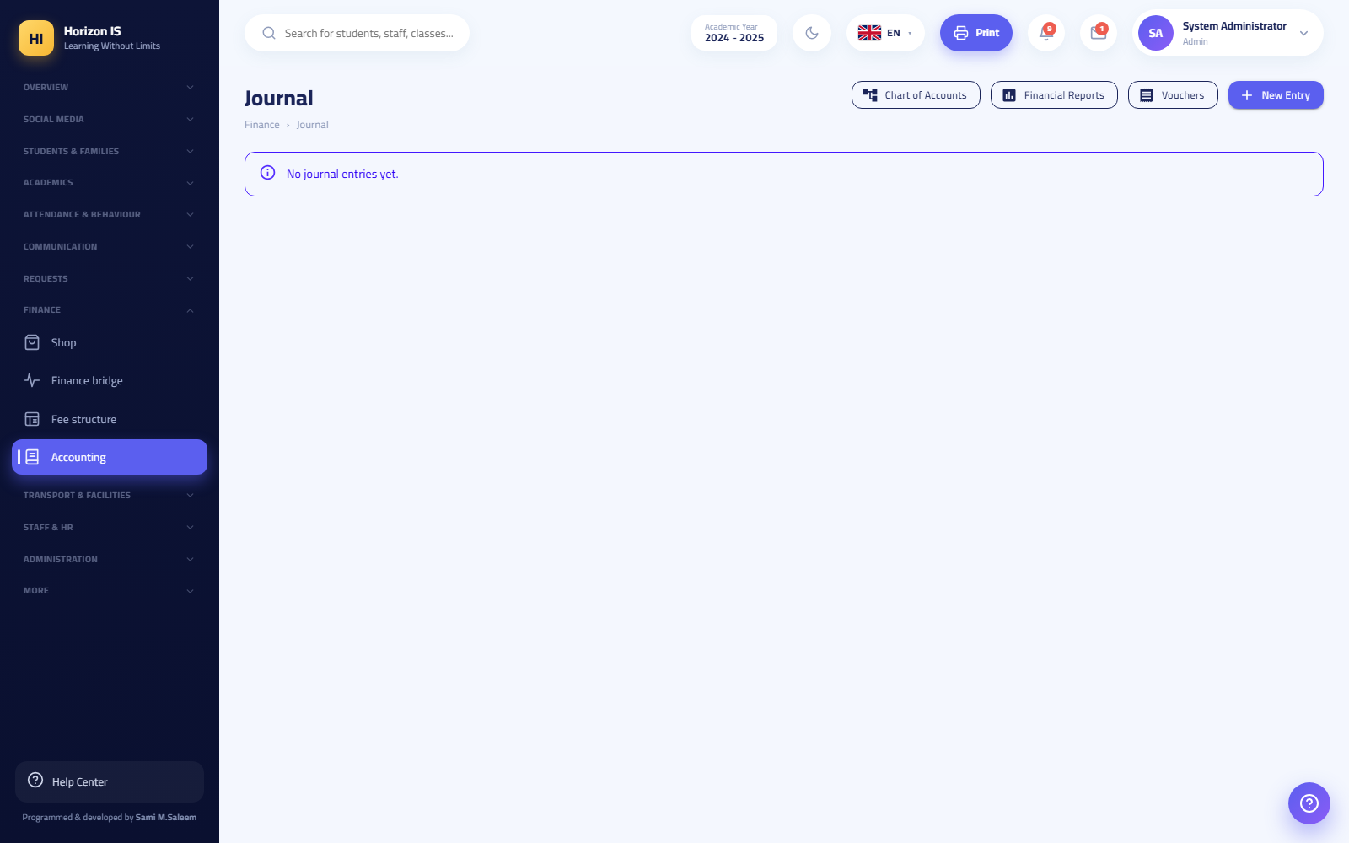دفتر اليومية
- Path: /finance/journal — title: Journal (دفتر اليومية).
- The New entry (قيد جديد) button records a manual accounting entry (debit/credit).
- Pills at the top of the page lead to: Chart of Accounts (شجرة الحسابات), Financial Statements (القوائم المالية), Vouchers (السندات).

Chart of Accounts
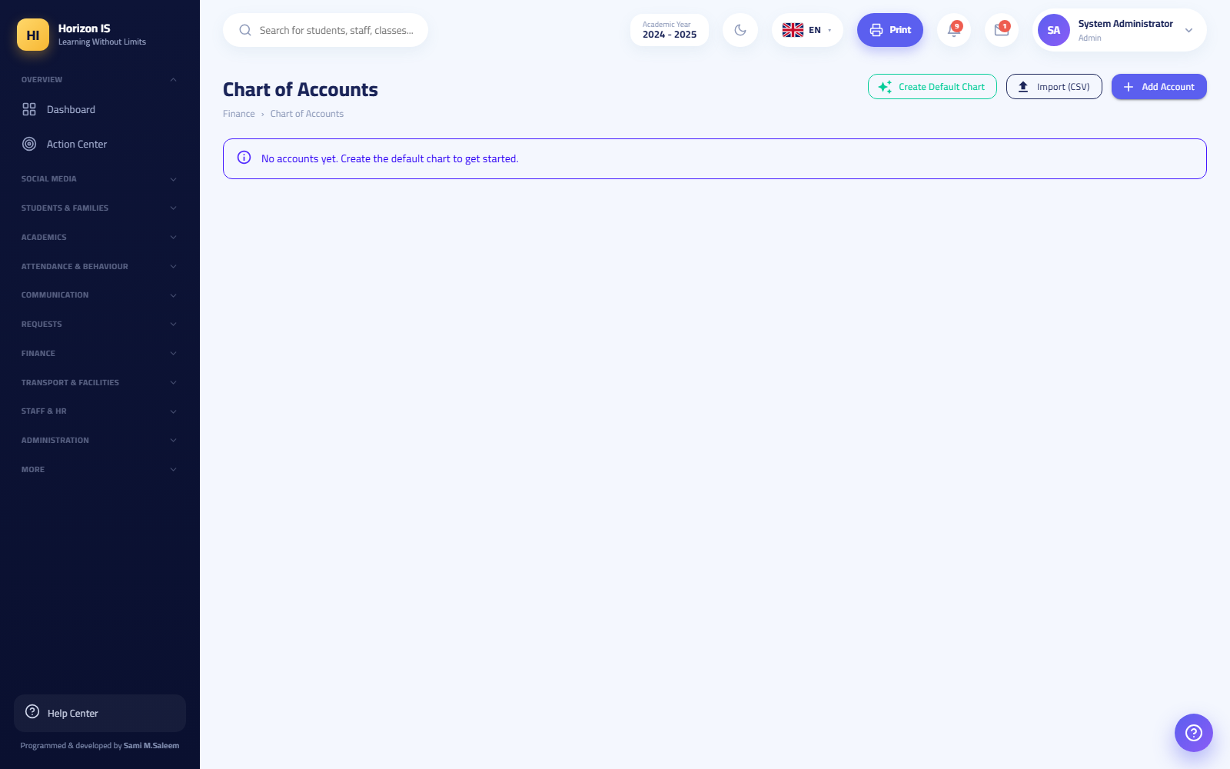شجرة الحسابات
- Path: /finance/accounts — title: Chart of Accounts (شجرة الحسابات).
- The buttons: Create default chart (إنشاء الشجرة الافتراضية) (to start a new school with a standard chart of accounts), Add account (إضافة حساب), Export (تصدير), Import CSV (استيراد CSV).
Warning: "Create default chart" is for the very beginning only. In a school that is already operating, add accounts one by one and never rebuild the chart.

Vouchers
السندات
- Path: /finance/vouchers — title: Vouchers (السندات).
- Two main buttons: Receipt voucher (سند قبض) (money in) and Payment voucher (سند صرف) (money out). Each voucher generates an official printable document and is posted to the books.

Financial Statements
- Path: /finance/reports — title: Financial Statements (القوائم المالية). Ready-made financial reports for viewing and printing (read only).

Accounting setup and cashboxes
- Path: /finance/setup — title: Accounting Setup (إعداد المحاسبة).
- This is where the cashboxes (الصناديق / البوكسات) that appear in the payment-recording window are defined: the Add cashbox (إضافة صندوق) button, then Save (حفظ).
Example: A "Reception" box and an "Accounts" box — every payment is attributed to a box, which makes it easy to reconcile each collection point separately.

Family Balances
Path: /family-balances — title: Family Balances (أرصدة العوائل).
أرصدة العوائل
Purpose See what every family still owes on one screen, and remind those in arrears.
Who can Management and the Accountant.
Steps 1. Open /family-balances and click Refresh (تحديث) for the latest figures. 2. Review the table: every family and its remaining balance. 3. To print: Print PDF (طباعة PDF). 4. To remind: click Remind overdue families ({count}) (تذكير المتأخرين) — the button requires a second confirming click before sending a bulk notification to all overdue families.
Expected result Every overdue family receives a polite notification of the remaining amount, in its own language.
Common mistakes - Clicking once and waiting for the send — nothing is sent until the second, confirming click.
Related topics Recording a payment · The Finance Bridge

7.6 6. The Shop
Path: /shop — sidebar: Finance ← Shop (المالية ← الحانوت). Permission: shop.manage (held by the Accountant by default).
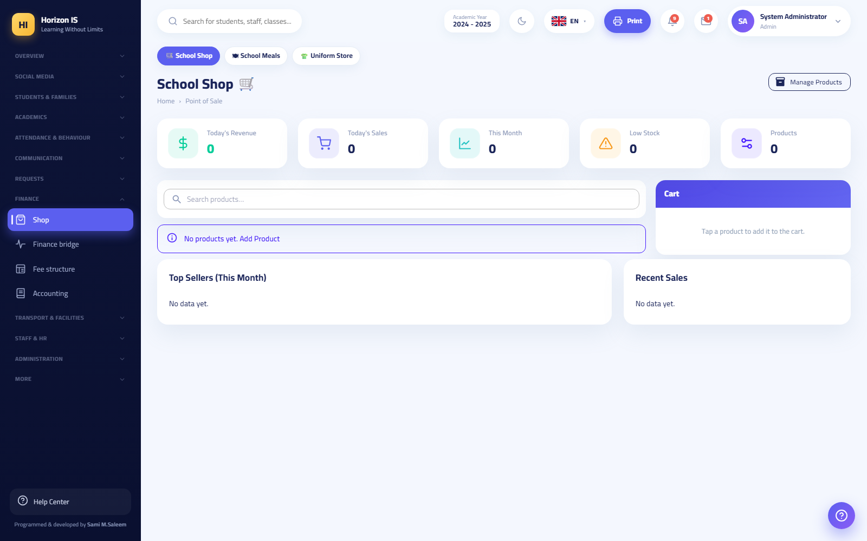شاشة الحانوت
Opening "Shop" shows three pills: School Shop (حانوت المدرسة) /shop, School Restaurant (مطعم المدرسة) /meals, Uniform Store (متجر الأزياء) /uniforms.

Selling from the point of sale
Purpose Record the shop's daily sales quickly, in cash or on a student's account.
Who can Holders of shop.manage (the Accountant and management by default).
Before you start Make sure the products are entered with correct stock (see Products).
Steps 1. Open /shop. You see the product grid and today's cards: Today's revenue (إيراد اليوم), Today's sales (مبيعات اليوم), This month (هذا الشهر), Low stock (مخزون منخفض). 2. Click a product to add it to the cart ("Click a product to add it to the cart"). Adjust quantities inside the cart. 3. Optionally: pick the student (to sell on their account) or type the customer name. 4. Choose the payment method: Cash (نقدًا), Card (بطاقة), or On account (على الحساب) (charged to the student's account). 5. Click the Collect {amount} (تحصيل) button. 6. To cancel the cart before collecting: Clear (تفريغ).
Expected result The message "Sale {number} recorded — {amount}." appears, stock drops automatically, and the sale shows in Latest sales (آخر المبيعات) and in today's revenue.
Common mistakes - Selling "on account" without selecting a student — pick the student first. - Ignoring the low/out (منخفض/نفد) stock alert until the item runs out.
Troubleshooting - The product does not appear in the grid? Search in Search for a product… (بحث عن منتج…) or check that it has not been deleted from product management.
Related topics Products · Installments and Payments

Managing products and stock
Path: /shop/products — the Manage products (إدارة المنتجات) button from the point of sale.
- Add product (إضافة منتج): name, Arabic name, category, code/barcode, price, cost, stock, reorder level.
- Restock (تزويد المخزون): open the product and click restock — "Enter a positive number to add or a negative number to deduct."
- Deleting a product asks for confirmation: "Delete product '{name}'?"
- Helper cards: Best sellers (this month) (الأكثر مبيعًا (هذا الشهر)) and Latest sales (آخر المبيعات).

The restaurant and uniforms
- School Restaurant (مطعم المدرسة) /meals: per-student meal subscriptions, with the weekly restaurant menu (قائمة المطعم) in /meals/menu (the "published" menu is what families see in the app) and non-subscription reasons (أسباب عدم الاشتراك) in /meals/reasons.
- Uniform Store (متجر الأزياء) /uniforms: uniform items and their stock, bundles (حزم) per stage (item + quantity), and Issue / Sell (إصدار / بيع) buttons plus bundle management.

7.7 7. The Requests Section
The Requests (الطلبات) section in the sidebar gathers everything awaiting an office decision:
Item | Path | Permission
Absence Requests (طلبات الغياب) | /absence-requests | attendance.manage
Payment Requests (طلبات الدفع) | /payment-requests | finance.payments.manage
My Leave (إجازاتي) | /my-leave | all staff (no permission)
Account Closure Requests (طلبات إغلاق الحسابات) | /departure-requests | admin.users.manage

Absence Requests
طلبات الغياب
Purpose Decide on the absence requests that guardians send from the app ("Report an absence").
Who can Holders of attendance.manage (teachers, homeroom teachers, department and stage heads, and management).
Steps 1. Open /absence-requests. 2. Review the request: the student, the reason, the duration (from/to), the note. 3. Click Approve (موافقة) or Reject (رفض).
Expected result The guardian sees the request's status in the app along with the name of who handled it, and the excuse is reflected on the attendance record.
Related topics The Attendance and Conduct chapter · The Action Center

My Leave and requesting leave (staff self-service)
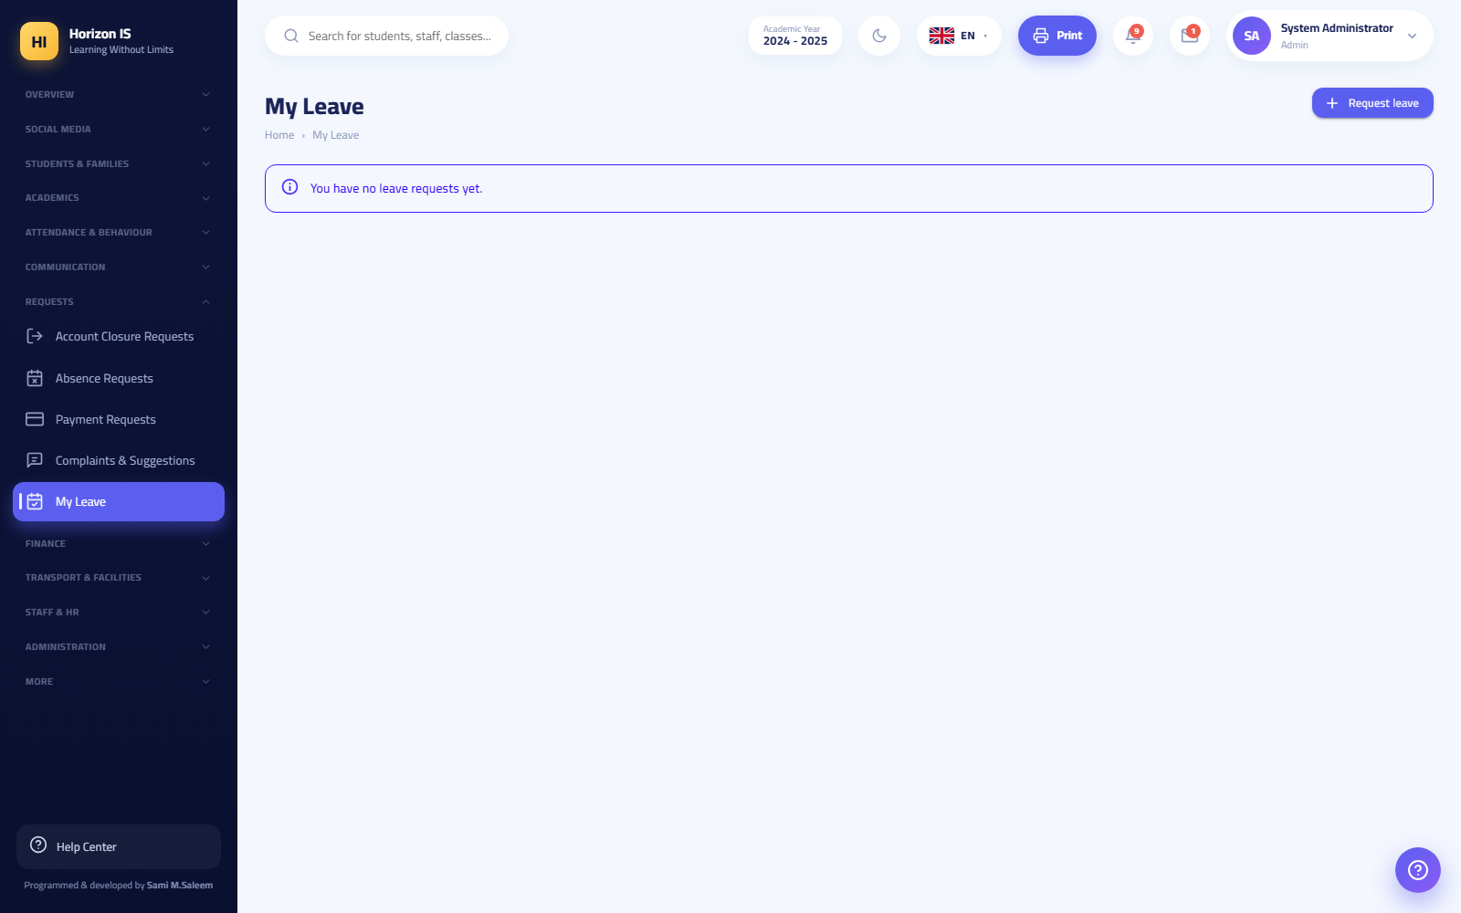شاشة إجازاتي
Purpose Every staff member — whatever their role — sees their leave balance and submits a request.
Who can Every signed-in staff member. No permission needed.
Steps 1. Open Requests ← My Leave (الطلبات ← إجازاتي) (/my-leave). You see your balance, your previous requests, and their status. 2. Click Request leave (طلب إجازة) (or open /request-leave directly). 3. Choose the leave type and the duration, write the reason, then Submit request (إرسال الطلب). 4. Track the status from the same screen until it is approved or rejected from Leave Management.
Note: A student's leave request is a different thing: the guardian submits it from the app or from the "My attendance" screen, and it is processed in Absence Requests.

7.8 8. Transport and Facilities
The Transport and Facilities (النقل والمرافق) section in the sidebar.

Transport: the screen map
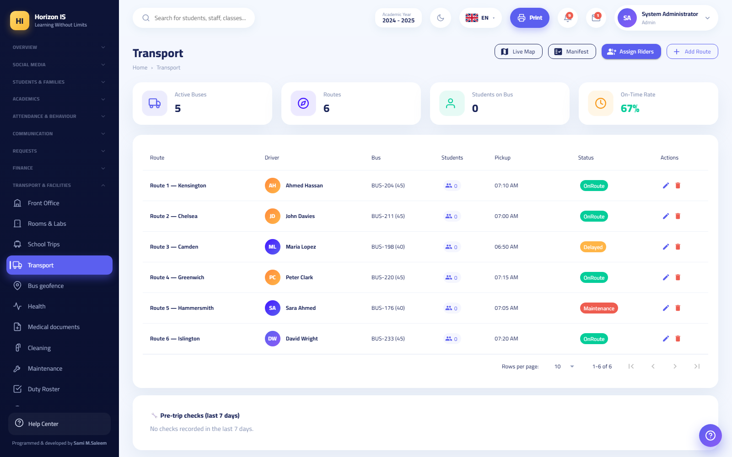شاشة النقل
Screen | Path | What it does
Transport (home) (النقل) | /transport | Routes and buses; the Add route (إضافة خط) button and links to the other screens
Assign Students to Buses (إسناد الطلاب إلى الباصات) | /transport/assign | Linking each student to their route and bus
Bus Manifest (بيان الباصات) | /transport/manifest | Passenger lists; Route manifest PDF (بيان الخط PDF), Move to another bus (نقل إلى باص آخر), Remove from bus (إزالة من الباص)
Live Fleet Map (خريطة الأسطول المباشرة) | /transport/live | Bus positions in real time; Show all buses (عرض كل الباصات)
Driver Mode (وضع السائق) | /transport/drive | The driver's in-trip screen
Bus Geofence (السياج الجغرافي للباص) | /transport/geofence | Geographic alert boundaries (permission transport.manage)
My Child's Bus (باص ابني) | /transport/my-bus | Guardian/student view only — visible to them, not to staff
Who can? Fleet-level reading (the manifest, the map, the overview) is protected: a manager, or a holder of transport.view/transport.manage; otherwise the request is rejected with "Transport data is restricted to the transport office" (بيانات النقل مقصورة على مكتب النقل). The driver sees only their own trip, and the guardian sees only their child's bus.
Driver mode in brief (mostly used from the mobile app): start the trip (Start trip (ابدأ رحلة) — requires explicit consent to share GPS location), and for each student: Boarded / Got off / Did not board (صعد / نزل / لم يركب) — each status instantly notifies the student's family; the Bus approaching (الباص يقترب) button gives advance warning; emergency buttons (breakdown/traffic/emergency); then Arrived (end trip) (وصلت (إنهاء الرحلة)), which shows the trip summary.
Tip: Train drivers to always end the trip — the summary (duration, distance, boarded/got off/absent) is the school's official record of the trip.

Pickup Call
Path: /pickup — title: Pickup Call (نداء الاصطفاف). Permission: facilities.view.
At the gate at dismissal time: when the guardian arrives (or taps "I have arrived for pickup" in the app), click Call (نداء) to summon the student to the gate, then Left (غادر) when they exit.

Health and medical documents
- Health (الصحة) /health — title: Health and Medical Records (السجلات الصحية والطبية). Permission: health.view (held by the Nurse by default; the Doctor holds it only by explicit grant). The Record visit (تسجيل زيارة) button documents every clinic visit.
- Medical Documents (الوثائق الطبية) /child-medical: guardians upload their children's medical documents from the app, and the health staff review them here. An Upload document (رفع وثيقة) button is also available to staff.
Important: Health records are sensitive data. Grant health.view only to authorized health staff.

Cleaning, maintenance, and the duty roster
- Cleaning (التنظيف) /facilities/cleaning (permission facilities.manage): cleaning-area schedules — Manage areas (إدارة المناطق), Add to schedule (إضافة إلى الجدول), Save (حفظ).
- Maintenance (الصيانة) /facilities/maintenance (permission facilities.manage): maintenance work tickets — the New job (عمل جديد) button for each fault.
- Duty Roster (جدول المناوبة) /duty (permission facilities.view): supervision shifts — Add shift (إضافة مناوبة) for management, and Check in (تسجيل حضور) for the person on duty.

7.9 9. Staff HR
Sidebar: Staff HR ← Staff (شؤون الموظفين ← الموظفون) (/staff, permission hr.view). Opening the page shows a pill strip covering the full HR file:
Pill | Path
Staff (الموظفون) | /staff
Staff Attendance (حضور الموظفين) | /staff/attendance
Time Clock (ساعة الحضور) | /staff/timeclock
Leave Management (إدارة الإجازات) | /staff/leave
Punch Corrections (تصحيحات البصمة) | /punch-corrections
Payroll (الرواتب) | /staff/payroll
Staff Conduct (سلوكيات الموظفين) | /staff-conduct
HR Settings (إعدادات الموارد البشرية) | /staff/hr-settings
Devices (الأجهزة) | /staff/devices

The staff directory
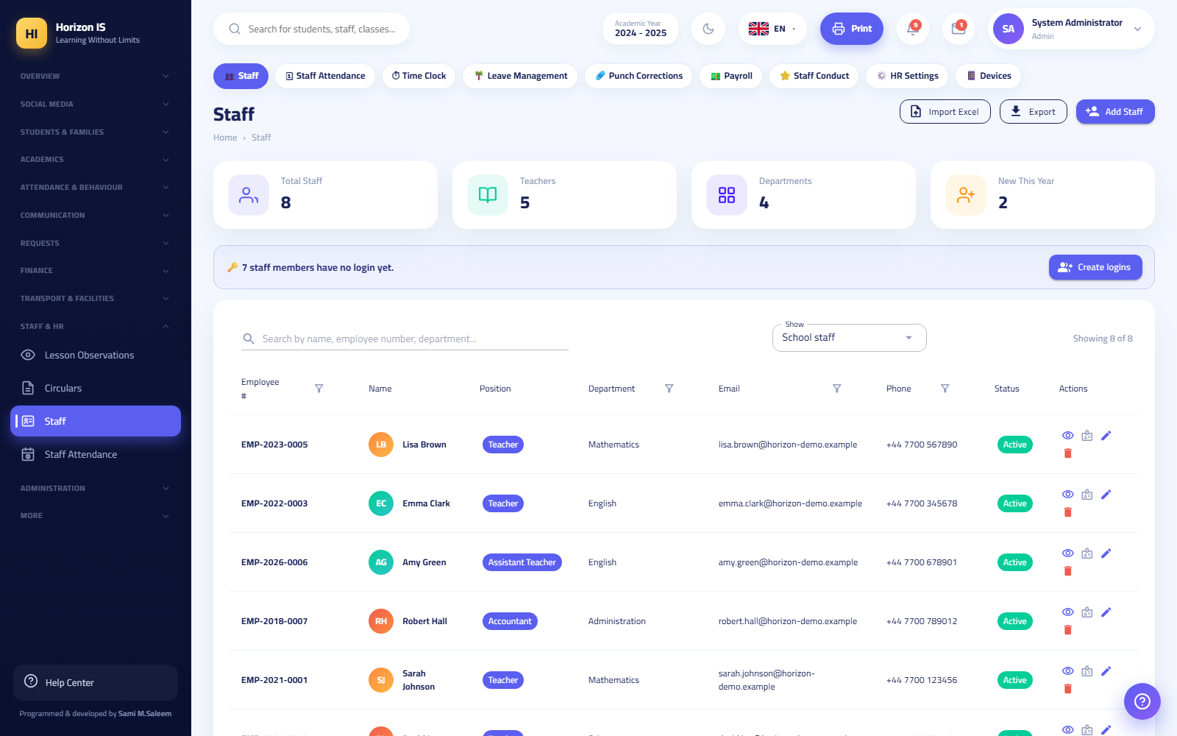قائمة الموظفين
/staff is the staff directory: search and filtering, an Export (تصدير) button, and an Add staff member (إضافة موظف) button. Each staff member's profile is at /staff/profile/{id}.

Adding a staff member
Path: /staff/add (editing at /staff/edit/{id}).
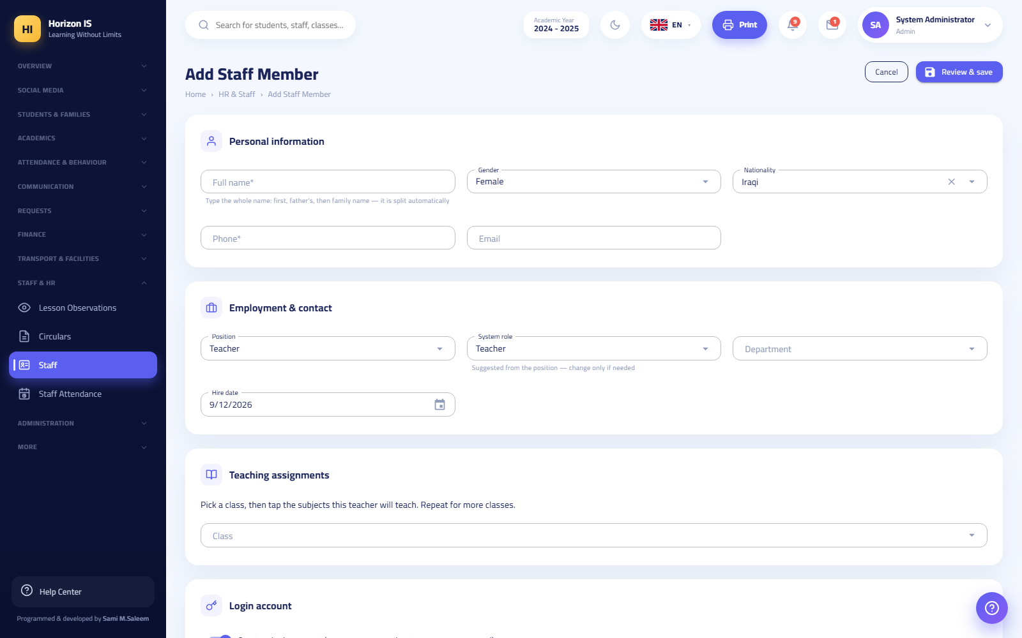نموذج إضافة موظف
Purpose Create the new staff member's employment record — which is not a login account (see the last step).
Who can Management only (creating staff records is restricted to management on the server).
Before you start Prepare: the full name, the phone number (mandatory), the email if any, the position, and the hire date.
Steps 1. Open /staff and click Add staff member (إضافة موظف). 2. Personal information: the full name in one field (the system splits it automatically into first/middle/last), gender, nationality. 3. Employment and contact: - Position (المسمّى الوظيفي): choose from the list (Teacher, School Manager, Secondary Department Head, Primary Department Head, Coordinator, Nurse, Accountant, Receptionist, Doctor, Librarian, Bus Driver, IT, Service Worker, General Staff). - System role (دور النظام): a separate list — read the warning below before choosing it. - Department (القسم): free text with suggestions. - Hire date, phone (mandatory), email. 4. Click Save staff member (حفظ الموظف). 5. Later, to give the staff member a login account: go to User Accounts — the staff record alone does not allow signing in.
Expected result - An automatic employee number in the format EMP-{year}-0001 (the counter includes those who have left). - The staff member appears in the directory and in the attendance, leave, and payroll screens.
Important — why does "System role" matter so much? The system role is not just a description. It is what decides who appears to families as an official contact in the app, across the entire school. Families are shown only the official communication roles: School Manager, System Manager, Registrar, department and stage heads, Nurse, Doctor, Accountant, Receptionist, IT, and the Safeguarding Officer. Service Worker, General Staff, and Bus Driver never appear to families — even if one of them is mistakenly placed on a teaching assignment. Choosing the wrong system role means either someone appears to families who should not, or someone families need to reach disappears from them.
Warning — "Position" carries weight too: Some position values are used literally inside the system: "Teacher" counts toward teaching-staff statistics, and "School Manager", "Secondary Department Head", and "Primary Department Head" are matched for report-card signatures. Enter the correct position from the list — do not improvise.
Common mistakes - Choosing "Teacher" as the system role for an administrative employee so they "see more" — permissions are managed from the permissions matrix, not from the system role. - Leaving the phone empty — the field is mandatory and the form will not save. - Expecting the staff member to sign in as soon as the record is saved — an account must be created in /users.
Troubleshooting - Additional fields appear only on the edit screen: work-hours start/end, and a Field work (عمل ميداني) option (exemption from the punch geofence) for mobile staff.
Related topics User Accounts · Roles and Permissions · Leave Management

Staff attendance and the punch clock
- Staff Attendance (حضور الموظفين) /staff/attendance (permission hr.manage): a daily register — for each staff member: present/absent/late/on leave with in/out times and a note, then Save (حفظ).
- Time Clock (ساعة الحضور) /staff/timeclock: a live board of today's punches (refresh, settings). Staff punch in from the mobile app: fingerprint confirmation + GPS location inside the school geofence, and fake-location apps are detected and blocked.
- Punch Corrections (تصحيحات البصمة) /punch-corrections: staff requests to fix a forgotten punch — Approve (موافقة) or Reject (رفض).
- Devices (الأجهزة) /staff/devices: staff phones approved for punching and sign-in — Add device (إضافة جهاز), Save (حفظ). Approval is once per phone.

Leave Management
Path: /staff/leave — the Leave Management (إدارة الإجازات) pill.
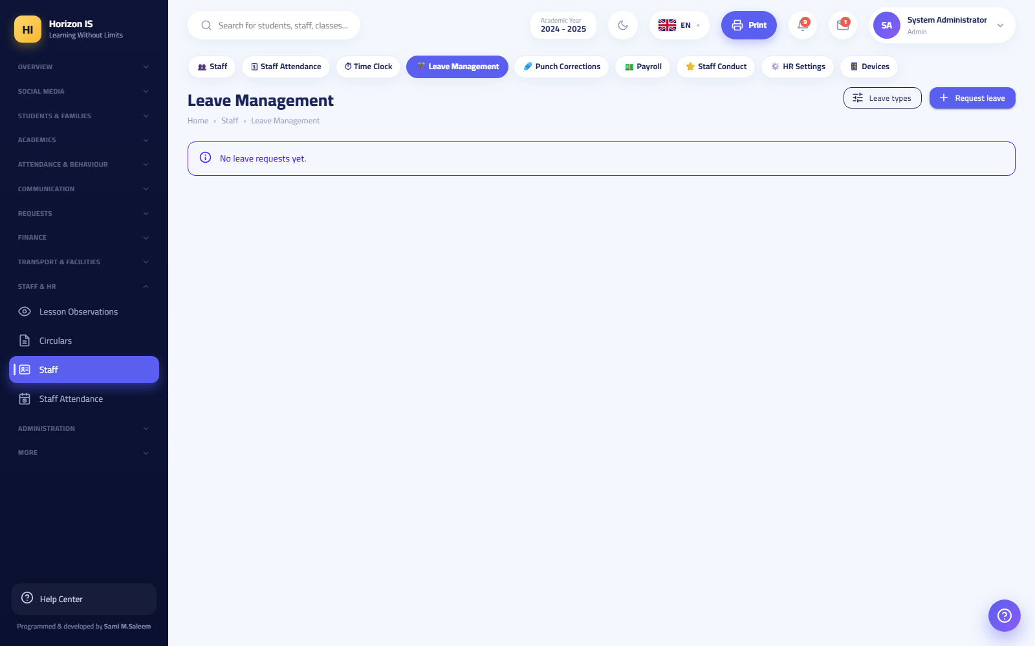إدارة الإجازات
Purpose Define leave types and decide on staff requests.
Who can Management (and "My Leave" is available to every staff member — see My Leave).
Steps 1. Open /staff/leave. 2. From the Leave types (أنواع الإجازات) button, define the types and the annual day count for each (annual, sick…). 3. Review incoming staff requests: approve, or click Reject (رفض). 4. The office can submit a request on behalf of a staff member using the Request leave (طلب إجازة) button on the same screen. 5. Save (حفظ).
Expected result The staff member sees the decision on their request in "My Leave" and in the app, and unpaid leave is reflected automatically in Payroll.

Payroll
Path: /staff/payroll — the Payroll (الرواتب) pill.
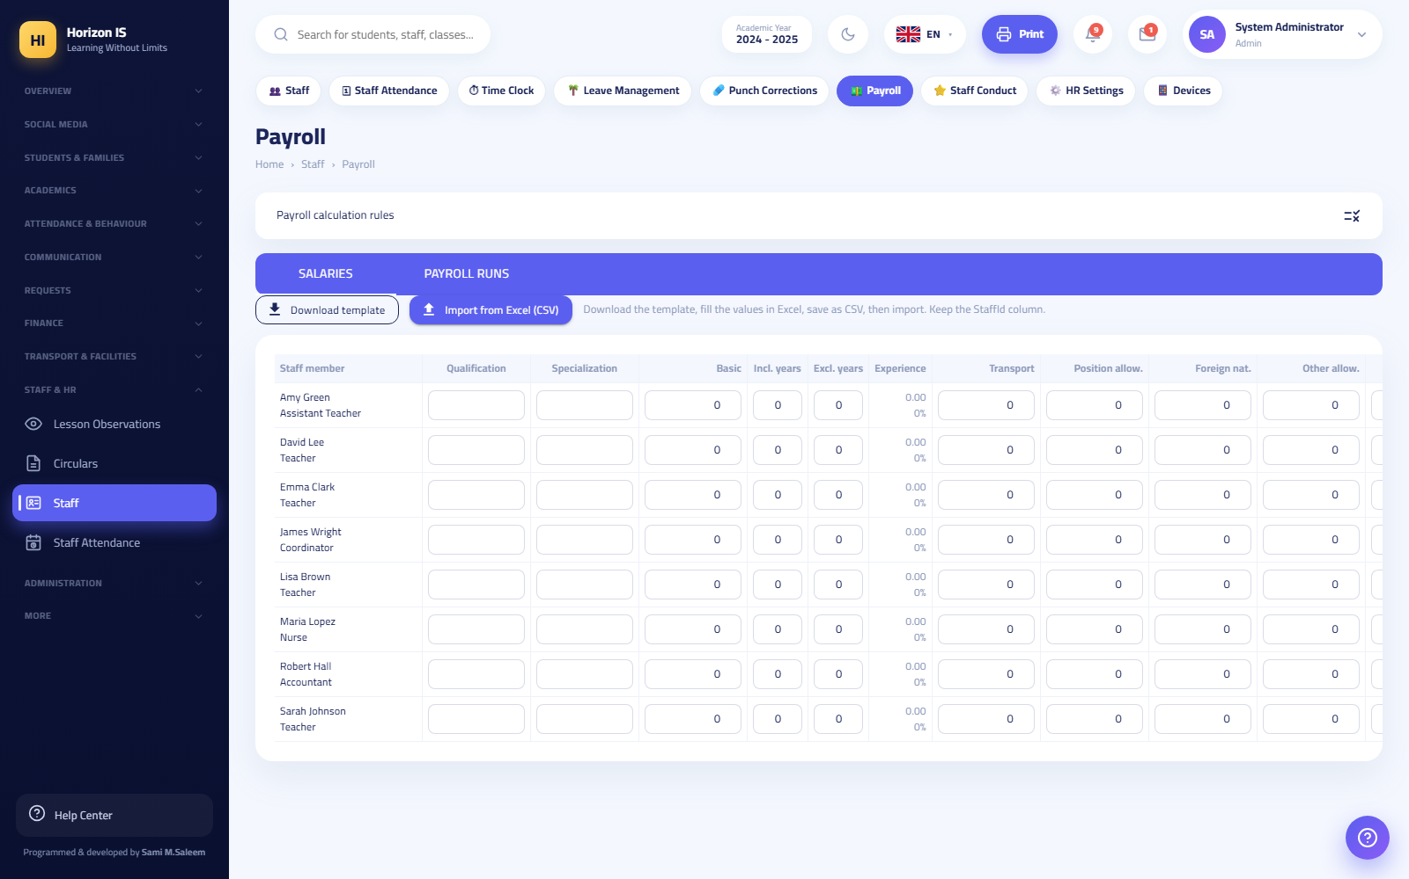شاشة الرواتب
Purpose Generate and review a monthly payroll sheet.
Who can Management (the pill lives in the Staff HR section).
Before you start Finish the month's attendance register and the leave decisions — deductions are read from both.
Steps 1. Open /staff/payroll. 2. Click Generate payroll (توليد المسيّر) for the desired month. Unpaid leave and unexcused absences are filled in automatically from the records, and the figures remain a draft that is editable. 3. Review the columns: base salary, experience, allowances, and the employer's social-security share. 4. For those who prefer Excel: Download template (تنزيل القالب) then Import from Excel (CSV) (استيراد من Excel (CSV)). 5. A wrong payroll sheet? Delete (حذف) then regenerate.
Expected result A complete monthly payroll sheet for all staff, built on actual attendance data.
Common mistakes - Generating the sheet before closing the month's attendance — you will have to delete it and regenerate.
Related topics Staff attendance · Leave Management

Staff conduct, HR settings, and circulars
- Staff Conduct (سلوكيات الموظفين) /staff-conduct: commendation and violation notes in categories — the Add category (إضافة فئة) button.
- HR Settings (إعدادات الموارد البشرية) /staff/hr-settings: work hours and the punch geofence location — Save settings (حفظ الإعدادات) and a Use my current location (استخدام موقعي الحالي) button to capture the school's coordinates while you are inside it.
- Circulars (التعاميم) /circulars (available to all staff): official circulars with attachments — Attach file (إرفاق ملف) then Send to all staff (إرسال إلى كل الموظفين), and each staff member clicks Acknowledge (إقرار بالاطلاع), documenting who has read it.

7.10 10. Administration and System
The Administration and System (الإدارة والنظام) section in the sidebar is the system's control room. Most of its screens are for management, and some are for the IT staff member.

User Accounts
Path: /users — title: User Accounts (حسابات المستخدمين). Permission: admin.users.manage (management + IT).
حسابات المستخدمين
Purpose Create login accounts and link them to people's records, reset passwords, and disable accounts.
Who can Management and the IT staff member. With two strict ceilings on IT: they can never grant the General Supervisor/School Owner roles ("This role cannot be granted from the IT module"), nor School Manager/System Manager ("Administrative roles are granted only by school management"), nor manage any account holding these roles.
Steps — creating an account 1. Open /users and click New user (مستخدم جديد). 2. In the Create account (إنشاء حساب) window: the full name, the email, the role (only the roles you are entitled to grant appear — and the server re-verifies), then Represents (يمثّل): staff member / student / family, and pick the linked record. 3. Save. The temporary password appears in a green panel only once: "Share it with the user — they will be asked to change it at first sign-in." 4. Hand the password to the staff member securely. At first sign-in they are forced to set a new password (10+ characters, with an uppercase letter, a lowercase letter, a digit, and a symbol).
Other steps on the same screen - Reset password (إعادة تعيين كلمة المرور): issues a new one-time temporary password. - Disable account (تعطيل الحساب): cuts off access immediately — session tokens are revoked and web and app sessions are closed together. - Accounts ranked above yours show no edit buttons — and the server refuses in any case.
Expected result An account linked to the right person, with the right role, and a temporary password handed over exactly once.
Common mistakes - Creating an account without linking it to the staff/student/family record — the link is what gives the person their personal screens (attendance punching, children's data…). - Closing the window before copying the temporary password — it will not appear again; use "Reset password".
Related topics Roles and Permissions · Adding a staff member · Account Closure Requests

Roles and Permissions
Path: /admin/permissions — title: Roles and Permissions (الأدوار والصلاحيات). Permission: admin.roles.manage.
مصفوفة الصلاحيات
Purpose Control what each role sees and does — the matrix is what draws the sidebar for everyone outside management.
Who can Management and the IT staff member. The "General Supervisor" role's permissions can be changed only by a General Supervisor: "Changing the General Supervisor's permissions is restricted to the General Supervisor."
Steps 1. Open /admin/permissions. 2. Pick the role from the right-hand panel. 3. Enable/disable the permissions, grouped by module (students, attendance, finance, administration…). The Grant all (منح الكل) and Clear all (مسح الكل) buttons speed things up. 4. Click Save changes (حفظ التغييرات) (or Discard (تجاهل)).
Expected result - The change takes effect at the next sign-in for every user holding the role — ask them to sign out and back in. - The sidebar items the role sees change automatically.
Important — the "floor" cannot be stripped: Every role has a core permission bundle that the system re-pins on every startup, "so that no role silently loses its essential screens." What you add above the floor stays; what you try to strip from the floor comes back on its own after a restart.
Note: The matrix does not control "which classes / which children" — the scope of classes, children, and buses comes automatically from assignments and family linking, not from here. And if you see an "Unknown roles" section, those are leftovers of old data that cannot be granted — ignore them.
Related topics User Accounts · Menu Designer

Menu Designer
Path: /settings/menu — the Menu Designer (تصميم القائمة) pill inside Settings. Permission: admin.settings.manage.
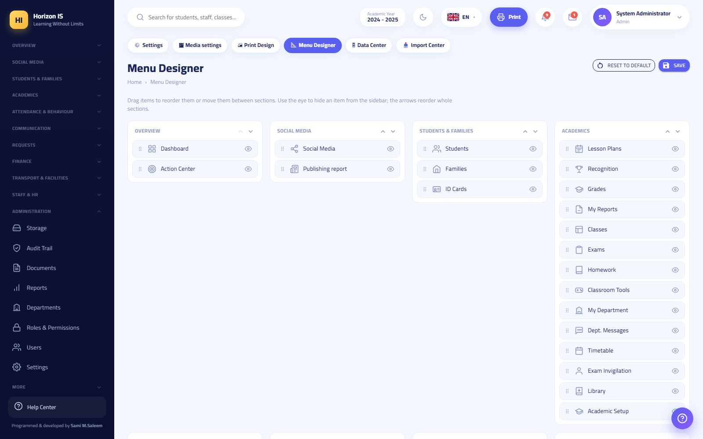تصميم القائمة
Purpose Customize your school's sidebar order: reorder items, move them between sections, hide what you do not use.
Who can Management.
Steps 1. Open /settings/menu. 2. Drag items to reorder them or move them between sections, and hide unused items. 3. Save (حفظ). To go back: Reset to default (إعادة الضبط الافتراضي).
Expected result A sidebar in your school's order for all users.
Important: The Menu Designer neither grants nor removes permissions. A hidden item's page remains protected by its permission, and a visible item does not open for someone without its permission. Access is managed exclusively from the permissions matrix. Items moved to an unknown section fall into an "Other" group at the bottom of the menu.

Feature Flags
Path: /feature-flags — title: Feature Flags (مفاتيح الميزات). Management only (the WebManager policy).
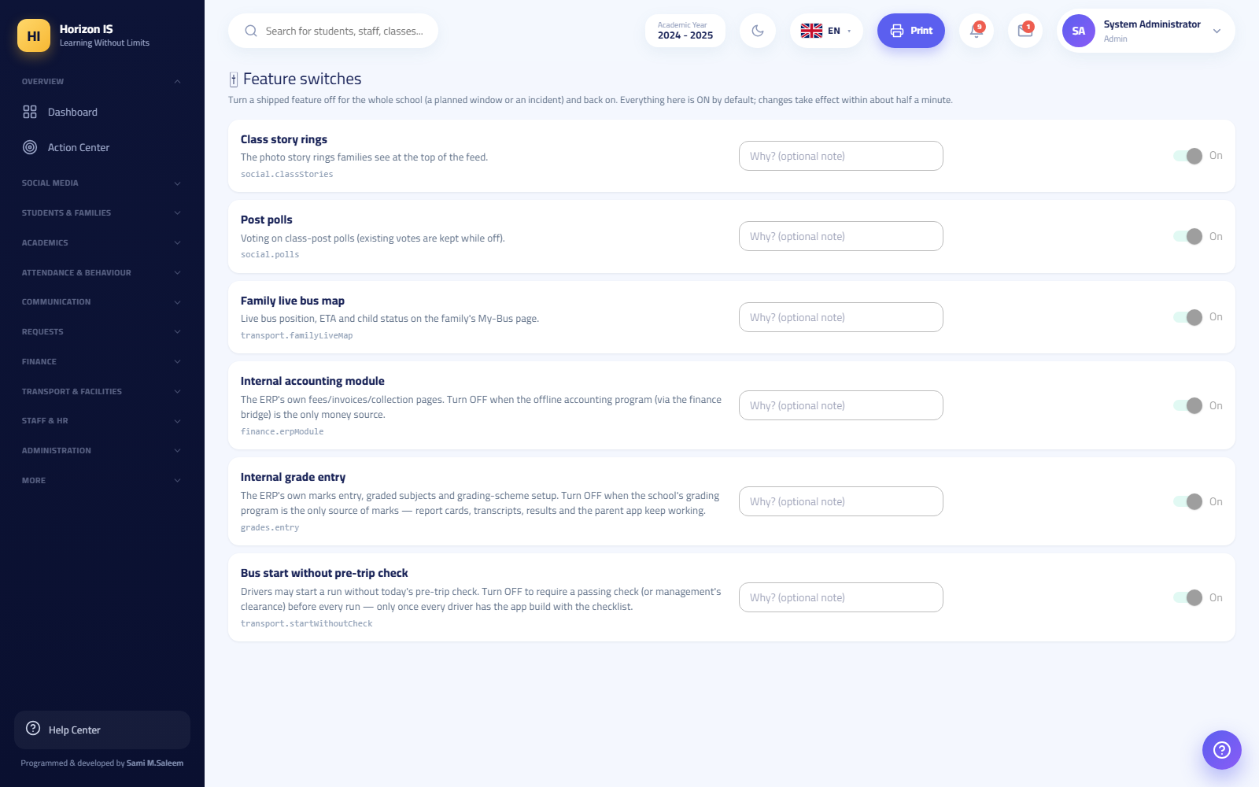مفاتيح الميزات
Purpose Turn a released feature off for the whole school (for a planned period or when there is a problem) and bring it back whenever you like.
Steps 1. Open /feature-flags. 2. Each feature has an On/Off (تعمل/متوقفة) switch and a Reason? (optional note) (السبب؟ (ملاحظة اختيارية)) field — always write the reason; it shows under Last change (آخر تغيير). 3. Save — "Saved."
Expected result Everything runs by default, and a change takes effect within about half a minute with no restart.
Example: Switching off FinanceErpModule hides the fee and accounting screens from the whole school immediately — and it is the first thing to check if "finance has disappeared".

Academic years and terms
Location: Settings (الإعدادات) (/settings) ← the Academic Year (السنة الدراسية) tab.
- The Academic years (السنوات الدراسية) table: the year, start, end, status — the current year carries a green badge.
- Set as current (تعيين كحالية): switch the working year.
- Roll over into this year (ترحيل السنة إلى هذه): end-of-year promotion — it shows a preview with the numbers first and then asks for confirmation: it promotes every active student one grade, graduates the top grade, wipes all section assignments (they are rebuilt via "Class Assignment"), and makes the target year current.
- Archive the year's results (أرشفة نتائج السنة): a final snapshot of all students' results before the rollover — preview then confirm; running it again replaces that year's records.
Warning: There is no "Add year" button — years are prepared by the system during provisioning. And before any rollover: archive the results first. There is also a grade-by-grade rollover tool at /year-rollover that requires typing the word RENEW to confirm.
Academic terms (first/second term, their weights and components) are managed from the Grading Schemes (أنظمة الدرجات) screen /grading-schemes via the Terms (الفصول) button — see the Grades and Reports chapter.

School Settings
Path: /settings — permission: admin.settings.manage. The settings pills:
شاشة الإعدادات
Pill | Path | What it does
Settings (general) (الإعدادات) | /settings | The school profile, the years, your account, and the backup
Media Settings (إعدادات الوسائط) | /settings/media | Image and video limits
Print Design (تصميم الطباعة) | /settings/print | Letterhead and styles for all printouts — Save (حفظ) and Reset to default (إعادة الضبط الافتراضي)
Menu Designer (تصميم القائمة) | /settings/menu | See Menu Designer
Data Center (مركز البيانات) | /admin/data | Bulk Excel export/import (template, valid-row check)
Import Center (مركز الاستيراد) | /import | Download Excel template (تنزيل قالب Excel) then Upload Excel/CSV file (رفع ملف Excel/CSV) then Import now (استيراد الآن)
In the general tab: the school name and logo — while the school code (رمز المدرسة (Code)) is read only: it is the deployment identity and never changes. In your account section: Upload photo (رفع صورة), Update password (تحديث كلمة المرور), and Enable/disable two-step verification (تفعيل/تعطيل التحقق بخطوتين).

Storage
Path: /storage — title: Storage (التخزين). Permission: admin.settings.manage.
شاشة التخزين
Purpose Monitor the media budget: where the space went, who the top uploaders are, and adjust the limits.
What is on the screen - Usage breakdown by type and by module, and a Top uploaders (أكثر الرافعين) list. - Management tools: the overall school budget (ميزانية المدرسة) and a per-user override (تجاوز لكل مستخدم) when needed. - The Migrate old files out of the database (نقل الملفات القديمة من قاعدة البيانات) button: moves old media stored inside the database into the file store, with a checksum integrity check on every file before it is accepted. Run once, under the supervision of the operating party.

Backups
Two places that must not be confused:
- A quick snapshot from Settings: in /settings, the backup section — "downloads a JSON file with the school profile and the record counts for each module". Useful for documentation and peace of mind ("{year} contains {count} records across {count} modules"), and "Backup snapshot downloaded." appears on completion.
- The real database backup: runs automatically on the server and is managed by the party operating the system — it is not something a school staff member does from the browser.
Important: The JSON snapshot is not a substitute for the database backup. In any data-loss incident contact technical support immediately — do not attempt to "restore" on your own.

The Audit Log and the Action Center
- Audit Log (سجل التدقيق) /audit (permission admin.audit.view): a read-only record of who did what and when — your first reference in any confusion ("who changed this?").
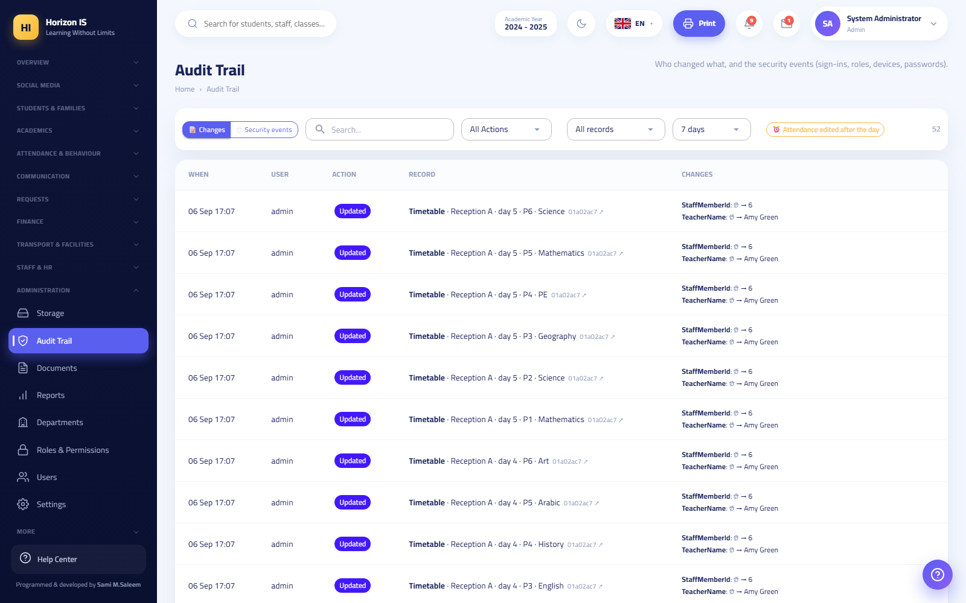سجل التدقيق
- Action Center (مركز الإجراءات) /action-center (the "Home" section of the menu, permission admin.audit.view): one live queue of everything awaiting a decision: result-publication approvals, absence, payment, and leave requests, pending devices, and more. Each card has an Open (فتح) button that takes you straight to the decision screen.
مركز الإجراءات
Tip: Make opening the Action Center the first habit of the morning for the administration staff member — if it is empty, nothing is stuck with you.

Account Closure Requests
Path: /departure-requests — title: Account Closure Requests (طلبات إغلاق الحسابات) (shown in the "Requests" section of the menu). Permission: admin.users.manage.
طلبات إغلاق الحسابات
Purpose Decide on guardians' requests to close their login account (the request is submitted from the mobile app: "Departure request / close account").
Who can Management and the IT staff member (admin.users.manage).
Before you start Make sure the request is intentional — talk to the family if the situation is unclear; the requester can also withdraw the request from the app before it is decided.
Steps 1. Open /departure-requests. 2. Review the request: who submitted it, and their optional reason. 3. Click Approve and close (موافقة وإغلاق) or Reject (رفض).
Expected result Approval disables the login account and deletes nothing: sign-in is blocked, sessions are ended, devices are barred, and notifications stop — while the student's and family's school records remain fully intact.
Common mistakes - Assuming approval "deletes the family from the system" — there is no deletion at all; it is only the closure of a login account. - Using this screen for a student leaving during the school day — that is the Departure Log (سجلّ الخروج) /attendance/departures, an entirely different thing.
Troubleshooting - The family came back after closure? Access is re-enabled from User Accounts, with a new family code if needed.
Related topics User Accounts · The Action Center

7.11 Chapter Summary
- Finance is protected in depth: reading is for the finance office, recording payments is strictly for management and the Accountant, and the receipt carries an automatic R-yymmdd-#### number.
- "Received" on a payment request records no money — the actual recording always happens on the Installments screen.
- The "System role" on the staff form decides who appears to families as a contact — the service worker and the driver never appear.
- Permissions come from the matrix, ordering from the Menu Designer, and full shutdown from Feature Flags — three different tools for three different questions.
- Closing an account is disabling, not deleting, and the audit log always answers "who did this?".

Chapter 8End-to-End Workflows
This chapter is the practical "backbone" of the manual. It takes ten core tasks that every school goes through during the academic year and explains each one step by step, exactly as it appears on screen: where you start, what you click, what happens after saving, and the mistakes users typically make.
Every section follows the same structure: Purpose, Who can do this, Before you start, numbered steps, Expected result, Common mistakes, Troubleshooting, and finally Related topics.
Important: The button and page names in this chapter are taken verbatim from the system. If you cannot find a button mentioned here on your screen, the most likely reason is that your role does not have the required permission — check the "Who can do this" section at the start of each workflow.
Demo environment note: To practice without touching real data, use the demo environment provided by system administration (the demo account with password School@2025). All names in the examples below are demo names such as "Demo Student" and "Demo Parent".

8.1 Chapter Map
# | Workflow | Who usually performs it
1 | Setting up a new academic year and terms | Administration (Principal / System Admin)
2 | Creating grade levels, classes, and sections | Administration
3 | Adding a staff member + login account + roles | Administration + IT staff
4 | Enrolling a student, linking the family, and the family login code | Registrar / Administration + IT
5 | Teaching assignments and building the timetable | Administration / Timetable manager
6 | Recording daily attendance (web and app) | Teacher
7 | Exams → mark entry → publication approval → family access | Teacher + Administration
8 | Fees: structure → assignment → payment → receipt | Accountant / Administration
9 | School-wide announcements, class posts, and stories | Administration + Teacher
10 | End-of-year rollover, graduation, and departures | Administration

8.2 1) Setting Up a New Academic Year and Terms

Purpose
Preparing the "time frame" the school operates in: setting the current academic year, defining the terms (first/second term) and the grade components inside each term, and configuring the general time settings (period length and time zone).

Who can do this
- School administration only: School Principal, School Owner, or System Admin. The Settings page is restricted by the admin.settings.manage permission.
- Managing terms in the grading schemes screen is also restricted to administration, and it appears only if the "mark entry" feature flag is enabled for your school.

Before you start
- Know the official start and end dates of the new year.
- If you are at the end of an old year, complete Workflow 10: End-of-Year Rollover first — archive before you roll over.
Important: There is no "Create academic year" button in the system. Academic year records are prepared by the system itself when your school is provisioned. Your job is: choosing which year is the "current" one, rolling over into it, and archiving the results of the finished year. If you cannot find the upcoming year in the table, contact technical support.

Steps — Managing Years
- From the sidebar open Settings (الإعدادات) (/settings).
- Go to the Academic Year (السنة الدراسية) tab, then the Academic Years (السنوات الدراسية) section. You will see a table of years (Year / Starts / Ends / Status), with the current year carrying a green Current badge.
- To switch the working year: click Set as Current (تعيين كحالية) next to the desired year. All screens (attendance, grades, fees...) always operate on the current year.
- At the end of the year: click Archive Year Results (أرشفة نتائج السنة) — the system takes a fixed snapshot of the final computed results of every active/enrolled student. A preview appears first, then a confirmation.
- Then click Roll Over the Year to This One (ترحيل السنة إلى هذه) on the new (non-current) year. A preview appears with the number of students who will be promoted and the number who will graduate, then you confirm the execution. The full rollover details are in Workflow 10.
شاشة الإعدادات — تبويب السنة الدراسية

Steps — Defining Terms and Grade Components
- From the sidebar open Grades (الدرجات), then choose the Grading Schemes (أنظمة الدرجات) tab (/grading-schemes).
- Click the Terms (الفصول) button. The term definition dialog opens.
- For each term set: the name (in Arabic and English), the order, the weight, and then the weighted components inside the term.
- Save. The term's maximum mark is computed automatically = the sum of its components' marks.
Example: A term with two components: "Coursework" out of 40 + "Final Exam" out of 60. The term's maximum mark automatically becomes 100.
Warning: Any term or component that already has student marks entered against it cannot be deleted — the system refuses the deletion and names the terms/components that are linked to marks. Plan the term structure before mark entry begins.

Steps — General Time Settings
- In the same Settings, set the Period minutes field (period length in minutes) — the timetable uses it across all classes.
- Make sure the school's time zone is correct (for example Asia/Baghdad).

Expected result
- The new year carries the Current badge, and all system screens operate on it.
- The terms and their components appear in the gradebook when entering marks.
- The finished year's results are stored as a fixed archive that appears in the student's academic record.

Common mistakes
- Rolling over before archiving. You rolled the year over and then discovered last year's results were never archived. The correct order is always: archive first, then roll over.
- Re-archiving unintentionally. Re-running "Archive Year Results" for the same year replaces that year's records with the version computed now. Do not re-archive after a new year has started unless you know exactly what you are doing.
- Forgetting to set the period length before building the timetable, which makes the printed period times wrong.

Troubleshooting
Symptom | Likely cause | Fix
I cannot see the Academic Year tab | You are not in an administration role | Ask the system admin to perform the operation
The "Terms" button is not visible in Grading Schemes | The mark-entry feature flag is off for your school | Your school imports marks from an external system; check with administration
The upcoming year is not in the table | Year records are created by the system | Contact technical support to add it

Related topics
- Workflow 2: Creating classes and sections — classes are linked to the current year.
- Workflow 7: Grades and publication — the terms and components defined here are the mark-entry columns.
- Workflow 10: End-of-year rollover — the full details of rollover and graduation.

8.3 2) Creating Grade Levels, Classes, and Sections

Purpose
Building the class structure for the current year: sections for each grade level (such as Year 7 section A and section B), then distributing unplaced students across the sections.

Who can do this
- Viewing the class list: anyone with the classes.view permission (teachers, the registrar, heads of department...).
- Creating and editing classes: administration only (the server-side command is restricted to administration).
- Class placement (/students/placement): administration or anyone with the students.edit permission.

Before you start
- Make sure the correct academic year is the "current" one (Workflow 1) — a new class is automatically linked to the current year.
- The grade levels (Reception, Year 1 … Year 11) are pre-provisioned in the system with their ordering and educational stages, along with the school's four houses. There is no screen for adding a new grade level — if you need a level that does not exist, contact technical support.

Steps — Creating a Section
- From the sidebar open Classes (الصفوف) (/classes).
- Click Add Class (إضافة صف).
- In the dialog fill in: - Grade level (الصف الدراسي) (the level, such as Year 7). Note: when editing an existing class this field is locked. - Section (الشعبة): a single letter such as A or B (the system converts it to uppercase automatically). - Capacity (السعة): the maximum number of students (default 30). - Room (القاعة) (optional).
- Save. The system builds the class code automatically (such as Year7-A) and the display name (such as "Year 7 A") and links it to the current year.
- Repeat for every section you need. The stat cards at the top of the page show: total classes, number of grade levels, average section size, and capacity utilisation.
- To edit or delete, use the row icons in the table. The edit dialog also exposes class student permissions: can students comment? Is chat available to them? And the class's attendance mode.
قائمة الصفوف
Tip: The system does not accept a duplicate section — trying to create "Year 7 - A" a second time is rejected with a clear message.

Steps — Placing Students into Sections
- From the sidebar open Students (الطلاب), then the Class Placement (توزيع الصفوف) tab (/students/placement).
- Set the target section size.
- For each grade level click Distribute (توزيع) (or Distribute All (توزيع الكل)): the system distributes only unplaced students across the level's sections, balancing both count and gender. Students already placed are never touched.
- Adjust manually as needed (move a student, Remove from Class (إزالة من الصف), Undo Last Move (تراجع عن آخر نقل)).
- When you are happy with the placement, click Approve and Lock (اعتماد وقفل) to fix it. You can later Unlock (إلغاء القفل) if needed.
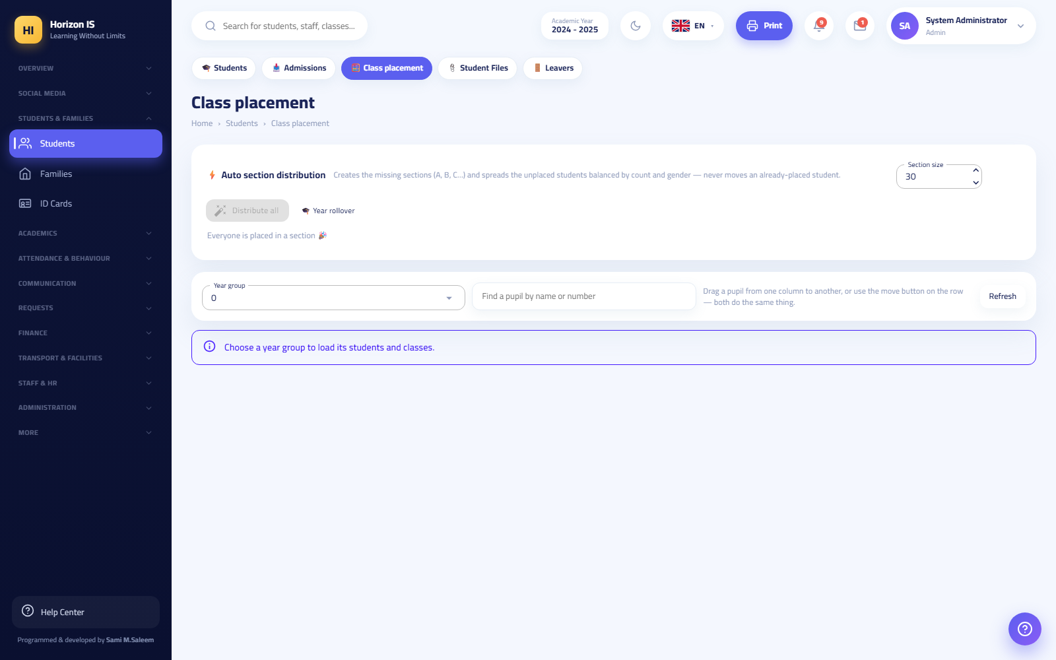شاشة توزيع الصفوف

Expected result
- The sections appear in every screen that depends on them: attendance, timetable, grades, fees.
- Every enrolled student is placed into a section, and the placement is approved and locked.

Common mistakes
- Creating sections before setting the correct current year — the section gets linked to the wrong year.
- Relying on auto-distribution to reshuffle already-placed students. Auto-distribution deliberately ignores placed students; to redistribute a student, remove them from their section first.
- A long or descriptive section letter (such as "A1B") — use a single clear letter.

Troubleshooting
Symptom | Likely cause | Fix
The "Add Class" button does not respond or is not visible | You are not administration | Ask the system admin
An "already exists" message on save | The same level + same section letter already exist | Choose another letter or edit the existing section
A student does not appear in placement | The student is already placed or is not active | Check the student's profile and status

Related topics
- Workflow 1: The academic year — classes are built inside the current year.
- Workflow 4: Enrolling a student — a new student needs a grade level at enrolment and then a section from placement.
- Workflow 5: The timetable — the timetable is built per section.
- Workflow 10: End-of-year rollover — the rollover clears section placements so they are rebuilt fresh each year.

8.4 3) Adding a New Staff Member: Employment Record + Login Account + Roles

Purpose
Bringing a new staff member into the system in three stages: (a) the employment record in HR, (b) a login account with a username and a temporary password, (c) controlling what they see and can do via the role and permissions.

Who can do this
- The employment record (/staff/add): administration (the server-side command is restricted to administration; viewing the list requires hr.view).
- Login accounts (/users): administration or IT staff (the admin.users.manage permission).
- The permission matrix (/admin/permissions): anyone with admin.roles.manage (administration and IT).
Important — IT staff limits: IT can create accounts and reset passwords, but they can never grant these roles: Global Supervisor, School Owner, School Principal, or System Admin — these are granted by administration only. IT also cannot manage an account that holds one of these roles.

Before you start
- Prepare: the full name, phone number (mandatory), email, job title, hire date.
- Decide the appropriate role from the system role list (Teacher, Registrar, Accountant, Nurse, Receptionist...). The role determines the default permissions.

Steps — (a) The Employment Record
- From the sidebar open Staff (الموظفون) (/staff) and click Add Staff — the /staff/add page opens.
- Fill in the Personal Information section: the full name in a single field (the system splits it into first/middle/last on save), gender, nationality.
- Fill in the Employment and Contact section: - Position (المسمّى الوظيفي): free text but consequential — the value "Teacher" feeds the staffing statistics, and the values "Principal", "Head of Secondary", and "Head of Primary" are used for the signatures on printed report cards. Write it precisely. - System role (دور النظام): this is the security role. Important notice: families are only ever offered the official communication roles in chat (administration, registrar, nurse, reception...) — a service worker, for example, is never shown to families. - Department, hire date, phone (mandatory), email.
- Click Save Staff Member (حفظ الموظف). The system assigns an employee number automatically in the format EMP-<year>-0001.
نموذج إضافة موظف

Steps — (b) The Login Account
- From the sidebar open Users (المستخدمون) (/users) and click New User (مستخدم جديد).
- In the Create Account (إنشاء حساب) dialog fill in: the full name, email, the role (you only see the roles you are allowed to grant — and the server checks again), then Represents (يمثّل): choose "Staff member" and link the account to the employment record you created in step (a).
- Save. The system displays the temporary password in a green panel once only with the notice: "Share it with the user — they will be asked to change it at first sign-in."
- Hand the staff member their username and temporary password securely (on paper or verbally — do not send them in public groups).
- The staff member's first sign-in: they open the login page and enter their credentials, and the system forcibly redirects them to the Set Your Password (عيّن كلمة المرور) page (/account/change-password). Password policy: at least 10 characters, including an uppercase letter, a lowercase letter, a digit, and a symbol. No session opens until the change succeeds.
صفحة تسجيل الدخول
Tip: Lost the temporary password before it was used? Open the account in /users and click Reset Password (إعادة تعيين كلمة المرور) — a new one-time temporary password is issued.
Warning: Disabling a staff account from the Users page ends their sessions immediately on both web and app. Use it right away when a staff member leaves.

Steps — (c) Roles and Permissions
- The role you chose gives the staff member a ready-made default permission "floor" (a teacher sees their classes, attendance, and gradebook; an accountant sees finance; and so on). You usually do not need anything more.
- If you want additions or customisation: open Roles and Permissions (الأدوار والصلاحيات) (/admin/permissions), select the role in the left panel, toggle the permissions grouped by module, then Save (حفظ).
- This matrix is what actually controls what appears in the sidebar for non-administration roles.
مصفوفة الأدوار والصلاحيات
Important: Permission changes take effect at the user's next sign-in, not immediately. Also note that every role has a default "floor" the system re-applies on every restart: whatever you add on top of the floor persists, but removing a permission that belongs to the floor itself is automatically restored — so a role can never accidentally lose its core screens.

Expected result
- The staff member has an employment record with an EMP-... number, a login account linked to it, and has completed their first sign-in and changed their temporary password.
- They see in the sidebar only what fits their role, and land on the correct dashboard at sign-in (a teacher on the teacher dashboard, and so on).

Common mistakes
- Creating a login account without linking it to the employment record (the "Represents" field) — the staff member loses their attendance clock and their professional profile in the app.
- Writing the position as free text ("Maths teacher" instead of "Teacher") — staffing statistics and report signatures break.
- Sending the temporary password over an insecure channel.
- Granting a higher role than needed "just in case". Grant the lowest sufficient role, and add individual permissions from the matrix when needed.

Troubleshooting
Symptom | Likely cause | Fix
The staff member signed in but the sidebar is almost empty | Their role has no permissions (such as "General staff") | Grant permissions from /admin/permissions and ask them to sign in again
"The account is temporarily locked after repeated failed attempts" | 5 wrong attempts | Wait 15 minutes or reset the password
I granted a permission and see no effect | The change takes effect at the next sign-in | The user signs out and back in
IT cannot edit a specific account | The account holds an administration role | "This account is managed by school administration only" — administration performs it

Related topics
- Workflow 5: Teaching assignments — after creating the teacher, link them to their classes and subjects.
- Workflow 6: Attendance — what a teacher sees is built from their assignments.
- Workflow 4: Family codes — the same IT role is the one that generates family login codes.

8.5 4) Enrolling a Student + Linking the Family + the Family Login Code + First App Sign-In

Purpose
The complete chain from a new student's arrival to their parents using the app: creating the student profile, creating or linking the family profile, generating the family login code and printing it, then the parent's first sign-in on the mobile app.

Who can do this
- Enrolling the student: the registrar (holds students.create) or administration.
- Family login codes: administration or IT staff only (the Families page requires families.view).
- First app sign-in: the parent themselves, using the printed code.

Before you start
- Prepare the student's data: the name in Arabic and English, date of birth, grade level (mandatory), and the father's details (name and phone are mandatory for a new family).
- If the student has enrolled siblings, know their family's name in the system — you will link to it instead of creating a duplicate family.

Steps — (a) Enrolling the Student and Linking the Family
- From the sidebar open Students (الطلاب) (/students) and click Add Student (إضافة طالب) — the /students/add page opens.
- Fill in the Student Basic Information section: the full name in Arabic and English (the system splits it automatically), gender, date of birth (the age is computed automatically), nationality, religion, blood type, phone, grade level (mandatory), and any medical notes/allergies/special needs if present.
- In the Family Information section choose one of two paths: - Existing family (sibling enrolment): search for the family and select it — the student inherits the guardians automatically, and no new family is created. - New family: fill in the father's information (name and phone mandatory), the mother's information, and the family's address and city. The system refuses to save without at least one guardian.
- Click Save Student (حفظ الطالب). The student and the family are created (or linked), and you go straight to the student's profile. If the enrolment came from an admission application on the admissions screen, the application automatically advances to the "Enrolled" stage.
- Do not forget to later place the student into a section via Class Placement.
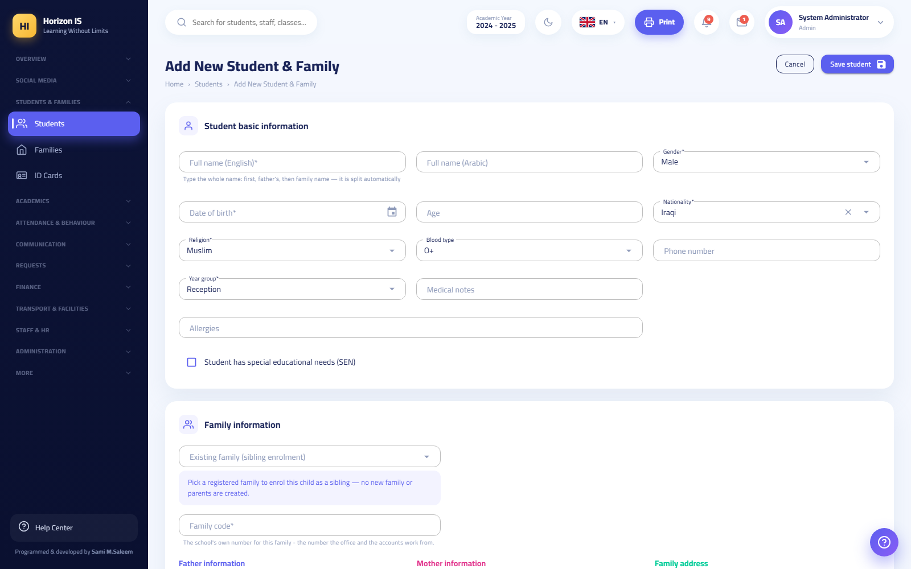نموذج إضافة طالب وعائلة

Steps — (b) Generating and Printing the Family Login Code
- From the sidebar open Families (العائلات) (/families) and switch to the Family Login Codes (رموز دخول العائلات) view.
- Choose what fits: - Generate for a class (توليد لصف): codes for all families of one section (best for start of year, section by section). - Generate for all families (توليد لكل العائلات): codes for every family in the school in one batch. - New Code (رمز جديد) next to a single family: generates a code for that one family only (and invalidates its old code).
- Print immediately: the Print Vouchers (PDF) (طباعة القسائم PDF) button opens a voucher file ready to cut and distribute; for a single-family generation an A6 card with a QR code is printed.
- Distribute the vouchers to the families (with the student's bag, for example), each voucher to its own family only.
صفحة العائلات — رموز الدخول
Warning: The code is shown once only, at the moment of generation — the system stores it encrypted (hashed) and no one can retrieve its text later, not even administration. If a voucher is lost before delivery, generate a new code for the family (the new one invalidates the old). After generation, the table only shows who has an active code, its expiry date, and whether it was used.

Steps — (c) The Parent's First Sign-In on the App
- The parent downloads the Horizon International School app from the store.
- On first open, the school picker appears: they choose their child's school from the group's school list. (A "Change School" button is always available on the login screen in case of a wrong choice.)
- On the login screen they tap Sign in with School Code (الدخول برمز المدرسة) (no email or password needed).
- On the Enter the Family Code 🎟 (أدخل رمز العائلة 🎟) screen they type the 8-character code from the voucher, or tap Scan the Barcode with the Camera 📷 (مسح الباركود بالكاميرا 📷) and scan the QR code.
- They land directly on the parent dashboard and see their children. The code works once, ties that phone to the account, and approves the device automatically.
- After signing in, the app offers enabling quick sign-in with fingerprint/face — an optional but recommended step.
Important: New phone or the app was deleted? The old code does not work a second time. The family requests a new code from school administration (step b-2 — "New Code" for a single family).

Expected result
- The student has a complete profile linked to a family (new, or the siblings' family).
- The family has a printed voucher with a valid code, or has actually signed in to the app.
- The parent sees in the app: attendance, homework, published grades, instalments, the bus, and chats.

Common mistakes
- Creating a new family for a sibling instead of linking to the existing family — the family's data fragments (two codes, two financial balances...). Always use the "Existing family (sibling enrolment)" option.
- Postponing printing after generation — the text cannot be retrieved later. The rule: generate, then print, in the same session.
- Generating "for all families" to fix a single family — it invalidates everyone's codes. To fix one case use "New Code" next to that family only.
- Forgetting the grade level at enrolment — the field is mandatory and the form will not save.

Troubleshooting
Symptom | Likely cause | Fix
"The code is invalid or already used — request a new code from the school." | The code was used before, was invalidated by a newer generation, or was mistyped | Generate a new code for that family and deliver it
The form refuses to save the student | A guardian is incomplete (name/phone) or no grade level chosen | Complete the mandatory fields
The parent changed phones and cannot sign in | The code works once and is tied to the first phone | A new code from the Families page
"Awaiting school approval" on the app | They signed in with a password from a new device that needs approval | IT approves the device from the device approvals screen

Related topics
- Workflow 2: Placement into sections — the new student needs a section.
- Workflow 8: Fees — after enrolment the fee is assigned to the student and the family follows its instalments in the app.
- Workflow 7: Results — what the family sees in "My Reports" is only what has been published.
- Workflow 10: Closing accounts on departure.

8.6 5) Teaching Assignments + Building the Timetable

Purpose
Defining "who teaches what, to whom, and how many periods a week" (teacher assignments), then laying those periods onto the weekdays in the Timetable Studio, with conflict detection and printing.

Who can do this
- All the building tools (the studio, assignments, coverage, utilities) for anyone in administration or holding academics.timetable.manage or classes.manage.
- Viewing the timetable (/timetable) is available to anyone with classes.view; a teacher sees their personal timetable, and a student sees theirs in the app.

Before you start
- Sections are ready (Workflow 2).
- Subjects are defined per grade level on the Subjects (المواد) page (/grades/subjects) — the timetable and assignments read from it.
- Teachers are registered (Workflow 3).
- The period length is set in Settings (Workflow 1).

Steps — (a) Teacher Assignments
- From the sidebar open Timetable (الجدول الدراسي), then the Teacher Allocation (توزيع المعلّمين) tab (/timetable/allocation).
- Choose the section. A grid of that grade level's subjects appears.
- For each subject set: the teacher and the number of weekly periods.
- Choose the homeroom teacher (مربي الصف) from the dedicated list.
- Click Save (حفظ).
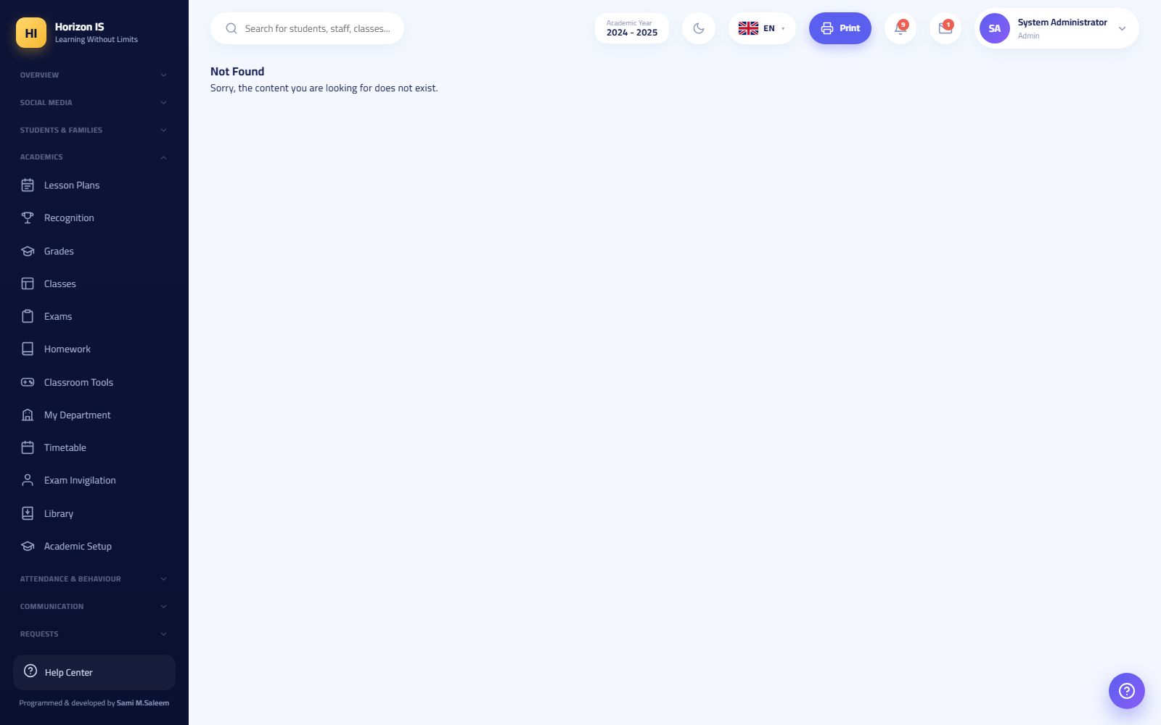شاشة توزيع المعلمين
Important: The assignment is not just an administrative sheet — it is what determines what every teacher sees across the whole system: their classes in attendance, their gradebook, and which parents can message them. A teacher with no assignments = empty screens.

Steps — (b) Building the Timetable in the Studio
- Open the Timetable Studio (استوديو الجدول) tab (/timetable-studio).
- Choose the view mode: class, teacher, or room, then choose the target (the section, for example).
- The required periods not yet placed (from the assignment counts) appear in a side "tray". To place a period: click the day/period cell and fill the dialog (subject/teacher/room). Every slot has a lock 🔒 that stops the generation tools from changing it, and a delete button.
- To speed up: Generate This Class (توليد هذا الصف) fills a single section automatically, or Generate the Whole School (توليد المدرسة كاملة) (a confirmation warning: it replaces the entire current timetable).
- Configure before generating: the Rules ⚖️ (القواعد ⚖️) dialog (distribution rules) and the Unavailability 🚫 (عدم الإتاحة 🚫) dialog (teachers' busy times).
- Watch the status bar at the top of the screen: ⚠️ conflicts with their count, or ✓ no conflicts. Resolve every conflict before approving.
- Printing 🖨️ (الطباعة 🖨️): a section timetable (classroom door card), a teacher's week, or the full school book for all sections.
- If your school builds its timetable in aSc Timetables: the Import aSc 📥 (استيراد aSc 📥) button uploads the file, shows a preview with matched and unmatched classes and teachers, then applies (replaces the board).
استوديو الجدول

Expected result
- A conflict-free timetable for every section, visible in /timetable, in teachers' timetables, and in the students' "Timetable" tab on the app.
- Every teacher sees only their own periods, and the period-attendance screen shows them their day's periods from their timetable.

Common mistakes
- Building in the studio before completing the assignments — the tray is empty and there is nothing to place.
- "Generate the Whole School" on a working timetable for a small tweak — the button replaces everything. For small edits, edit cells manually, and lock 🔒 whatever must not move before any generation.
- Ignoring the conflict bar and printing in a hurry — a teacher appears in two sections at the same period.
- Assignment period counts that do not match the curriculum plan — orphan periods remain in the tray.

Troubleshooting
Symptom | Likely cause | Fix
A subject does not appear in the assignment | Not defined for this grade level | Add it in /grades/subjects for that level
The teacher cannot see their timetable | The assignment is unsaved or the account is not linked to the employment record | Check the assignment and the "Represents" link on the account
Auto-generation leaves many gaps | Unavailability constraints are tight or the counts are large | Review the unavailability and rules dialogs, then regenerate
aSc import shows unmatched items | Class/teacher names differ between the two systems | Unify the names and re-import

Related topics
- Workflow 6: Attendance — period attendance reads from this timetable.
- Workflow 3: Staff — the teacher must have a record and account first.
- Workflow 1 — the period length and time zone.
- The Coverage (التغطيات) tab in the same group records a teacher's absence and assigns who covers their periods.

8.7 6) Recording Daily Attendance — the Teacher on Web and App

Purpose
Recording the section's attendance every morning (and per period, if your school uses period attendance), so that every student's status reaches administration, the absence reports, and the parents.

Who can do this
- The teacher, the homeroom teacher, and heads of department/stage (the attendance.view and attendance.manage permissions are part of their default floor), and administration.
- The Administration Review (مراجعة الإدارة) button on the daily register is for administration only.

Before you start
- The section has its students placed (Workflow 2) and the teacher is assigned to it (Workflow 5).
- On the app: sign in once on a good network so your class lists are stored for offline work.

Steps — On the Web
- From the sidebar open Attendance (الحضور) — the Daily Attendance (الحضور اليومي) tab opens (/attendance).
- Choose the section and the date.
- For each student tap their status: Present (حاضر) / Absent (غائب) / Late (متأخر) / Excused (بعذر). For a quick start click All Present (الكل حاضر) then adjust the exceptions.
- To add a reason or detail for a student: the note (ملاحظة) icon next to their name.
- Click Save Attendance (حفظ الحضور). A message appears: "Attendance saved successfully." (تم حفظ الحضور بنجاح.)
- A student left during the day? Record their early departure from the same page (it appears in the departure log (سجلّ الخروج)).
- For printing: Today's Absences PDF (PDF غيابات اليوم) or Monthly Register PDF (PDF السجل الشهري) from the same page.
السجل اليومي للحضور
The rest of the attendance group's tabs, when needed: Period Attendance (حضور الحصص) (recording each period separately), Monthly Register (السجل الشهري) (the month grid per section), Absences (الغيابات), Period Absences (غيابات الحصص), Period Attendance Reports (تقارير حضور الحصص), and Absence Insights (رؤى الغيابات) (analytics and early warning — for administration and timetable managers).

Steps — On the Teacher App
- From the teacher home screen choose My Classes (صفوفي), then tap the section, then Attendance (الحضور).
- Tap each student's status: Present (حاضر) / Absent (غائب) / Late (متأخر), or All Present (الكل حاضر) then adjust.
- Tap Save Attendance (حفظ الحضور) — "Attendance saved" (تم حفظ الحضور) appears.
- No internet? No problem: the list is stored on the device, and saving with no network queues the record with the message "No connection — saved and will be sent automatically when the internet returns" (لا يوجد اتصال — حُفظ وسيُرسل تلقائياً عند عودة الإنترنت), then it is sent on its own later ("Pending attendance records sent ✓" — أُرسلت التحضيرات المعلقة ✓). If a pending record is rejected (for example because the day was locked), the app tells you explicitly that it was rejected and asks you to record it again — it is never dropped silently.
- From the same screen you can record a student's early departure: departure time, reason, a note, and a notify the parent toggle.
- For a specific period: the Period Attendance (حضور الحصص) screen shows your day's periods from your timetable — choose the period, record, and save.

Expected result
- The day's register is saved and appears immediately in administration dashboards, absence reports, and the monthly register.
- The parent sees their child's status in the app, and receives the early-departure notification if enabled.
- A day approved by administration via Administration Review becomes read-only.

Common mistakes
- "All Present" then an immediate save without review — absent students get recorded as present. Make a quick scan of the room a fixed habit before saving.
- Recording lateness as absence — use "Late" so the monthly report stays accurate.
- Opening the wrong date and recording today onto it — check the date at the top of the page first.
- Confusing "Excused" with the note — "Excused" is an official status counted in reports; the note is extra free text.

Troubleshooting
Symptom | Likely cause | Fix
I cannot see my section in the list | You have no teaching assignment on it | Ask administration to set the assignment
The register is read-only | The day was approved by administration (Administration Review) | Ask administration to reopen the day if a correction is needed
"Pending attendance records could not be sent and were rejected — please record them again" | A pending record collided with a locked day or the data changed | Open the section and record the day again
A student is missing from the list | Not placed into the section, or not active | Check Class Placement

Related topics
- Workflow 5: The timetable — period attendance reads your periods from the timetable.
- Workflow 4 — the parent follows attendance from the app and submits absence requests that are handled on the absence requests screen.
- Workflow 10 — the daily departure log is one thing; leaving the school permanently is another.

8.8 7) Exams → Mark Entry → Publication Approval → Family Access

Purpose
The full academic cycle: scheduling exams and printing their materials, entering marks in the gradebook, then — and this is the most important part — passing the results through the dual-approval publication gate before any parent sees them.
Important — the golden rule: Entered marks are never seen by families just because they were saved. Nothing reaches the families except a published report card that went through an approval request, then the approval of another manager, then publication.

Who can do this
- Scheduling exams: anyone with academics.exams.manage (teachers, heads of department, administration).
- Mark entry: anyone with academics.gradebook.view/manage (the teacher for their own classes). The whole module sits behind the "mark entry" feature flag — if it is off, your school works by importing from the external grading system.
- Locking the term: administration (and the head of stage within their floor).
- Requesting approval, approving, and publishing: administration only, and the approval must come from a manager other than the one who requested it.

Before you start
- The terms and components are defined (Workflow 1), the subjects are defined per grade level, and the grading scheme (the scale and grade boundaries) is ready in /grading-schemes and assigned to the levels.
- The report card design is ready in Report Templates (تصاميم التقارير) (/report-templates).

Steps — (a) Scheduling and Printing Exams
- From the sidebar open Exams (الامتحانات) (/exams).
- Click Schedule Exam (جدولة امتحان) and fill in: the title, subject, section, date, time, room.
- Repeat for the remaining exams. For printing: General Schedule PDF (PDF الجدول العام) or Section Schedule PDF (PDF جدول الشعبة).
- For big exam days: Exam Seating (تجليس الامتحانات) generates a mixed seating plan for a full day, then print: room layouts, door lists, and seat slips.
شاشة الامتحانات

Steps — (b) Entering Marks
- From the sidebar open Grades (الدرجات) — Gradebook — Mark Entry (سجل الدرجات — إدخال العلامات) opens (/grades).
- Choose: class + subject + term.
- Enter each student's mark in each component's column (the system prevents exceeding the component's maximum). The total and the letter grade are computed automatically from the grading scheme's boundaries.
- Click Save Marks (حفظ العلامات). Import/Export CSV buttons are available for bulk work.
- Once entry is complete and reviewed, administration locks the term with the Lock (القفل) button — a Locked (مقفل) badge appears and editing is blocked (exceptional unlocking is in administration's hands).
سجل الدرجات — إدخال العلامات

Steps — (c) The Dual-Approval Publication Gate
- Open the Report Templates (تصاميم التقارير) tab (/report-templates).
- Choose the report card design and the target grade level.
- Click Request Approval (طلب اعتماد) — a publication request is recorded in your name.
- Another manager opens the same page (or goes through the action centre) and clicks Approve (اعتماد) in the approvals table. Approving your own request is rejected in both the UI and the server: "Your request needs another manager's approval." (طلبك يحتاج اعتماد مدير آخر.)
- After approval, click Publish to Parents (نشر لأولياء الأمور). The system refuses to publish without an unconsumed approval for the same (design + grade level).
- At the moment of publication every card is frozen as a fixed snapshot: any later mark edit does not leak into what you published. Re-publishing archives the previous version and requires a new approval request (one approval = one publication run).
- Students with an unsettled payment hold are skipped automatically at publication (the holds are managed on the same page).

Steps — (d) What Families and Students See
- On the web: My Reports (تقاريري) (/my-reports) shows the family/student only the published and non-held cards — an Open (فتح) button on each card.
- On the app: the child's card ← Exams and Grades (الامتحانات والدرجات).
- For internal administration printing: section results in /grades/results, printing all of a section's cards from /report-cards/{ClassId}, and the cumulative academic record from the academic record page.

Expected result
- Exams scheduled with their printouts, marks saved and locked, and cards published after dual approval.
- Every parent sees their children's card (except those skipped by a payment hold) as a trusted frozen snapshot.

Common mistakes
- Expecting that saving means publishing. The most common misunderstanding: "We entered the marks, why can't the parents see them?" — because publication is a separate three-step process (request ← another manager's approval ← publish).
- Requesting approval and attempting self-approval — forbidden by design; arrange in advance who the second manager is.
- Editing marks after publication and waiting for parents to see them — the published version is a frozen snapshot; a correction requires a new approval and publication cycle.
- Publishing before importing/updating the payment-hold list — the result reaches a family that should have been held back.

Troubleshooting
Symptom | Likely cause | Fix
The grades page is read-only with an alert bar | The mark-entry feature flag is off for your school | Marks are imported from the external system via the import screen
I cannot edit — "Locked" | The term is locked | Administration unlocks temporarily and relocks
The publish button refuses | No unconsumed approval for the same design and level | Request a new approval and have another manager approve
One family cannot see the card while everyone else can | A payment hold on the student | Check the holds on the Report Templates page and Fees
A student with no letter grade | The grade boundaries are not assigned to the student's level | Check /grading-schemes and the scheme's assignment to levels

Related topics
- Workflow 1 — the terms and components are the entry columns.
- Workflow 8 — the payment hold blocks the card of a non-paying family.
- Workflow 10 — archive the results before rolling over the year.
- Workflow 4 — the family reaches the card from the app or "My Reports".

8.9 8) Fees: Fee Structure → Assignment → Recording a Payment → Printing the Receipt

Purpose
The financial cycle for instalments: defining the fee components and their amounts per grade level, assigning the final fee and discounts to each student, setting an instalment plan for the family, recording payments with an official numbered receipt, and printing the statements.

Who can do this
- Fee structure and assignment: anyone with finance.fees.manage (the accountant and administration).
- Recording payments: the accountant or administration only — the rule is enforced verbatim on the server: "Recording payments is for the finance office only", regardless of any other permissions.
- All finance pages are hidden from other staff (a message appears stating that financial data is restricted to the finance office).
- The parent: view only in the app — there is no in-app electronic payment.

Before you start
- Students are enrolled and placed (Workflow 4 and 2).
- The school's decisions are ready: the amount per grade level, the proration policy (months/days/none), and the approved discounts (sibling discount...).

Steps — (a) The Fee Structure
- From the sidebar open Fee Structure (هيكل الرسوم) (/finance/fees).
- In the Year Settings (إعدادات السنة) card: the academic year, number of days, number of months, and the proration method (none / months / days) — then save.
- In the Fee Components (مكوّنات الرسوم) card: click the create-standard-components button to generate the usual components in one batch, or Add a Component (أضف مكوّنًا) manually: the Arabic/English name, the source (manual or linked to meals), whether it accepts discounts, and whether it is active.
- In the fee grid per grade level/section: enter each component's amount, then Save (حفظ).
هيكل الرسوم

Steps — (b) Assigning Fees and Discounts per Student
- Open the Fee Assignment (توزيع الأقساط) tab (/finance/fees/assign).
- Search for the student and select them — their fee computed from the structure appears.
- Adjust the final fee and apply the discounts (named discounts are defined in the Discount Setup (إعداد الخصومات) tab, including sibling discounts).
- Save. After auditing you can lock the student's fee for the year (an audit lock) so it cannot be changed except by a deliberate reopen.
- For follow-up: Student Fees (رسوم الطلاب) (each student's position), Expected Revenue (الإيراد المتوقّع) (a printable report), Fee Collection (تحصيل الرسوم) (the collection monitoring dashboard).

Steps — (c) The Instalment Plan and Recording a Payment
- Open the Instalments (الأقساط) tab (/finance/installments).
- The side panel lists the family accounts (search + an "only with outstanding dues" filter). Select the family.
- Click Set the Plan (تحديد الخطة) to split the amount due into dated instalments.
- When money is received: click Record Payment (تسجيل دفعة) and fill the dialog: the date, the amount, the currency (dinar or dollar — converted at the stored exchange rate into the school's main currency), the payment method, the cashbox (البوكس), notes, and optional attachments (up to 4MB per file).
- Save. The system issues a receipt number automatically in the format R-yymmdd-XXXX and the message "Payment recorded …" (تم تسجيل الدفعة …) appears.
- The payment appears in the list with the receipt number, date, amount, its equivalent in the main currency, the method, and the cashbox. Locked payments carry a 🔒 and cannot be deleted.

Steps — (d) Printing, Reminders, and Payment Requests
- Print Statement (طباعة الكشف) on the instalments page prints the selected family's account statement.
- The Family Balances (أرصدة العوائل) page (/family-balances) shows each family's remaining balance with Print PDF (طباعة PDF) and a Remind Debtors (تذكير المدينين) button (requires a second confirmation click).
- For an official voucher on the accounting template: Accounting ← Vouchers (المحاسبة ← السندات) (/finance/vouchers) — Receipt Voucher (سند قبض).
- When a parent declares a payment from the app, it appears in Payment Requests (طلبات الدفع) (/payment-requests): the Received (استلام) button only acknowledges seeing it — it records no amount; the accountant must record the payment in the instalments screen as usual.
- The parent in the app sees: the total due, paid, remaining, the children's plans and the payment list, and a Contact the Accounts Office (التواصل مع إدارة الحسابات) button to open a chat with the accountant.

Expected result
- Every student has an audited final fee, and every family has a clear instalment plan.
- Every payment has a unique numbered receipt, and statements can be printed at any moment.
- The family follows its financial position in the app in real time.

Common mistakes
- Treating "Received" in payment requests as recording the amount — it is only an acknowledgement; money enters the books only through "Record Payment".
- Choosing the wrong currency (dollar instead of dinar) — it corrupts the conversion to the main currency. Review the stored exchange rate before collection season.
- Forgetting to choose the correct cashbox — daily cashbox reconciliation breaks.
- Editing the fee structure after collection has started without reviewing the assignments — use the audit lock on finished student fees.

Troubleshooting
Symptom | Likely cause | Fix
The finance menus are not visible in the sidebar | You have no finance permissions, or the finance module is off for your school | Check with administration
The "Record Payment" button refuses despite my permissions | Recording is restricted exclusively to the accountant and administration roles | The accountant performs it
I cannot delete a payment | The payment is locked 🔒 | Locked payments are final by design; handle it with accounting entries
The family cannot see today's payment in the app | It was recorded on another family, or not recorded yet | Search by receipt number on the instalments page

Related topics
- Workflow 7 — the payment hold blocks publication of a late-paying family's report card.
- Workflow 4 — the instalments screen in the parent app.
- The finance bridge and the accounting screens (the journal, the chart of accounts, the financial statements) have their own chapter in this manual.

8.10 9) School-Wide Announcements + Class Posts + Stories

Purpose
Delivering the school's voice: a school-wide announcement that reaches everyone, a class post that reaches the families of one section, and short daily stories that appear in the stories bar on the parents' screen.

Who can do this
- Posting on Social: staff (the section is available to the team; a teacher posts to their own classes).
- The "All Classes" audience (school-wide broadcast) and official announcements: administration roles and anyone with communication.announcements.manage (heads of department/stage within their floor).
- Content moderation (/moderation): administration.
- Parents and students: read and react only — they cannot create posts or groups.

Before you start
- Decide the audience before writing: everyone? One section? Staff only? — the audience choice is the difference between a school-wide announcement and a class post.
- Prepare the images/video (images over 3MB are compressed automatically in the app).
Important: The old Announcements (الإعلانات) page (/announcements) carries a banner explaining that new announcements are now published through the class feed and reach everyone there, and that the list shows past announcements only. Any new broadcast = a Social post with the "All Classes" audience.

Steps — A School-Wide Announcement or a Class Post from the Web
- From the sidebar open Social Media (سوشيال ميديا) (/social) and click New Post (منشور جديد).
- Choose the audience: - Specific classes (صفوف محدّدة) — then tick the desired sections (mandatory): this is the class post. - All classes (كل الصفوف) — the school-wide broadcast for the whole school. - Staff only (الموظّفون فقط) — an internal circular that no parent or student sees.
- Write the text and attach an image, a video, or an album.
- Publish. The post appears in the same feed that parents open in the "class feed" on the app, with likes and comments.
خلاصة السوشيال

Steps — A Class Post from the Teacher App
- From the teacher home screen tap New Post (منشور جديد) (it opens the New Class Post (منشور صفّي جديد) composer).
- Choose the class, write the text, add images (compressed automatically over 3MB) or a video.
- Optional extras: tagging students visible in the photos, a poll (استفتاء), or an invitation with RSVP.
- Choose: Publish Now (انشر الآن), schedule for later, or save as a draft. A message appears: "Post published" (تم نشر المنشور) or "Post scheduled" (تمت جدولة المنشور).
- After publishing, the teacher can see who viewed the post and send a reminder to those who have not.

Steps — A Daily Story
- From the stories composer in the app (for staff), shoot or pick a photo/short clip and publish it as a story.
- The story appears in the stories bar at the top of the parent's home screen under the school's name, and disappears automatically after its duration.

Steps — Content Moderation
- Reports on posts and comments arrive at Content Moderation (الإشراف على المحتوى) (/moderation).
- For each report: Dismiss (تجاهل) or Hide (إخفاء) the content.

Expected result
- The school-wide announcement appears in every family's feed and they receive a notification.
- The class post appears only to the families of the chosen section.
- The story appears in the parents' stories bar and expires on its own.

Common mistakes
- Choosing "All Classes" for a post about one section — a Year 7 section's activity reaches the whole school. Check the audience buttons before publishing.
- Looking for the broadcast button on the old Announcements page — new broadcasts go through the Social composer with the "All Classes" audience.
- Publishing photos containing students from another section inside a section's post — review the photos before attaching.
- Sending an internal circular with a public audience instead of "Staff only".

Troubleshooting
Symptom | Likely cause | Fix
The "All Classes" button is not visible to me | The broadcast audience is for administration and announcement managers | Ask administration, or post to your own classes
A parent cannot see the post | They are not in the post's audience (another section) or have not refreshed the feed | Check the selected sections
The video refuses to upload | It exceeds the video limit (10MB in the app) | Shorten or compress the clip
A post disappeared from the feed | Moderation hid it after a report | Check the content moderation page

Related topics
- Workflow 4 — families view the feed and stories from the app.
- Personal messaging (chats, groups, voice messages) has its own chapter — Social is the school's public voice, while chats are a person-to-person channel.
- Circulars (التعاميم) (/circulars) is a separate channel for official internal circulars with acknowledgement-signature tracking.

8.11 10) End-of-Year Rollover: Promotion, Graduation, and Departures

Purpose
Closing the academic year safely: archiving the results, promoting students one grade up (7A ← 8A), graduating the final grade, then handling leavers and closing their families' accounts on request.

Who can do this
- Administration only (the WebManager policy), and the class rollover page sits behind a feature flag administration can enable.
- Account closure (/departure-requests): anyone with admin.users.manage.

Before you start
- Publish every report card that needs publishing (Workflow 7) — publishing after the rollover is more complicated.
- Run Archive Year Results from Settings (Workflow 1).
- Settle the financial position as much as possible (Workflow 8) — debts stay on the family, but follow-up is easier before the classes are reshuffled.
- Take a backup (the backup button in Settings) before any execution.
Warning: The rollover is a large bulk operation performed once a year. Read the preview carefully before confirming, and never run it "just to try" on a real environment.

Steps — Method (a): Rolling Over Class by Class
- Open the End-of-Year Rollover (ترحيل نهاية العام) page (/year-rollover).
- The page shows every section with its grade level, its student count, and a suggested destination: the same section letter one grade up (7A ← 8A); the final grade's suggestion is 🎓 Graduate (تخريج); and any ambiguous case is left at No Rollover (بلا ترحيل).
- Change any section's destination from its dropdown freely (merging two sections, changing a letter, keeping a section without rollover...).
- Watch the live preview line: how many students will be moved and how many will graduate.
- To execute: type the word RENEW in the confirmation box ("Type RENEW to confirm" — اكتب RENEW للتأكيد) then click Execute Rollover (تنفيذ الترحيل).
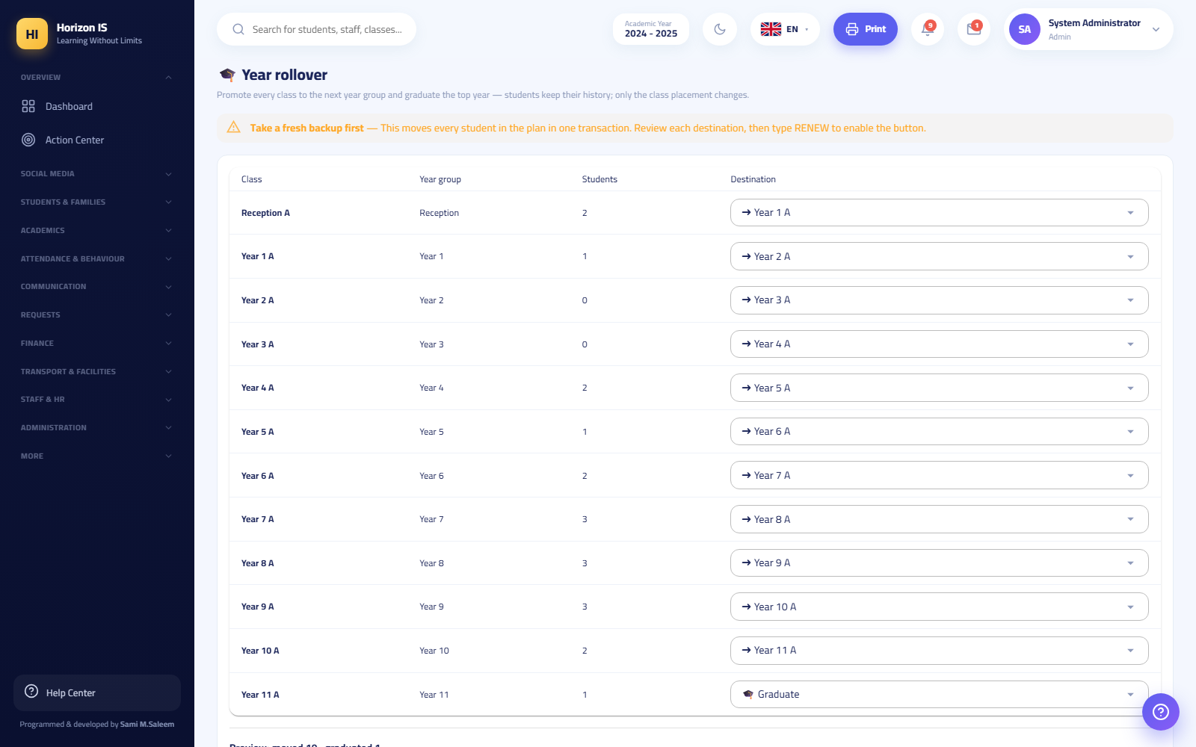صفحة ترحيل نهاية العام
Tip: The system freezes the student lists before the move begins, so a chain like 7A ← 8A ← 9A can never promote a student twice in the same run. Perform the whole rollover in one well-planned run.

Steps — Method (b): Rolling Over the Whole Year from Settings
- Open Settings ← Academic Year (الإعدادات ← السنة الدراسية).
- On the new (non-current) year click Roll Over the Year to This One (ترحيل السنة إلى هذه).
- Read the preview: the number who will be promoted, and the number who will graduate from the final grade level.
- Confirm. The system: promotes every active/enrolled student one grade level by order, graduates the final level, clears all section placements, and makes the new year the current one.
- Start the new year by rebuilding the sections and the placement: Workflow 2.
Important: Clearing the section placements is intentional — sections are rebuilt fresh every year through the Classes page and Class Placement. Do not be surprised that students are "without a section" on the morning of the new year; that is the normal procedure.

Steps — Leavers and Account Closure
- A student leaving the school: open their profile ← Edit (تعديل) and change their status (the statuses include graduation and others). There is no separate "transfer wizard" — the status on the student's profile is the reference, and their record stays preserved.
- A family requesting closure of their login account (from the app: a departure/account-closure request): the request arrives at the Account Closure Requests (طلبات إغلاق الحسابات) page (/departure-requests).
- Review the request and click Approve and Close (اعتماد وإغلاق) or Reject (رفض).
Important: Approving the closure only disables the account: no sign-in afterwards, sessions are ended, devices are blocked, and notifications stop — but it does not delete any school or financial record. The student's records remain intact.

Expected result
- Every continuing student is in their new grade level, and final-grade students have the status "Graduated".
- The new year is the current one, and the old results are archived and appear in the academic record.
- Departing families' accounts are closed without losing any record.

Common mistakes
- Rolling over before archiving or before publishing the cards — always order it: publish ← archive ← roll over.
- Running both methods (a) and (b) thinking they are two consecutive steps — they are alternatives for the same purpose; choose one depending on whether you need class-by-class control or a bulk rollover.
- Panicking at the disappearance of section placements after the rollover — intentional behaviour; the placement is rebuilt.
- Deleting leavers' accounts instead of approving the closure — the approved closure preserves the history and stops access; do not look for a delete.

Troubleshooting
Symptom | Likely cause | Fix
The End-of-Year Rollover page does not exist | The feature flag is off | Administration enables it from the feature flags
The execute button is disabled | You did not type RENEW in the confirmation box | Type it exactly, in capital letters
A section's destination is "No Rollover" | An ambiguous case (no matching section one grade up) | Set the destination manually from the list
A departed family still receives notifications | The closure request has not been approved yet | Approve it in Account Closure Requests

Related topics
- Workflow 1 — archiving and setting the current year.
- Workflow 2 — rebuilding the sections and the placement after the rollover.
- Workflow 7 — publish the cards before closing the year.
- Workflow 8 — settling balances before departure.
- Workflow 4 — enrolling the new year's newcomers.

Chapter 9Troubleshooting, FAQ, and Glossary
This chapter is your reference for when "nothing works the way it should". Read it in this order:
- Troubleshooting: problem → likely cause → fix, using the literal messages that appear on screen.
- FAQ: more than twenty questions school staff actually ask, with direct answers.
- Glossary: the meaning of every term you will meet in the system and in this manual.
- Appendix: browsers, support contact, and keyboard shortcuts.
Important: Every message quoted in this chapter is copied literally from the system's screens. If you see the exact same message in front of you, the fix listed next to it is its fix.

9.1 Part One: Troubleshooting

1. I cannot sign in
The web sign-in page is /login; in the app it is the first screen after choosing the school. A failed sign-in always shows a clear message — match your message against this table:
Sign-in screen
Message on screen | What it means | What to do
"The email or password is incorrect." (البريد الإلكتروني أو كلمة المرور غير صحيحة.) | Wrong credentials | Check your typing (keyboard language, capital letters). Try the username instead of the email, or the other way around. If that fails, request a password reset (Section 2).
"The account is temporarily locked after repeated failed attempts. Try again in 15 minutes." (قُفل الحساب مؤقتًا بعد محاولات فاشلة متكررة. حاول بعد 15 دقيقة.) | 5 consecutive failed attempts lock the account for 15 minutes | Wait the full 15 minutes, then try once, calmly. Do not keep retrying during the lock — it will not open any sooner.
A message that the parent / student portal is closed | The school has temporarily switched off family or student sign-in | This is an administrative decision, not a fault. Contact the school administration.
A message that this device is awaiting school approval | A new device the IT department has not approved yet | See "Device not approved" below.
A message that the device is blocked | The IT department has blocked this device | Contact your school's IT department.
Tip: The sign-in field accepts either the email address or the username — both work in the same box.

A. The password is temporary — "Set your password"
When your account is created (or after your password is reset) you receive a temporary password. On your first successful sign-in you will not enter the system directly — the system redirects you to the "Set your password" (عيّن كلمة المرور) page (/account/change-password), which carries this sentence:
"Your account is using a temporary password. Choose a new password to continue." (حسابك يستخدم كلمة مرور مؤقتة. اختر كلمة مرور جديدة للمتابعة.)
This is normal, intended behavior — not an error. Enter the temporary password, then a new password that satisfies the password policy:
- At least 10 characters.
- An uppercase letter + a lowercase letter + a digit + a symbol (such as ! or #).
Error messages on this page:
Case | What it means
The current password is incorrect | You mistyped the temporary password — copy it exactly as you received it
The new password is rejected | It does not satisfy the policy above — the page displays the required conditions
Important: The sign-in session is only created after the password change succeeds. Closing the page before changing means you have not signed in yet.

B. The account is disabled
When an account is disabled from the "User accounts" (حسابات المستخدمين) page (/users), the following happens immediately:
- Every open session is terminated (web and app together).
- The system rejects any new sign-in with that account.
If you were signing in normally and were suddenly logged out of every device with your credentials no longer accepted, the likely cause is that the account was disabled, or that an "account closure request" submitted by the family from the app was approved. The only fix: contact the school administration — there is nothing to repair on your side.
Warning: Approving an account closure request only disables sign-in and deletes no records. The student's data, grades, and finance records remain intact in the system.

C. Device not approved — app and web
The system ties every account to its known devices:
- The app (mobile): every sign-in automatically registers the phone with the school. A new phone shows you the "Awaiting school approval" (بانتظار موافقة المدرسة) screen with a "Back to sign-in" (العودة لتسجيل الدخول) button. This is not an error in your credentials — your credentials are correct, but the phone itself is waiting to be approved.
- The web (browser): the first browser you sign in from is approved automatically. Later browsers may be held pending approval (depending on the school's setting), and you see the awaiting-approval message on the sign-in page.
Who approves devices? The IT department or the administration:
- From the app: IT panel → "Device approvals" (موافقات الأجهزة) tab — approve or block the pending phones.
- From the web: staff list → staff pill bar → "Devices" (الأجهزة) (/staff/devices).
- Pending devices also appear in the administration's "Action Center" (مركز الإجراءات) (/action-center).
Tip: Clearing the app's data or factory-resetting the phone can make the phone look like a new device, so it returns to the waiting state. This is normal — IT approves it again.
For parents: a new phone is approved in one of exactly two ways: a new family code from the school (works once and approves that phone automatically) or manual approval by the IT department.

D. Two-factor authentication (2FA)
If two-factor authentication is enabled on your account, after the correct password you move to the "Two-factor verification" (التحقق بخطوتين) page (/login/2fa) and enter the authenticator-app code (6 digits).
Problem | Fix
The code is always rejected | Make sure the phone's clock is set to automatic — clock drift breaks the codes
You took too long to enter the code | The verification step is valid for only 5 minutes after the password — go back to the sign-in page and start again
You lost the authenticator phone | You cannot fix this yourself — ask the system administration to help via your account in /users
In the app: if an authenticator app is registered on your account, a third field "Authenticator app code (6 digits)" (رمز تطبيق المصادقة (6 أرقام)) appears on the sign-in screen itself.
Related topics: password reset (Section 2), device approval (C above), the user management chapter.

2. I forgot my password — the reset path
Purpose Get a staff member, parent, or student who forgot their password signing in again, through a new temporary password.
Who can do this The administration (System Admin, School Principal, School Owner) and the IT department — from the "User accounts" page. There is no self-service "Forgot password" link on the sign-in screen; this is intentional, for the safety of student data.
Before you start - Verify the identity of the person requesting the reset (in person or via a known phone call) — never reset a password based on an anonymous text message. - Remember: the IT department cannot manage accounts that hold administration roles (System Admin / School Principal / School Owner) — those can only be reset by a higher-level administrator.
Steps
- From the sidebar open "Users" (المستخدمون) (/users).
- Search for the account by name or email and open it.
- Click "Reset password" (إعادة تعيين كلمة المرور).
- The new temporary password appears exactly once in a green panel with a notice: share it with the user, and they will be required to change it at first sign-in. Copy it now — it will not be shown again.
- Hand the temporary password to the user through a safe channel (a folded note, a phone call, in person).
- The user signs in with it, the system redirects them to the "Set your password" page, and they choose their permanent password.
User accounts page
Expected result The user signs in with the temporary password, changes it immediately, then uses the system normally. The old password becomes invalid.
Common mistakes
- Closing the window before copying the temporary password — you will have to run the reset again.
- Sending the temporary password to a public chat group — send it to the intended person only.
- The user types a new password that does not satisfy the policy (10 characters, upper+lower+digit+symbol) and then assumes "the system is broken".
Troubleshooting
Symptom | Cause | Fix
The reset button does not appear for you | The account outranks your permission (example: IT trying to manage an administrator account) | Ask senior administration
The user says "the temporary password is rejected" | It was copied incompletely or with an extra space | Reset again and re-send it precisely
A parent with no email address at all | Families normally sign in with the family code | Generate a new family code from the "Families" (العائلات) page instead of a password
Related topics: temporary passwords (1-A), family codes (the student and family registration chapter), IT department permissions.

3. "Not authorized" or a missing menu item
How the system decides what you see: the sidebar is not the same for everyone. The rule:
- Leadership roles (Super Admin, School Owner, School Principal, System Admin) see all items.
- Every other staff member sees an item only if their role holds its permission (example: "Students" requires students.view, and "Finance" requires finance permissions).
- Students and families have short, fixed menus that never change.
So "my colleague sees a screen I don't" is not a fault — it is a permissions difference.
Where permissions are managed: the "Roles and Permissions" (الأدوار والصلاحيات) page (/admin/permissions) — a matrix: pick the role on the left, switch permissions on or off group by group, then save.
Roles and permissions matrix
Important: A change in the matrix takes effect at the user's next sign-in. You changed a permission and the user sees no difference? Ask them to sign out and back in.
Points you must know:
- The role floor (minimum): every role has a core permission bundle that the system re-applies on every startup — you can add on top of it and your additions stick, but removing a core permission reverts automatically, so a role can never accidentally lose its essential screens.
- Roles with no default permissions: Receptionist, Doctor, Facilities Worker, General Staff — these roles are created with no permissions at all; their holder sees only the bare minimum (Home, My Leave, Circulars…) until the administration grants permissions from the matrix. A doctor who cannot see health records? That is why — grant their role health.view and health.edit.
- Hard gates (the matrix cannot cross them): some operations are locked to the role itself regardless of permissions: - Financial data: "Financial data is restricted to the finance office." — shown to anyone who is not administration or an "Accountant" role and does not hold the revenue-view permission. - Fleet transport data: "Fleet transport data is restricted to the transport office." - Recording financial payments: administration or the "Accountant" role only. - Grade locking, publication, year rollover, staff records: administration only.
- The menu designer: each school can hide items or reorder them from "Settings → Menu Designer" (الإعدادات ← تصميم القائمة) (/settings/menu). An item missing for everyone even though the permission is granted? Check the menu designer — it may be hidden on purpose.
- Scope comes from assignment, not the matrix: a teacher sees their own classes because the teaching assignment defines that — there is no "all classes" permission in the matrix. A teacher not seeing a class? Check "Teacher Allocation" (توزيع المعلّمين) in the timetable, not the permissions.
Related topics: the roles and permissions chapter, the timetable chapter (assignment), the menu designer.

4. Data is not showing
The screen opens but is empty or incomplete? Check these causes in order:

A. You are in the wrong school (group app)
The "Horizon International School" app shows a school picker screen on first launch. Each school is a completely independent system — a school's account does not work in another, and its data does not appear in another. Picked the wrong school? On the sign-in screen the "Change school" (تغيير المدرسة) button takes you back to the school list.

B. The publication gate: grades reach families only when published
This is the rule teachers ask about most: entering grades does not mean families receive them. A parent or student sees in "My Reports" (تقاريري) (/my-reports) only report cards that were officially published, and publication passes through three steps on the "Report Templates" (تصاميم التقارير) page (/report-templates):
- An administrator clicks "Request approval".
- A different administrator (not the one who requested) approves — self-approval is rejected: "Your request needs approval from another administrator." (طلبك يحتاج اعتماد مدير آخر.)
- "Publish to parents" — each approval allows exactly one publication run.
So: "the family cannot see the grades" usually means not published yet, not a technical problem.
- Only one student not receiving the card even though it was published? Students under a payment hold (an unpaid installment recorded with a hold) are skipped by publication automatically. Review the hold list on the report templates page together with finance.
- A published card is a frozen snapshot — editing grades after publication does not show to the family until a new approval-and-publication cycle is run.

C. Feature flags are switched off
Entire sections sit behind feature flags that the administration manages from the "Feature Flags" (مفاتيح الميزات) page (/feature-flags). The flags that actually exist:
Flag | What switching it off hides
Class stories | The story photo rings at the top of the families page
Post polls | Voting on class post polls (old votes remain stored)
Live bus map for families | The live location and ETA on the "My Child's Bus" page
Internal accounting section | The fees, installments, and collection pages all disappear from the menu (switched off when the external accounting program via the finance bridge is the only source of money)
In-system grade entry | Mark-entry screens and grading schemes become hidden/read-only — report cards, results, and the family app keep working
Example: "All the fee pages vanished from the menu!" — check the "Internal accounting section" flag first before assuming a fault.
صفحة مفاتيح الميزات

D. Other quick causes
Symptom | Likely cause | Fix
A teacher cannot see a class in attendance/grades | No teaching assignment for that class | "Timetable → Teacher Allocation"
Empty lists after a new year starts | The "current" academic year was not switched | "Settings → Academic Year → Set as current"
Students with no sections after rollover | Rollover clears section assignment on purpose | Re-place them from "Class Placement" (توزيع الصفوف) (/students/placement)
A parent sees only one of their children | The other child is not linked to the same family | The registrar corrects the student-family link

5. File uploads rejected

Size limits and the literal messages
Type | Limit | Message when exceeded
Chat image | 3 MB | "The image is too large (limit 3 MB)." (الصورة كبيرة جدًا (الحد ٣ ميغابايت).) — but the app automatically compresses larger images before sending, so you will rarely see it
Voice message | 3 MB (and a 5-minute safety cap) | "The voice message is too long (limit 3 MB)." (الرسالة الصوتية طويلة جدًا (الحد ٣ ميغابايت).)
Chat video | 10 MB | "The video is too large (limit 10 MB). Try a shorter clip." (الفيديو كبير جدًا (الحد ١٠ ميغابايت). جرّب مقطعًا أقصر.)
Chat file/document | 5 MB | "The file is too large (limit 5 MB)." (الملف كبير جدًا (الحد ٥ ميغابايت).)
Homework submission photo | 5 MB | "The image is too large (maximum 5 MB)." (الصورة كبيرة جدًا (الحد الأقصى ٥ ميجابايت).)
Payment attachment | 4 MB per attachment | A rejection message in the payment recording dialog

Document types allowed in chat
Documents are restricted to: PDF, Word (doc/docx), Excel (xls/xlsx), CSV, ZIP. Anything else is rejected with:
"That file type isn't allowed. Send PDF, Word, Excel, CSV or ZIP."
And the check runs on the file's real content, not its name — a disguised file (for example a program renamed to .pdf) is rejected with:
"That file's contents don't match its type."
Extra rules for ZIP files: they are inspected from the inside and rejected if they contain executables, scripts, macro-enabled Office files, nested archives, or encrypted files.
Tip: Large PDF? Most scanners and office apps have a "Reduce PDF size" option. Large video? Record a shorter clip instead of trying to compress it.

The storage budget
Each school has a media budget that the system manages from the administration's "Storage" (التخزين) page (/storage) (heaviest uploaders, per-user limits). If an upload of valid size and type keeps being rejected, the user's or the school's quota may be full — the administration reviews it from the storage page.

6. Voice messages
The correct way to use it: in chat, long-press the microphone button for quick recording (like WhatsApp), or tap once to open a pinned recording bar with a live waveform.
Problem | Message/symptom | Fix
Recording does not start | "Microphone permission is required to record." (يلزم إذن الميكروفون للتسجيل.) | Grant the app microphone permission from the phone settings (Settings → Apps → the app → Permissions), then come back and try
Recording stops by itself | You hit the safety cap (5 minutes / 3 MB) | "The voice message is too long (limit 3 MB)." — send the message in two parts
An old message will not play on iPhone | "This voice message's format is not supported on this device." (صيغة هذه الرسالة الصوتية غير مدعومة على هذا الجهاز.) | Old messages were recorded in a format iOS cannot play. Update the app to the latest version — recent versions handle the formats and record in a format everyone understands. New messages after the update play on every device
Audio recorded but nothing is heard | Media volume or silent mode | Raise the media volume; on iPhone check the side silent switch
Important for iPhone: if you hit audio playback problems, the first step is always to update the app from the store. iOS playback problems were fixed at the root in recent versions.

7. Notifications are not arriving
Check this list in order — in the vast majority of cases the cause is in it:
- Is the device approved? A device "awaiting school approval" receives nothing, because it never signed in. (Section 1-C)
- Are app notifications allowed on the phone? Phone settings → Notifications → the app → Allow. On Android also check "battery optimization" — some devices (especially those with aggressive battery saving) kill notifications; exclude the app from battery saving.
- Is the conversation muted? Every conversation has a "Mute notifications" (كتم الإشعارات) option. On mute you see "Notifications for this conversation are muted 🔕" (كُتمت إشعارات هذه المحادثة 🔕), and on unmute "Conversation notifications restored 🔔" (أُعيدت إشعارات المحادثة 🔔). Open the conversation and check.
- Sign out, then back in. Signing in refreshes your notification address (the push token) with the server — this fixes "notifications suddenly stopped after a system update or restoring a phone backup".
- Open the app regularly. The notification count badge refreshes when the app opens, even if push is delayed.
- A helper alternative: a Telegram account can be linked to receive alerts, from the "Connect Telegram" (ربط تيليغرام) page (/connect-telegram) on the web.
Warning: Do not delete and reinstall the app as a first fix — reinstalling can make the phone look like a new device that needs IT approval again. Try the steps above first.

8. Report and printing problems
Symptom | Cause | Fix
The print button does nothing | The browser blocks pop-ups | Allow pop-ups for the system's site in the browser settings, then retry
The PDF downloads empty or as a white page | Your web session expired | Sign in again in the same browser, then print — PDF links need a live web session
The report is cropped or scrambled when printed | Browser zoom is not 100%, or the margins | Reset the zoom to 100% with Ctrl+0, then print with Ctrl+P and choose default margins
A student report card will not open for the family | Not published, or the student is under a payment hold | See the publication gate (Section 4-B)
The printout letterhead is missing or outdated | The print design was not updated | The administration edits it from "Settings → Print Design" (الإعدادات ← تصميم الطباعة) (/settings/print)
"Print vouchers" for family codes does not show the codes later | Codes are shown once at generation only, then stored encrypted | Print immediately at generation; if the moment has passed, generate a new code (it cancels the old one)
The timetable/attendance/exams PDF is stale | You printed a saved copy from before the edit | Regenerate the file from the print button after saving
Printing any page as you see it: Ctrl+P (Cmd+P on Mac). PDF files inside the app open in a built-in viewer:

9.2 Part Two: FAQ
1. I forgot my password — what do I do? There is no self-service on the sign-in screen. Contact the school administration or the IT department; they reset it from the users page and you receive a temporary password that you change at first sign-in. (Section 2)
2. I received a temporary password, and on sign-in a page appeared asking me to change it — is this normal? Yes, this is the design. You do not enter the system until you choose a permanent password (at least 10 characters, upper+lower+digit+symbol).
3. "The account is temporarily locked" — how long do I wait? 15 minutes after 5 failed attempts. Waiting is the only fix; trying during the lock does not open it sooner.
4. A parent bought a new phone and cannot sign in — why? Every phone must be approved. The fastest route: a new family code from the school (they sign in with it directly and the phone is approved automatically). The alternative: the IT department approves the pending device manually.
5. The family code says "The code is incorrect or already used — request a new code from the school." (الرمز غير صحيح أو مستخدم — اطلبوا رمزاً جديداً من المدرسة.) A family code works once only. If it was ever used (even on the same old phone), it is spent. The school generates a new code from the "Families" page — and the new code cancels the old one.
6. Why don't I see the "Finance" menu while my colleague does? Financial data is restricted to the administration, the "Accountant" role, and anyone explicitly granted a finance permission. The menu shows only what your role holds a permission for. (Section 3)
7. The teacher entered the grades but the family cannot see them in the app — where is the fault? No fault: grades reach families only after official publication (request approval → a different administrator approves → publish). Before that they are internal only. (Section 4-B)
8. We published the cards and everyone received them except one student — why? The student is most likely under a payment hold; publication skips them automatically until the hold is lifted and a new publication cycle is run.
9. The administration changed my permissions and nothing changed for me. The change takes effect at the next sign-in. Sign out, then back in.
10. Who can record a payment from a family? The administration or holders of the "Accountant" role only — even if others are granted finance view permissions, the recording itself is locked: "Only the finance office can record payments". A "payment request" notification from the family records no money — "receiving" the request is only an acknowledgment, and the payment is recorded manually in "Installments".
11. Can a parent or student create a chat group? No, by design. Creating groups and channels is exclusive to staff. Families can only message the official contacts shown to them (their children's teachers and the school office).
12. Voice messages do not work on iPhone. Update the app from the store — iOS audio playback was fixed at the root. Very old messages in an unsupported format show a clear message. (Section 6)
13. I sent a file in chat and it was rejected even though it is small. Documents are restricted to PDF, Word, Excel, CSV, and ZIP, and the check runs on the file's real content, not its extension. ZIP files are rejected if they contain programs, scripts, or nested archives. (Section 5)
14. How do I mute a noisy conversation without leaving it? Open the conversation → conversation options → "Mute notifications". You will see "Notifications for this conversation are muted 🔕" and you can undo it any time.
15. Notifications never reach me at all on a new phone. Check in order: device approval, notification permission on the phone, excluding the app from battery saving, then a sign-out/sign-in to refresh the push token. (Section 7)
16. Does attendance work without internet? Yes, in the app: class lists are cached, and offline saves queue up and send automatically when the network returns — "No connection — saved and will be sent automatically when the internet returns." (لا يوجد اتصال — حُفظ وسيُرسل تلقائياً عند عودة الإنترنت). If a pending attendance record is later rejected, the app tells you explicitly and never drops it silently.
17. The attendance clock says "get closer to the school location" while I am inside the school. Clock-in requires a GPS position inside the school's geofence. Turn on "High accuracy" for location, move away from the building's interior toward a window or courtyard, and wait for the accuracy reading shown on screen to improve. If the problem persists for everyone, the geofence radius may need adjusting from "HR Settings".
18. The message "Fake location detected — stop mock GPS apps" appeared. (موقع وهمي مكتشف — أوقف تطبيقات GPS الوهمي) The app detects location-spoofing software and blocks clock-in with it. Remove/disable any mock location app and try again.
19. How do I change the system language? Web: the language flags on the sign-in card (Arabic, English, Kurdish Badini, Turkish, German, Swedish). App: from the flags on the sign-in screen or from "My Account". Arabic is the default language.
20. How do I enable fingerprint or face sign-in in the app? After the first successful password sign-in the app offers "Enable quick sign-in?" — accept. Or enable it later from "My Account → Fingerprint / Face sign-in".
21. I sent a message by mistake — can I withdraw it? Yes: long-press your message → "Undo send" (تراجع عن الإرسال). "Edit message" (تعديل الرسالة) is also available for text.
22. We approved a parent's "account closure request" — was their children's data deleted? No. Approval disables sign-in only: sessions are terminated, devices are blocked, and notifications stop. Student records, grades, and finance remain intact.
23. I have children in two schools of the group — can I switch between them in the app? Each school is an independent system with an independent account. From the sign-in screen use "Change school" to switch, and sign in with each school's account separately.
24. Where does a parent find report cards? On the web, the "My Reports" (تقاريري) page (/my-reports); in the app, from the child's screen. It shows published cards only.
25. Why is our grades page read-only with no mark entry? Your school uses an external grading program, so the "In-system grade entry" flag is switched off. Grades are imported ready-made, and report cards, results, and the family app work normally.
26. "Set as current" versus "Year rollover" — what is the difference? "Set as current" only switches the working academic year. "Rollover" is a full end-of-year operation: promote students one stage, graduate the final stage, and clear section assignments so they can be rebuilt. Always archive the year's results before rolling over.

9.3 Part Three: Glossary
Term | Meaning
School (tenant) | The independent unit in the system. Each school in the group has its own fully isolated data, accounts, and settings; nothing crosses between two schools except through deliberate transfer tools.
Academic year | The largest time container (e.g. 2024 - 2025). Exactly one is "current", and classes, attendance, and fees are built on it. There is no button to create a year — the system prepares the years, and the administration switches the current one, rolls over, and archives from "Settings".
Term (semester) | A division of the year for grading purposes (first/second term…); each term has a weight and grade components (e.g. coursework 40 + final exam 60) configured in "Grading Schemes".
Stage (grade level) | The student's vertical level (Reception, Year 1 … Year 11). It governs curriculum, subjects, and fees, and the student climbs one stage at rollover.
Class / section | The actual section students sit in: a stage + a section letter (e.g. Year 7 - A) with a capacity and a room. Sections are rebuilt each year through "Class Placement".
Teaching assignment | Linking a teacher to a subject, a class, and a weekly period count ("Teacher Allocation"). It is what determines which classes a teacher sees in attendance and grades — scope comes from assignment, not from permissions.
Timetable slot | A day+period cell in the timetable carrying a subject, a teacher, and a room; built in the "Timetable Studio" manually or by automatic generation, and an individual slot can be locked.
Publication (the publication gate) | The golden rule of grades: families see a report card only after request approval → approval by a different administrator → publish. A published card is a frozen snapshot, and each approval allows one publication run.
Payment hold | A financial flag on a student that makes publication skip their card until dues are settled and the hold is lifted.
Invoice / installment | The amount owed by the family per the fee structure and installment plan. Managed in "Fee Structure" and "Installments", with payments recorded against them under an automatic receipt number in the form R-yymmdd-####.
Voucher | The official accounting document: a receipt voucher for money in and a payment voucher for money out, from "Accounting → Vouchers".
Finance bridge | The synchronization channel between the school's fee records and the accounting program (exchanging encrypted packages). When it is the only source of money, the "Internal accounting section" is switched off.
Family code | An 8-character sign-in code (or QR) printed as a voucher for the family. It works once: it creates the parent's session and approves their phone automatically. It is stored encrypted and its text is visible only at the moment of generation; a new phone needs a new code.
Device approval | Every phone (and sometimes every browser) must be approved by the school before signing in. A new device is "awaiting school approval" until the IT department approves it from "Device approvals".
Feature flag | A school-level on/off switch for an entire feature (class stories, polls, bus map, internal accounting, grade entry). All are on by default; the flags exist for planned or emergency temporary switch-off.
Role versus permission | A role is the person's title (teacher, accountant, registrar…) and a permission is a fine-grained right to a screen or an action (such as students.view). A role is a permission bundle with a fixed floor, and the administration adds on top of it from the "Roles and Permissions" matrix. Some actions are locked to the role itself no matter the permissions (recording payments, for example).
Hub (pill navigation) | A single menu item that opens a group of related screens as "pill" buttons at the top of the page — such as the attendance hub (daily register, period attendance, monthly register…), the grades hub, and the fees hub. Nine hubs in the system shorten the sidebar.
Temporary password | A password generated at account creation or reset, shown once, forcing its owner to choose a permanent password at first sign-in.
Two-factor authentication (2FA) | An extra protection layer: after the password, a 6-digit code from an authenticator app is required. Enabled from "Settings" on the web.
Cashbox | The cash box a cash payment is attributed to when it is recorded; set up in "Accounting Setup".
Audit log | A read-only record of who did what and when (/audit) — the administration's reference in any dispute.
Geofence | A geographic circle around the school (or the bus route) used to verify staff clock-in locations and bus alerts.
Class feed and stories | The social channel: class posts with photos, video, and polls, plus story rings at the top of the family screen. Distinct from official "Announcements" and from personal "Messages".
Offline queue | The app's mechanism when the network drops: saves are stored locally and sent automatically when the connection returns, with explicit notice if any pending item is rejected.
Rollover | The end-of-year operation: promote all active students one stage, graduate the final stage, clear section assignments, and make the new year current. Preceded by "archiving the year's results".
Menu designer | A per-school tool to reorder the sidebar, group it, or hide items from it ("Settings → Menu Designer").

9.4 Appendix

Supported browsers
- Use a modern, updated browser: Google Chrome or Microsoft Edge (recommended); the system also works on recent Firefox and Safari.
- The web portal works on desktop and mobile, but for families and students the app is the best experience on mobile.
- The system is live and interactive (it keeps a live connection to the server) — if a disconnection message appears, reload the page with F5.
- Do not use very old browsers or aggressive "data saver" modes that cut live connections.

Contacting support
[Put your school's support contact details here: the IT officer's name, internal phone number, email, and support hours]
Before contacting support, prepare:
- Who: username and role (teacher/parent/…).
- Where: web or app, and the screen name or its link.
- What: the exact literal text of the message shown, or a screenshot of it.
- When: the time the problem occurred — it helps the administration match the audit log.
Tip — the demo environment: for training and safe experimentation, a demo environment with dummy data (such as the "demo student") is available; trainees sign in to it with the demo password School@2025. Never experiment on the school's real data.

Keyboard: zoom and printing
Action | Windows | Mac
Zoom in | Ctrl + + | Cmd + +
Zoom out | Ctrl + - | Cmd + -
Reset zoom to 100% | Ctrl + 0 | Cmd + 0
Print the current page | Ctrl + P | Cmd + P
Reload the page | F5 or Ctrl + R | Cmd + R
Find on the page | Ctrl + F | Cmd + F
Important: Before any official printing, reset the zoom to 100% with Ctrl+0 — non-standard zoom crops tables and letterheads in print.
Related topics: the sign-in and getting-started chapter, the roles and permissions chapter, the grades and publication chapter, the messaging and communication chapter, the finance chapter.

