T

TradeERP — Sales, Inventory, POS & Accounting

User & Training Manual
From company setup to period close — step by step, with real screens
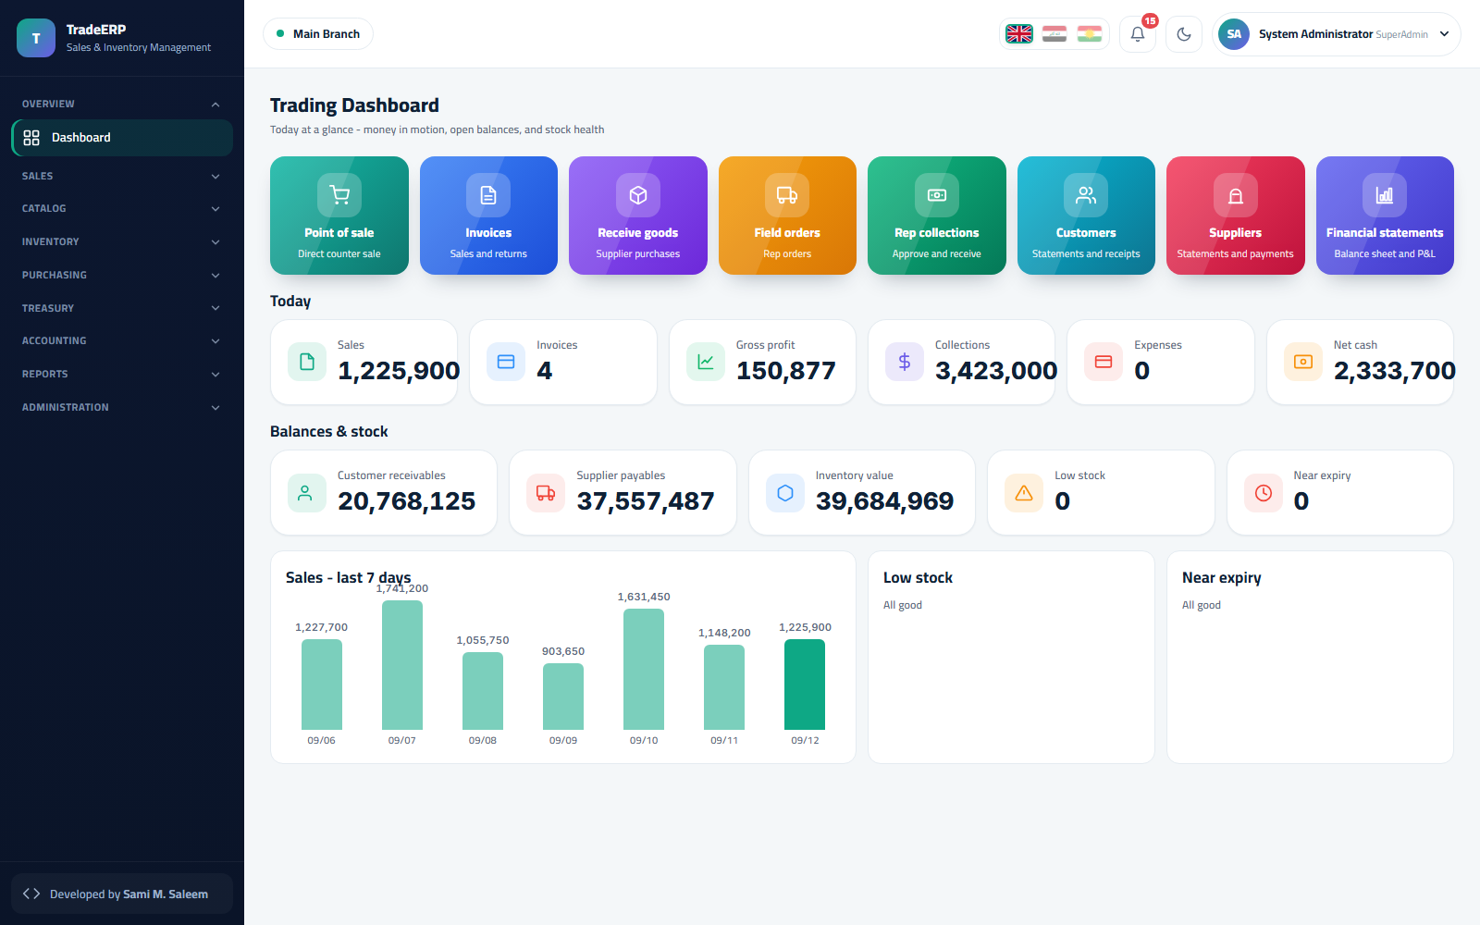
Version 1.0 · Prepared 2026-09-12
Every screen in this manual comes from a demo environment with entirely fictional data.

Table of Contents
- 1. Introduction and Quick Start
- 1.1 What is TradeERP?
- 1.2 Who uses it?
- 1.3 Signing in
- 1.4 The main layout
- 1.5 Patterns you will meet on every screen
- 1.6 Ten-minute first tour
- 2. Organization Setup
- 2.1 Company profile
- 2.2 Branches and warehouses
- 2.3 Document numbering
- 2.4 Users
- 2.5 Roles and permissions
- 2.6 Chart of accounts
- 2.7 Cashboxes
- 3. Catalog and Inventory
- 3.1 Categories
- 3.2 Products
- 3.3 Stock on hand
- 3.4 Batches and expiry (FEFO)
- 3.5 Stock ledger
- 3.6 Adjustments
- 3.7 Transfers
- 3.8 Stock counts
- 4. Purchasing
- 4.1 Suppliers
- 4.2 Purchase invoices
- 4.3 Goods receipt notes
- 4.4 Purchase returns
- 4.5 Paying suppliers
- 4.6 Purchasing reports
- 5. Sales and Point of Sale
- 5.1 Customers
- 5.2 Cash sessions
- 5.3 Point of sale
- 5.4 Sales invoices
- 5.5 Orders
- 5.6 Returns
- 5.7 Collections
- 5.8 Sales representatives
- 6. Treasury and Accounting
- 6.1 How the books are kept
- 6.2 Cashboxes and cash sessions
- 6.3 Expenses
- 6.4 Journal
- 6.5 General ledger
- 6.6 Trial balance, income statement, balance sheet
- 6.7 Accounting periods
- 7. Reports, Administration and Safety
- 7.1 Reports
- 7.2 Audit trail
- 7.3 Data integrity
- 7.4 Backups
- 7.5 Frequently asked questions

Chapter 1Introduction and Quick Start

1.1 What is TradeERP?
TradeERP is a web-based commercial management system for companies and stores that sell goods: wholesalers, distributors, supermarkets, showrooms, and multi-branch retail chains. It brings the whole trading cycle into one place:
Area | What it covers
Catalog | Products, categories, units, barcodes, prices
Inventory | Stock on hand per warehouse, batches with expiry dates (FEFO), movement ledger, adjustments, transfers, stock counts
Purchasing | Suppliers, purchase invoices, goods receipt, returns, supplier balances
Sales | Point of sale (POS), sales invoices, orders, returns, customers, sales representatives and their custody
Treasury | Cashboxes, cash sessions, expenses, collections
Accounting | Double-entry journal, general ledger, trial balance, income statement, balance sheet, accounting periods
Administration | Users, roles and permissions, branches, numbering, backups, data-integrity checks, audit trail
Every sale, receipt, or expense you post creates the matching journal entry automatically — the accountant never re-types operational documents.
Demo note. All names, amounts and documents shown in this manual come from a demo company ("My Trading Company") whose data is generated automatically. Nothing in it is real.

1.2 Who uses it?
Role | Typical user | Main screens
System Administrator | Owner / IT | Everything, plus users, permissions, backups
Branch Manager | Store manager | Dashboard, sales, purchases, inventory, reports of the branch
Cashier | Front desk | Point of sale, cash sessions, customers
Accountant | Finance | Treasury, journal, ledger, statements, periods
Sales Rep | Field sales | Rep orders, collections, custody (also through the mobile app)
The system ships with 15 predefined roles; each role's permissions can be adjusted from Administration → Permissions.

1.3 Signing in
- Open the system address in a modern browser (Chrome, Edge, Firefox, Safari).
- Enter your username or e-mail and password.
- Choose the interface language with the flags at the top of the login card: English, Arabic or Kurdish. Arabic and Kurdish switch the whole layout to right-to-left.
- Click Sign in. Keep "Keep me signed in" ticked on your own device only.
Sign-in page with the language flags
On first sign-in a new account is asked to set its own password.

1.4 The main layout
The dashboard — today's numbers, balances, low stock and near-expiry alerts
- Sidebar (start side) — grouped menu: Overview, Sales, Catalog, Inventory, Purchasing, Treasury, Accounting, Reports, Administration. Click a group title to expand it.
- Top bar — the active branch, language flags, notifications bell, dark/light mode, and your profile menu.
- Dashboard — quick tiles for POS, invoices, purchases, customers and reports; Today counters (sales, invoices, returns, collections, expenses); Balances & stock (customer receivables, supplier payables, inventory value, low-stock and near-expiry counts); a 7-day sales chart and the low-stock / near-expiry lists.

1.5 Patterns you will meet on every screen
- Lists have a search box, filters, column sorting and paging. The ⋮ or pencil icon on a row opens edit/view actions.
- Forms validate as you type; required fields are marked and the save button stays disabled until the form is valid.
- Documents (invoices, receipts, vouchers) have a status: Draft → Posted. Posted documents are immutable; corrections are made with returns or adjusting entries.
- Numbers follow the branch-scoped numbering series set in Administration → Numbering.
- Dates and money respect the company base currency (IQD by default) and the USD rate defined in company settings.
- Print buttons open a print-ready view of the document or report.

1.6 Ten-minute first tour
- Open Catalog → Products and look at a product: units, barcode, purchase and sale prices.
- Open Inventory → Stock on Hand and pick a warehouse.
- Open Sales → Point of Sale, click Open session, scan or click a few products, then Pay (F9).
- Go to Sales → Invoices — your sale is there, posted.
- Open Accounting → Journal — the sale's journal entry (cash / revenue / COGS / inventory) was created automatically.
- Open Reports → Sales for the day's totals.
You have just walked the complete path from the shelf to the ledger.

Chapter 2Organization Setup
Set these up once, in this order, before the first sale.

2.1 Company profile
Administration → Company. Name (English/Arabic), legal name, tax and registration numbers, phone, e-mail, address, base currency, USD↔IQD rate, default language, and the company logo (shown on the login page and on printed documents). Gift and discount limits per invoice are also set here.
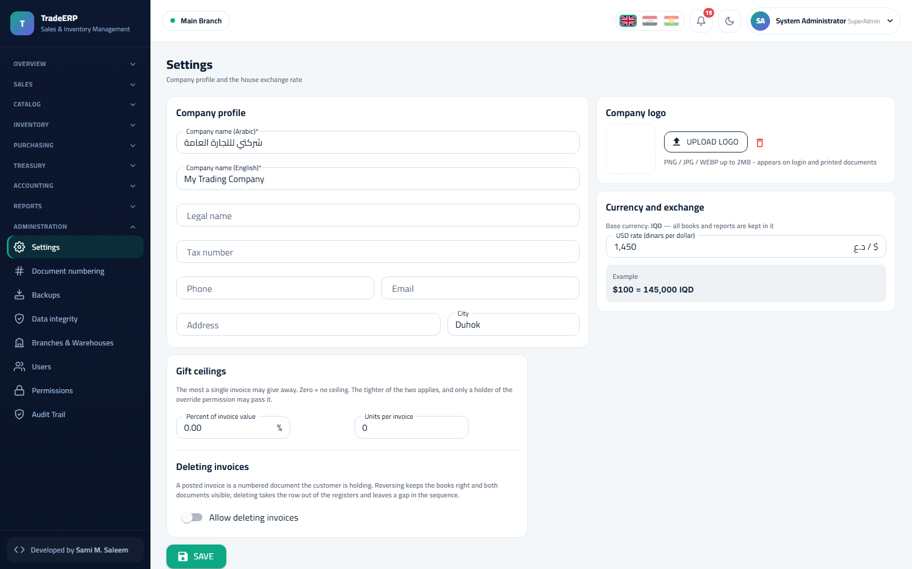Company settings

2.2 Branches and warehouses
Administration → Branches. Every branch has a code, a name, and one or more warehouses. Stock, cash sessions and document numbering are all branch-scoped: a user sees only the branches assigned to them, and the top-bar branch selector switches the context.
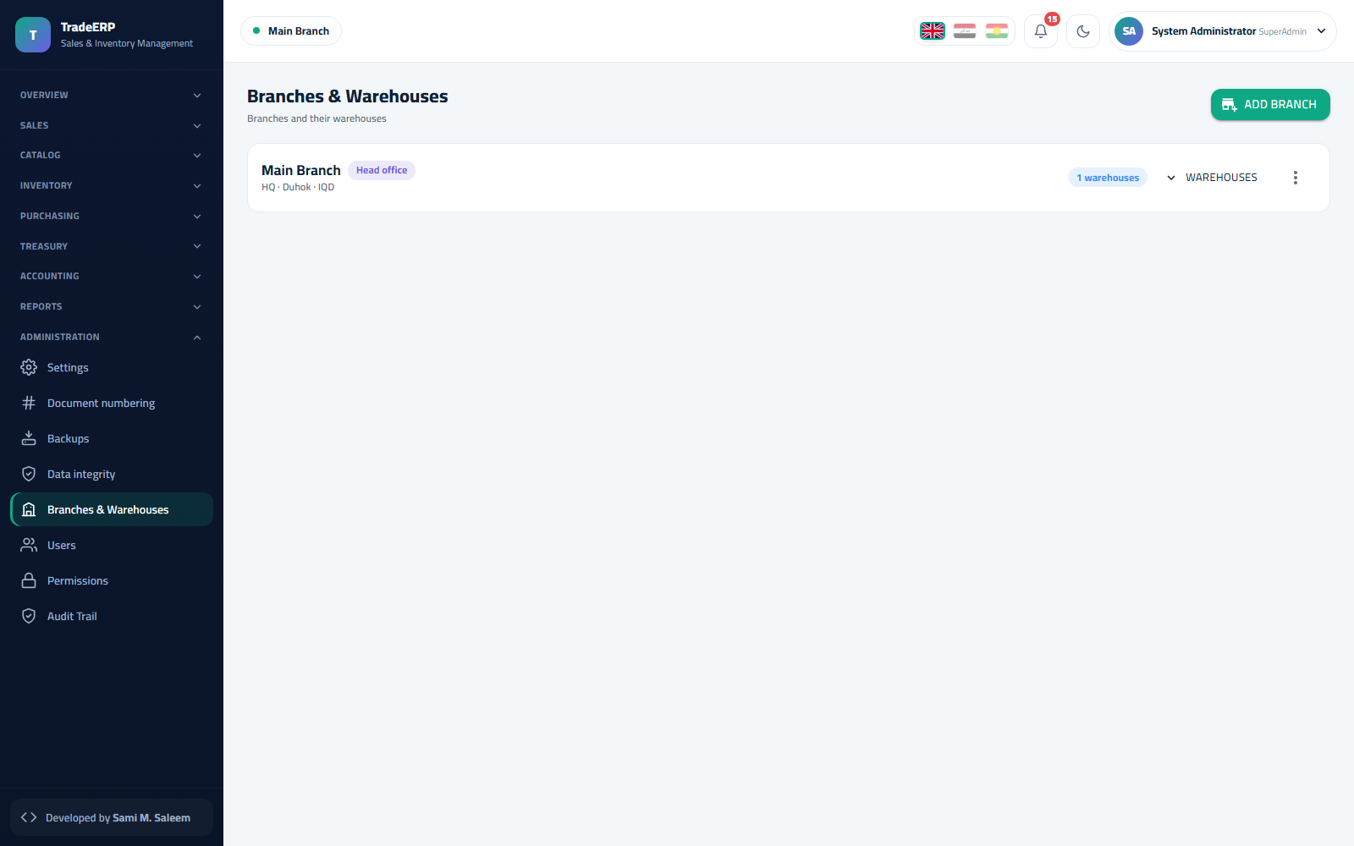Branches and their warehouses
Tip. Create one "Main" warehouse per branch first. Add "Damaged" or "Showroom" warehouses later only if you really move stock between them.

2.3 Document numbering
Administration → Numbering. Each document type (sales invoice, purchase invoice, receipt, payment voucher, journal entry…) has its own prefix, next number and padding per branch. Numbers are assigned when a document is posted, so drafts never consume a number.
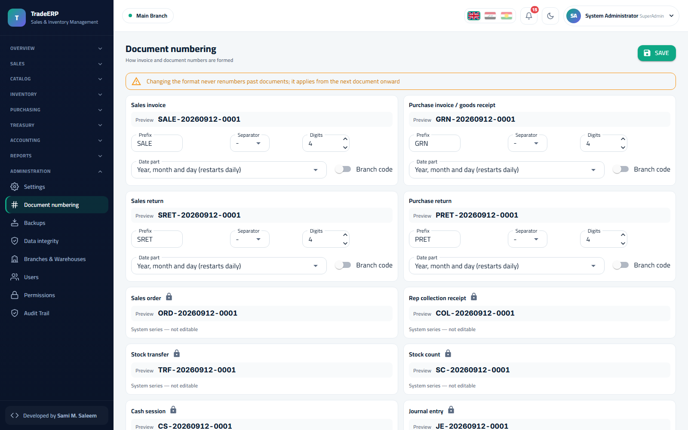Numbering series per document type and branch

2.4 Users
Administration → Users. Create a user with a username, e-mail, full name, role, home branch and default warehouse. New users are created with "must change password" switched on, so the temporary password you hand over is replaced on first sign-in. Deactivate (never delete) users who leave — their history stays in the audit trail.
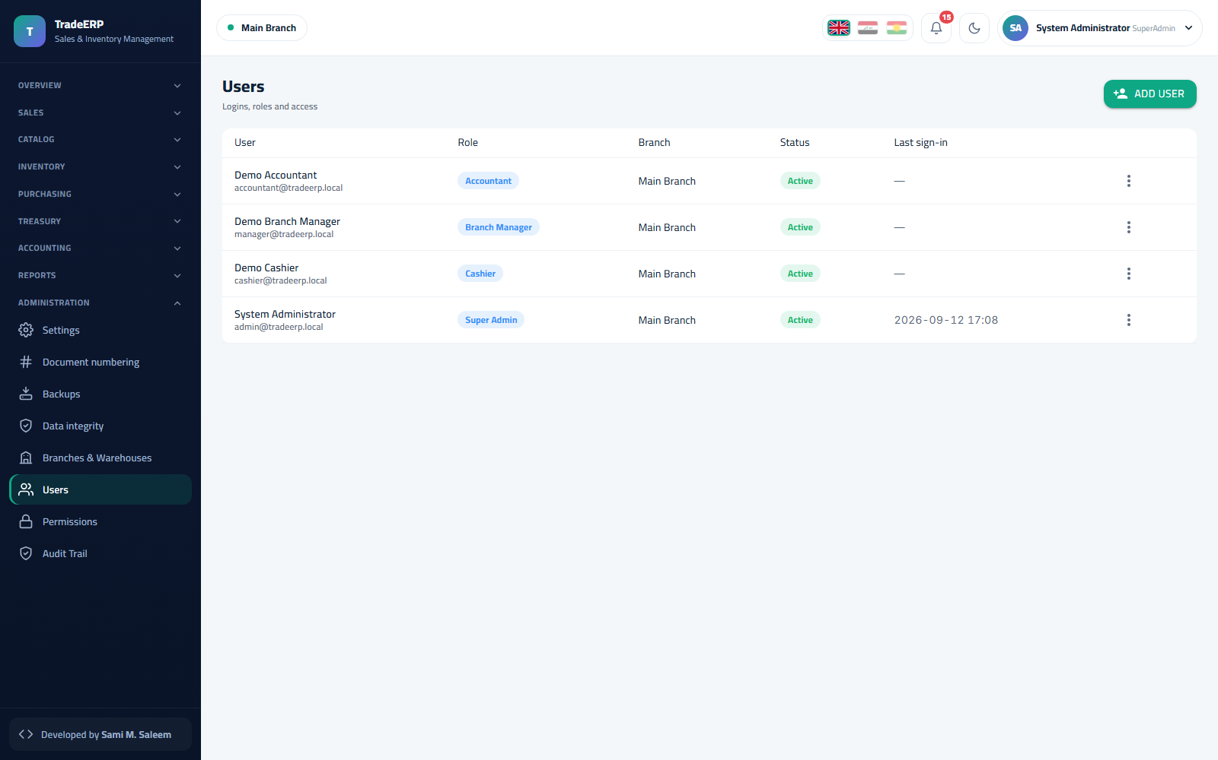Users list

2.5 Roles and permissions
Administration → Permissions. The matrix lists every permission (view / create / post / cancel / export…) against every role. Tick or untick, then Save; the change reaches signed-in users on their next request — no re-login needed.
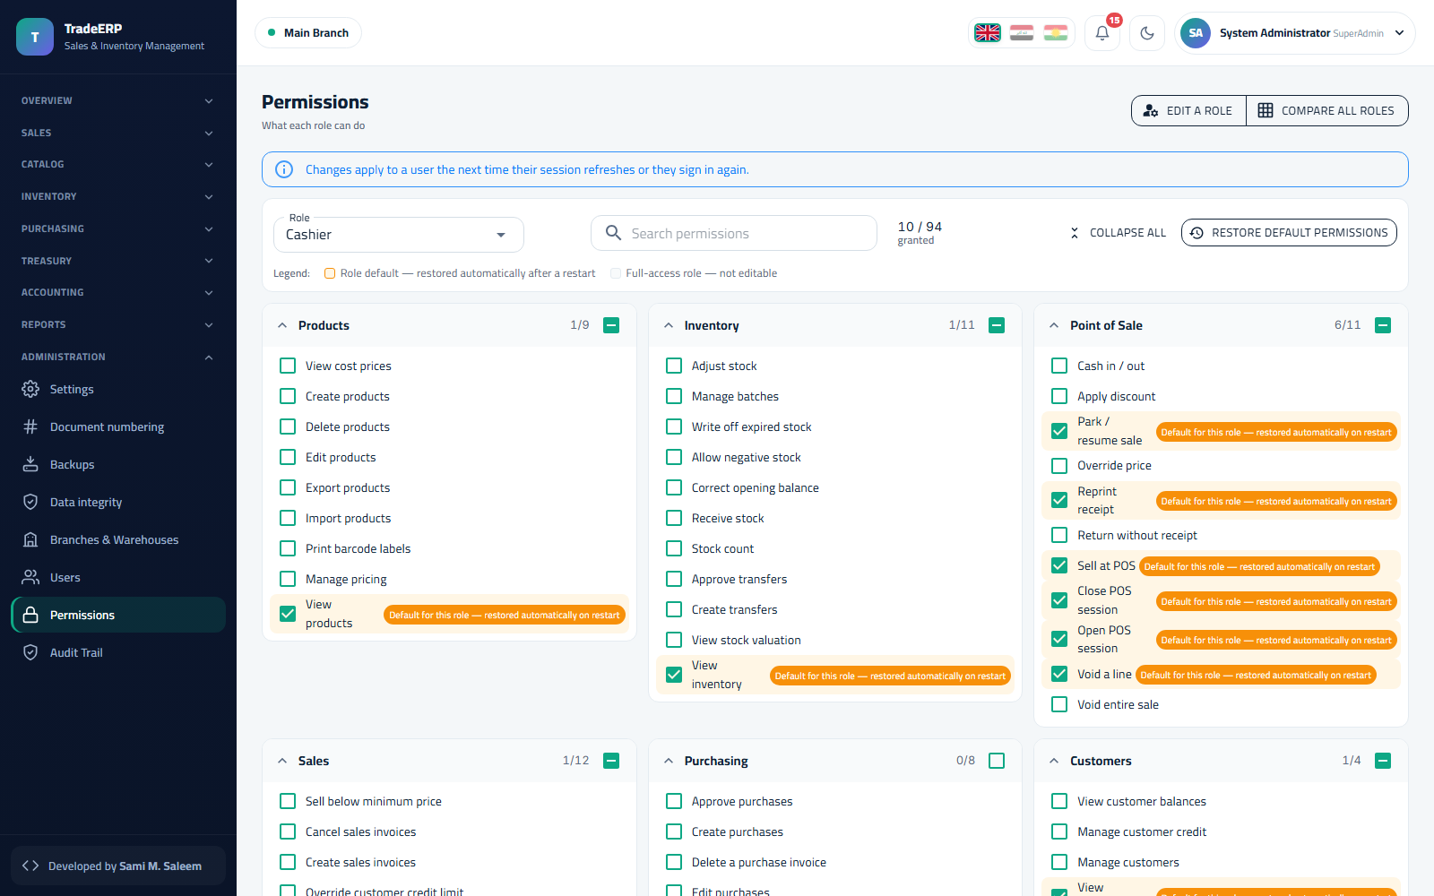The permission matrix
Rule of least privilege. Cashiers post sales but do not cancel posted invoices; accountants see money screens but not payroll; only the administrator manages users and backups.

2.6 Chart of accounts
Accounting → Chart of Accounts. A ready chart (assets, liabilities, equity, revenue, expenses) is created for you with the control accounts the automatic postings use (cash, receivables, inventory, payables, sales revenue, COGS, discounts, VAT). Add sub-accounts freely; do not delete control accounts.
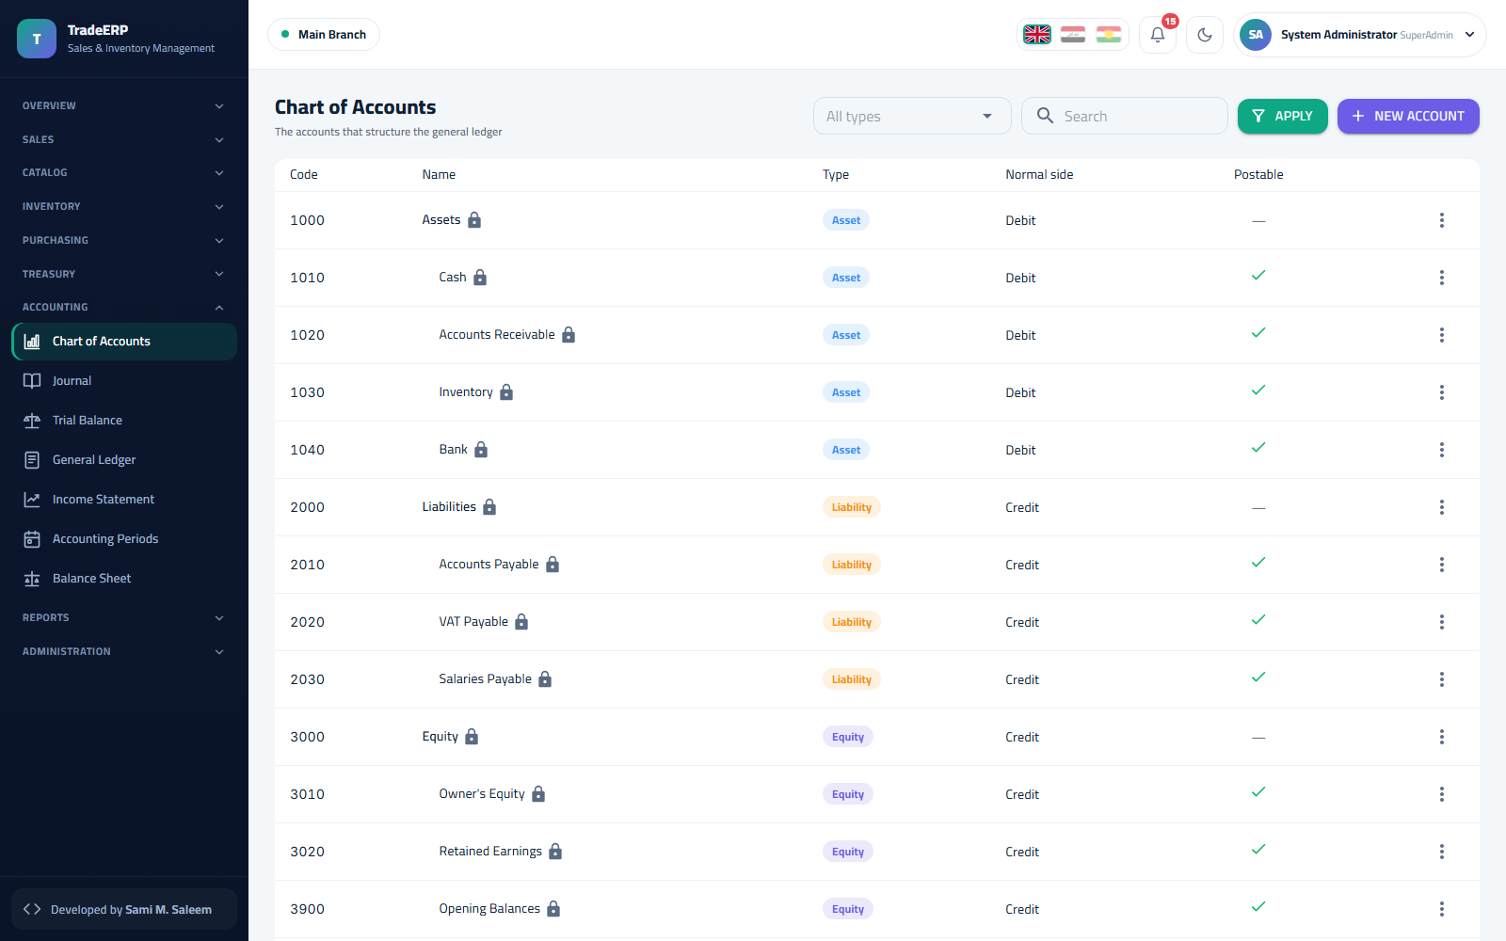Chart of accounts

2.7 Cashboxes
Treasury → Cashboxes. One cashbox per till or safe, each linked to a ledger account and a branch. POS sessions open and close against a cashbox.
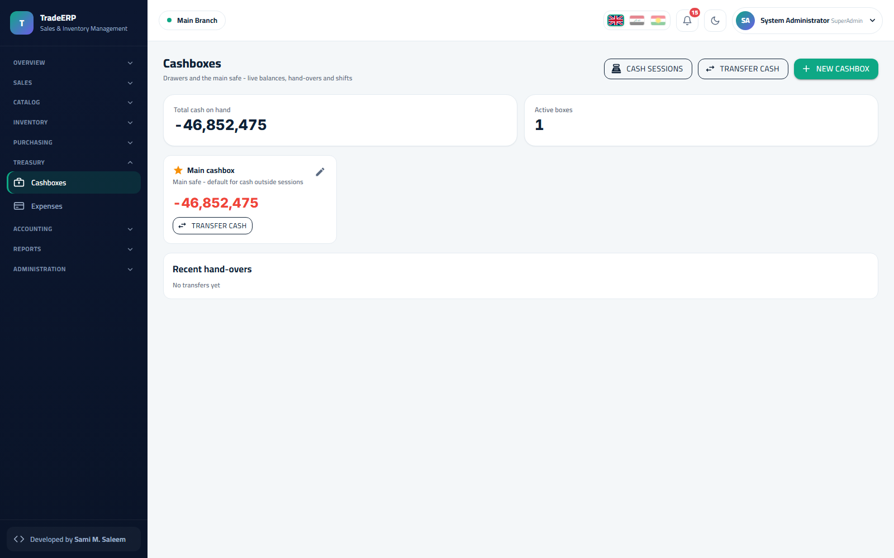Cashboxes

Chapter 3Catalog and Inventory

3.1 Categories
Catalog → Categories. A two-level tree (category → sub-category) with English and Arabic names, display order and an active flag. Categories drive the quick-filter chips on the POS screen and the grouping in reports.
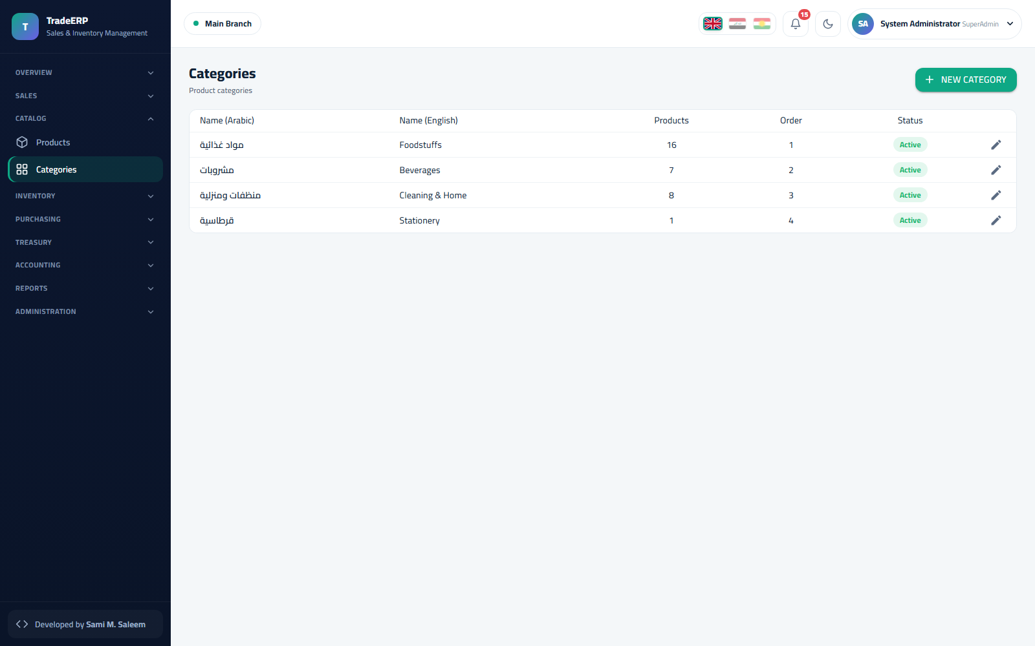Categories

3.2 Products
Catalog → Products. Each product has: code, barcode(s), English/Arabic names, category, base unit and optional pack units (e.g. carton of 24), purchase price, sale price(s), VAT flag, reorder level, and whether it is batch-tracked (expiry).
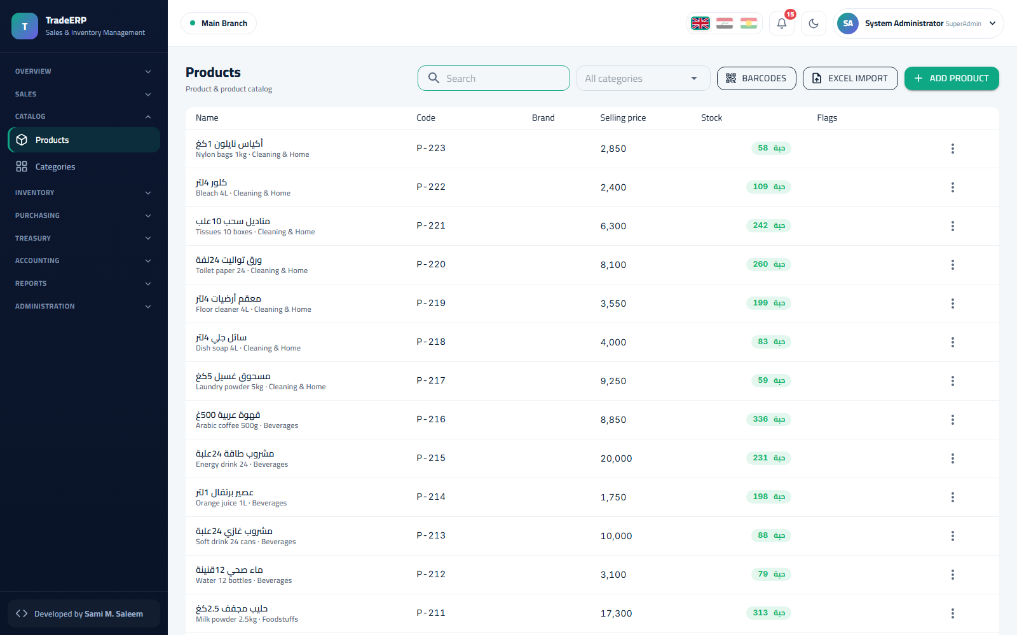Products list
Steps to add a product:
- Products → Add product.
- Fill code, names, category and base unit.
- Add pack units with their multipliers if the product is bought or sold in packs.
- Enter prices; enable Batch / expiry tracking for food, medicine, or chemicals.
- Save. The product is immediately available in POS and purchasing.
Prices can also be updated in bulk from the list with Import from Excel (the template is downloadable from the same menu).

3.3 Stock on hand
Inventory → Stock on Hand. Quantity, reserved, available, reorder level and status per product per warehouse. Filter by warehouse, category or status (low, out, near expiry).
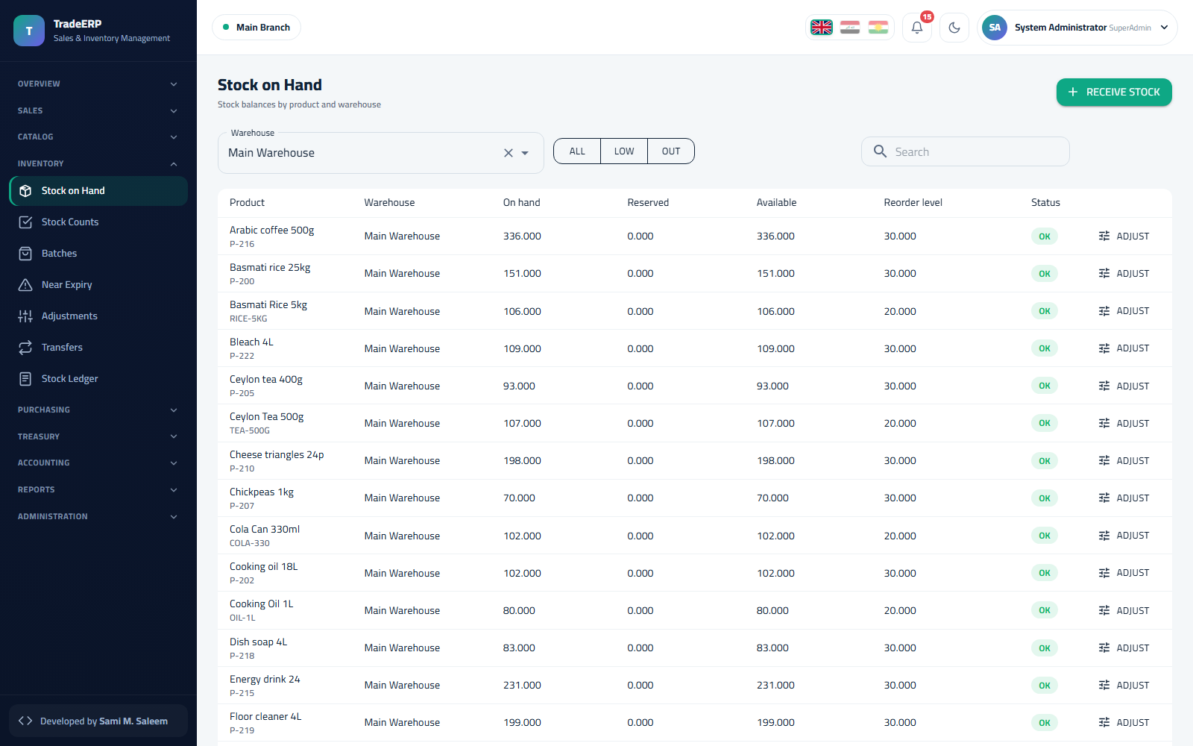Stock on hand per warehouse

3.4 Batches and expiry (FEFO)
Inventory → Batches. For batch-tracked products every goods receipt creates a batch with its own expiry date, quantity and unit cost. When a sale is posted the engine issues stock from the batch that expires first (First-Expired, First-Out), and the cost of goods sold is taken from that batch — so margins are always real.
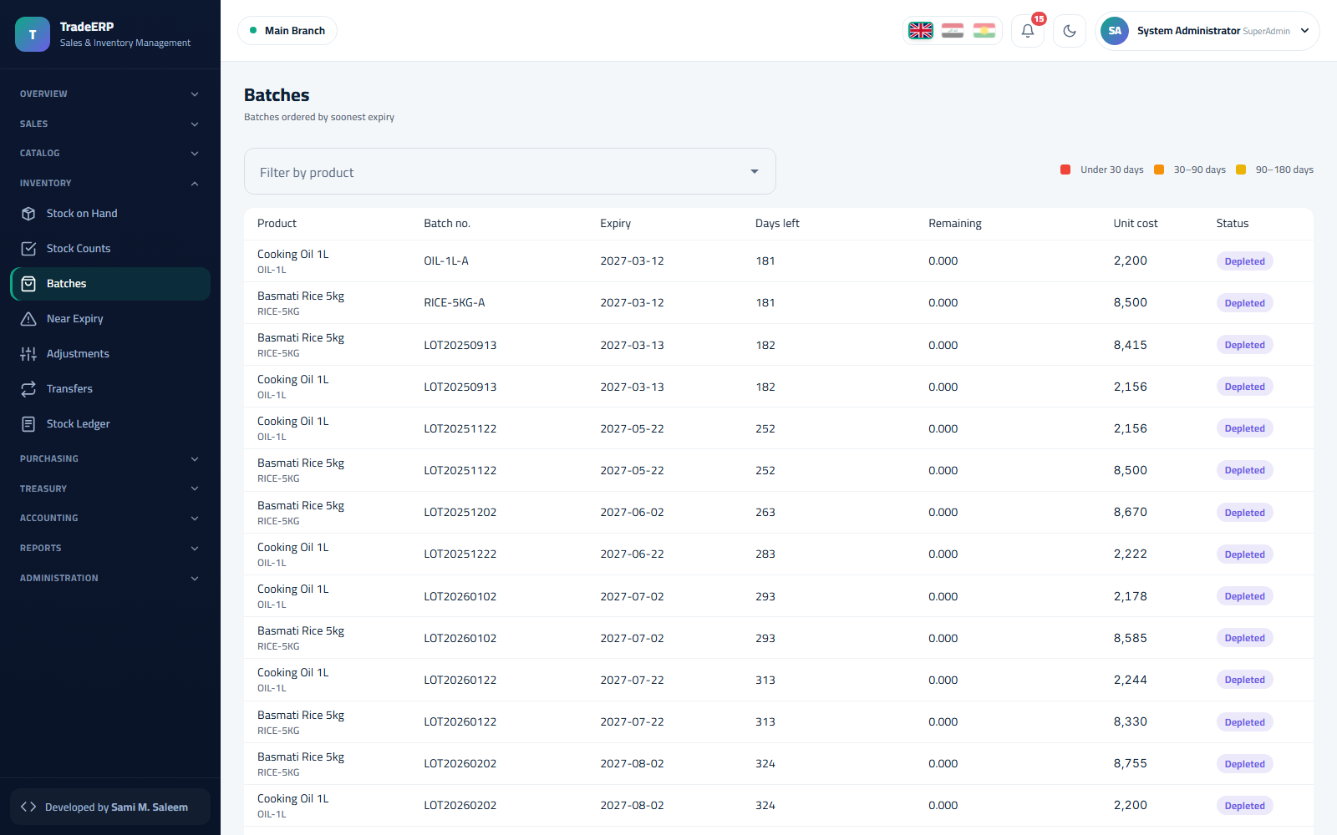Batches with expiry dates and remaining quantities
Inventory → Expiry lists everything expiring in the next 30 / 60 / 90 days so it can be discounted or returned to the supplier in time.
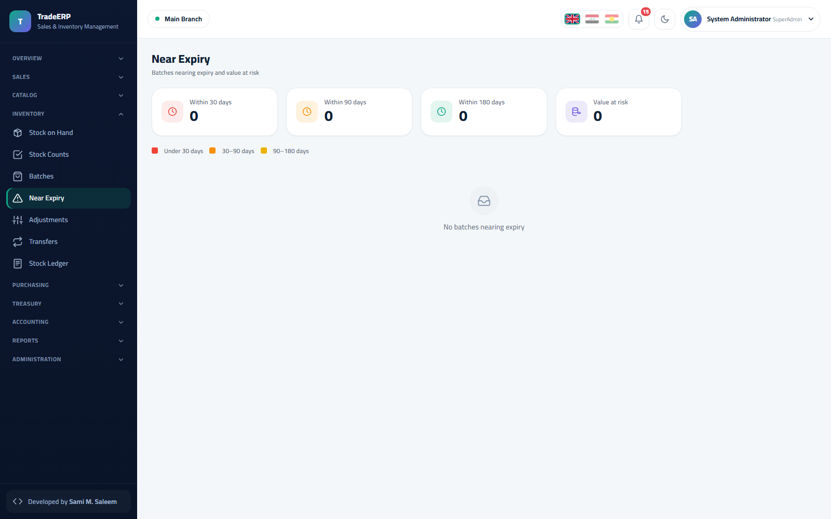Near-expiry watch list

3.5 Stock ledger
Inventory → Stock Ledger is the audit trail of stock: one line per movement (receipt, sale, return, adjustment, transfer, count) with the document reference, quantity in/out, unit cost and running balance. If a quantity ever looks wrong, this is where you find out why.
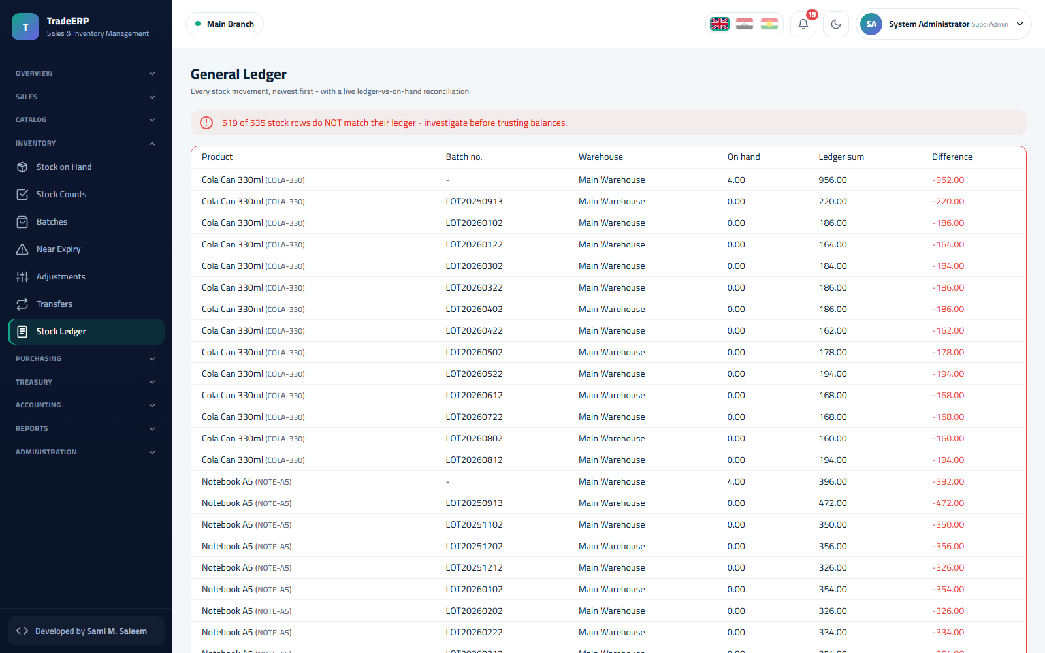Stock movement ledger

3.6 Adjustments
Inventory → Adjustments. Record damage, loss, found stock or opening balances: choose warehouse, product, batch (if tracked), quantity (+/−), reason and note, then post. The adjustment produces the stock movement and the accounting entry (inventory ↔ shrinkage/opening-balance account).
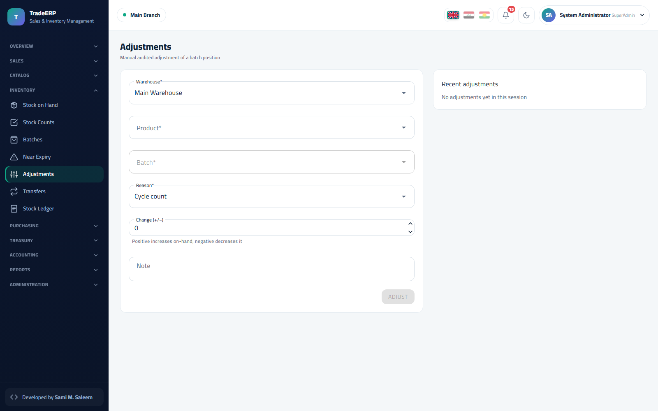Stock adjustment form

3.7 Transfers
Inventory → Transfers. Move goods between warehouses (same or different branch). A transfer is issued from the source and received at the destination; in-transit quantity is visible until the receiving side confirms.
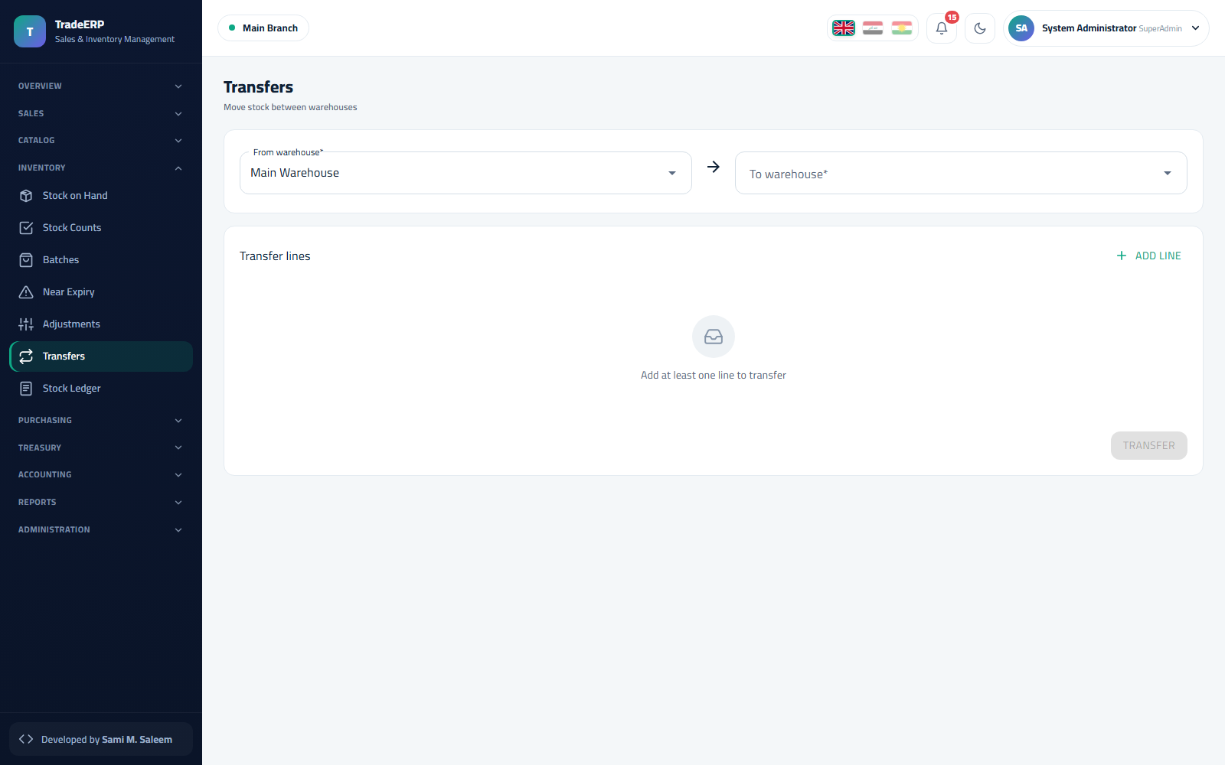Warehouse transfers

3.8 Stock counts
Inventory → Counts. Start a count for a warehouse (optionally one category), print the count sheet, enter counted quantities, review the variance list, and post — differences become adjustments automatically with a full paper trail.
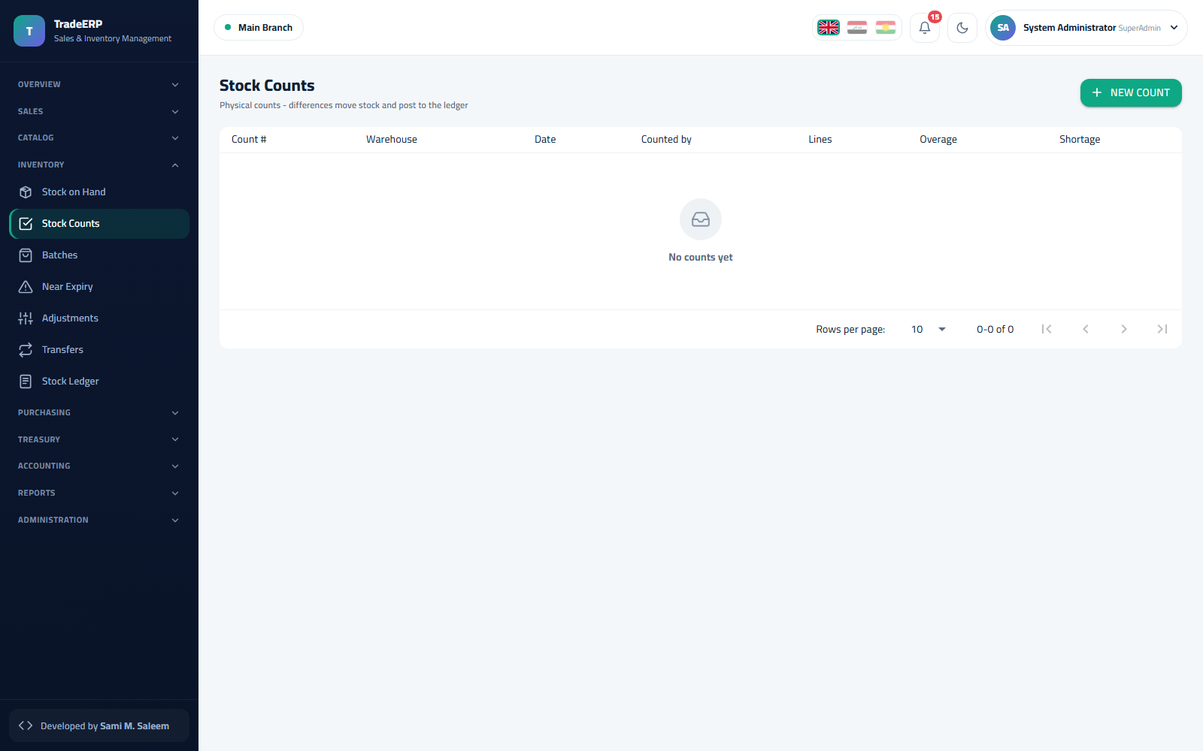Stock count with variances

Chapter 4Purchasing

4.1 Suppliers
Purchasing → Suppliers. Name, contact details, payment terms, opening balance and a linked payable account. The list shows each supplier's outstanding balance live.
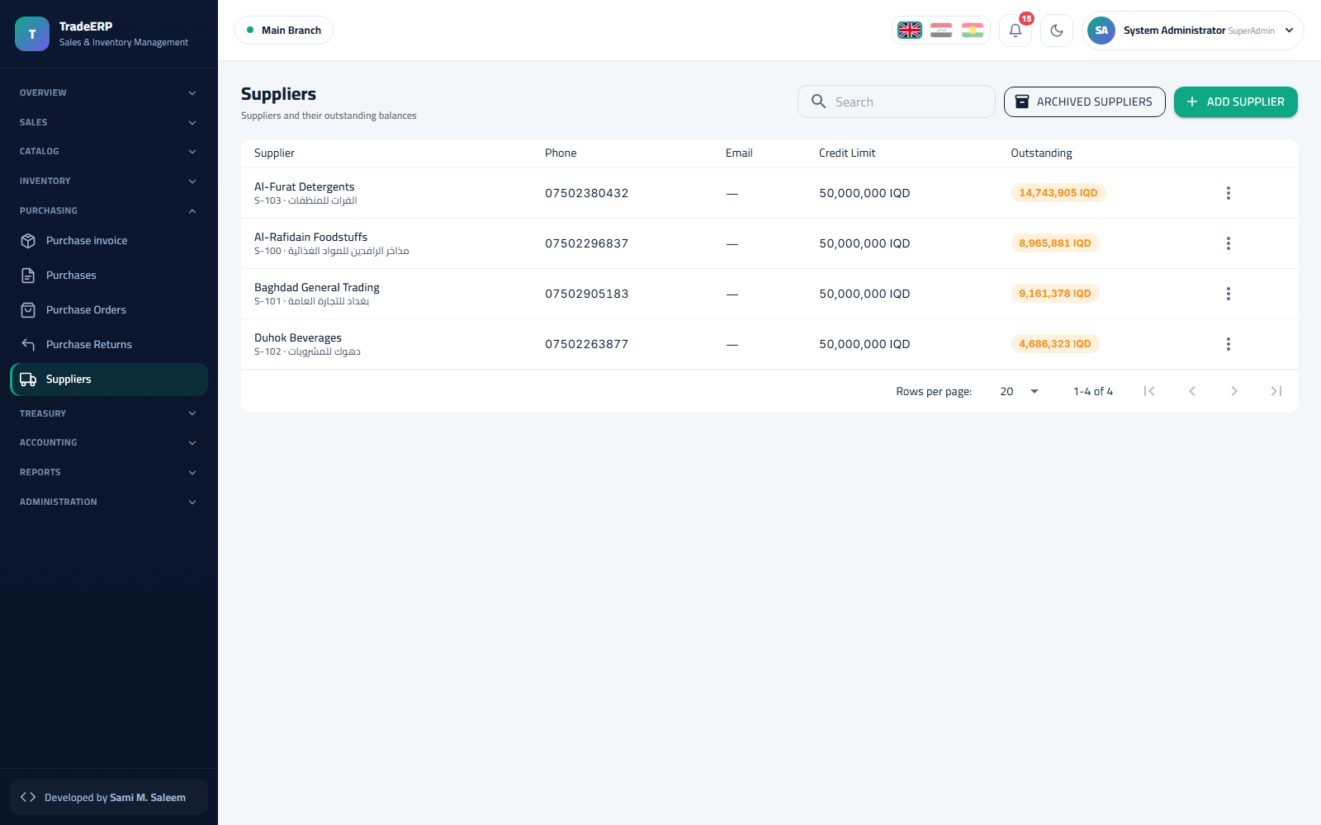Suppliers with outstanding balances

4.2 Purchase invoices
Purchasing → New Purchase.
- Choose supplier, warehouse and invoice date; type the supplier's invoice number.
- Add lines: product, unit (base or pack), quantity, unit cost, discount, VAT. For batch-tracked products enter the batch number and expiry date — this is what feeds FEFO later.
- Add freight or other landed costs if the supplier charged them; they are spread over the lines' cost.
- Post. Stock is received, the batches are created, the supplier balance increases, and the journal entry (inventory / VAT / payable) is written.
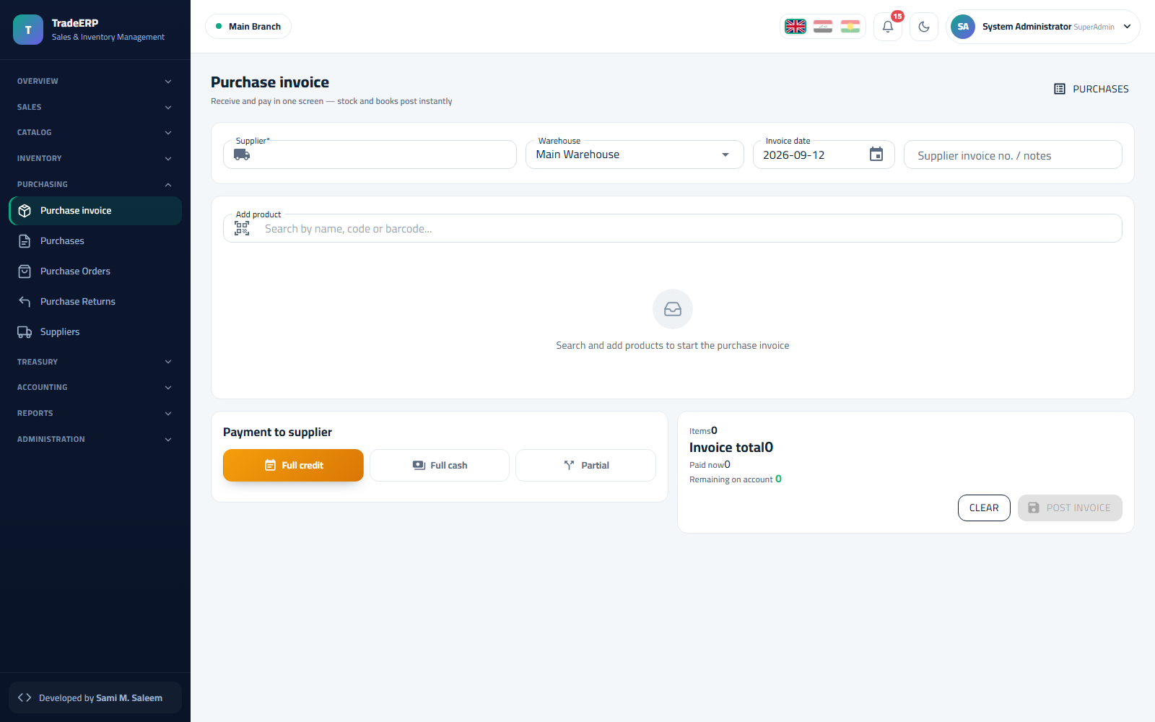New purchase invoice with batch and expiry per line
Purchasing → Invoices lists all purchases with status, totals and paid/unpaid amounts.
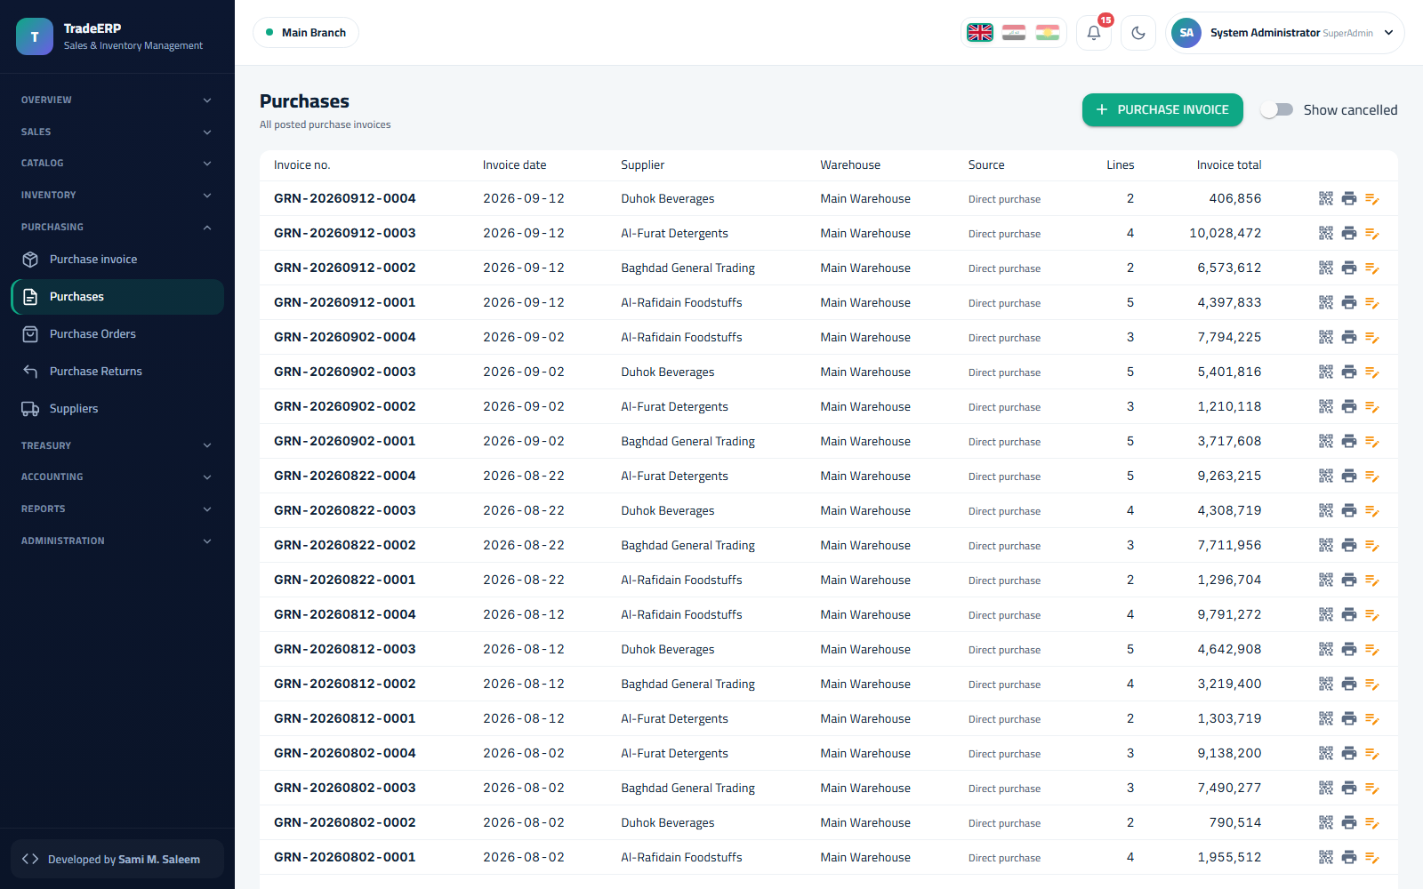Purchase invoices

4.3 Goods receipt notes
When goods arrive before the invoice (or in several deliveries), receive them with a goods receipt against the order; the invoice later matches the receipts so stock is never counted twice.

4.4 Purchase returns
Purchasing → Returns. Pick the original invoice, select the lines and quantities going back, and post. Stock leaves the warehouse from the exact batch, and a credit is recorded against the supplier.
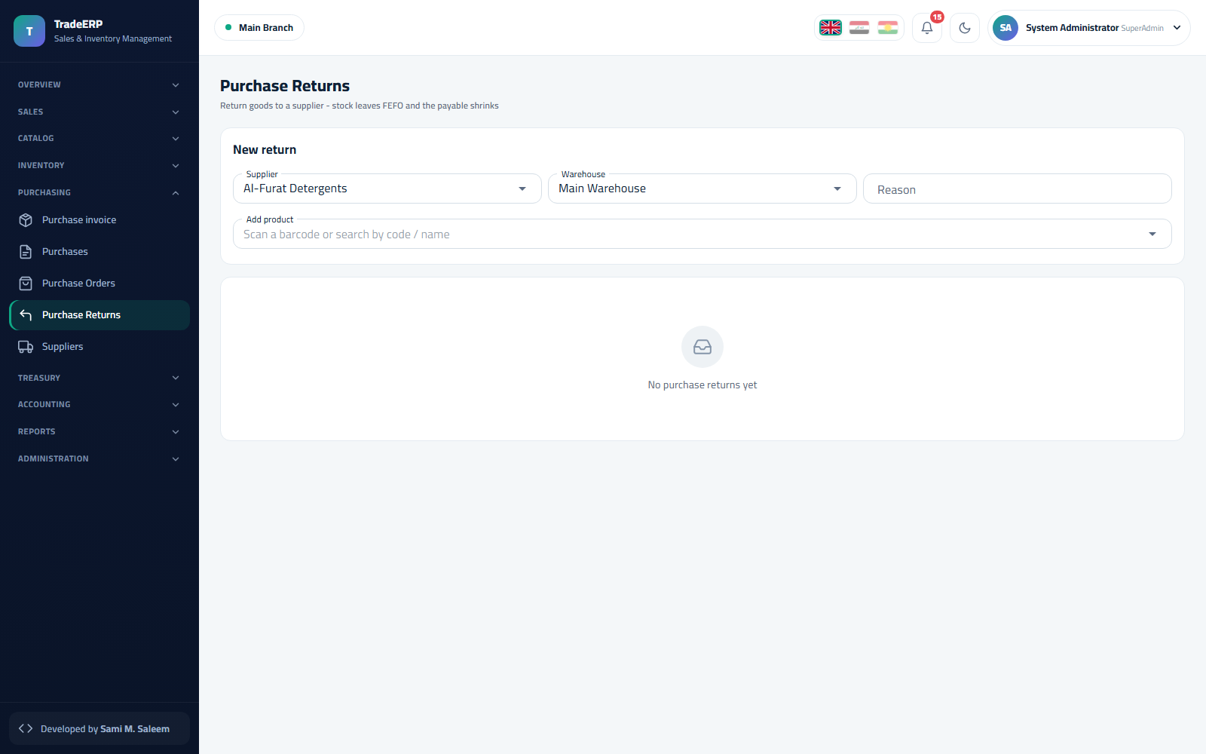Purchase returns

4.5 Paying suppliers
Supplier payments are recorded from Treasury (payment voucher against the supplier) or directly from the supplier's page → Pay. Each payment can settle one or several invoices; the remaining balance is shown per invoice.

4.6 Purchasing reports
- Reports → Purchases — purchases by supplier, product or period.
- Reports → Item Card — the complete history of one product across purchases, sales and adjustments.
- Reports → Valuation — inventory value by warehouse at weighted-average cost.

Chapter 5Sales and Point of Sale

5.1 Customers
Sales → Customers. Individuals or companies with contact details, credit limit, payment terms, price list and an opening balance. The list shows the outstanding balance and the last payment date.
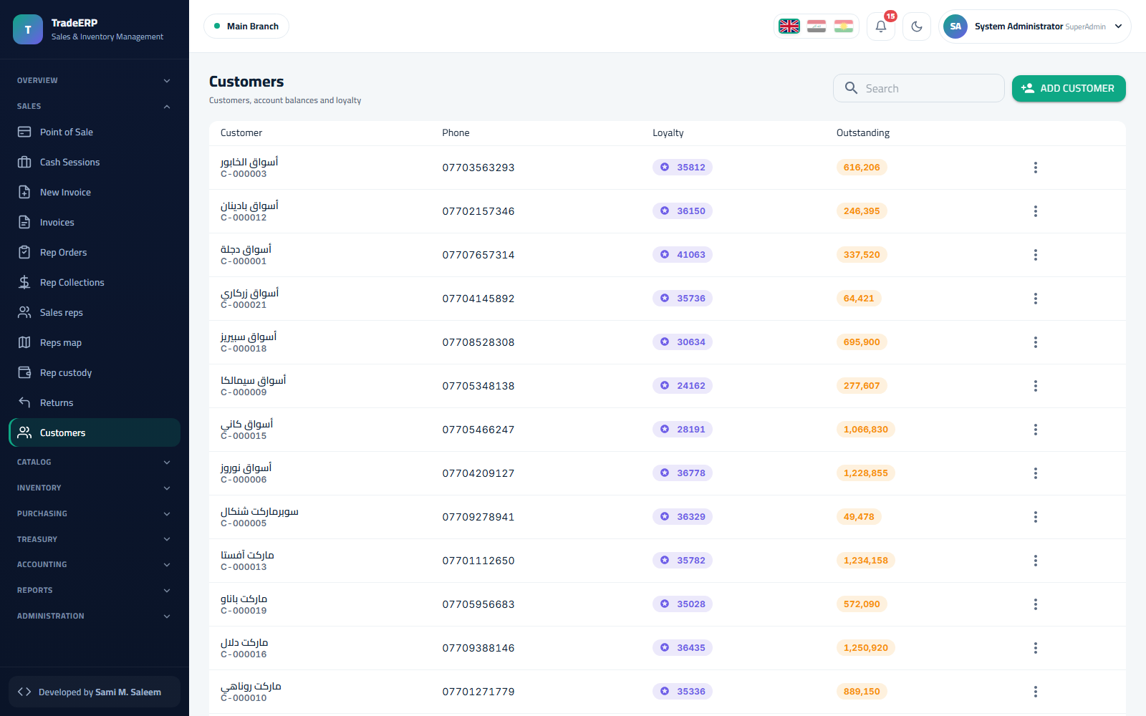Customers and balances

5.2 Cash sessions
A cashier cannot sell without an open session. Sales → Cash Sessions (or the Open session button on the POS) asks for the cashbox and the opening float. At the end of the shift the cashier closes the session by counting the drawer; the system shows expected vs counted cash and records any difference.
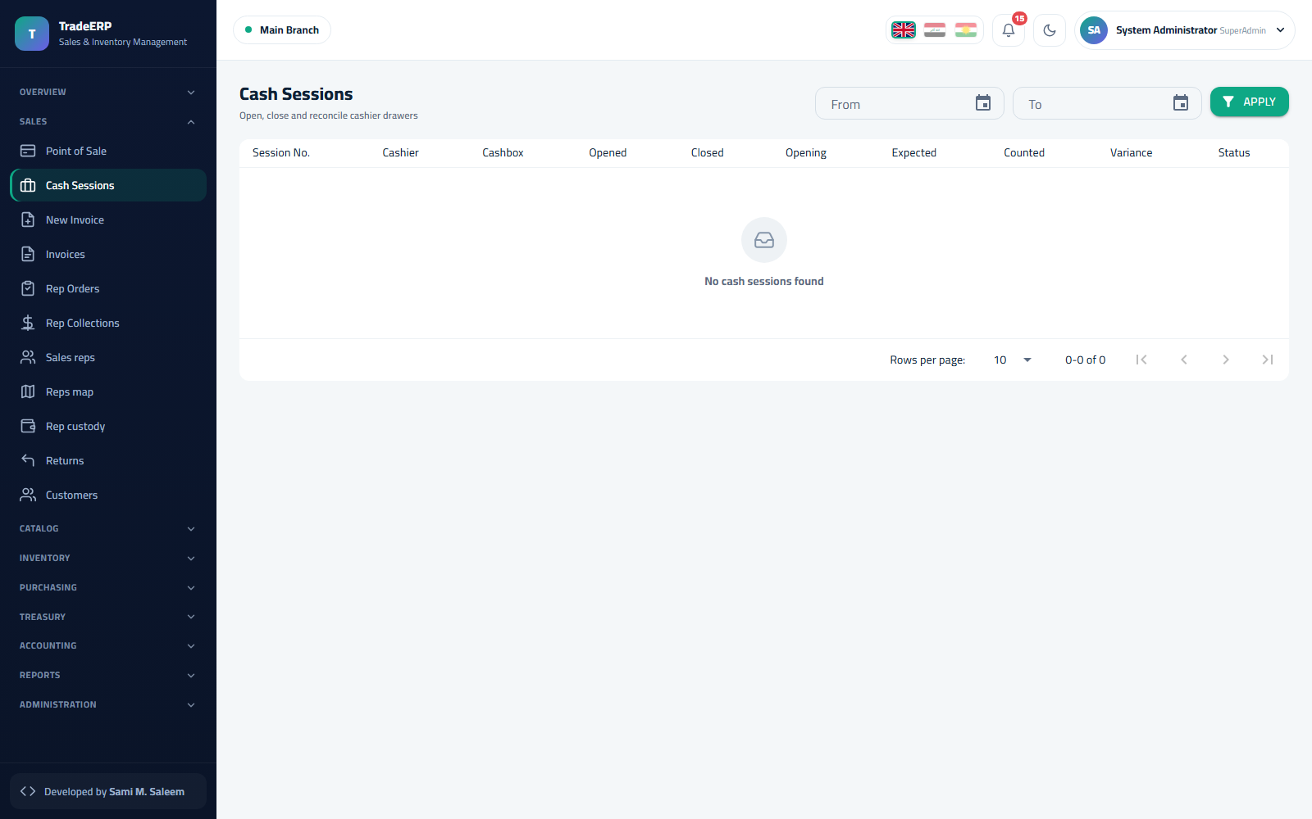Cash sessions — open, close, differences

5.3 Point of sale
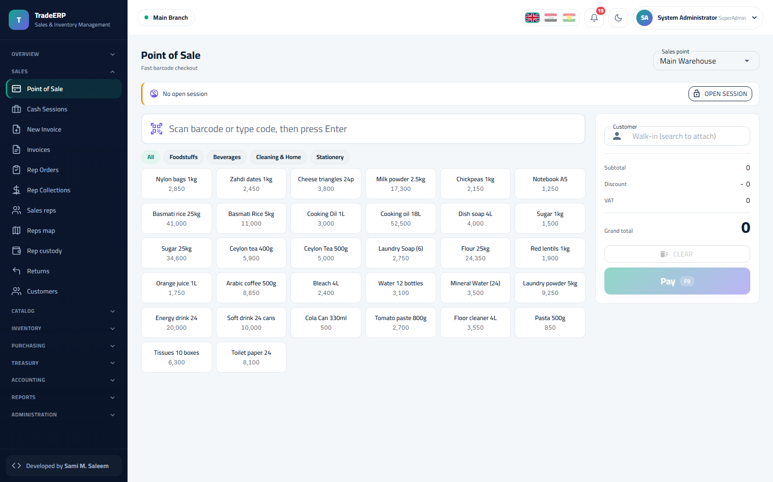Point of sale
The POS is built for speed:
- Scan a barcode (or type the code) and press Enter — the line is added with quantity 1; scan again to increase.
- Or click a product tile; the category chips filter the tiles.
- Attach a customer when the sale is on account or should count toward their history; leave Walk-in otherwise.
- Adjust quantity, unit or line discount in the cart; give an invoice discount if allowed by your role.
- Pay (F9): choose cash, card, or on-account; enter the amount received — the change is calculated.
- The receipt prints and the invoice is posted. Stock, cash, customer balance and the journal are updated in the same transaction.
Keyboard shortcuts: F9 pay · Esc clear · F2 customer search · + / − quantity.

5.4 Sales invoices
Sales → New Invoice is the full-form counterpart of the POS for wholesale or delivery sales: customer, warehouse, due date, per-line prices and discounts, notes, and delivery details. Sales → Invoices lists everything with status and payment state; a posted invoice can be printed, e-mailed, or returned.
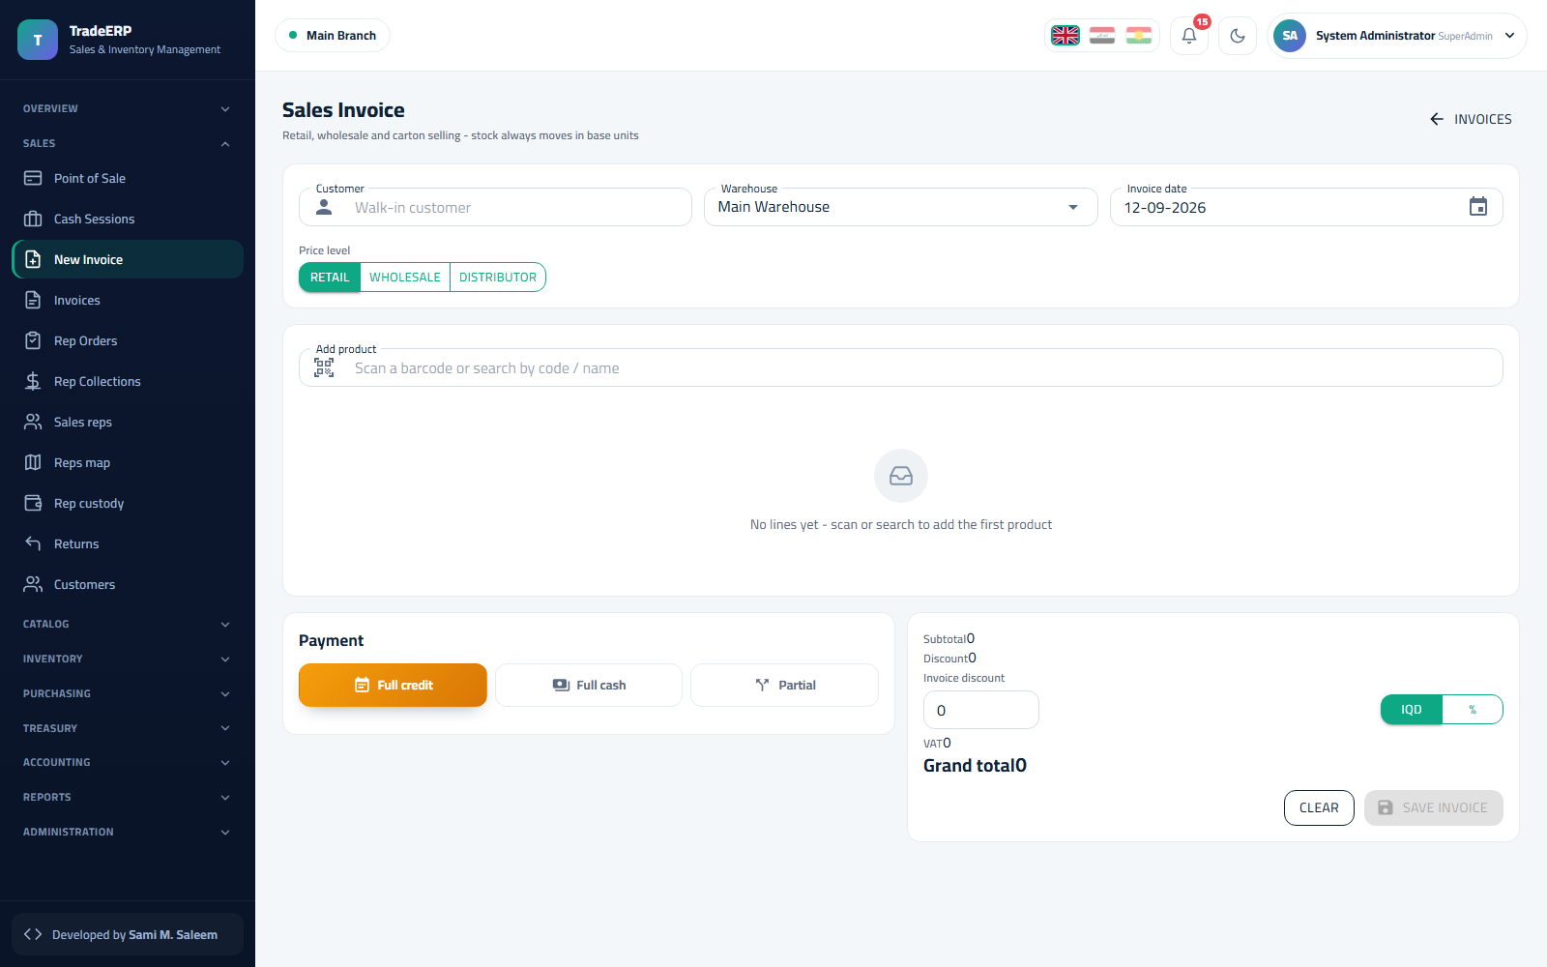New sales invoice 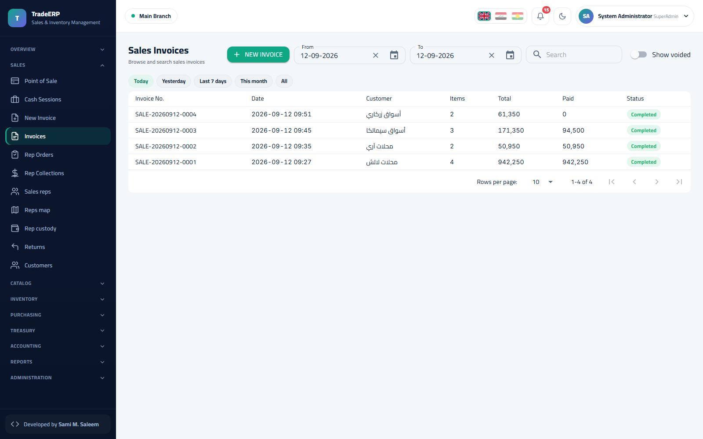Sales invoices

5.5 Orders
Sales → Rep Orders are orders taken by sales representatives in the field (from the mobile app) or entered for later delivery. They reserve stock and are converted to invoices when delivered.
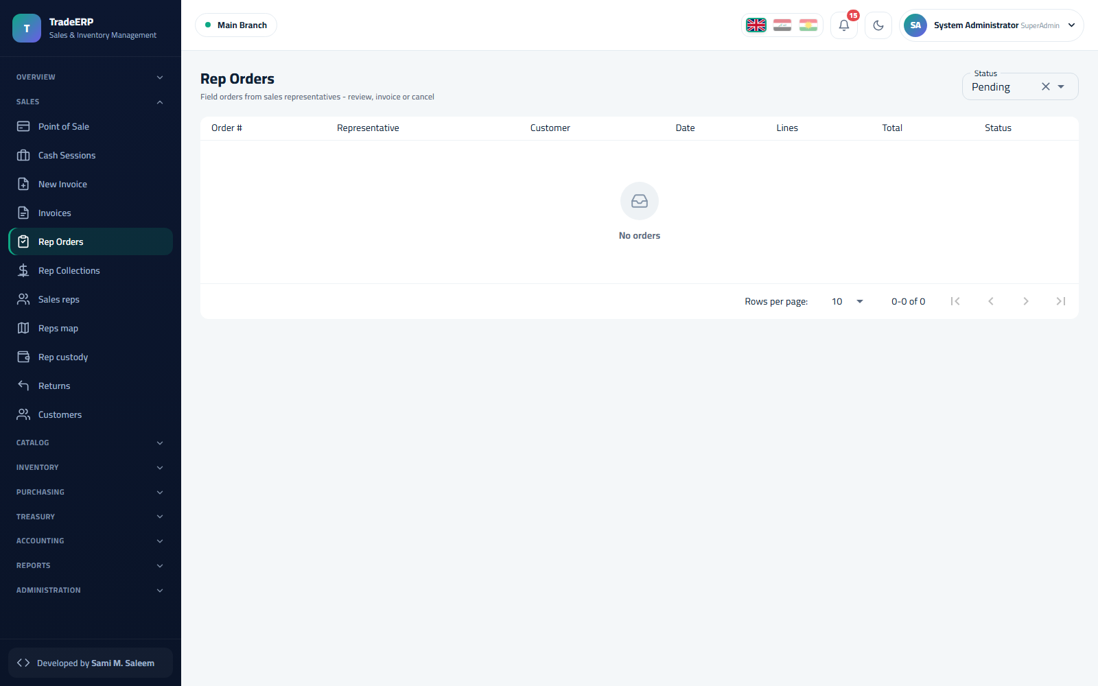Sales orders

5.6 Returns
Sales → Returns. Choose the original invoice, select lines and quantities, pick the refund method (cash, on-account credit). Stock comes back to the warehouse — into its original batch — and the reverse journal entry is posted.
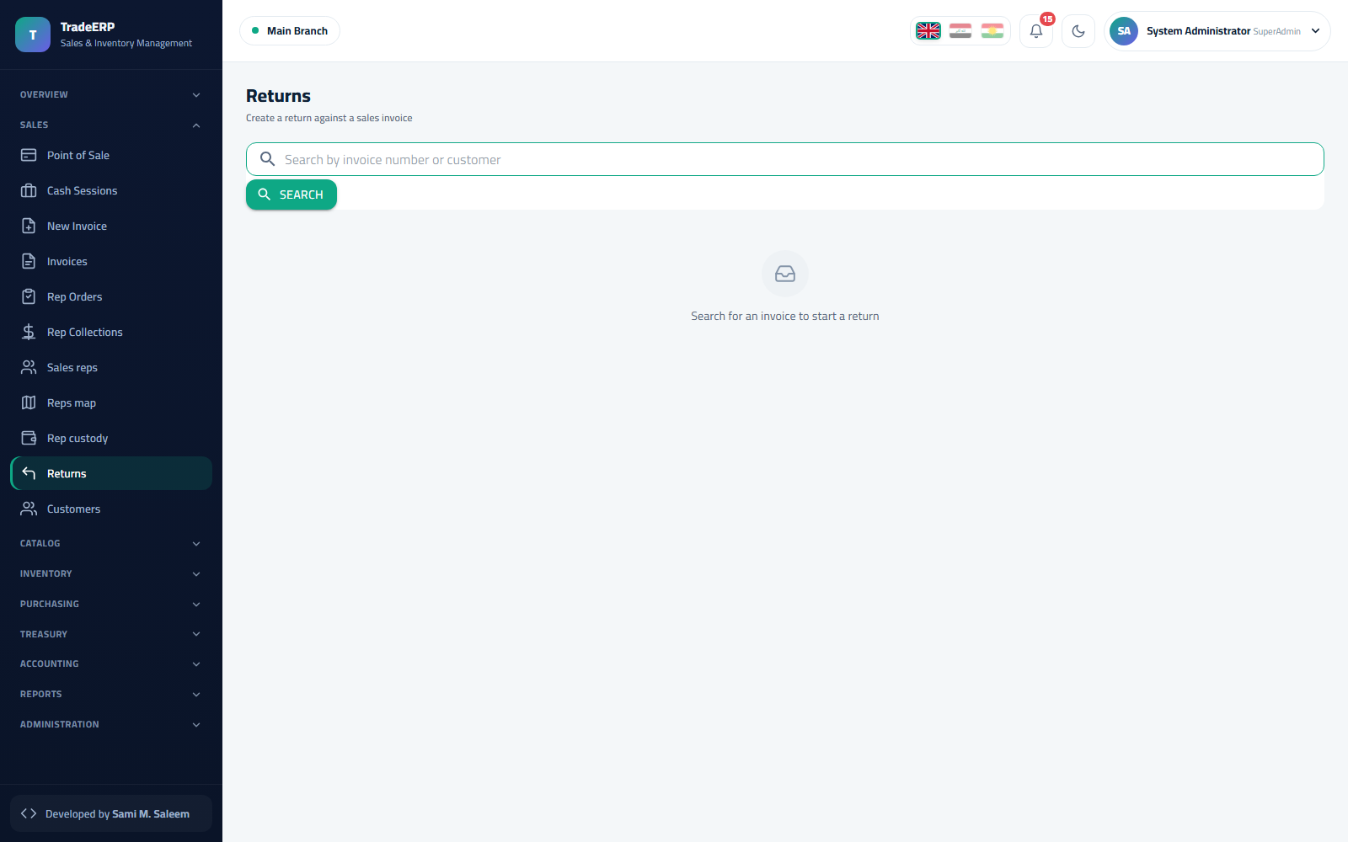Sales returns

5.7 Collections
Sales → Rep Collections records money collected from customers against open invoices (by the cashier or by a rep). Partial payments are allowed; the invoice shows the remaining amount.
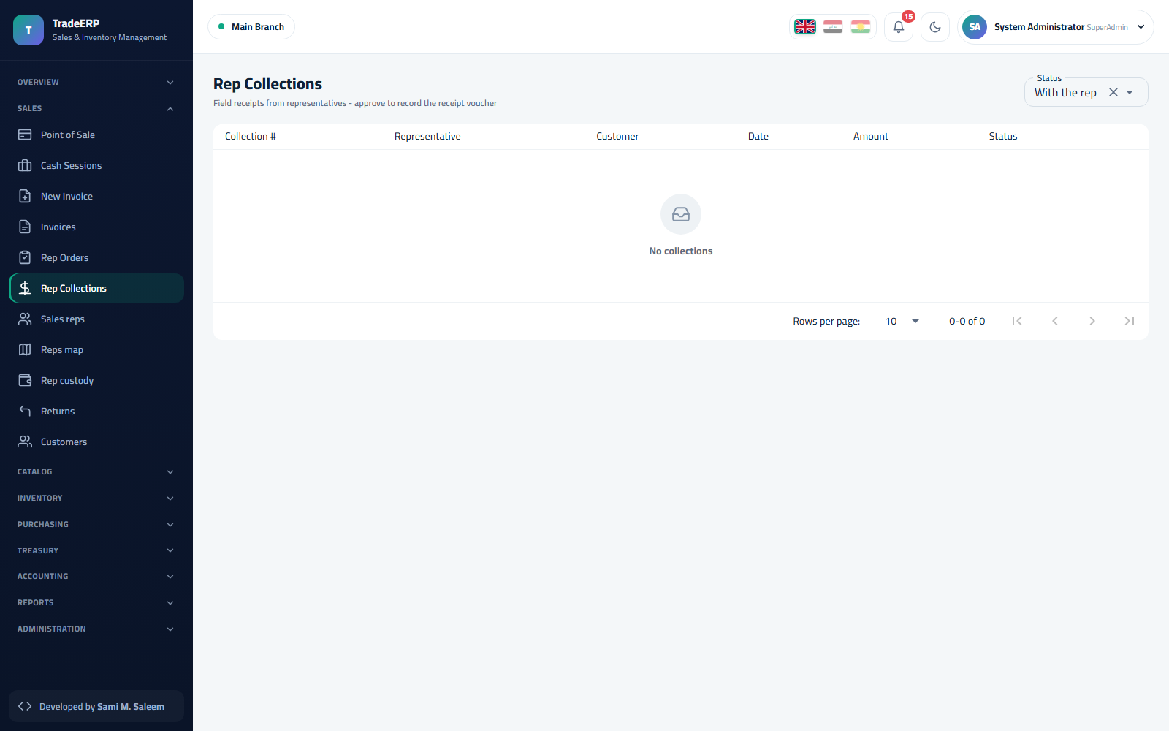Collections against open invoices

5.8 Sales representatives
- Sales → Sales reps — the rep master data and their linked user (for the mobile app).
- Sales → Reps map — where reps are and where their customers are.
- Sales → Rep custody — cash and goods a rep is holding: collected money not yet handed over and stock loaded on the van. Custody is settled when the rep hands over at the branch.
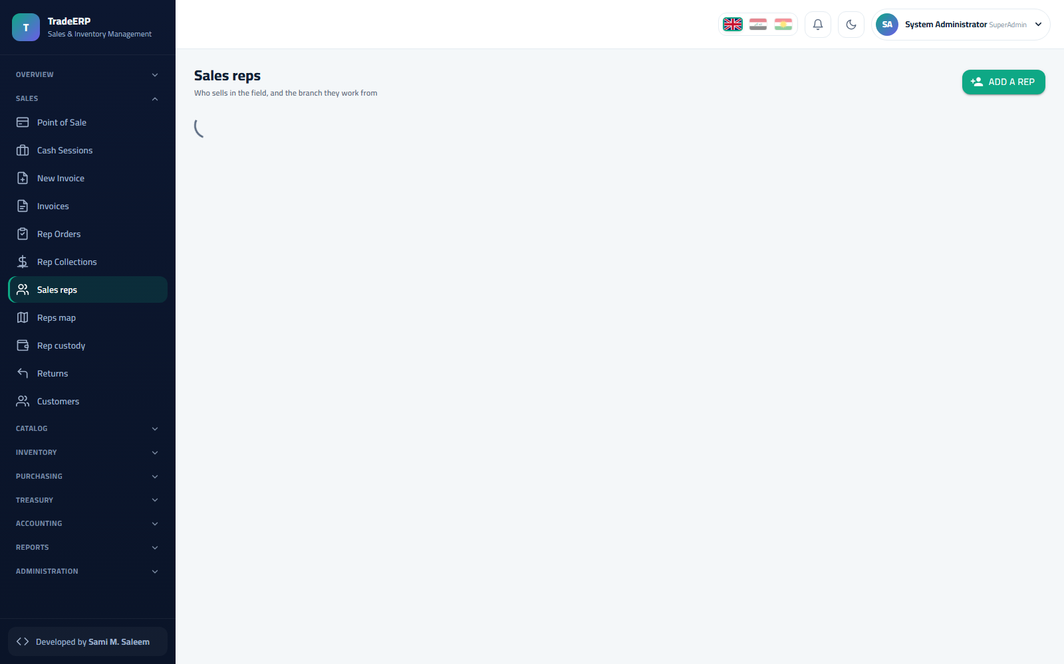Sales reps 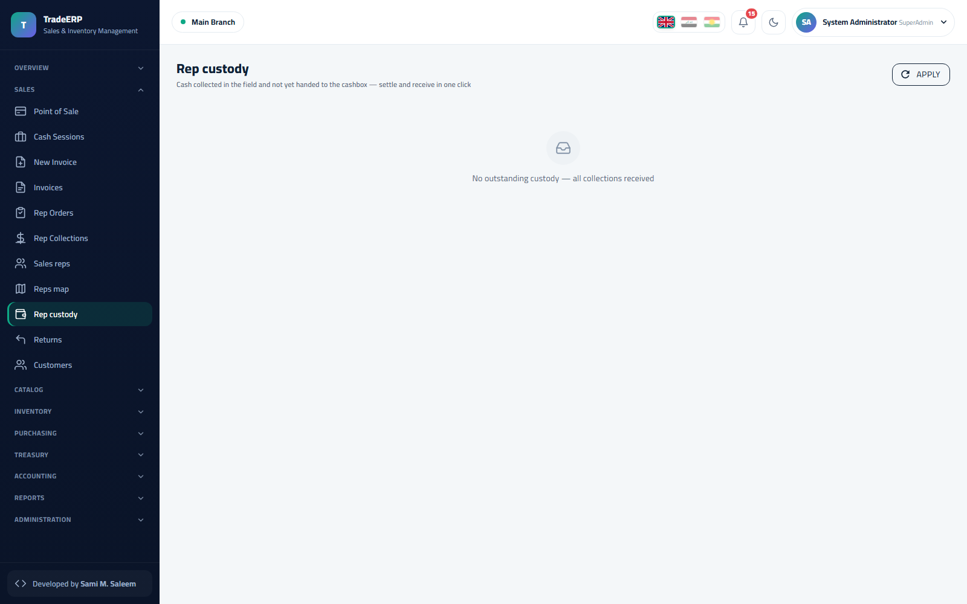Rep custody — cash and goods held by each rep

Chapter 6Treasury and Accounting

6.1 How the books are kept
TradeERP is a double-entry system. Every operational document posts a balanced journal entry:
Document | Debit | Credit
Cash sale | Cash (cashbox) · COGS | Sales revenue · VAT payable · Inventory
Credit sale | Customer receivable · COGS | Sales revenue · VAT · Inventory
Purchase invoice | Inventory · VAT receivable | Supplier payable
Customer collection | Cash | Customer receivable
Supplier payment | Supplier payable | Cash
Expense | Expense account | Cash
Stock adjustment (loss) | Shrinkage expense | Inventory
Because the entries are generated, the trial balance always ties to the operational reports. The Data integrity check (Administration) proves it on demand.

6.2 Cashboxes and cash sessions
Treasury → Cashboxes shows each cashbox with its current balance and the open session (if any). Money moves between cashboxes with a transfer; the safe is usually fed by closing tills into it.
Cashboxes and balances

6.3 Expenses
Treasury → Expenses. Category (rent, salaries, utilities, transport…), amount, cashbox, date, payee, note, and an optional attachment (receipt photo). Posting an expense reduces the cashbox and debits the expense account.
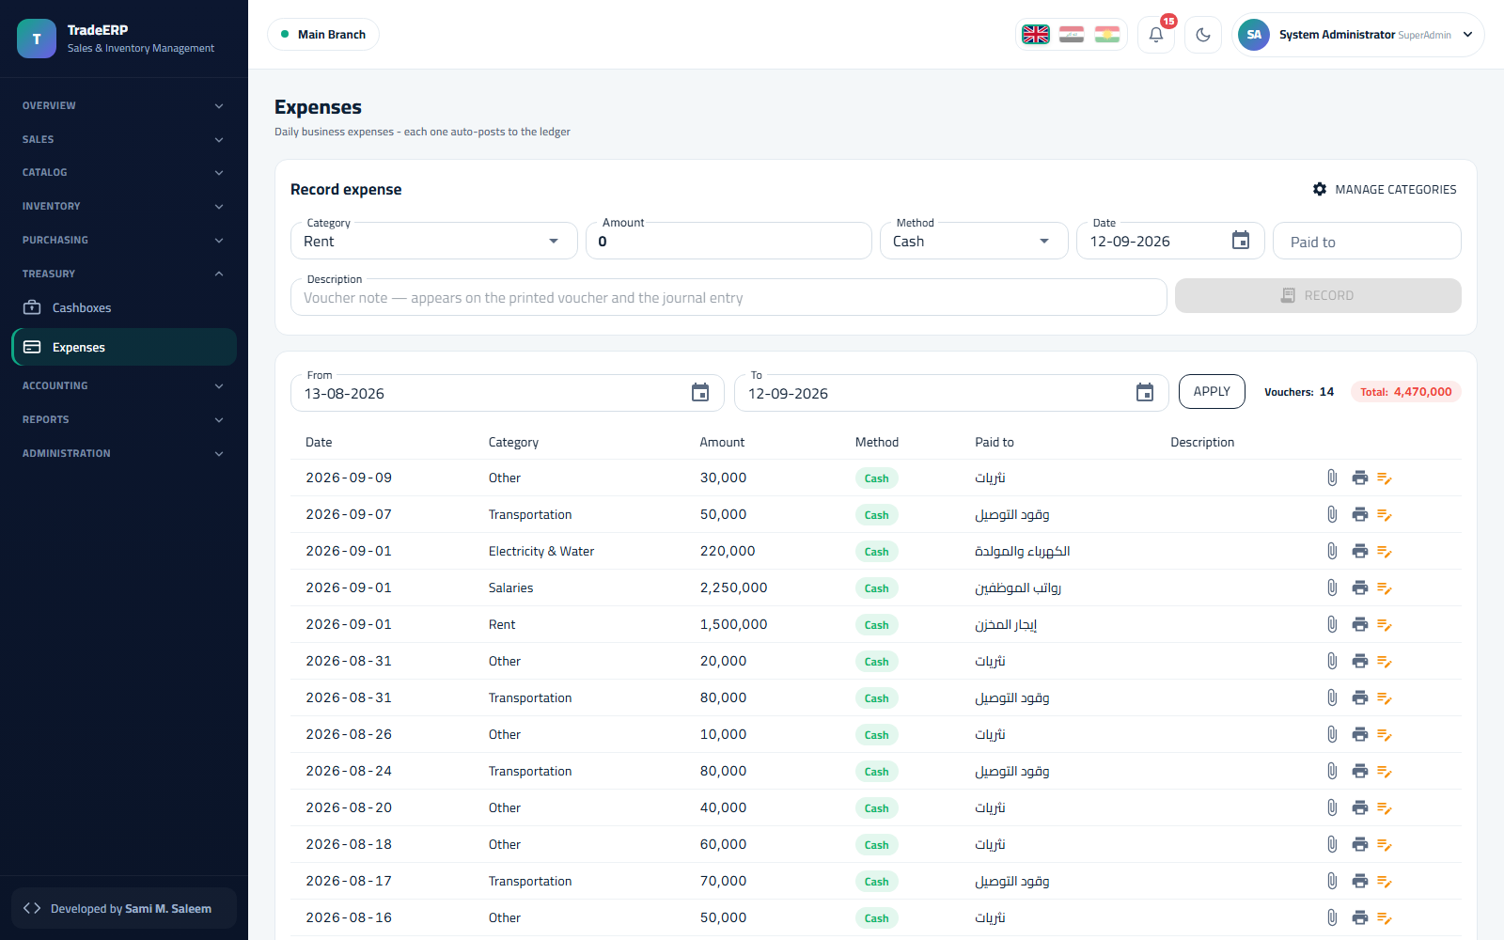Expenses

6.4 Journal
Accounting → Journal lists every entry — automatic or manual — with number, date, description, source document, total and status. Manual entries (e.g. owner's capital, depreciation) are created with New entry: lines must balance before posting.
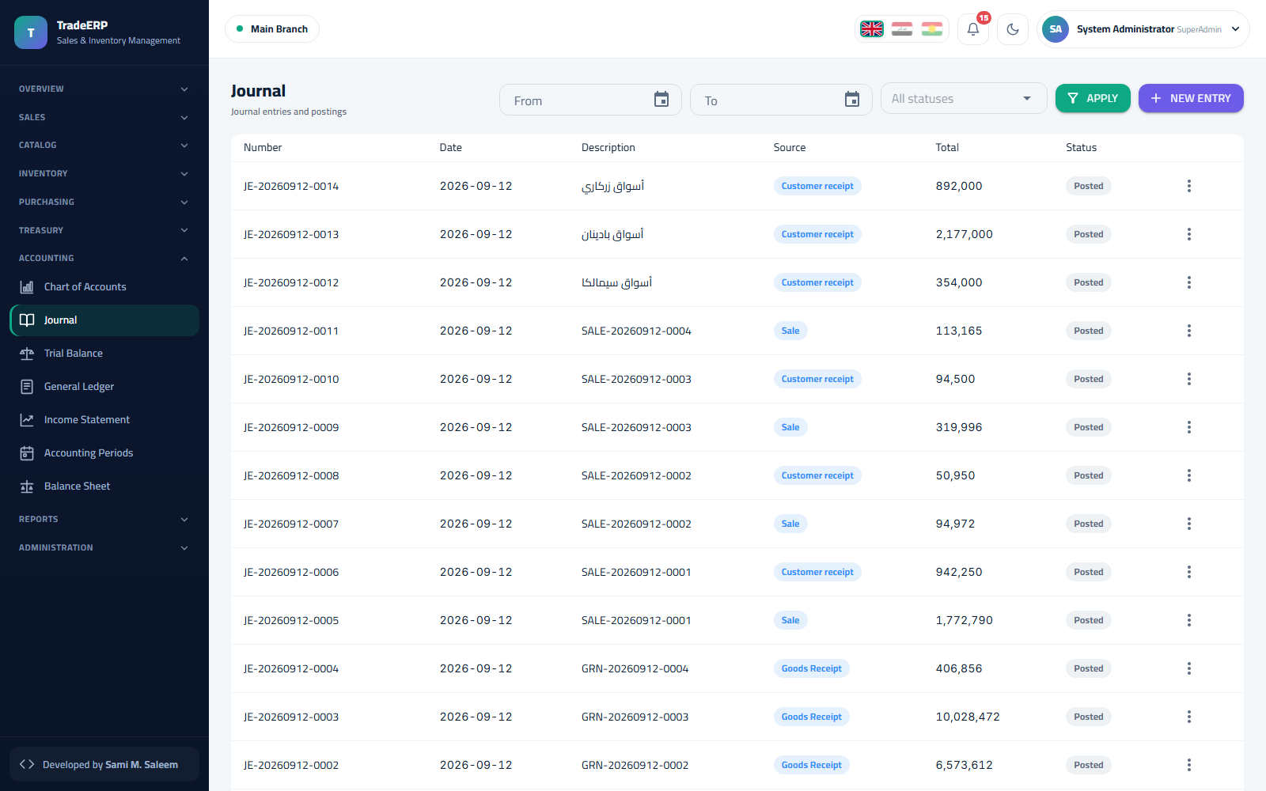Journal

6.5 General ledger
Accounting → General Ledger. Choose an account and a period to see its opening balance, every posting with the source document, and the closing balance. Click a line to open the original document.
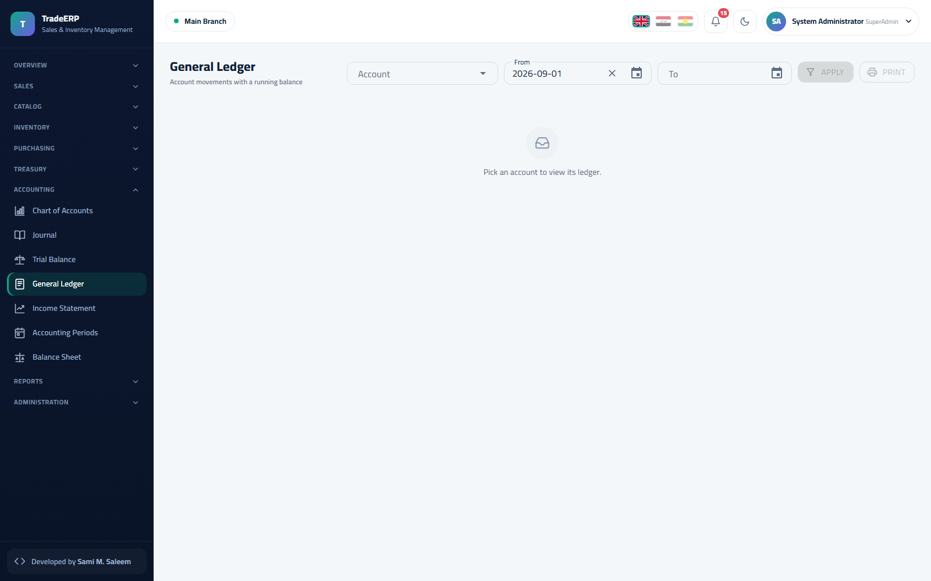General ledger

6.6 Trial balance, income statement, balance sheet
- Trial Balance — all accounts with debit and credit totals; the footer proves debits = credits.
- Income Statement — revenue, cost of goods sold, gross margin, expenses and net profit for a period.
- Balance Sheet — assets, liabilities and equity as at a date, including current-year earnings.
Each statement has a date/period picker, Apply, and Print.
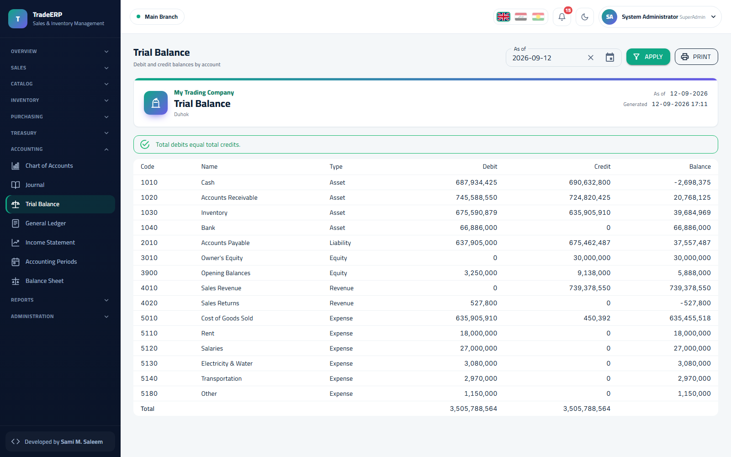Trial balance 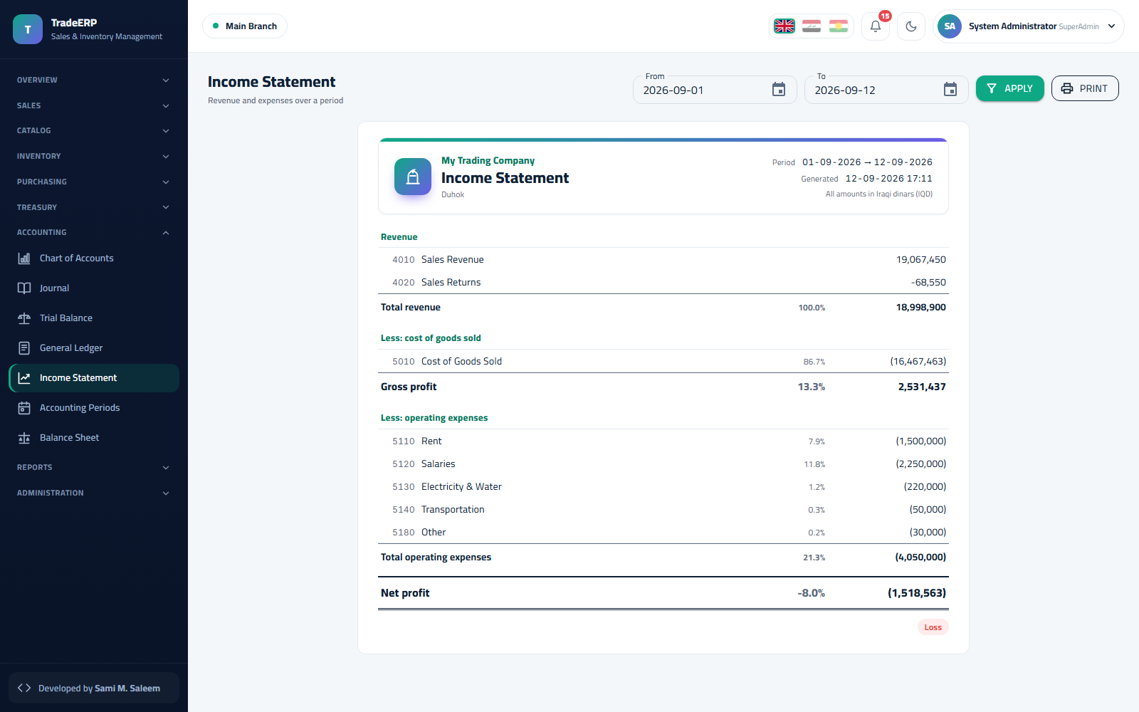Income statement 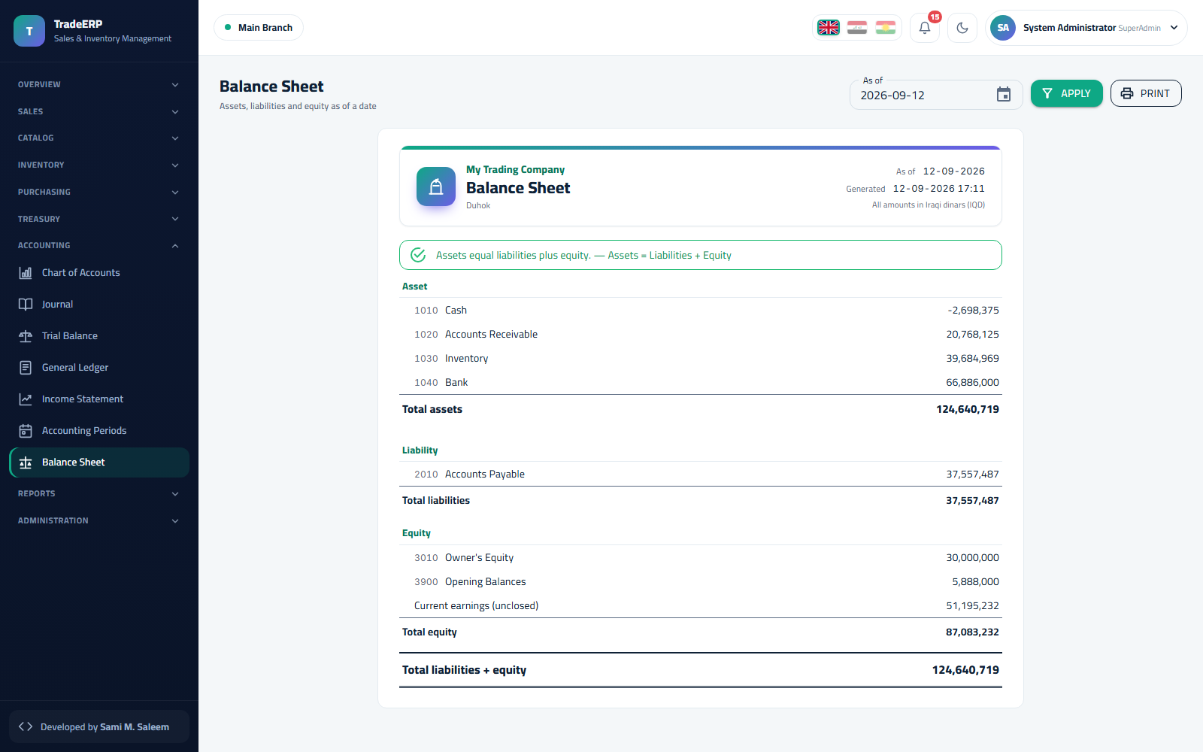Balance sheet

6.7 Accounting periods
Accounting → Periods. Months are opened and closed by the accountant. Nothing can be posted, cancelled or edited into a closed month — this is how year-end figures stay final. Re-opening a period requires the corresponding permission and is recorded in the audit trail.
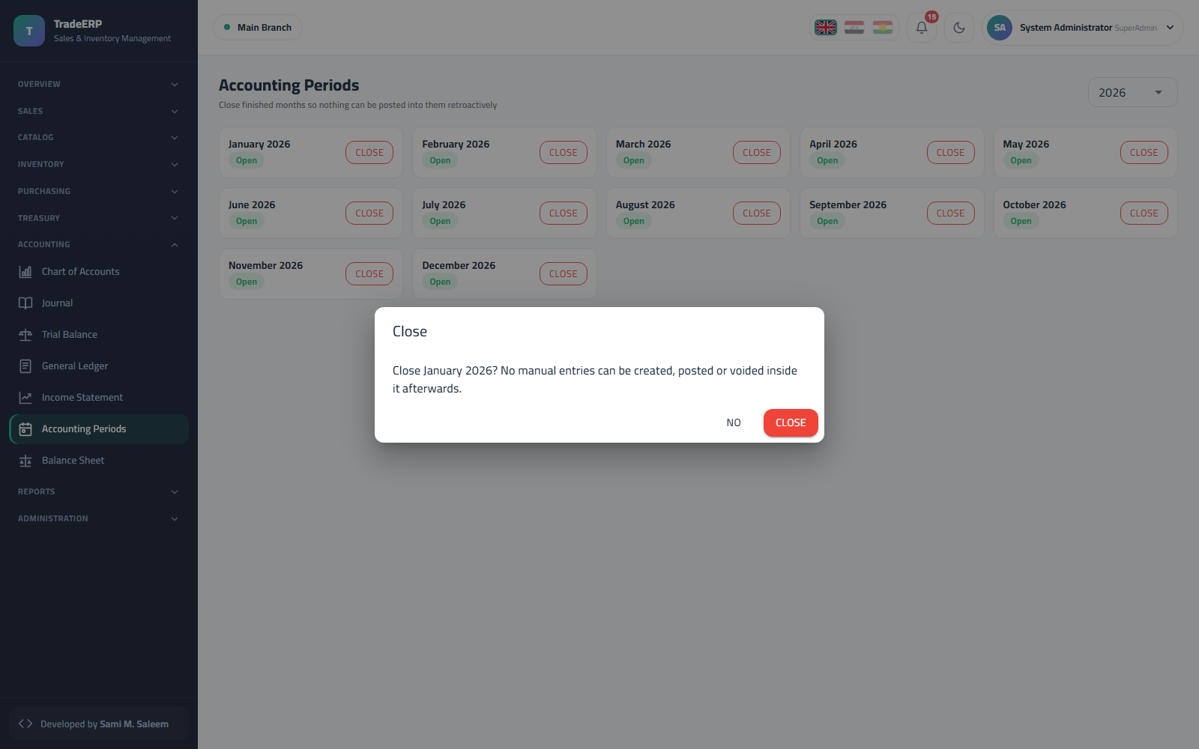Accounting periods

Chapter 7Reports, Administration and Safety

7.1 Reports
All reports live under Reports and share the same controls: period picker, branch/warehouse filter, Apply, Excel and Print.
Report | Answers
Sales | Sales by day, product, category, cashier or customer; totals, discounts, VAT, margin
Purchases | Purchases by supplier, product, period
Collections | Money collected per day / cashier / rep
Balances | Customer and supplier balances as at a date
Aging | Receivables aged in 30/60/90/120-day buckets — who to call first
Item Card | Full movement history of one product
Valuation | Stock value per warehouse at weighted-average cost
Reps | Sales, collections and custody per representative
Gifts | Free items given away, against the company's gift limits
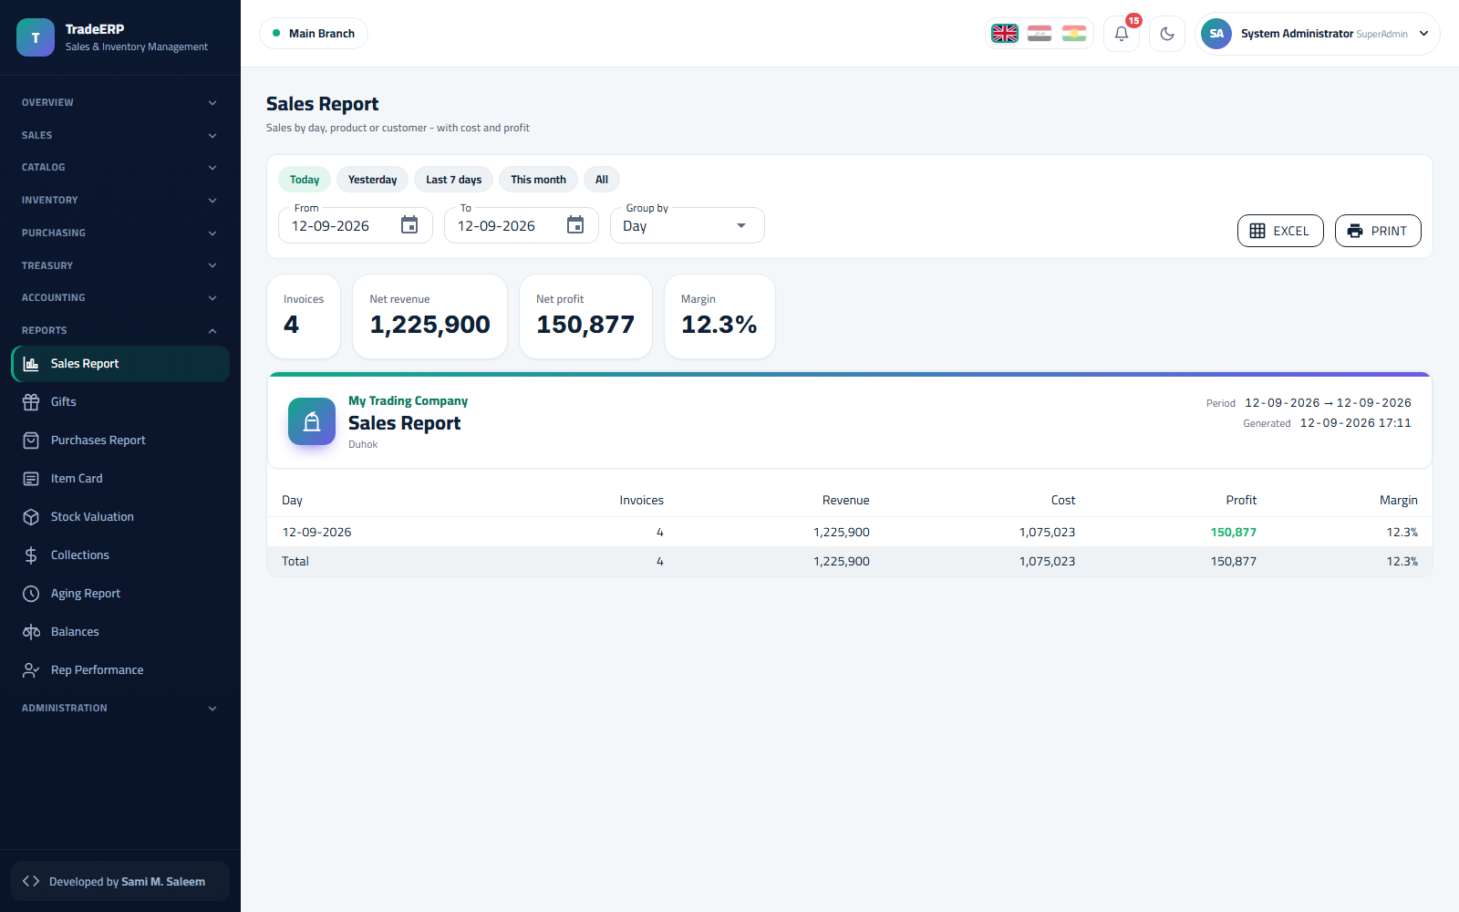Sales report 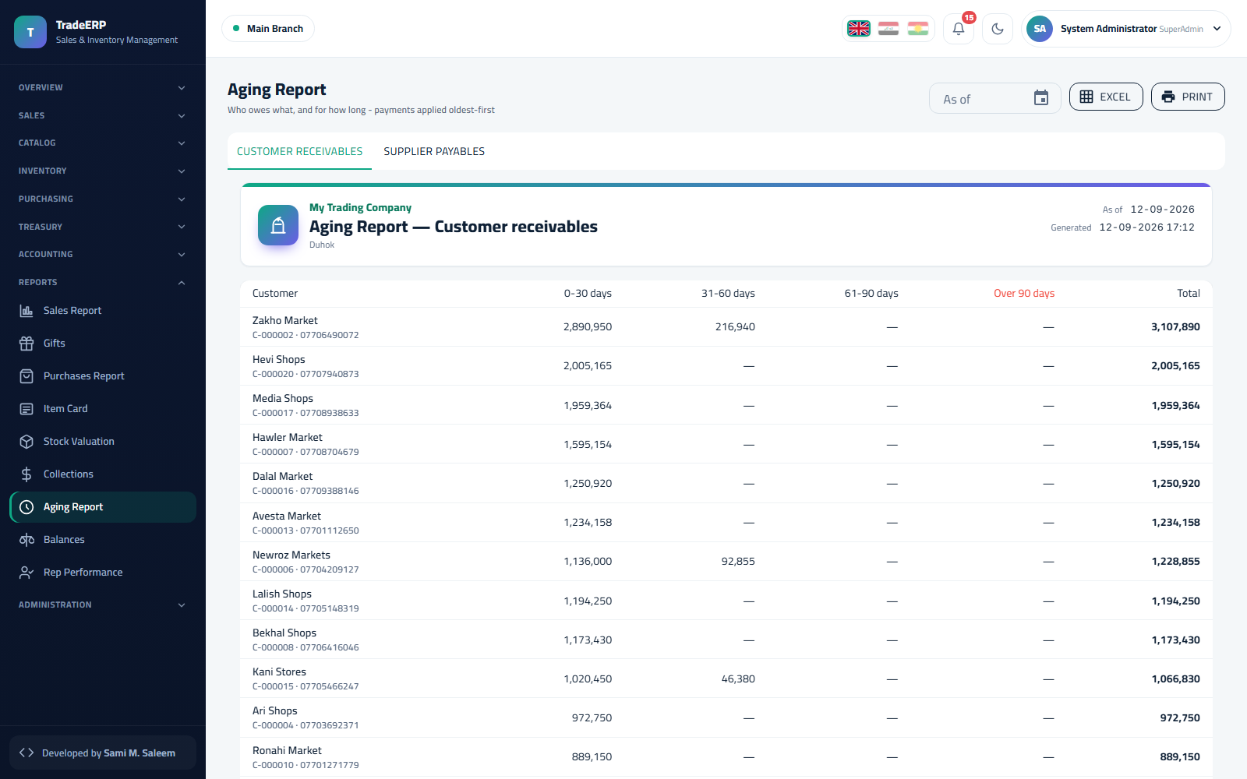Receivables aging 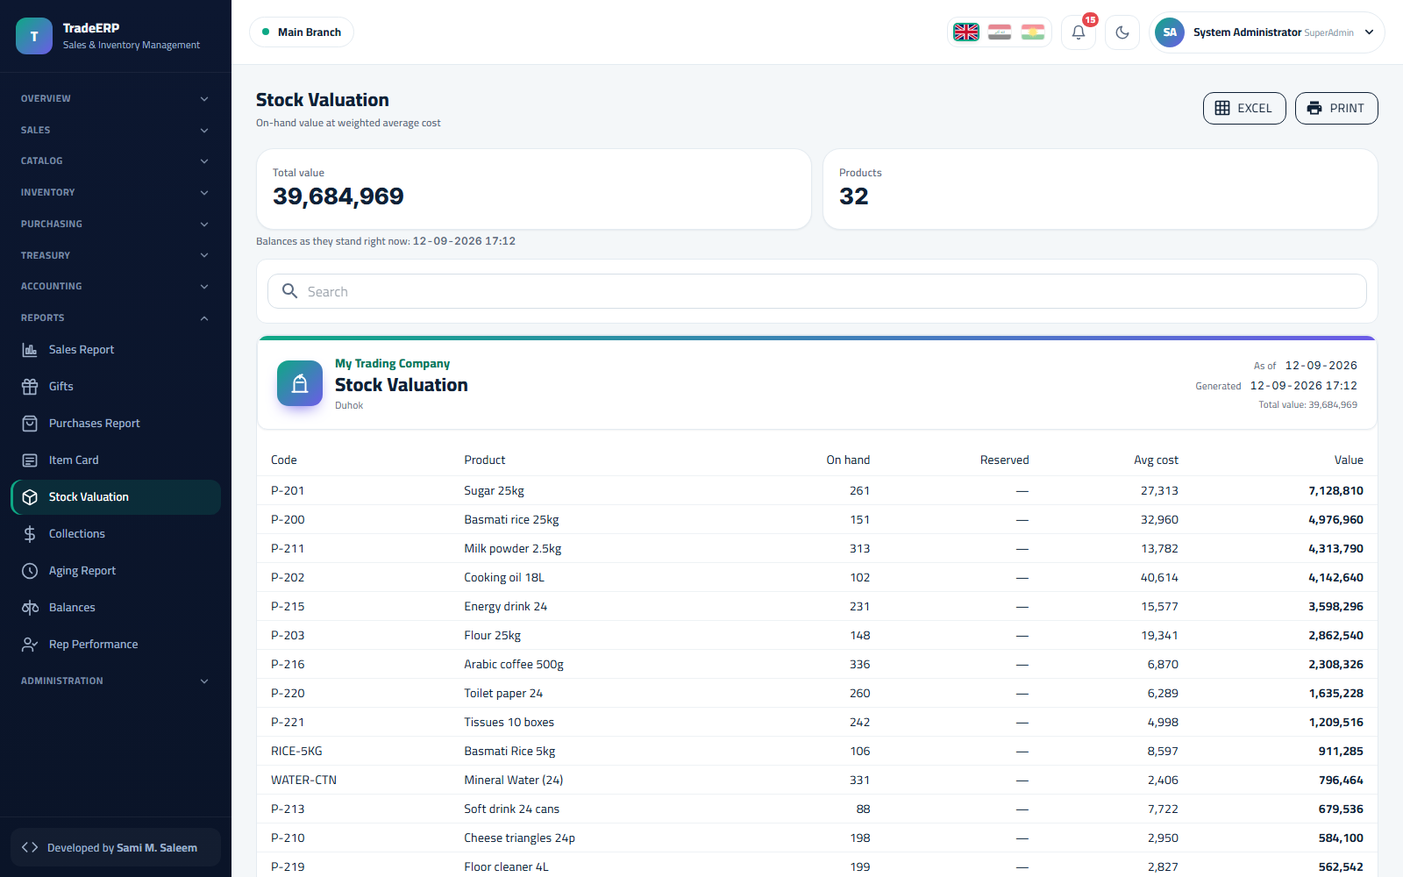Inventory valuation

7.2 Audit trail
Administration → Audit Trail. Who did what, when, from where — every create, update, post, cancel, login and permission change, with before/after values. Filter by user, entity or date; export to Excel for auditors.
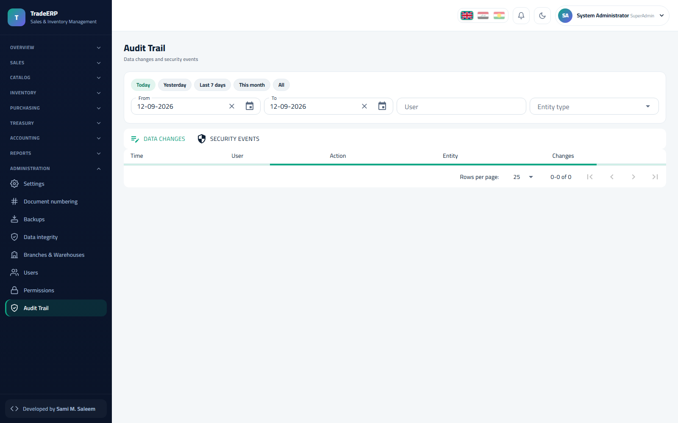Audit trail

7.3 Data integrity
Administration → Data Integrity runs a set of reconciliations: stock ledger vs stock on hand, customer balances vs open invoices, cashbox balances vs sessions, journal totals vs documents. Every check shows expected, actual and difference. Run it after any import or restore.
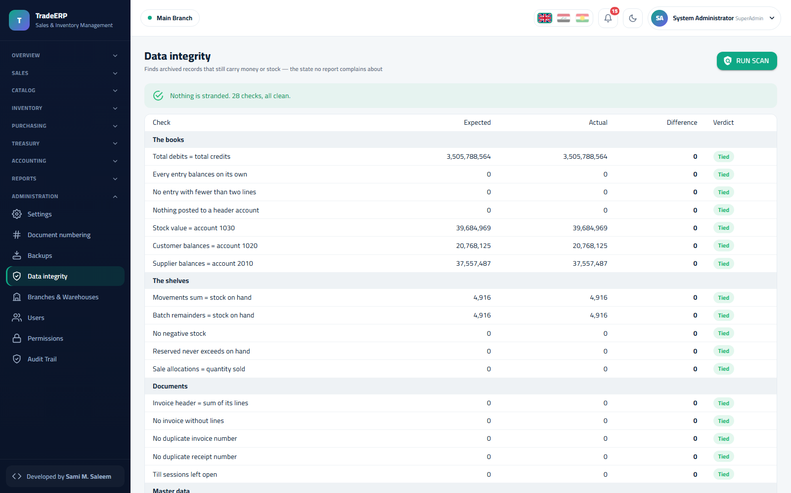Data integrity checks — all green

7.4 Backups
Administration → Backups. Nightly automatic backups plus Back up now; every file is listed with size, date and an integrity status, and can be downloaded. Restoring is a guarded, two-step action reserved for the administrator.
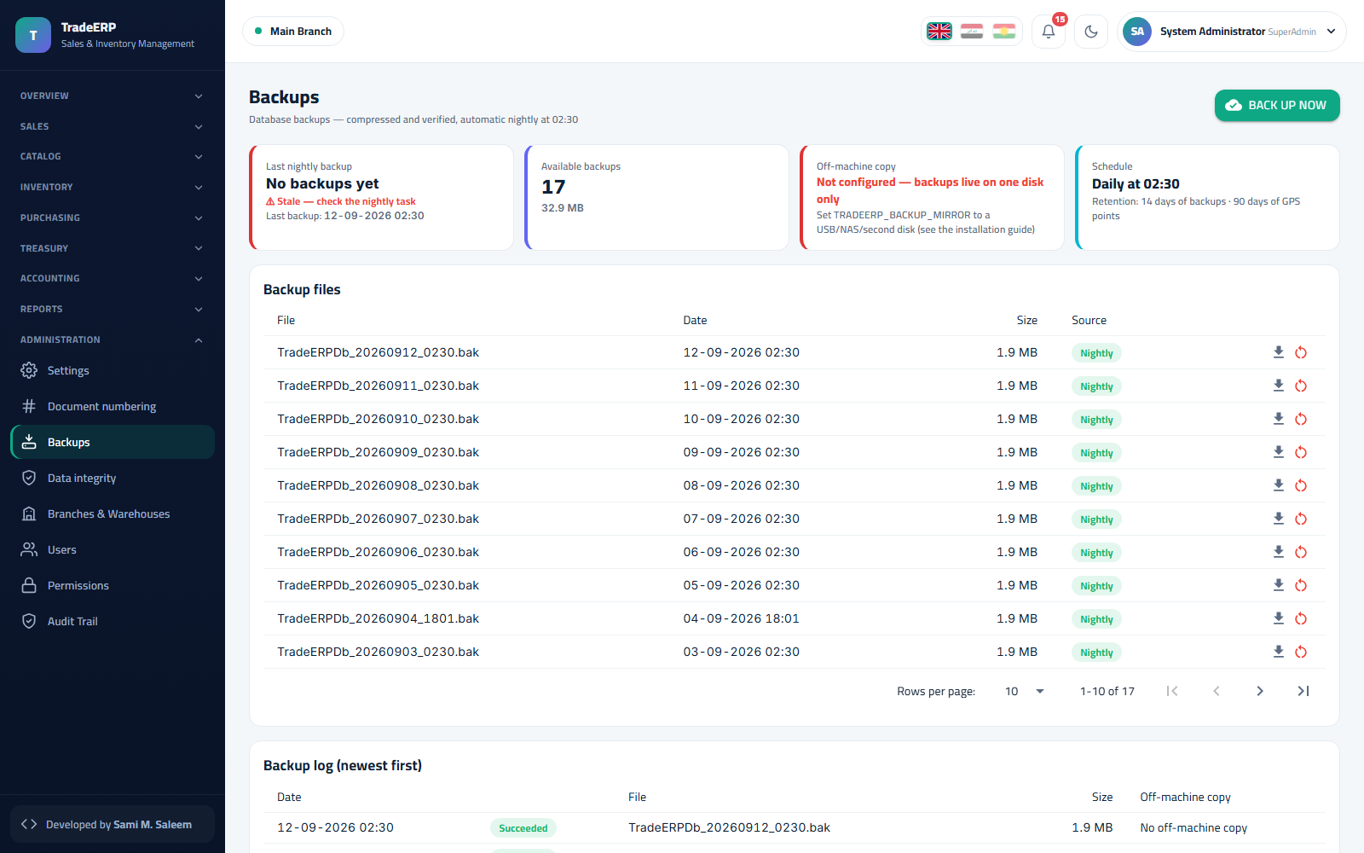Backups

7.5 Frequently asked questions
The POS says "No open session". Click Open session, choose the cashbox and enter the opening float. Sessions are per cashier per day.
A product does not appear on the POS. Check it is active, has a sale price, and belongs to a category; products with zero available stock are still shown but flagged.
I posted an invoice with the wrong price. Posted documents cannot be edited: create a return for the wrong lines and a new invoice with the right price. The audit trail keeps both.
The trial balance does not balance. It always balances; if a report looks off, run Data Integrity and check for a closed period that blocked a posting — the offending document will be in Draft.
Can two branches share stock? No — stock is per warehouse. Use a transfer.
Which browsers are supported? Current Chrome, Edge, Firefox and Safari on desktop; tablets work for POS with a Bluetooth scanner.

